

**ViMal-Total Suite: A Suite of Tools Consisting of Guides, Apps and Scripts to Support the Modern Honey Network (MHN) Platform**

**James Finglas**

**B00094138**

Department of Informatics School of Informatics and Engineering Technological University Dublin

Submitted to Technological University Dublin in Partial Fulfilment of the requirements for the degree of:

Bachelor of Science (Honors) in Computing

Module Name: 4th Year Thesis

Supervisor: Aurelia Power

Submission Date: 15-5-2020

# Project Declaration Form

Group Members: James Finglas

Supervisor: Aurelia Power

Course Co-Ordinator: Stephen O'Shaughnessy

Module Name: 4th Year Thesis

Submission Date: 15-5-200

I declare that the work contained in this report which I now submit on the program of study leading to the award of Degree of Honors B.Sc. in Computer Science in Technological University for Dublin is my own work and has not been taken from the work of others. Any sources which have been referenced or analyzed have been cited using the IEEE standard within the body of this report. It is entirely my own work except where otherwise stated and has not been submitted for assessment for an academic purpose at this or any other academic institution other than in partial fulfilments of the requirements stated above.

I have read and understood the Technology University Dublin’s policy regarding plagiarism.

X

James Finglas

# Acknowledgements:

I would like to extend my deepest thanks to my course coordinator Stephen O'Shaughnessy, who also taught our module in Application Security. His coverage of Python in this module instilled in me a great respect for the power of the Python programming language, even in basic simple forms to provide great functionality in cyber security applications.

Indeed, it was this content that inspired my choice for my project this year, and Mr. O’Shaughnessy’s’ advice and feedback in the early days helped to shape the scope and direction of the project. This was invaluable to my project and this early saving of time was crucial.

I would also like to extend my sincere thanks to my project supervisor, Aurelia Power. I was very lucky to have such a gifted programmer and teacher overseeing my project. But her greatest contribution was in helping to shape the structure of my thesis. It was only at the end of the project as the thesis began to take shape in its final revision that I fully appreciated how much more professional and concise the document appeared by following Ms. Powers’ recommendations regarding the document structure.

Lastly, I would like to extend my thanks to Technology Institute for Dublin, Blanchardstown, as a whole and all the teachers I have been fortunate enough to have studied under during my four years. The experience was a profoundly enjoyable and life changing one and I have gained skills I never dreamed I would acquire, and not only have I acquired these skills and a degree, but I have discovered a deep and fulfilling love for the area of Digital Forensics & Cyber Security.

# Abstract

This project is focused in the area of honeypots and how they lend themselves to the ability for novice cyber security students to teach themselves data analytics skills that could potentially help to address the recruitment gap in the cyber security recruitment sector. The specific goal of my project is to produce a suite of tools in the form of guides, scripts and apps to decrease the difficulty curve in deploying the Modern Honey Network (MHN) platform. This will include an installation guide, a sensor / sensor configuration guide. Management scripts to help manage the platform uptime and storage space, a redeveloped version of the MHN-Splunk app, and a custom designed Python-Based data parser which makes use of the Virus Total API to retrieve threat intelligence data from the Virus Total platform.

The introduction to the project lays out the logic behind the projects conception while the methodology sections discusses how each section was to be approached from the research elements to the practical implementation.

Before addressing the practical elements of my Project, I posed several research questions which can be broken down as follows:

* Are Honeypots a viable source of threat intelligence?
* Is MHN still a viable honeypot platform?
* Could MHN be used as a self-directed teaching platform as well as a threat intelligence tool?
* If so, are there guides that could help aid in the installation and configuration to aid students in installing the platform and begin self-directed learning?
* Are there other competing platforms available that offer the kind of functionality MHN offers easier than MHN?
* Does the MHN-Splunk app Possess areas that need updating to improve its viability?
* Could an improved set of apps and guides and/or scripts resulting in a greater level of usability result in increased threat intelligence gathering allowing young users and fresh research students to gain skills applicable in the cybersecurity sector helping to reduce the recruitment gap that currently exists?

These questions were addressed via a literature review and a critical analysis of the MHN platform and one of its most direct competitor platforms, the ‘T-Pot’ platform, for competitive analysis.

The Implementation and testing phases cover the design, implementations and various testing phases of the project before a future work sections discusses the potential work and fixes to be applied to the project beyond the scope of the projects allowed time frame. The conclusions section lays out the project conclusions along with analyzes the projects process.

“*If you* ***know*** *the* ***enemy*** *and* ***know*** *yourself, you need not fear the result of a hundred battles. If you* ***know*** *yourself but not the* ***enemy****, for every victory gained you will also suffer a defeat. If you* ***know*** *neither the* ***enemy*** *nor yourself, you will succumb in every battle*.”

* Sun Tzu, ‘The Art of War’, circa 500 b.c.

Contents

Project Declaration Form 2

Acknowledgements: 3

Abstract 4

Table of Figures 9

Table of Tables 14

1.0 Introduction 15

1.1 Motivation 23

1.2 Project Goal, Aims & Objectives 26

1.3 Research Questions 27

1.4 Summary 28

2.0 Methodology 29

2.1 Methodology Overview 29

2.2 Methodology System Analysis and Requirements 30

2.3 Methodology: MHN Sensor & MHN-Splunk App Critical Analysis 32

2.4 Methodology: System Design & Implementation 33

2.5 Methodology: Testing 34

3.0 Literature Review 35

4.0 System Analysis, Requirements and Design 78

4.1 Overview Dashboard 79

4.2 Sensor ID 1 - Shockpot Sinkhole 84

4.3 Sensor ID 2 - Dionaea 90

4.4 Sensor ID 3 - Cowrie 98

4.5 Sensor ID 4 - Snort 103

4.6 Sensor ID 5 - Amun 106

4.7 Sensor ID 6 - Elastichoney 110

4.8 Sensor ID 7 - Glastopf 113

4.9 Sensor ID 8 - Suricata 114

4.10 Senor ID 9 - p0f 123

4.11 Sensor 10 - Shockpot 125

4.12 Sensor 11 - Wordpot 126

4.13 Sensor 12 - Magenpot 128

4.14 Sensor 13 - Drupot 132

4.15 Sensor 13 - Conpot 133

4.16 Vimal Python based Virus total Parser 136

5.0 System Implementation 144

5.1 Modern Honey Network Management/Sensor Server & Analytics SIEM Installation Guide 144

5.2 MHN Management & Sensor Server Scripts 144

5.3 Updating the MHN-Slunk App 145

5.3.1 Overview Dashboard Update 150

5.3.2 Indicator Dashboard Removal 155

5.3.3 Shockpot Sinkhole Sensor Dashboard Removal 155

5.3.4 Dionaea Dashboard Update 155

5.3.5 Cowrie (Formerly Kippo) Dashboard Update 157

5.3.6 Snort Dashboard Update 159

5.3.7 Amun Dashboard Creation 161

5.3.8 Elastichoney Dashboard Update 164

5.3.9 Glastopf Dashboard Creation 166

5.3.10 Suricata Dashboard Creation 166

5.3.11 p0f Dashboard Update 169

5.3.12 Shockpot Dashboard Update 171

5.3.13 Wordpot Dashboard Creation 173

5.3.14 Magenpot Dashboard Creation 175

5.3.15 Drupot Dashboard Creation 175

5.3.16 Conpot Dashboard Update 175

5.4 ViMal-Total: A Python-Based VirusTotal Parser 177

6.0 System Testing 207

6.1 ViMal-Total Python Based VirusTotal Parser Testing 207

6.1.1 Uncompiled Window/Linux Version Testing White Box Testing 207

6.1.2 Compiled Window/Linux Version Testing White Box Testing 209

6.1.2 Window/Linux Version Testing Black Box Testing 210

6.1.2.1 Window/Linux Version Testing Black Box Testing Survey Question 1 211

6.1.2.2 Window/Linux Version Testing Black Box Testing Survey Question 2 212

6.1.2.3 Window/Linux Version Testing Black Box Testing Survey Question 3 213

6.1.2.4 Window/Linux Version Testing Black Box Testing Survey Question 4 214

6.1.2.5 Window/Linux Version Testing Black Box Testing Survey Question 5 215

6.1.2.6 Window/Linux Version Testing Black Box Testing Survey Question 6 216

6.1.2.7 Window/Linux Version Testing Black Box Testing Survey Question 7 217

6.1.2.8 Window/Linux Version Testing Black Box Testing Survey Question 8 218

6.1.2.9 Window/Linux Version Testing Black Box Testing Survey Question 9 219

6.1.2.10 Window/Linux Version Testing Black Box Testing Survey Question 10 221

6.1.2.11 ViMal-Total Python base VirusTotal Parser System Revisions 224

6.1.3 Re-developed MHN-Splunk App Comparative Testing 228

7.0 Future Work 237

8.0 Personal Mission Statement 238

9.0 Conclusion 239

10.0 Appendix 241

11.0 Glossary 242

12.0 References 244

# Table of Figures

Figure 1 ‘Technically Professionals Cybersecurity Professionals Continue to Be in Short Supply’ respondent demographics, 2019 [4]. 16

Figure 2 Industry Sectors employment statistics based on 1500 people surveyed [4]. 17

Figure 3 Organizations reporting unfilled cybersecurity positions [4]. 18

Figure 4 Time taken to fill a cybersecurity position [4]. 18

Figure 5 Hiring demand per organizational level (Dark green = Tier 1 analyst, Light green = tier 2 researcher, orange = c-level executives and tier 3 operators) [4]. 19

Figure 6 Example of GUI output in The Deception Toolkit, the world’s first recognized Honeypot, released first in 1997 [6]. 20

Figure 7 The MHN web portal home page displaying the current number of attacks and important attack information. 21

Figure 8 Documentation from the MHN GitHub page listing the supported Linux distributions [7]. 23

Figure 9 Here we can see the process of setting the log files group permissions to 'www-data'. This can be altered to the 'root' group. If this happens the MHN platform cannot log data to the log file resulting in a service spawn error. 23

Figure 10 Map of sciences produced by 2007/8 study, 'Clickstream Data Yields High-Resolution Maps of Science' [29]. 35

Figure 11 The back-bone network of the Internet as of October 2017 [31]. 36

Figure 12 The millions upon millions of BGP connections that facilitate the vastness that is the digital space between backbone connections as of 2010 [33]. 37

Figure 13 Here we see that the 2012 Anonymous internet census detected and mapped over 450 million vulnerable machines from the 38

Figure 14 Email volume and spam percentage record for the month of January, 2020 by the Talos security department of Cisco [38]. 42

Figure 15 Storinator server drawer chassis [39]. 43

Figure 16 A Storinator rack & merge tower hosing in this case, 5 drawer style server pods [40]. 43

Figure 17 Linus Sabastian of YouTube fame, founder of the fantastic Linus Tech Tips channel stands in front of 3 petabytes of data storage [41]. 44

Figure 18 Projected estimates of data growth from 2006 to 2020 [42]. 45

Figure 19 A breakdown of the classification of the types of honeypot deployments and the risks associated with each, Care of the Sans Institute [44]. 47

Figure 20 T-Pot Test machine at the time of testing the T-Pot Honeypot platform. 52

Figure 21 A resource snapshot taken from the T-Pot virtual machine at idle. 53

Figure 22 The t-pot platform administrator web platform. 54

Figure 23 The log file for the Dionaea sensor (dionaea.log) deployed remotely, sitting at over 124GB in size at the time of taking this snapshot. 56

Figure 24 A resource snapshot taken from the MHN cloud machine at idle. 56

Figure 25 The MHN web portal home page. 57

Figure 26 The MHN threatmap 58

Figure 27 The MHN sensor deploy menu. 58

Figure 28 The MHN attack reports page. 59

Figure 29 The MHN payload rules screen. 59

Figure 30 The MHN rule management interface. 60

Figure 31 The MHN sensor viewing window. 60

Figure 32 The MHN chart viewing tab. 60

Figure 33 Snapshot of the main overview dashboard of the T-Pot platform. 62

Figure 34 Users can elect to inspect the Elk stack directly. 63

Figure 35 Elasticsearch indexed files 63

Figure 36 The ELK stack file browser. 64

Figure 37 The Structured query tab allows for search queries to be created and stored. 64

Figure 38 The any request tab for testing queries. 65

Figure 39 The CyberChef GUI. 66

Figure 40 Logstash event data can also be viewed directly. 67

Figure 41 The dashboard modification screen. 68

Figure 42 The T-Pot map creation tab. 69

Figure 43 The T-Pot development console. 69

Figure 44 The T-Pot cluster health monitoring feature. 70

Figure 45 The ELK stack integration management interface. 70

Figure 46 A T-Pot dashboard visualization tab pre data entry. 71

Figure 47 Rapid 7's recognition of Splunk as the dominant market leader in the SIEM arena [49]. 73

Figure 48 Question 1 of Honeypots, Threat Intel & Teaching survey. 78

Figure 49 The upper third of the Overview dashboard which acts as the main page of the MHN-Splunk app. 79

Figure 50 The invalid search relating to the 'Commands Executed' panel within the Overview dashboards upper third section. 80

Figure 51 The middle third of the Overview dashboard which makes up the home page of the MHN-Splunk app. 80

Figure 52 The lower third of the Overview dashboard which makes up the main page of the MHN-Splunk app. 81

Figure 53 The 'Top Username panels invalid search. 82

Figure 54 The 'Top Passwords' panels invalid search. 82

Figure 55 The indicators dashboard. 83

Figure 56 Here we see the Shockpot Sinkhole sensor has been deployed. 84

Figure 57 The process is added to the running processes. 84

Figure 58 A sample of the Shockpot.log file from the Shockpot sinkhole sensor. 85

Figure 59 The mhn-splunk.log file displaying false positive results for the Shockpot sensor. 86

Figure 60 Shockpot sinkhole configuration file 86

Figure 61 The first 5 panels of the Shockpot dashboard displaying the Events per hour, MD5, SHA1 and SHA256 data. 87

Figure 62 The lower 4 panels displaying the top attackers, top URL's downloaded, top sensors, and Shockpot events. 88

Figure 63 The Shockpot log displayed via SSH overlaid over the MHN-Splunk app highlighting the first Shockpot event logged in both. 89

Figure 64 The Dionaea sensor is deployed for analysis. 90

Figure 65 The upper half of the dionaea.conf configuration file. 91

Figure 66 The Dionaea.log in our prior test deployment showing 125GB in size. 92

Figure 67 The second half of the dionaea.conf configuration file. 94

Figure 68 A sample of the dionaea.log file. 95

Figure 69 The first 3 panels of the Dionaea dashboard, displaying events per hour, top MD5's and top captured URL's. 96

Figure 70 The next 4 panels of the Dionaea dashboard, displaying Top Dionaea attackers, top ports, top sensors and events. 97

Figure 71 Cowrie is deployed on the sensor server. 98

Figure 72 The Cowrie process is added to the running processes. 98

Figure 73 A sample of the cowrie.log file. 99

Figure 74 The server identification options in the cowrie.cfg configuration file. 99

Figure 75 The top 4 panels of the Kippo dashboard that will be converted into a cowrie dashboard. 101

Figure 76 The lower 4 panels of the Kippo dashboard which will be converted into a Cowrie dashboard. 102

Figure 77 A sample of the Snort alert.log file 103

Figure 78 The top 5 panels of the Suricata/Snort dashboard, displaying ‘Events per Hour’, ‘Top Sensors’, Top Destinations’, ‘Top Source Ports’ 104

Figure 79 The lower 5 panels of the Suricata/Snort dashboard. 105

Figure 80 the MHN-Splunk output logged for the Amun sensor via the HPfeeds logger. 106

Figure 81 The Amun sensor being run in single file scanning mode. 106

Figure 82 The scan completes with 0 matches. 107

Figure 83 Altering the server IP, IP range, and adapter setting sin the amun.conf file. 107

Figure 84 Editing the IP block rules in the amun.conf file. 108

Figure 85 View the vulnerability module ports in the amun.conf file. 109

Figure 86 The Elastichoney config.json configuration file. 110

Figure 87 The upper half of the current Elastichoney dashboard with encompasses the ‘Events per Hour’ and ‘Global Attacks’ panels. 111

Figure 88 The lower half of the current Elasticsearch Dashboard. 112

Figure 89 Attempting to install glastopf as root results in a installation error. 113

Figure 90 The error is repeated on a test user account with sudo permissions. 113

Figure 91 The Suricata data is now being logged to the mhn-ssplunk.log file with our fix having been applied. 114

Figure 92 The current Snort/Suricata dashboard consisting of invalid Suricata searches, as the ‘suricata.alerts’ fields does not exist in the log. 115

Figure 93 The user, group, PID, and log location settings in the suricata.yaml configuration file. 116

Figure 94 Enabling logging of TLS and DNS data in Suricata. 116

Figure 95 Enabling logging of PCAP information in Suricata. 117

Figure 96 Enabling Debug logging the Suricata. 117

Figure 97 Enabling syslog and dropped connection logging in Suricata. 118

Figure 98 Enabling TCP, HTML body, and LUA (error) logging in Suricata. 119

Figure 99 Managing the intrusion detection settings in Suricata. 120

Figure 100 Adjusting the PCAP settings in Suricata. 121

Figure 101 A sample drop rule from the drop.rules file which manages the IPS blocking function of the Suricata sensor. 122

Figure 102 The upper half of the current p0f dashboard. 123

Figure 103 The lower half of the current p0f sensor. 124

Figure 104 The second Shockpot sensor (non-sinkhole version) with the 'only_exploits' attribute pre-configured to 'True'. 125

Figure 105Adjusting the Wordpot server details via the Wordpot.conf configuration file. 126

Figure 106 altering the blog title, version and author WordPress details via the wordpot.conf configuration file. 126

Figure 107 Adding plugins and theme in the Wordpot.conf file. 127

Figure 108 Editing the Magenpot webserver deployment port and name of the website to be deployed. 128

Figure 109 Adjust the version information that will be declared when running the Magenpot sensor. 128

Figure 110 HPFeeds and public IP configuration options for the Magenpot sensor 129

Figure 111 events being logged against our deployed Magenpot sever. 129

Figure 112 No individual events returned from the agave (Magenpot) sensor. 130

Figure 113 No events at all showing on the MHN webservers main page. 130

Figure 114 The MHN platforms HPfeeds-Logger file which the preprocessing function for agave.event (Magenpot) sensor with the highlighted error. 131

Figure 115 0 Events retuned when searching for agave.events log data in the mhn-plunk.log index.. 131

Figure 116 The drupal config.toml file which mirrors the Magenpot config.toml file. 132

Figure 117 Channing the sensor ID, timeout duration, user/group settings and log file location in the Conpot config.cfg file. 133

Figure 118 Activating the SQLite, MYSQL, and Syslog setting, as well adjusting the host, facility and socket (port) settings. 133

Figure 119 Altering the HPfeeds details (this will result in the sensor no longer logging to the MHN management server). 134

Figure 120 altering the public IP service from which a public IP will be obtained as well as the interface and mac address settings. 134

Figure 121 The upper half of the current Conpot Dashboard. 135

Figure 122 The lower half of the current Conpot dashboard. 135

Figure 123 A sample search of the itb.ie domain on the Virus Total website [12]. 138

Figure 124 Here we see a sample of the detection results, or lack thereof, as the case may be [12]. 139

Figure 125 Here we see the verbose output from the details tab [12]. 140

Figure 126 Data from the relations tab [12]. 141

Figure 127 The community tab containing community comments, if any [12]. 141

Figure 128 Entering the view section of the Splunk platform to add a view. 145

Figure 129 Assigning the identification features to a view. 146

Figure 130 Entering view permission settings. 146

Figure 131 Adjusting permissions settings so that only pour current app can access the new view. 147

Figure 132 Designing the webpage, or view, for the first of two Amun based dashboards. 147

Figure 133 Entering the navigation menu to add a navigation link. 148

Figure 134 Adding the navigation links for our two new Amun dashboard views. 149

Figure 135 The new Amun dashboards are ready to be formatted. 149

Figure 136 The upper third of the updated Overview dashboard. 150

Figure 137 The updated 'Commands executed' search field which is now correctly searching for Cowrie data. 151

Figure 138 The middle third of the newly updated Overview dashboard. 152

Figure 139 The lower third of the newly updated Overview dashboard. 153

Figure 140 The 'Top Usernames' panel with its updated search parameters, now correctly searching for Cowrie data. 154

Figure 141 The 'Top Passwords' panel with its updated search parameters, now correctly searching for Cowrie data. 154

Figure 142 The top 3 panels of the new updated Dionaea dashboard. 155

Figure 143 The lower half of the Dionaea Analytics dashboard. 156

Figure 144 The second new Dionaea dashboard, 'Dionaea Events'. 156

Figure 145 The top 4 panels of the newly created Cowrie Analytics Dashboard designed to replace the Kippo Dashboard. 157

Figure 146 The lower 5 panels of the newly created Cowrie Dashboard designed to replace the Kippo dashboard. 158

Figure 147 The Newly created Cowrie Events dashboard designed to increase the efficeny of the Cowrie Analytics dashboard by reducing recurrsive searches. 158

Figure 148 The upper of the new Snort Dashboard. 159

Figure 149 The lower half of the newly created Snort Dashboard. 160

Figure 150 The lower three panels of the newly created Amun Analytics dashboard. 162

Figure 151 The first 5 panels of the newly created Amun analytics dashboard. 162

Figure 152 The Newly created Amun Events dashboard containing the Amun events panel. 163

Figure 153 The updated Elastichoney Analytics dashboard containing the 'Events per Hour' and 'Global Events' panels. 164

Figure 154 The lower half of the updated Elastichoney Analytics dashboard. 165

Figure 155 The newly added Elastichoney Events dashboard. 165

Figure 156 The search parameters of the new dashboard are updated to search for the correct field 'suricata.events., instead of 'suricata.alerts'. 166

Figure 157 The upper half of the newly created Suricata Dashboard. 167

Figure 158 The lower half of the newly created Suricata dashboard. 168

Figure 159 The upper half of the updated p0f panel. 169

Figure 160 The lower half of the updated p0f dashboard. 170

Figure 161 The new p0f Events dashboard which contains only the p0f Events panel. 170

Figure 162 The upper half of the Shockpot Analytics Dashboard. 171

Figure 163 The newly created Shockpot Events dashboard. 172

Figure 164 The upper half of the newly created Wordpot dashboard. 173

Figure 165 The lower half of the newly created Wordpot dashboard. 174

Figure 166 The newly created second dashboard 'Wordpot Events' created to house the 'Wordpot Events' panel. 174

Figure 167 The newly updated Conpot analytics sensor. 175

Figure 168 The newly created Conpot Events dashboard containing the Conpot events Panel. 176

Figure 169 Activity diagram laying out the functionality of the first sub menu option, the HASH options. 178

Figure 170 Activity diagram laying out the functionality of the second sub menu option, the Scan ID options. 179

Figure 171 Activity diagram laying out the functionality of the third sub menu option, the File options. 180

Figure 172 Activity diagram laying out the functionality of the fourth sub menu option, the URL options. 181

Figure 173 Activity diagram laying out the functionality of the fifth sub menu option, the IP options. 182

Figure 174 Activity diagram laying out the functionality of the sixth and final sub menu option, the Domain options. 183

Figure 175 Consolidated use case Diagram displaying all functions. 184

Figure 176 Here we see the MainMenu frame displayed. 188

Figure 177 Here we see a sample Hash report mined from a json and output to the Hashreportoutput text field. 191

Figure 178 Here we see a sample of statistical data mined from a json and output to the Hashreportoutput text field (With confirmation alert message). 192

Figure 179 here we see that the user has requested a text file be generated from the data contained within the Hashreportoutput text field. 193

Figure 180 Here we see a sample of the text file generated by the users request to create a text file. 194

Figure 181 The file browser window opened by the askopenfilename() function. 197

Figure 182 The TypeError error that is produced if the user attempt to perform a search with no data present in the search field. 207

Figure 183 The error created when the user attempts to select a file to be scanned then cancels the file selection process. 208

Figure 184 The responses to the black box testing survey question 1. 211

Figure 185 The responses to the black box testing survey question 2. 212

Figure 186 The responses to the black box testing survey question 3. 213

Figure 187 The responses to the black box testing survey question 4. 214

Figure 188 The responses to the black box testing survey question 5. 215

Figure 189 The responses to the black box testing survey question 6. 216

Figure 190 The responses to the black box testing survey question 7. 217

Figure 191 The responses to the black box testing survey question 8. 218

Figure 192 A sample of user feedback to question 9. 219

Figure 193 Another sample of user feedback to question 9. 219

Figure 194 Another sample of user feedback to question 9. 219

Figure 195 Another sample of user feedback to question 9. 220

Figure 196 Another sample of user feedback to question 9. 220

Figure 197 The function to create the API key storage Json file 'api_File.json'. 224

Figure 198 The API entry logic with messagebox prompt handled by easygui. 225

Figure 199 The new getapikey() get function to retrieve the apikey from the api_File.json file. 226

Figure 200 Here we can see an example of the getapikey() function being called when the Hashfunction button is pressed. 226

Figure 201 Here we see the try being inserted just below the declaration of the apikey and resource variables, and just above the response variable declaration to catch errors related to invalid apikey or resource errors. 226

Figure 202 The test log folder to be used in the MHN-Splunk app comparative testing. 229

Figure 203 Here we see the demonstration logs have been added as an index. 230

Figure 204 The index has been created and pre-indexing has completed giving us 18,221,600 events to conducting our testing with. 231

Figure 205 Here we can see that the original MHN-Splunk has been imported into the Splunk platform and we are ready to begin the first round of testing. 231

# 

# Table of Tables

Table 1 Overview dashboard comparison table . 232

Table 2 Overview dashboard comparison table. 233

Table 3 p0f dashboard comparison table. 234

Table 4 Conpot dashboard comparison table. 235

Table 5 Elastichoney dashboard comparison table. 236

# 1.0 Introduction

In the modern cybersecurity era, it could be argued that data is the sun around which the world of cybersecurity revolves. Data is stored, and moves from device to device, through networks and across vast infrastructures exposing data to innumerable and exponentially growing points of vulnerability across vast attack surfaces. These points of vulnerability exist at all layer’s be they human, physical device or network layers. Coinciding with this exponential growth of networks and data the amount of data being stored, is the growing threat posed by bad actors (hackers) who may seek to access or steal data for malicious purposes.

Cisco’s annual report ‘Threats of the Year report - A look back at the tactics and tools of 2019’ indicates a worrying increase in DNS hijacking attacks, remote access attacks, potential threats to encrypted traffic, phishing, social and digital extortion attacks [1]. All of this suggests a change from direct intrusion via remote code execution (RCE) and port intrusion attacks or brute force methods, to man in the middle (MITM) style access attacks. While this does not reduce the threat from traditional attacks, it does mean that the entire digital infrastructure attack surface is more at threat that ever before.

In order to better defend against the threats each layer of the attack surface will face, research must be continuously conducted. At the human layer, social engineering and lack of security awareness training are some of the biggest threats. This paper will not deal with that layer as it is beyond the scope of the work undertaken here, although it is a field of study that deeply fascinates this researcher and the impact of that layer on the other two layers cannot be understated. But it is specifically in these last two layers, physical devices and networks that this paper and its practical elements are based.

To defend physical components and network access points, many devices and software applications will be implemented from intrusion detection and protection devices, network sniffing devices, firewalls (both hardware and software) and anti-virus, malware and phishing prevention/detection/removal agents. But there is a common theme running through the origins of each of these devices or software development projects. Research.

Research is the backbone of all cyber security defense projects. Without a working knowledge of the types of attacks that a system or network and its infrastructure is likely to face, we cannot defend against that which we know will happen, nor can we; with any degree of real accuracy, predict what is likely to happen. The importance of research in the development of new defense strategies was recognized in the EU 2017 state of the union paper [2].

Here we begin to run into the first major issue regarding cyber security research and threat intelligence generation. The scale and speed of growth in the cyber security industry places the industry in the position of being able to meet the demands of the industry in so far as qualified professionals is concerned. However, the growth in data breaches suggested that the adversaries to safe data, hackers; are not suffering an equal problem in terms of the number of skilled professionals. The problem is discussed and analyzed in the ‘State of Cybersecurity 2019’ report released by the Information Systems Audit and Control Association (ISACA), which tells us that a large hiring gap remains throughout the entire cyber security industry. Further to this hiring gap, positions are remaining vacant for extended periods of time due to this shortage of skilled professionals [3].

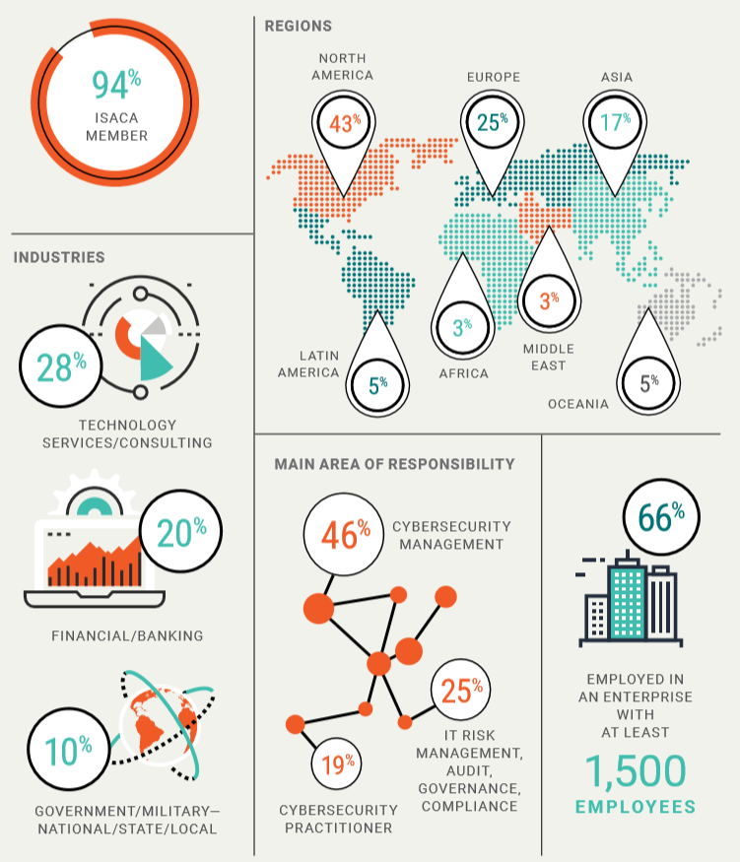

Figure ‘Technically Professionals Cybersecurity Professionals Continue to Be in Short Supply’ respondent demographics, 2019 [4].

Above, in figure 1, we can see the scale of the problem across the developed world and the beginnings of the crisis affecting the developing world. The problem is particularly bad in North America and Canada suffering a 46% recruitment gap across the sector. Furthermore, we can see that regarding practical implementation of research and defense as well risk management and compliance, we see that 44% of the recruitment gap hits these crucial areas.

Next, in figure 2, we see that the Technology Services / Consulting Services sectors, which include Cybersecurity related IT services, is the largest growth sector currently. Naturally, any industry with this level of growth and this scale of a recruitment gap is not operating at peak efficiency which increases the risk associated with bad agents. [1]

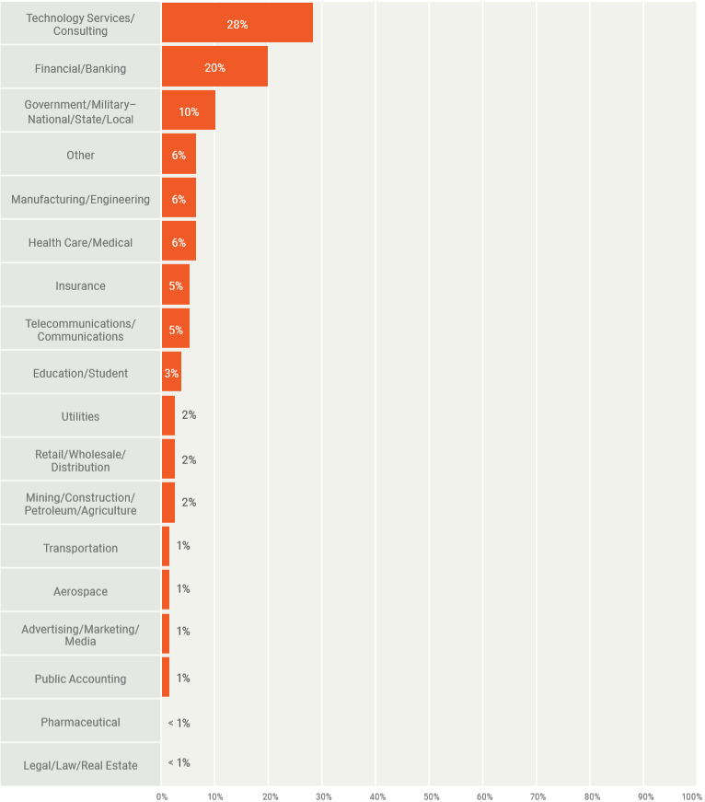

Figure Industry Sectors employment statistics based on 1500 people surveyed [4].

Figure 3 paints a picture of the number of organizations reporting unfilled cybersecurity roles.

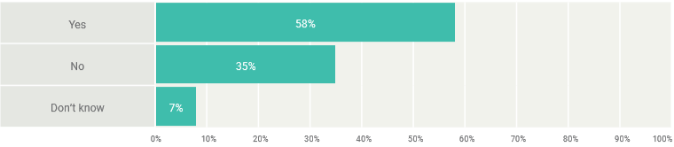

Figure Organizations reporting unfilled cybersecurity positions [4].

This delay has a secondary effect. Companies naturally want to get the right candidate for the analyst and research roles they need to fill, but with the recruitment gap, this leads to prolonged periods of positions remaining vacant as the industry struggles which such a low numerical pool of qualified applicants.

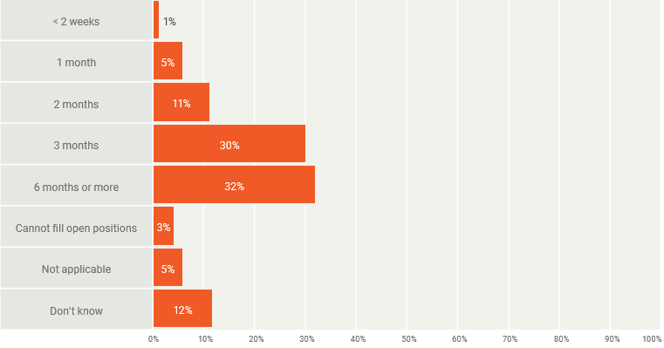

Figure Time taken to fill a cybersecurity position [4].

Over the past year the report finds that tier one analysts’ roles have seen a 75% increase in demand and tier 2 research roles have seen a 23% increase in demand.

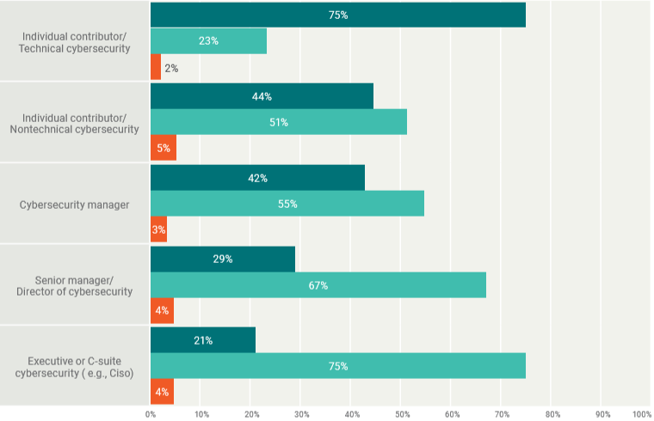

Figure Hiring demand per organizational level (Dark green = Tier 1 analyst, Light green = tier 2 researcher, orange = c-level executives and tier 3 operators) [4].

Given that such a large recruitment gap exists, and the exponential growth in the cybersecurity sector, it is reasonable to wonder how the industry is likely to keep up with the frequency of newly emerging zero-day attacks, malware variants, RCE’s and MITM network attacks across the entire attack surface of their networks. Fewer researchers results in less threat intelligence being generated. And with the current pool of experienced professionals being diluted through all three generally recognized tiers of cyber security employment model, leaving less dedicated researchers, the level of threat intelligence is even further diminished.

This is where Honeypots and open source threat intelligence comes into play. In 1997, Fred Cohen introduced the world to the concept of setting up a computer, through programming and software, to act as a potential victim in order to purposefully collect network related activity and attack related data. This application, called ‘The Deception Toolkit’, seen below in figure 6; was the world’s first honeypot which consisted of collection of UNIX based Perl scripts designed to capture event data related to network traffic and intrusion data. The following year we saw the first commercial implementation of this Honeypot called ‘CyberCop Sting3’. 1997 and 1998 gave rise to many such Honeypot applications such as NetFacade and the windows specific Honeypot ‘Back Officer Friendly’. With the ability to gather and analyze network and attack data now in place a further question was asked. What does one do with all the data one has collected? It is conceivable that anyone researcher would be quickly overwhelmed with data to analyze which would stagnate development of mitigation techniques. This gave rise to the first crowd sourcing group of Threat Intelligence sharing researchers, known as ‘The Honeypot Project’ [5].

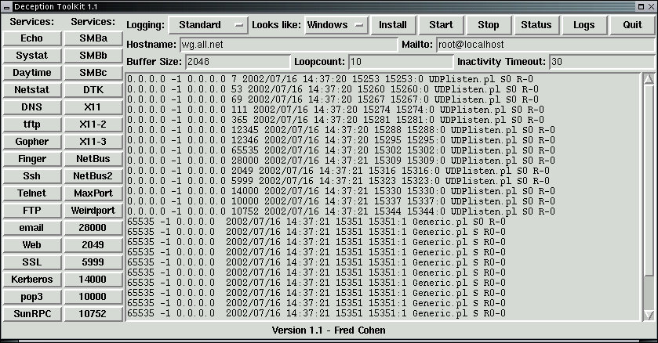

Figure Example of GUI output in The Deception Toolkit, the world’s first recognized Honeypot, released first in 1997 [6].

Over the years, since those early days of threat intelligence generation, many platforms and tools have been developed; both proprietary and open source. These tools are used to generate the threat intelligence which is then uploaded to online repositories such as threatfeed.io, Virus Total, IBM-X Force, Cisco Talos, FireEye and many more.

One tool that became very popular in contemporary years, is the Modern Honey Network (MHN) platform. This is a deployment platform which aims to facilitate rapid deployment of Honeypot servers for the purposes of generating threat intelligence and testing the implementation of defensive and mitigation methods and/or hardware.

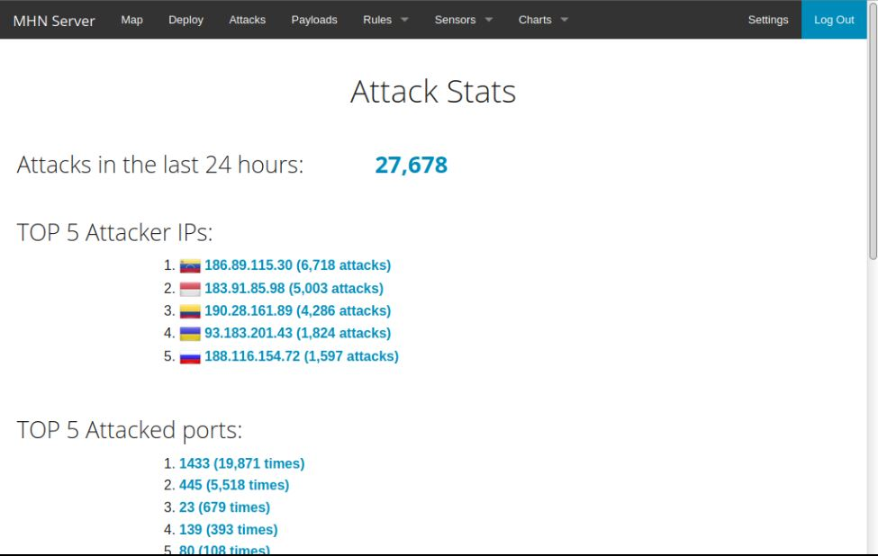

Figure The MHN web portal home page displaying the current number of attacks and important attack information.

MHN is deployment platform scripted in Python, with Flask containers, which allows for the deployment of sensors which make up a Honeypot machine. Once sensors have been deployed, the main server acts a management server for the collection of all data from all Honeypot machines.

However, collection of network and attack data is only a part of the threat intelligence gathering process. A MHN Honeypot semsor will, depending on the sensors deployed, generate Hashes, IP’s, Domain’s, Malware file scrapings, URL’s and/or Geographical data. This data must be mined and analyzed. There are many ways this can be done such as the use of a Security Information and Event Management (SIEM) like Elastic Search or Splunk. The Author of the MHN application also created a Splunk App (MHN-Splunk) which allows for analysis of the data gathered by MHN. This Splunk App has the capability to distil the data collected down into pertinent event related data such as geo-location, Hashes, IP’s, Domains, URL etc. While this tool has not been maintained fully for some time, it is still functional and capable of generating solid and relevant threat intelligence.

This is the area in which my Thesis will be based. While principally aimed at data analysis, I will also touch on data collected via MHN post collection. Basic installation guides are readily available, though these are far from comprehensive. However, due to the lack of regular updating of the platform; there are some known issues regarding regular maintenance which can increase server downtime. I will attempt to develop methods (both configuration of sensors and scripts) to reducing these problems which may be applied to both the management server and the honeypot sensor servers. Next, I will develop standalone Virus Total Parser program. Lastly, I will redevelop the MHN-Splunk App to modernize it. The aim will be to add new dashboards and improve the overall efficiency of the data mining process. As a final step, should the allotted project time allow for it in the development process I will attempt to add a web GUI version of my Virus Total Parsing program to a Splunk Dashboard. Should the time prove prohibitive in fulfilling this optional step, this will be complete as future work beyond the projects allotted time frame.

One of the great benefits of the MHN platform is the ease of use, which allows for any user, which a relatively low level of Linux experience; to deploy several sensors and immediately begin generating threat intelligence, once they understand the process, which can be quite difficult to learn given the sporadic nature of information particular related to debugging issues.

This is an area that has perhaps been lacking. Specifically, an easy to install, deploy and manage honeypot platform that with a minimum number of tools, allows non-technical experts to once again begin to contribute to threat intelligence generation. In the case of the MHN platform, this can be achieved via guides.

This is a symbiotic endeavor, where the user gains both knowledge and experience in the use of honeypots, SIEM’s, attack vectors, bad agents coupled with the ability to analyze data. These are vital skills to any security analyst/researcher.

And the quid-pro-quo for the security community is a fresh, revitalized, continuous source of threat intelligence data. I hope to ease the difficulty that newcomers to the arena of cybersecurity encounter as they begin to delve into this world while simultaneously allowing them to contribute to security in a very meaningful way by helping to keep bad reputation lists, and block lists up to date. By increasing the confidence of known IP’s such that they may be upgrades from bad reputation IP’s to block IPs. To track the propagation of known malware variants and to document the emergence and spread patterns of new zero-day attacks.

## 1.1 Motivation

During the Networking Security Analytics module undertaken by 4th year students as part the final year of a degree (Hons) course in digital forensics & cyber security (2020), an assignment was completed which required students to deploy the MHN platform, and analyze data retrieved from the sensor configurations each student chose to deploy. This was a self-directed learning assignment. With no previous experience of Honeypots, this was initially, a somewhat daunting experience, however; once the installation process was begun it proved less dauting than anticipated. However, despite installation guides being available, many Students expressed frustration at the difficulty in finding these guides, as well trouble shooting and debugging. Consolidated information pertaining to installation of the platform, analytical software, support applications, API’s and Linux packages needed to help run the platform smoothly and maintain platform uptime was simply not readily available and indeed students found they had to search long and hard on forum sub threads and obscure references sites for such information.

Upon getting the Management server set up, and some sensors deployed, it quickly became apparent that some issues existed. As previously mentioned, The MHN platform is no longer maintained by the original developer (Although some contributors do push minor changes to GitHub). As such it is only rated as being fully compatible with the Linux distributions, Ubuntu 16.04, 18.04 add CentOS 6.9. This increased the need and demand for trouble shooting support specifically tailored to deployments on these supported platforms.

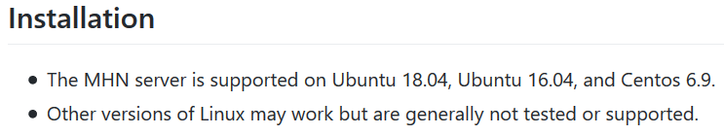

Figure Documentation from the MHN GitHub page listing the supported Linux distributions [7].

Furthermore, the log files and error files are created with root ownerships. This creates periodic issues writing to files.

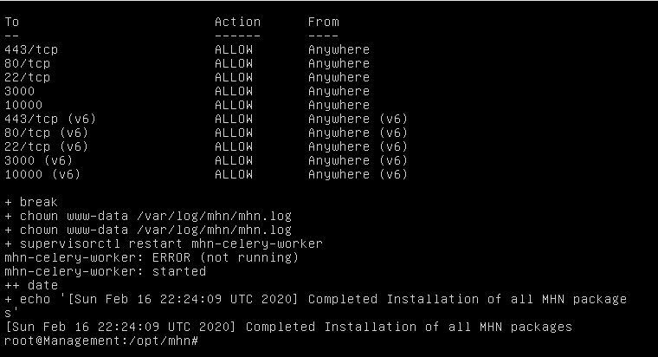

Figure Here we can see the process of setting the log files group permissions to 'www-data'. This can be altered to the 'root' group. If this happens the MHN platform cannot log data to the log file resulting in a service spawn error.

Drive space issues also occur if the log files grow too large which shuts down the ‘CeleryWorker’ and/or ‘HpFeeds’ services with transfers logs between sensor servers and the management server. This is particularly a problem if some known troublesome sensors such as Dionaea are left in default logging mode (generating huge logs very swiftly) and the mongo database on the management server can also grow quite rapidly if uptime is maintained. For this reason, Drive space must be continuously monitored and managed. This is not automated.

If at any stage the communication between the sensor machine and the management server breaks, the mongo database service will also crash. This requires it to be restarted. Upon restarting the service, a new log may be created once again with root access permissions re-creating the issue with writing to files. This is caused by file permissions being changed back to root permissions. The file permissions must be monitored and reset to the group ‘www-data’ or the platform will be unable to write to its log files and will crash again.

The combination of issues set a high level of user interaction requirement and help debugging these issues is scarce. Most of the help that can be found, is found on websites such as stackoverflow.com buried in user posted questions/responses and on the GitHub and Wiki pages related to the project, but even at that, a lot of debugging via logs is required to establish what is the root cause of each error resulting in downtime until a pattern is established.

And yet, despite the list of issues with maintaining the platform uptime, the data gathered is still very good and relevant data from many of the sensors if the sensors can be deployed without issue and network uptime is maintained. There are more modern and arguably advanced sensors available, such as those contained in the ‘ICS-Security-Tools’ suite of Honeypots. This is a collection or standalone Honeypots and deployment platforms. [8]. These sensors include:

* Supervisory Control and Data Acquisition (Scada) Honeynet – Digital Bond: This emulates a programmable logic control (PLC) comms server with management interfaces.
* Scada Honeynet – Cisco: This simulates industrial networks
* ConPot (Available in MHN) – An ICS Honeypot emulating industrial servers.
* GridPot: An open source toolset for simulating realistic electrical grid servers.
* GasPot: sensor for simulating IOT-based gauges (Veeder Root Guardian AST) used in maintaining records of oil and gas levels.
* T-Pot: Another stand-alone Honeypot Platform. Much like MHN but more modern and advanced. With a higher skill requirement.
* SEL-2924 Bluetooth to Serial Adapter Emulator: This simulates a connector which appears to be attached to an SEL-751A feeder protection relay (Current regulator and communications passthrough).
* HoneyPoint Security Server™: A commercial honeypot distribution which includes SCADA and IT emulators.
* Awesome Honeypots – A list of general common honeypots
* Nozomi Tristation Basic Honeypot: A TriStation dissector which includes PCAPs and a Honeypot simulator.

However, these are much more complex honeypots to use and more advanced, with each being a standalone sensor or platform instead of an all in one installation and deployment platform except for T-Pot. A closer look at these platforms and Honeypots takes place in a further section of this work.

So, it is the ease of installation and deployment (again, once the process is understood fully) that sets MHN apart as a more viable platform for non-advanced Linux users. But how does this relate to the recruitment gap in the cybersecurity sector?

Well, bad actors tend to be young white males, as discussed in the white paper ‘The internet and its opportunities for Cybercrime’ although variations in offender groups is rising [9]. The paper further goes on to describe the general types of young hackers as ‘wizards’, ‘samurai’, ‘newbies’ and ‘script kiddies’, with skill sets ranging from highly skilled to no skill at all, but all share the common link, an interest in cyber related malicious activity.

A study undertaken in North Carolina in the US surveyed 1617 adolescents under the age of 18, ranging from 9th grade to 12th grade students. It was discovered that of these 1617 students; 3.1% (110) were found to have hacked an e-mail account at least once, 14.3% (190) percent were found to have hacked a Facebook account, and 12.1% (191) found to have hacked a website at least once [10].

What we see here is a trend showing that young people are gaining computer skills far younger than previous generations but are lacking proper direction and constructive creative productive real-world activities to engage these cyber skills. And lacking direction, are prone to directing their energies into malicious behaviors. Taking the numbers above as a baseline and working out the average number of students who carried out at least one form of hacking activity that gives us 164 students rounded up to the nearest decimal.

This is just over 10.14% of the total 1617 students surveyed. If we take these figures as a general cross section of modern youth, we can see there is a vast potential for young people, with the correct guidance and toolsets, to direct this energy into positive productive cybersecurity activities that could help to vastly increase the amount of open source threat intelligence generated, while teaching young people a very in demand series of skills such as data analytics, forensics and threat analysis which could lead to careers in cyber security.

While this would contribute to an increase in the potential recruitment pool and help to fill the recruitment gap in the cyber security employment sector, the project is not merely aimed at the youth demographic. The project is aimed at all cyber security enthusiasts who are just beginning their journey and it will help ease them into the arena of cyber security data analytics and research.

## 1.2 Project Goal, Aims & Objectives

The goal of this project is to analyze the current state of the MHN platform in order to discover the current level of viability of the platform and to discern which areas of the platform need to be improved. Should the platform be deemed viable, a full installation guide covering all aspects of the platform will be designed. This will be a comprehensive tutorial with the aim being that a complete novice will be able to deploy the platform will full functionality using nothing more than the guide. Through this installation guide, a novice user will also gain experience working with the Linux operating system, as well basic cloud server deployments. As well as improvements, the project will assess what can be added to the MHN-Splunk App to improve functionality and improve the training aspect of the platform regarding data analytics. This will include improving the naming convention of dashboard menus and data outputs as well optimizing searches and minimizing the number of searches per dashboard to streamline the functionality on machines with minimal resources. An attempt will be made to add dashboards for sensors that do not currently exist in the MHN-Splunk App.

Where issues resulting in downtime exist, efforts will be undertaken to discover root causes of the issues via log analysis, with the goal of developing universal Bash scripts or Cronjob scripts which will manage the known issues which result in downtime and diminish the effectiveness and viability of the platform as a threat intelligence gathering tool.

A Stand-Alone data collection tool will be designed to work with the Virus Total API. The goal of this tool will be to facilitate rapid data collection and dumping to text files of data pertaining to events, actors, and other data types collected from datamining the honeypot sensor data collected from the MHN platform via the Splunk SIEM. This application shall be developed, in python (3.7) to parse data collected from the virus total API pertaining to data gathered via the MHN-Splunk App. This parsing will be carried out remotely without the need to access the website using Virus Total’s proprietary API [11] [12]. There shall a minimum of 2 versions of this program. Each of these programs shall be standalone programs, one to be run on the Windows operating system and one to be run on the Linux Operating system. This is necessary as; like with any program language, the appearance of programs often varies between these operating systems. The list of functions the application shall contain are be detailed in a later section in this work (Methodology % System design and Implementation). A third version of this application may be compiled as a windows executable, purely for convenience and demonstration purposes.

Lastly, should time allow for it, an attempt will be made to incorporate a version of this parsing program into the MHN-Splunk App, to allow for a reduction in tool sprawl while analyzing data collected via MHN. This increases the user focus while working and learning by reducing the need to switch between platforms and applications as all relevant data can be mined in one screen/platform. However, regardless of whether the attempt to incorporate the parsing program into the MHN-Splunk app is successful or not, the standalone versions will still be provided to allow users to use them as stand-alone versions outside of the MHN-Splunk app for the purposes of preparing reports.

The final product will be a suite tools and guides aimed to achieve the following:

* Rapid deployment of all aspects of the MHN platform by even novice users.
* Automated server and sensor maintenance including log management, storage management, database monitoring and file permission monitoring.
* Improved functionality and modernization of the MHN-Splunk app which is incorporated into the Splunk SIEM analytics platform.
* Rapid data acquisition and output regarding data pertaining to events, actors and threats mined from Honeypot data in preparation for use in reports.

## 1.3 Research Questions

My Thesis poses several questions which can be broken down as follows:

* Are Honeypots a viable source of threat intelligence?
* Is MHN still a viable honeypot platform?
* Could MHN be used as a self-directed teaching platform as well as a threat intelligence tool?
* If so, are there guides that could help aid in the installation and configuration to aid students in installing the platform and begin self-directed learning?
* Are there other competing platforms available that offer the kind of functionality MHN offers easier than MHN?
* Does the MHN-Splunk app Possess areas that need updating to improve its viability?
* Is it viable that with proper guidance, users with minimal Linux experience could deploy the platform?
* Could an improved set of apps and guides and/or scripts resulting in a greater level of usability result in increased threat intelligence gathering allowing young users and fresh research students to gain skills applicable in the cybersecurity sector helping to reduce the recruitment gap that currently exists?

The research questions will be answered by conducting a survey of users who have previous experience using the MHN platform as well as the SIEMs that can be used to analyze the data collected by the MHN platform.

Once the decision to adopt the MHN platform, Splunk SIEM and MHN-Splunk app has been justified, design and implementation phases of the guides, scripts and apps that will make up the suite of products that will facilitate the project will begin.

## 1.4 Summary

The report begins with an introduction which discusses some general concerns surrounding the growth of the information age, the internet and the volumes of data contained with the digital space our world is now centered around, and the threats which face this area. It briefly touches on how research is a vital tool in developing defenses in this digital information age and how a recruitment gap in the cyber security sector affects our ability to meet these threats. The introduction then highlights how honeypots serve as an aide to researching current and emerging threats to our digital world and how the reinvigorating of a tool such as the MHN platform with a decreased learning curve could potentially help to close this recruitment gap by making it possible for novice students to teach themselves real world cyber security related data analytics skills

Next, the report covers the motivations behind the projects conception, such as aiming to reduce the complexity of the platform installation, while reducing the possibility of creating potential errors during system upkeep, and increasing the efficiency and total amount of data collected by sensors via the MHN-Splunk app and also providing further threat intelligence via a python based Virus Total parsing tools. This is followed up by the project aims, which elaborates on these areas and the research goals which establish the research questions to be addressed during the project’s literature review and critical analysis sections.

The methodology section establishes how each step in the project is to be undertaken, including the research approach to answering the research questions, the tools and methods to be employed in meeting the practical elements of the project and the types software design life cycle (SDLC), and types of testing to be undertaken following the implementation phase.

The literature review addresses the research questions of the project by combining a review of current literature surrounding honeypots with a full in-depth critical analysis of both the MHN platform and a comparative analysis of one of its main competitor platforms, the ‘T-Pot’ honeypot platform.

The system design and implementation phases document the system conception design and implementation phases whereby the program user and function interactions are established using elements of the unified modeling language (UML) framework such as use case diagrams before the programs are implemented via the Python based PyCharm integrated development environment (IDE) in the case of the ViMal-Total Python-Based Virus Total parsing app, and the Splunk security integration and event management (SIEM) tool which also serves as its own IDE for developing Splunk based apps and tools. A ‘future work’ section established the plans for the project beyond the scope of the allotted time frame. The final section is the conclusions section which established the overall project conclusions.

# 2.0 Methodology

## 2.1 Methodology Overview

The goal of the project is to develop a series of guides, scripts and applications to allow a novice user or intermediate user to establish a fast deployment of the MHN platform while negating the possible pitfalls and problems that can arise during said installation and configuration, such that the user can then focus on self-educating themselves in cyber security based data analytics. Scripts will be either Bash scripts or Cronjob scripts to be added to the Crontab file.

Research questions will be answered via a literature review, critical and comparative analysis of the MHN and T-Pot platforms and surveys. This will determine which platform should for the focus of the project and justify these choices.

The chosen platform will be deployed on a minimum of two cloud-based servers on the Digital Ocean cloud platform. One server to be used as a platform management server, the other to be used as a sensor server. A local machine will be used to access these machines and a laptop may be used to access them while this researcher is moving from campus to home and vice versa [7].

On the platform management server, the XFCE desktop environment will be installed to allow for visual exploration and GUI based use of the server as an optional feature. This is a quality of life function for users’ less familiar with CLI functionality although, for the sake of reserving system resources for the running of the platform, CLI use will be recommended as the best method of user/system interaction once the user feels confident and skilled enough to shut down the desktop environment [13].

The TeamViewer Virtual Network Client (VNC) application will be used to create a VNC connection to the client to allow for a full no compromises Desktop user experience, if the user wishes to work directly on the server. The client will also need to be installed on any remote Desktop or Mobile device the user wished to access the server from. [14].

The servers will be protected by both the IP-Tables and Uncomplicated Firewall (UFW) firewalls as well as the installation of both intrusion detection system (IDS) and intrusion prevention system (IPS) sensors on the sensor server in the form of the Suricata and Snort Honeypots [15] [16] [17] [18].

In programming the software design life cycle (SDLC) is an essentially part of the design process. However, in cyber security it is not unknown for security analysts to design small programs without the use of an SDLC, with the goal being the design and deployment of a tool rapidly for personal use. In this case, while the project does not require a vast amount of programming, it does require some programming. The python-based Virus Total app that will be developed will require the use of a combination of the Waterfall and SCRUM agile SDLC’s. The initial planning of the program will be conducted using the waterfall SDLC which will involve using elements of the unified modelling language (UML) such as use case and activity diagrams. However, once the implementation of the program begins, the SDLC will switch to the SCRUM agile SDLC to allow for rapid development based on testing and tester feedback and suggestions.

Since the program is relatively small in nature, the program will be a classless design (restricted to just the main class) which will be an objectless design that will not focus on object-oriented design.

## 2.2 Methodology System Analysis and Requirements

One each Server, the program NCurses Disk Usage (ncdu) will be used to visually identify disk storage space to aid in maintaining platform uptime. [19]

The program ‘Git’ package will be installed to allow the use of the ‘git clone’ command to pull down repositories from the GitHub platform [20].

The free version of Splunk enterprise SIEM will be used for data analysis and visualization as well exporting reports. This will also be used as a development integrated development environment (IDE) for the redesign of the MHN-Splunk app [21].

The Splunk-MHN application will be added to Splunk for specialized data mining and visualization. This will be one of the core components of the project to be redesigned [22].

Python 3.7.5 will be installed on both remote and local machine to handle any python code compiling or running of python based apps that are running outside of platforms that incorporate internal python API’s [23].

Pycharm™ Community Edition Will be used as my IDE to write, and where necessary compile my python code [24].

PuttyGen will be used to generated RSA keys (public & private) as needed and Putty will be used to securely connect to the servers via a secure shell (SSH) connection.

WinSCP will be used as an SSH based portal (via Putty RSA authentication with RSA keys) for the secure encrypted downloading of files. This may be automated via a Putty connection later, which will require Putty for Linux to be installed to be installed on the server [25] [26].

The Survey Monkey web survey platform may be used for testing feedback [27].

The revised MHN-Splunk application will be designed so that it facilitates inexperienced or novice users in providing the tools needed so that they can self-educated themselves in cyber security data analytic. To that end, it is anticipated that the most likely hardware the app will be run on will be computers with minimal or reserved hardware. Therefore, the revised app will need to run efficiently on a machine of no less than a quad core modern CPU with 8 threads and 8GBS of ram available while threads iterate over relatively small files. Conversely, the app should be capable of handling big data should the machine in use have enough resources to handle large volumes of data. Any attempts to search large volumes of data of machines with minimal resources that fail will not be reflection a failure of design. Testing will be conducted on a machine with enough resources for analyzing big data to ensure all bottle necks are removed and the testing is an adequate stress test of the systems maximum potential.

The Apps dashboards will need to reduce recursive searches where possible and improve efficiency to achieve this functionality on low end computers. Further to the novice users’ requirements regarding the ability to self-educate in cyber security data analytics, as many dashboards as possible, that do not already exist will be added.

The windows version of the Python based Virus Total API parser will remain an open source product. A windows version of the source code will be supplied should users wish to further develop the code. However, a self-contained executable version of the program will also be required for users that have no experience with programming.

The Linux version of the Python based Virus Total API parser will be executed direct from the Linux terminal CLI using the python command or from an IDE such as PyCharm should the user prefer. However, it is likely that an IDE will make adding the required dependencies and packages far easier. All guides will assume this method is being used.

Both versions of the Python based Virus Total API parser will need to be fast, efficient, and capable of running on systems with a minimum of 8GB’s of ram and a Quad core CPU with 6-8 logical cores. Windows based systems running the pre-compiled executable will not require python to be installed, but those running the uncompiled version will require python 3.7.5 to be installed with all packages (as declared in the programs import statements) added to their chosen IDE.

The MHN Installation Guide will need to be a step by step guide such that a complete Linux novice could follow each step and each a successful installation and configuration of the MHN platform in a reasonable time frame. The steps should be easy to understand and follow and be accompanied by visual aids where possible.

The Sensor guide should follow the same standards of the MHN installation guide and be easy to understand, follow and allow for a novice to achieve the best and most optimal sensor configuration to suit their needs.

Any scripts developed to aid in the management of the MHN platform, or its deployed sensor servers should be simple to deploy and universal to all systems so long as the usage steps provided are followed to the letter.

## 2.3 Methodology: MHN Sensor & MHN-Splunk App Critical Analysis

In analyzing the MHN honeypot sensors and the MHN-Splunk app we will be seeking to answer some important questions which are as follows:

1. In the global sense of the MHN app, is the naming and wording convention appropriate?
2. Can a virus Total lookup function which outputs data directly inside the Splunk dashboard GUI be incorporated?
3. Is the sensor in question relevant?
4. Can this sensor be run concurrently with all other sensors, or are there limiting factors that prohibit this sensor running alongside another sensor or series of sensors?
5. Are there any detrimental elements of a given sensors normal operation that might requiring alteration or mitigation through config files to better improve the uptime of the MHN platform and therefore better improve the threat intelligence gathering of the platform?
6. Does the sensor have a dashboard provided?
7. If the sensor does not have a dashboard supplied, why?
8. Is there a workaround that might allow for a dashboard to designed?
9. If a sensor does exist, is it efficient?
10. If the sensor is not efficient, can it be improved to run more efficiently on small form factor and thin client PC’s?

In order to best facilitate the critical analysis in the most efficient simplest way possible, the sensors will be installed and analyzed individually and sequentially beginning with ID 1 working up to ID 14, initially; and analyzed one by one, including dashboards should they exist. We will also be focusing on basic functionality and configuration that a novice or intermediate user might use. Features considered too advanced will be out of scope.

## 2.4 Methodology: System Design & Implementation

The python Virus Total parsing app will be a GUI based program which will utilize the Virus Total API commands to retrieve data from the Virus Total database data sets relating to reports. These reports will be handled by the Python ‘requests’ 3rd party package which will be imported into the IDE of choice, which in this case is to be PyCharm. The program will contain a main frame which will act as the home page for the program. This home page will contain a banner image, which will be managed via the 3rd party PIL package, and a basic set of navigation buttons which will allow the user to navigate through the pages incrementally or to jump directly to any given page. Text will be displayed via labels with buttons being triggered either by event calls or function calls.

The program will consist of frames for each of the following function:

* Hash Lookup Page:
* Scan ID Lookup Page:
* File Scan Lookup Page:
* URL Lookup Page:
* IP Lookup Page:
* Domain Lookup Page

This functionality will be handled by creating a simple array which will hold the frames and iterate through them.

The program will auto generate reports as needed which shall contain any report details and a numerical count system will be created which shall utilize a local file storage system to maintain a working record of how many files have previously been created for each frame in order to keep track of the number to appended to each new file to maintain accurate record keeping.

Some functions will output information message boxes to the screen. This will be handled by the ‘messagebox’ function within the ‘tkinter’ API.

Occasionally variables will be initialized by user input. This will be handled primarily by the internal python ‘entry()’ function but in the case of the initial initialization of the global API key variable, this initialization will be handled by the 3rd party ‘easygui’ package.

Where JSON file management is required, be it to retrieve JSONs or to mine keys/values from JSONs, the 3rd party json package will be used.

The ‘askopenfilename()’ function will be used to select files from the local machine with the 3rd party OS package being used to manage file location paths and confirmation of file existence at established paths.

All text mined from JSON key/value fields will be output to text fields within the program.

Error handling will be managed via try’s with broad excepts, while error messages will be output via the ‘messagebox.showinfo(“”)’ function.

## 2.5 Methodology: Testing

As of compiling this report and during the duration of the work undertaken while completing the project for this thesis submission, the world is suffering the impacts of the Novel Coronavirus Covid-19 outbreak. This has forced a prolonged period of isolation. This has made enlisting the support of fellow students and cyber security professionals for localized black box testing almost impossible.

Therefore, my testing will consist primarily of white box testing, some remote black box testing, although this is expecting to be limited due to peoples focus shifting to taking care of their families during the isolation period.

A series of local white box tests will be undertaken for the revisions applied to the post-modification MHN-Splunk app followed by comparative testing of any dashboards that allow for direct comparison to establish some efficiency improvement figures.

# 3.0 Literature Review

The scale and scope of the problem we face in relation to the evolution of big data, the internet, cloud computing and the age of the hacker is now so vast that to simply grasp the scale of the growing problem requires the use of analogies and some creative thinking to help humans visualize the problem. So, before we examine the contributions of honeypots in tackling the problem, we must understand what the problem is and the scale of the problem. Let us begin by visualizing the growth of the internet, big data, cloud databases and networks, the internet of things (IoT), and the sheer scale threats pose to this ever-growing digital world that we humans rely more and more upon every day.

To put this into some context in 2007/8 a team of analyst’s, researchers’ and scientists decided to map out the data streaming activity between 23 educational institutions. The research mapped out over 1 billion user interactions with the data base over the given period. This research was conducted to attempt to produce a visual image, or map of the size and scale of this small slice of the digital world the exists all around us. The results allowed the team to provide a detailed breakdown of the map and its interconnections to form a view of contemporary scientific activity and correct under representations of the social sciences and humanities that is commonly found in citation data. The visual map which resulted is… impressive. And gives us a taste of the scale of what we are dealing with [28]. Even this small slice of the internet dwarfs the original ARPNET, one of the first internet implementations.

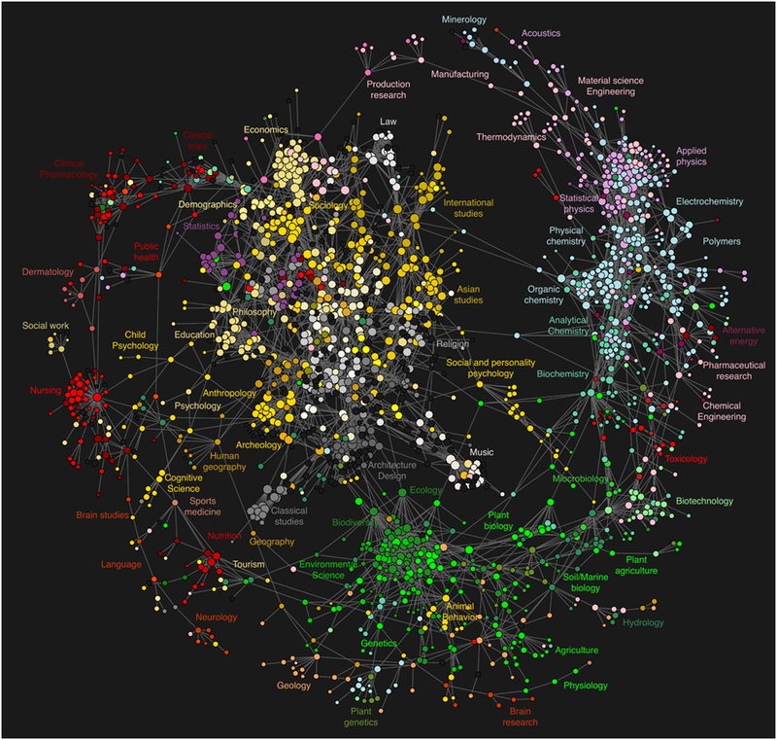

Figure Map of sciences produced by 2007/8 study, 'Clickstream Data Yields High-Resolution Maps of Science' [29].

This is 1 billion interactions over a network smaller than the size of the original ARPNET although undoubtedly connecting more computers and people, but this serves to form a slice that is less than a drop in the ocean of the modern digital space and yet this is all from just 1 college.

To put this into some international context, we can see a similar map exists regarding the backbone connections of the internet. These are the core trunk lines which serve as massive data lanes between countries, across oceans consisting of land lines, WI-FI and Bluetooth® and even satellite connections in places. These are often considered jurisdictional boundaries too which is highly relevant where cyber-attacks are concerned (and therefore, honeypots/honeywebs).

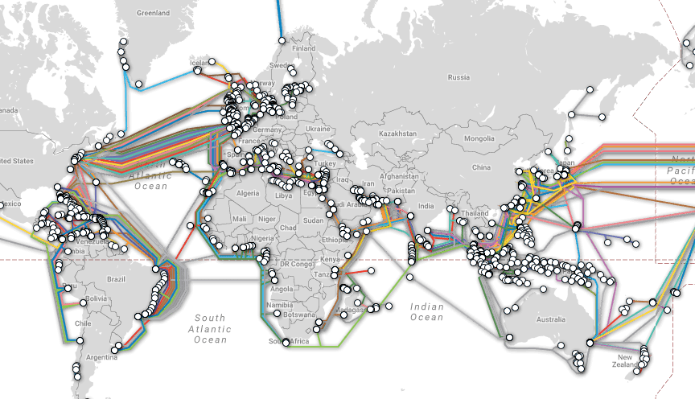

Figure The back-bone network of the Internet as of October 2017 [31].

Now we can begin to see the scale of the internet. Next, we go another layer deeper to the autonomous system layer of the internet. This layer handles routing protocols such as BGP. This can be considered as a switching protocol which handles switches on the national and international level, or; the protocol which handles routers communicating with routers to create a routing map which enables data to traverse the back bone connections via the fastest or best possible routes [32].

This layer of the internet is now suffering routine BGP table attacks, and it is very difficult to simply install antivirus software to protect a network of this scale. So how do we protect such a vast network? Well the only way is with rules. But how do we known which rules to employ and how do we gain intelligence on what threats exist without exposing the internet itself to threats? We will return to this question later.

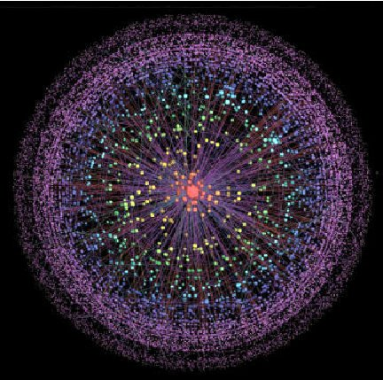

Figure The millions upon millions of BGP connections that facilitate the vastness that is the digital space between backbone connections as of 2010 [33].

Now beyond this is the layer that contains the vast trunk lines that form the arteries long which data flows through the digital space we recognize as containing consumer and corporate networks and computers. This layer readers may believe they can begin to conceptualize in terms of the scale of the potential machines connected or perhaps the amount of data involved in traversing these vast interconnected networks. But can we?

In 2012, a fascinating project was undertaken as a proof of concept project which set out to map as many IPv4 device as possible using ICMP, DNS, and SYN scans of common ports as a mapping methodology. While this is strictly not illegal, port scanning that results in system damage or profit lose to companies has resulted in civil suits against hackers and security researchers and as such is consider a bad practice that researchers should only perform with permission or for genuine research. In this case the question of the ethics regarding this project is out of scope of the research, but the map developed by the results is not and forms the final part of the attempt to visualize the scope and scale of the vastness of our current digital space and the data that exists within it [34].

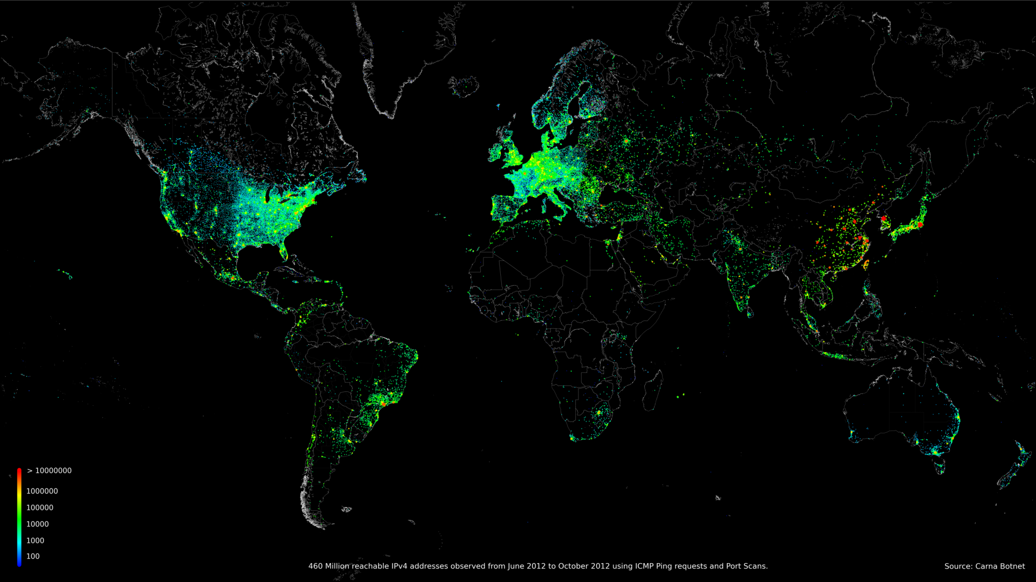The results of the data cannot be considered at an academic level as the curator of the data remains anonymous, however, as a purely visual aid it is relevant and very interesting to be able to visualize potentially vulnerable machines.

Figure Here we see that the 2012 Anonymous internet census detected and mapped over 450 million vulnerable machines from the

months of Jun 2012 to October 2012. This does not include other months or secure machines.

The full IPv4 utilization map in gif form can be viewed here:

<http://internetcensus2012.github.io/InternetCensus2012/images/geovideo.gif> [30].

It is a fascinating snapshot of internet usage.

Having now provided a multifaceted visual picture of the vastness of the digital space the worlds data now resides in and traverses daily there is one thing left to consider regarding the vastness and the threats this network and data face every day.

This network encapsulates our digital space, and it also represents the entirety of the attack surface presented to bad actors. Every port is an access point for these bad actors who may wish to penetrate networks and acquire data for illicit reasons. Or to simply maliciously damage machines, encrypt user’s data for monetary reasons, or to hijack machines, incorporate them into an illicit Botnet and create larger threat actors to spread attacks. Every port is a potential doorway to threats. As vast as the network is or grows to be, the threat grows with it to match it.

Regarding the vast amount of targetable data that now exists and can be monetized, the words of Carl Sagan seem very apt:

“*Meanwhile the Cosmos is rich beyond measure: the total number of* ***stars*** *in the universe is greater* ***than*** *all the grains of sand on all the beaches of the planet Earth.”*

* Carl Sagan, Cosmos.

The world of hacking is extensive and where once the hacker was universally ostracized, feared and immediately recognized as a threat, the lines have now blurred with professional ethical hackers and security experts rising to attempt to meet the challenge posed by malicious hackers.

Today we have white hat hacker’s, grey hat hackers and black hat hackers. The origins of hacking in the digital space can be traced back to the origins of the idea of ‘open source software’. Hackers at this time believed in privacy, freedom of information, data and the digital space and access to the digital space and data above all else. As discussed by Julia Rone, of Cambridge University, England, in her paper ‘Hacking and Hacktivism’, hackers often view technology and pursue clever new hacks with a passion most people don’t have for technology. They often flirt with the legality and morality of their actions. Are often highly utilitarian, making use of software and hardware in highly unintended and unanticipated ways, pragmatic, leaving no stone unturned in their efforts to gain access, poetic in their target choice and highly artistic in the deployment of their art or ‘Hacks’ [35]. It is commonplace for hackers to take pride in their hacks and leave watermarks or calling cards to identify the hacker or hacker group responsible for a ‘big’ or ‘notorious’ hack.

A white hat hacker is an ethical professional. While a white hacker may study the methods of other hackers, he or she will only practice these methods in an air-gapped sandboxed environment, and usually also purely for the purposes of learning how best to defend against these methods. Grey Hats are often very skilled and while they are generally ethical people, they also delve into the murky worlds of the potentially criminal hacker. This is usually done because grey hat hackers tend to believe that in order to be able to stop the criminal, you must understand the criminal and the criminal world’s ways and means. Grey hats can be good people who dabble in bad things, or bad people who dabble in good things. It is the murkiest sub-group of hackers and for this reason grey hat hackers while they may enter the realm of white hat hacking and black hat hacking often cause some discomfort to hackers who inhabit either of those realms.

Last, we have the realm of the black hat hacker. These are hackers who do what they do for non-ethical reasons. These reasons can vary from criminal, self-enrichment, or purely to maliciously hurt people or machines for their own amusement or revenge. While there is a section of the black hat community who are relatively unskilled who are known as ‘skids’ which is a reference to the terms ‘script kiddies. These are hackers who skill level is lower and execute automated tools or deploy previously prepared scripts but have no real knowledge of how these tools and scripts do what they do.

This is one of the largest areas of concern where black hat hacking is concerned the skill required to hack has been steadily lowering as automated tools continue to emerge in large numbers. However, the back-hat hacker is, at the bleeding edge of skill, usually the most skilled hacker and the most significant threat, constantly ahead of the cyber defense community, because; while the black hast hacker is proactive, constantly probing hardware, networks software and access points for new vulnerabilities, the cyber defense community is reactive and can only react to new events.

This is where threat intelligence plays a vital role in helping to create deterministic algorithms that help in predicting behavior patterns and reduce the likely hood of a new ‘0day’ attack penetrating systems.

There are two further groups who may exist at one of these areas of hacking or may even fluctuate among them. There are governmental/Corporate hackers. These are hackers who may work for a private organization or a government department that require them to hack for corporate or state espionage or defend against such hacks. And lastly there is the hacktivist, who hacks for socio-political reasons and who, while often criminal, can also be strangely ethical and moral. The realm of digital space must take all these potential threat actors into consideration. Particularly when the band together to form groups such as the ‘Anonymous’ hacktivist group.

Now, to cover the entire realm of hacking and the various types of threats posed by hackers and hacks would be a paper unto itself and far beyond the scope of this research, however, before we understand the importance of honeypots we must have some idea of the sheer volume of traffic traversing the digital space.

So how does the process of hacking work? A hack usually starts with random or specifically targeted scanning of ‘ports’ or access points to a machine or network. This is to determine if an access point is ‘alive’ or online and listening.

But there are other ways to gain access. One of these ways is to send out phishing emails. These can be mass spammed, or individually targeted. An individual phishing email purporting to come from a trusted source is known as spear phishing. These can even be targeted directly against a high-ranking member of an organization such as a company CEO, known as whale phishing. These emails may contain a piece of software which unobtrusively attempts to install itself and connect out to the hacker’s system giving them an access into the companies’ network or a ‘reverse shell’. This is very bad and can very easily lead to machine being completely hijacked. Once a hacker gains a foothold in one machine, he or she may begin attempts to pivot off that system and attack other machines accessible within the network.

Returning to port scanning, the attacker is aiming to gain an access. This would be achieved by scanning for systems running within a network or services running directly on those ports. The user can then find exploits for those services, if they exist and once an access point is gained will attempt to achieve what is known as a ‘reverse shell’ in order gain ‘persistence’ meaning their access is persistent. The reverse shell means that their access is ostensibly origination from inside the network on the machines end and is much less likely to be detected or shutdown, although good modern industrial protection services should detect all but the latest ‘0day’ attacks for which no protection has yet been developed. Beyond this point the permeations of possibilities of what could be done, what hack tools could be deployed, what data could be accessed or what damage could be done, and the potential cost of such activities is almost endless and continuously growing exponentially.

It is these initial attempts at penetration that form the backbone of hacking. Before a hack can be completed, access must be attempted, and it must succeed. For every service possibly running on machine there are many versions, and for every version that has existed for some time the likelihood that there is a possible hack increases, often right up the current running and often considered ‘safe’ versions. But even these ‘safe’ services are only safe if a new ‘0day’ hack is not discovered, and these are discovered with regular frequency.

What this means is that every day, while our regular safe traffic traverses the digital space, conducting business, exchanging web pages, messages, and so on; there are also millions of attacks taking place every second. Machines are being scanned almost constantly.

The earlier mentioned unofficial 2012 internet census report reported that it had recorded 54 billion IPv4 address records. While again, we must be dubious of data reported from Anonymous sources, however, this is quite possibly accurate. With over 400 million of these scans in just a few months being detected as vulnerable.

There are just under 4.5 billion possible IPv4 address values that can be assigned, and sub netted with approximately half a billion of those being private addresses [36]. These IPv4 Address were exhausted on the 3rd February 2011 [37]. So, with approximately 4 billion address now having been assigned and sub netted and all these subnets branching into many subnets of subnets, it is highly likely we have far exceeded this 54 billion device number reported in 2012. When one considers the sheer number of IoT devices, mobiles devices, microprocessors and switches and relays that now require WIFI access that have come into existence since 2012 alone, the sheer staggering number of connections through which data can traverse daily begins to come into focus.

Cisco, who are one of the biggest corporate networking companies in the world, both physically and in terms of how much of the digital space’s networks they manage, through their security monitoring department, ‘Talos’; produces numbers on the volume of email data passing through its waterfall honeypot and releases this information on a month by month basis and the numbers are astonishing.

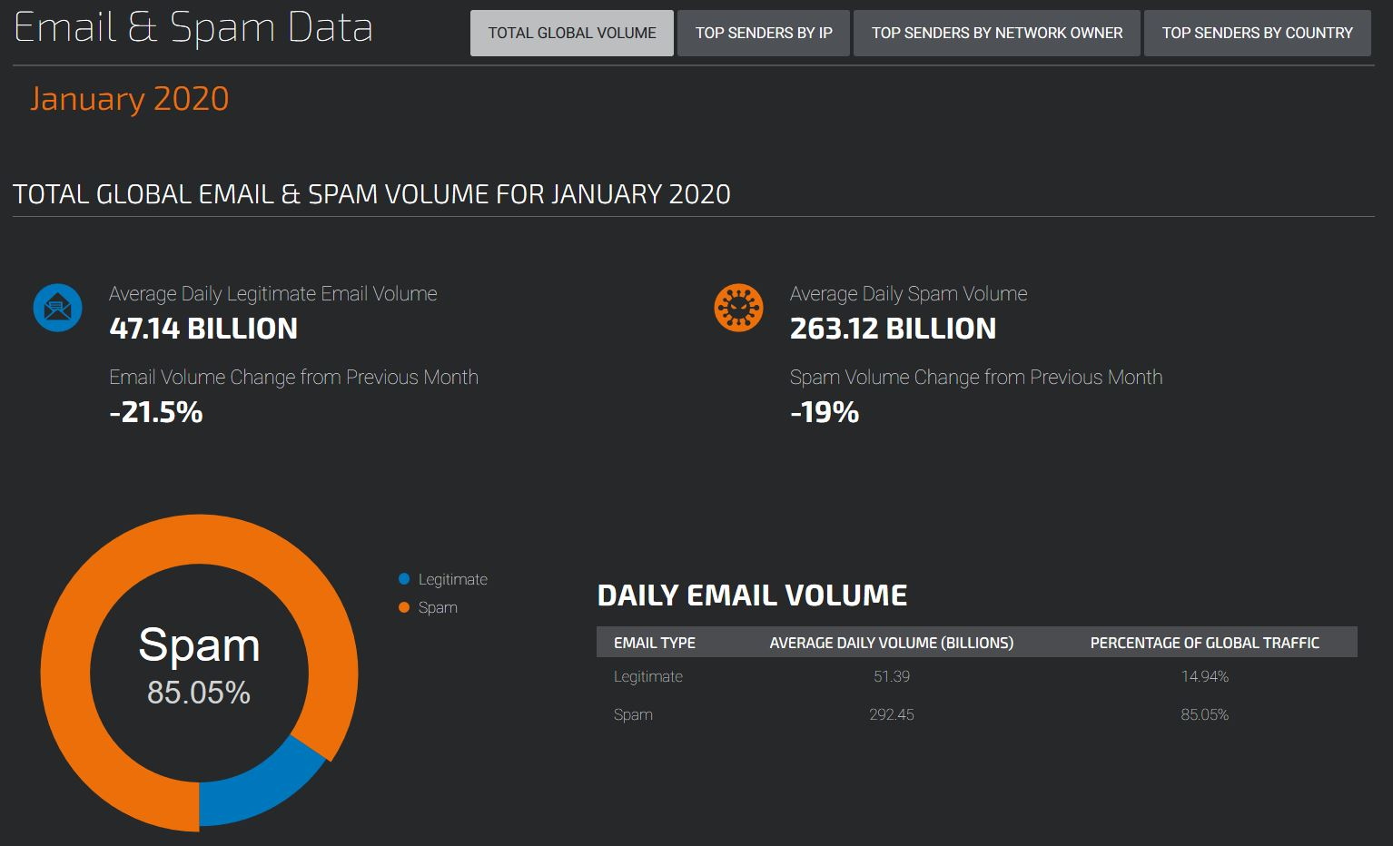

Figure Email volume and spam percentage record for the month of January, 2020 by the Talos security department of Cisco [38].

As seen above in figure 14, in January of 2020 alone, cisco recorded a daily volume of on average 47.14 billion emails. Of these, 85.05% where identified as spam emails. While not all this spam email quota would be phishing emails, it is reasonable to say that we could expect a significant portion of it to be malicious in nature. But let us be ultra conservative here and suggest that just 1% of these spam emails are phishing emails (the real number is likely much higher). 85% of 47 billion is roughly 39.5 billion. 1% of this figure 370 million phishing emails circulating the digital space, daily, at a minimum conservative estimate. The real threat is much higher though hard figures are likely impossible to calculate.

Statistics on ports and port scanning would be very difficult to calculate. But we can reasonably expect them to match statistics, if not exceed the statistics for e-mails.

To put the sheer volume of data that now exists to be threatened by hackers into perspective is incredibly difficult and again can only really be examined in abstracts, or with visual aids to gain an appreciation of the huge numbers we are talking about since most people would likely not understand phrase like petabyte, exabyte or zettabyte.

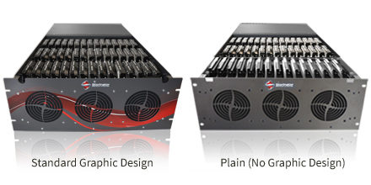

Figure Storinator® server drawer chassis [39].

Figure 15 gives us a view of a Storinator® server drawer chassis, or pod; made by 45Drives™, a server component fabrication company, which can house vast amounts of data storage which we will see below.

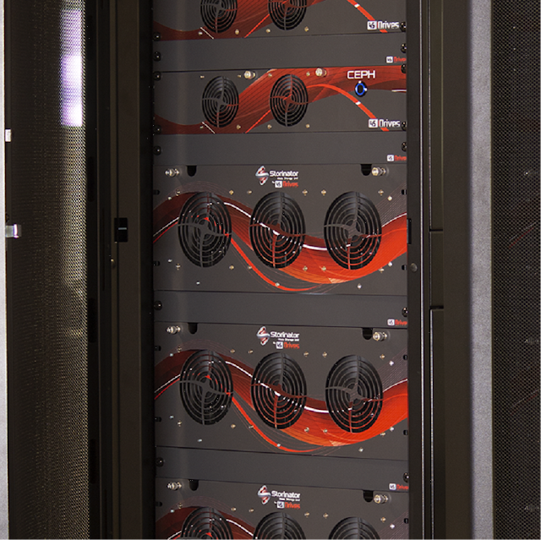

Figure A Storinator® rack & merge tower hosing in this case, 5 drawer style server pods [40].



Figure Linus Sabastian of YouTube fame, founder of the fantastic Linus Tech Tips channel stands in front of 3 petabytes of data storage [41].

Figure 17 above, shows Linus Sabastian, a famous YouTube tech content creator who founded the channel Linus Tech Tips and later went on to establish the media company Linus Media Group. In 2018/19, due to his company’s excessive data storage demands brought about by the massive amount of creative tech videos they film in high resolution he created a server, the building of which was filmed under the title “petabyte project’.

Approximately one year later, this server has reached a few hundred gigabytes short of max capacity. What you see in the above image is 3 petabytes of storage sitting on a desk in preparation of building another huge server. So how much is a petabyte? Well to put it into a perspective that the average consumer level PC user will understand, a Gigabyte is 1000MBs, a terabyte is 1000 Gigabytes. The average consumer grade hard drives these days that have become the standard non-operating system storage drives are 2 terabyte drives, or 2000 gigabytes of hard drive storage space. If we are generous and assume the average home consumer user has one of these 2 terabyte drives, what you see on this would be the equivalent of 1500 2 terabyte consumer storage devices. And the smallest rack and merge towers house at least 2 pods capable of this level of storage. There are literally millions of these types of pods mounted into hundreds of thousands if not millions of these types of rack and merge towers making up vast numbers of exabytes or zettabytes of data before we even factor in consumers home data.

There are 1 billion gigabytes in an exabyte and 1 billion terabytes in a zettabyte. Research conducted by Huadong Guo (et al). of the International Cooperation and Exchange of the National Natural Science Foundation China, in the paper Scientific big data and Digital Earth’; estimates that by the end of 2020 the world’s total data pool will have reached if not exceeded 40 zettabytes [42].

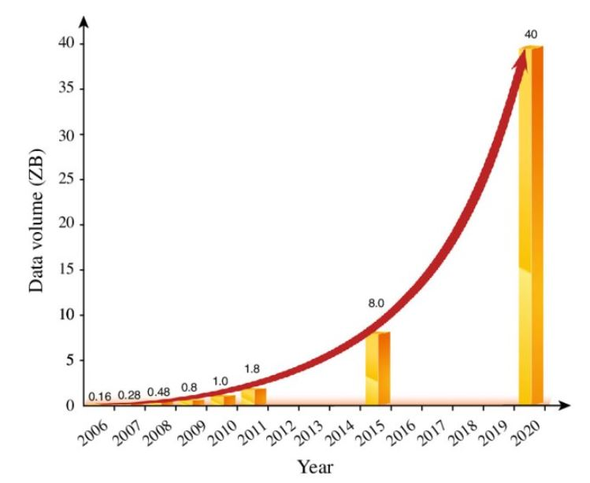

Figure Projected estimates of data growth from 2006 to 2020 [42].

Having examined the size and scale of the digital space that now exists, the sheer volume of data traversing the internet and the almost incomprehensible amount of data that exists, and the threats to it, we can begin to understand the scale of the problem facing the digital space as it continues to evolve.

How can we monitor and manage this digital space and prepare defensive measures to protect it in an ever-evolving virtual space of almost limitless size scale and scope? Does the computing power to do such a thing even exist yet?

Well… perhaps not. Perhaps not in one single machine. Plus, like a hippopotamus trying to pass through a flea sized hula-hoop, passing all traffic through one; or even several monitored checkpoints would create a bottleneck that would kill the efficiency of the digital space. So how can we detect and categorize threats, and determine which addresses are bad or suspicious? What are the most common threats? Predict new or emerging threats or behavior patterns? And achieve all of this without affecting, altering or otherwise negatively impacting this incredible virtual machine that is our digital world? It begins with server’s setup to purely detect malicious traffic, or honeypots. Returning to the earlier question of how we generate rules to protect this digital world, how do we generate these rules?

This is where Honeypots come in.

A Honeypot is a server, or interconnected series of sensors designed to detect, catalog and analyze data pertaining to network and/or system activity on a given system or network. As discussed by Przemyslaw Mazur, in the paper ‘Honeypot’, there are many types of Honeypots such as [43]:

* Standard Bait Honeypot: this is a server or sensor designed to simulate a given system in order to capture traffic of a type that may directed against such a simulated system, be it legitimate or illegitimate traffic for the purposes of analysis. This can be a dedicated system or a simulated system. An example of such a dedicated system is the Sensor deployed by Talos, of the Cisco corporation which is used to detect and analyze email traffic as has been documented in this report.
* Commercial Honeypots: For example, KFSensor, which is a Windows based commercial sensor which monitors all network traffic and system activity.
* Open Source Honeypot: Such as Modern Honey Network or T-Pot which are both open source platforms which any user can freely deploy.
* Physical Server: This is a custom designed physical machine with Honeypot software deployed.
* Virtual Server: This can be a cloud based virtual Operating system install or a local virtual install.
* HoneyToken: A honey token is a singular file which exists for the sole purpose of alerting the creator or installer of the sensor to activity related to the file being accessed.
* Machine Learning / A.I.: A honey pot designed to teach the artificial intelligence software analyzing the data what good and/or bad traffic/activity is. This may be to better deal with incident response or perhaps to better [predict possible future 0day attacks.
* Centralized Honeypot: The previously mentioned Talos sensor would again fall into this category. Rather than being deployed in many locations and attracting traffic, many sensors are deployed in one location where traffic is routed in vast quantities.
* Waterfall Honeypot: Again, the Talos server is an apt example here, this is where data passes through a server and analyzed, any traffic that is deemed of interested is copied or re-directed to another server for more in-depth analysis.
* De-Centralized server: This is the form most common to open source sensors and/or platforms such as the MHN platform which will examine in more detail later.
* Production Server: This is a sensor which might be deployed environment and are designed to distract potential system attackers from the real production environment.
* Honeyweb: a series of interconnected honeypot sensors which combine to form a web of server.

With regard to the type of Honeypot one should chose to deploy and where one should deploy it, both geographically and in terms of physical or virtual, dedicated or decentralized, well these decisions will vary in a production or corporate in environment, but for an open source deployment, where general traffic, and threat intelligence is concerned one need only consider the types of traffic one might wish to attract, capture and analyze and the ease or difficulty with which a sensor may be deployed.

So, what factors might influence these decisions and what risks might any such deployment of a honeypot present? This is addressed and represented, quite brilliantly; by Abhilash Verma in the published paper ‘Production Honeypots: An Organizations View’ as published by the SANS Institute [44].

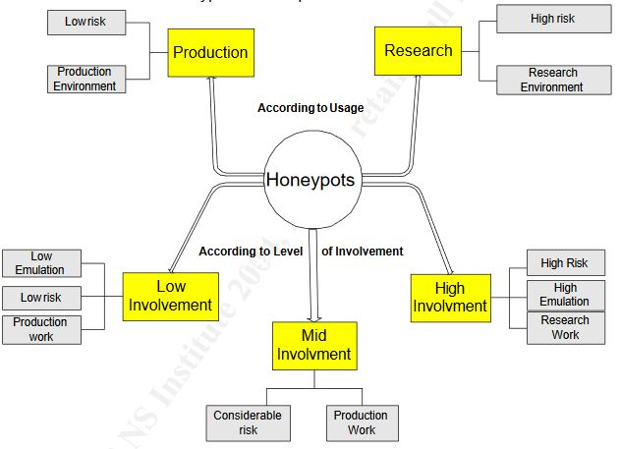

Figure A breakdown of the classification of the types of honeypot deployments and the risks associated with each, Care of the Sans Institute [44].

As we can see above in figure 19, there are 2 usage classifications. Production and research. Production is considered low risk as it is generally deployed to deal with known threat vectors. This type of platform serves as a vehicle for the generation of general threat intelligence. IP addresses, domains, malware files, URL’s, geographical data and other general types of data and behaviors and data such as what sections of the production environment are being targeted, which services, what data is being targeted?

The second classification is the research classification. Naturally, by its nature this is high risk. This is a server aimed at detecting new threat vectors and emerging behavior patterns.

Since with new threat vectors the only defense is the use of deterministic algorithms, which attempt to determine what an intrusion is attempting to achieve based on the behavior of similar previous intrusions, the risk factor in research is much higher. For obvious reasons, these are not sensors the open source threat intelligence community should be deploying unless they are very skilled and prepared to accept the risk to their software, hardware and networks.

Within these classifications there are three sub classifications, high, mid and low involvement. This addresses how much interaction is required on the part of the user to maintain the sensor. Within each of these interaction levels there are low risk, considerable risk and high risk sensors as well sensors that involve low level emulation, meaning they might simulate for example, a port, or a service, mid-level, or production which might simulate an entire machine, or high emulation which might simulate an entire factory (or any large scale industrial or public enterprise from a nuclear power station to a hospital or school).

Honeypots serve some valuable functions in today’s digital space. Firstly, these sensors (or platforms such as MHN) can be deployed often quite rapidly without a vast amount of technical skill. Some skill is required of course, but generally speaking gathering data is far easier then analyzing data and determining real threat intelligence from false positives or simple noise where ports might have been scanned or ‘fuzzed’ but no actual threat existed beyond the scan.

The first role Honeypots play is obviously the collection of data relating to malicious internet traffic. Such as:

* What was the port scanned?
* What are the most common ports which malicious user attempt to access?
* What password attempts are most common and what username and passwords where attempted?
* What vulnerabilities are threat vectors attempting to exploit?
* What tools, exploits or scripts are be3ing deployed?
* What services are being targeted?
* What data are threat vectors attempting to access?
* Did the attacker achieve a shell?
* Is the shell still active?
* Was persistence achieved and if so, how?
* What details can be mined regarding the event, such as IP, geolocation, system used, OS used, DNS, Tools deployed?

This kind of data is easily gathered from open source, production, low interaction, low risk, decentralized or virtually deployed honeypot sensors or platforms, such as the MHN platform. This is the crux of the value of Honeypots. Naturally it stands to reason that the more honeypots being operated globally, the more data and threat intelligence that can gathered, collated through open source repositories and distilled to form a vital picture of the health of our digital space, the current relevant threats and potentially emerging threats and what possible mitigation steps might be taken to reduce their impact.

These low threat low interaction honey pots have advantages. They generate small volumes of data relative to large sensor deployments such as the Talos sensor network. This is great for researchers’ who are new to the arena of honeypot data analytics and need to ease the selves into digesting thousands of alerts, before attempting to analyze 10’s of millions if not hundreds of millions of events. These smaller log outputs are also more conducive to running on local machines or cloud servers with less resources. Therefore, the cost of deployment is low.

The very low interaction aspect means the sensor requires very little user interaction and allows the user to instead focus on data analytics once the platform is deployed (aside from maintenance should it be required).

There are two further advantages of honeypot deployments and these are two reasons we should greatly encourage open source threat intelligence by the non-professional security enthusiast’s community or the youth who display an interest in the security sector. Honeypots serve as a deterrence where a threat actor might discover that the target he or she is attempting to penetrate has a forward facing honeypot network deployed, he or she might be discouraged from attempting any further access once it is known that the system will be setup to waste his or her time and make things harder and other ‘softer’ targets might be a more efficient use of his or her time. Honeypots also serve a distraction where they are not detected or recognized for what they are. And while a threat actor might think he or she has penetrated a production environment, they have instead penetrated a honeypot and all his secrets, scripts, tools and activities are being logged and the security community is gaining valuable threat intelligence. With the vastness of the digital space our data occupies, Honeypots are now one of the best sources of threat intelligence in large volumes.

As noted by Nor Badrul Anuar (et al), honeypots were recognized by the Systems Administration and Networking Security (SANS) Institute in 2002 as being critical to learning how intruders probe and attempt to gain access to systems by recording all such activity so that methods of remediation and mitigation might better be developed and deployed, as well as providing forensics material to aid in the apprehension of and prosecution of intruders [45].

Having established the types, classifications of Honeypots, we must now examine the decision to focus the project on the Modern Honeypot Network (MHN) platform. Why should a user use this platform as an entry level Honeypot platform over others as a teaching tool to ease them into world of data analytics and threat intelligence generation? Well, perhaps the best way to examine this, is to first examine a comparison against what is perhaps the biggest competitor to the MHN platform today in the open source Honeypot arena, T-Pot [46].

The T-pot Honeypot platform is a platform based on Docker containers. The docker container platform currently supports 11 language stacks which include:

* C / C++
* Clojure
* Go
* Hy
* Java
* Node
* Perl
* PHP
* Python
* Rails
* Ruby

As well as supporting these languages, the Docker platform added support for Amazon Web Services and the Perl / Hy projects in 2014/5 [47]. Naturally this is a vast container platform and while the Docker platform is designed to automate the deployment of the honeypot service, if one where to run into deployment issues or bugs, it is reasonable to presume that fixes might be beyond the skills of novice users attempting to install a system that will allow them to learn to analyze honeypot data. This is not a reason to avoid using the platform as our platform of choice, however it is a potential problem to consider as it is likely that with so many languages supported, the sensor will be written in many languages. Great skill would be needed to work with so many languages if issues arose.

The T-pot Platform is a standalone installation that must be installed onto a physical or virtual machine. This is quite restrictive as it forces the user to commit to the exact Operating system deployment used for the platform as well as restricting the options for customization and configuration. And herein we meet the first major flaw in the platform from the perspective of a new or even intermediate user. Resources. As a standalone install the platform has minimum requirements which even by today’s standards are not minimal respective to what might be considered the average resources available in a low end thin client..

While the system requirements do state that it may be possible to run the platform on less than the recommended minimum specifications, this needed to be tested as the average thin client would tend to sit around 4GB of ram with a dual or quad core CPU. To gauge the performance on a system running around the middle of these specifications I elected to install and evaluate the system on a virtual machine assigned 4 GB of ram and 2 Logical cores. As the test machine was a reasonable fast modern mid-range performance laptop (Acer Predator Helios 300), the ram is fast, running at 3200mhz and the and the CPU is a 8th generation i7 8750h 2.2ghz capable of periodical boost to 3.8ghz.

The hard drive being used to store the fires is a Seagate SSHD hybrid drive. This is a reasonably fast seek and access drive with fast read and write speeds. The hardware was expected to pose no noticeable bottleneck so long as the host machine was not under heavy load, which is was not.

There are 5 types of install which are as follows [48][2]:

* Standard Installation

Honeypots: adbhoney, ciscoasa, conpot, cowrie, dionaea, elasticpot, heralding, honeytrap, mailoney, medpot, rdpy, snare & tanner

Tools: cockpit, cyberchef, ELK, elasticsearch head, ewsposter, NGINX, spiderfoot, p0f and suricata

6-8 GB RAM (less RAM is possible but might introduce swapping)

128 GB SSD (smaller is possible but limits the capacity of storing events)

Network via DHCP

A working, non-proxied, internet connection

* Sensor Installation

Honeypots: adbhoney, ciscoasa, conpot, cowrie, dionaea, elasticpot, heralding, honeytrap, mailoney, medpot, rdpy, snare & tanner

Tools: cockpit

6-8 GB RAM (less RAM is possible but might introduce swapping)

128 GB SSD (smaller is possible but limits the capacity of storing events)

Network via DHCP

A working, non-proxied, internet connection

* Industrial Installation

Honeypots: conpot, cowrie, heralding, medpot, rdpy

Tools: cockpit, cyberchef, ELK, elasticsearch head, ewsposter, NGINX, spiderfoot, p0f and suricata

6-8 GB RAM (less RAM is possible but might introduce swapping)

128 GB SSD (smaller is possible but limits the capacity of storing events)

Network via DHCP

A working, non-proxied, internet connection

* Collector Installation (because sometimes all you want to do is catching credentials)

Honeypots: heralding

Tools: cockpit, cyberchef, ELK, elasticsearch head, ewsposter, NGINX, spiderfoot, p0f and suricata

6-8 GB RAM (less RAM is possible but might introduce swapping)

128 GB SSD (smaller is possible but limits the capacity of storing events)

Network via DHCP

A working, non-proxied, internet connection

* NextGen Installation (Glutton replacing Honeytrap, HoneyPy replacing Elasticpot)

Honeypots: adbhoney, ciscoasa, citrixhoneypot, conpot, cowrie, dionaea, glutton, heralding, honeypy, mailoney, rdpy, snare & tanner

Tools: cockpit, cyberchef, ELK, elasticsearch head, ewsposter, fatt, NGINX, spiderfoot, p0f and suricata

6-8 GB RAM (less RAM is possible but might introduce swapping)

128 GB SSD (smaller is possible but limits the capacity of storing events)

Network via DHCP

A working, non-proxied, internet connection

These preconfigured install configurations are quality of life options, Sensors can be installed or removed later. However, the requirements do rule out less powerful systems. And servers that meet these requirements online can be prohibitively expensive for young cyber security researchers.

T-pot incorporates the ELK (Elasticsearch, Logstash, Kibana) analytical SIEM platform by default, there is no option to choose another at installation. Furthermore, the platform does not offer support for pre-configured the Splunk SIEM dashboards. Elasticsearch is a Lucene (JSON-based) search engine. Logstash is an ingest pipeline for data to be analyzed and Kibana is the visualization tool that displays results of searches.

We will analyze this option in more detail later. But the lack of a choice of SIEM here seems an oversight. While the ELK analytical platform is a fantastic platform, and its open source nature does not detract from this at all, it could be argued that it is, at the entry level stage more difficult to use with a higher skill requirement. The learning curve for Elk will be compared to that of Spunk during a critical analysis.

One thing that must be noted in appreciation of the Elk dashboard implementations with the Kibana plugin within the T-Pot platform is that they are visually stunning. Upon installing this platform, it is immediately clear the amount of work that went into these dashboards. While being pretty is neither a strong pro or con, id does lend itself to use ability and this area is a strong pro where it serves to increase usability. This researcher has been greatly impressed by the work undertaken to make the visualizations of data pop and yet remain easily digestible by the user.

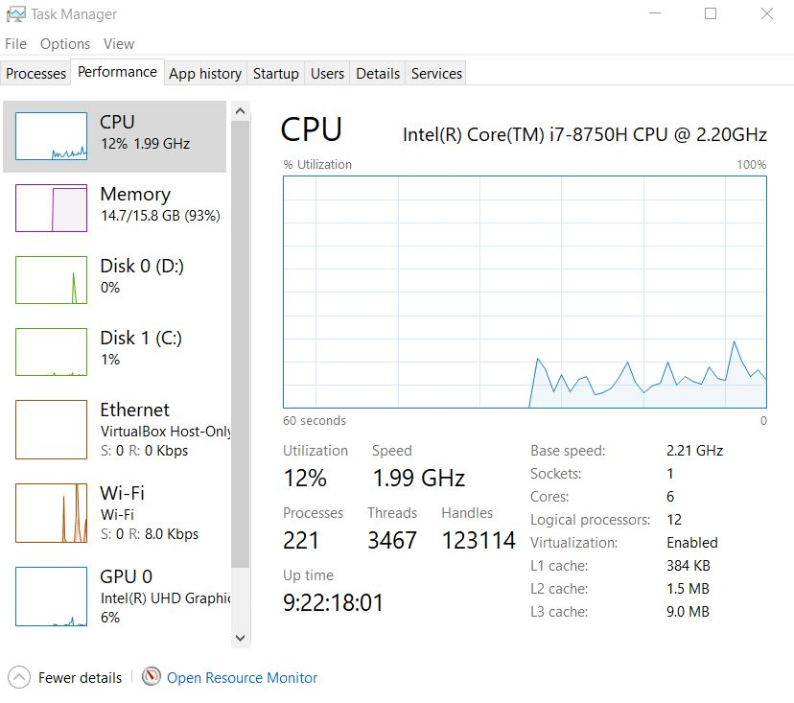

Figure T-Pot Test machine at the time of testing the T-Pot Honeypot platform.

The T-Pot platform was installed on a virtual machine, with a second virtual machine used to run Linux Ubuntu to access the web and administrator portals. As can be seen above in figure 24, the host machine is not under heavy load even running 2 virtual machines with each being assigned 4GB of ram and 2 logical cores. The high RAM allocation is indicative of the ram allocations, rather than high load. The system has 16GB of RAM total.

The installation was one of the longest this researcher has come across for a long time, taking approx. 25 mins. This was unexpected. Hundreds of container-based repositories were downloaded during this process. The process of trouble shooting this installation would be immense to say the least. Again, this is only a consideration in that if trouble shooting is necessary, it is likely to be beyond the capabilities of most novice Linux users.

In terms of performance, the host system was used as a test bed of the base performance. As the system was air gapped from outside network access and only accessible via the second Ubuntu VM, the Platform is not logging or digesting any files during this test. It is therefore reasonable to say that the system would perform slower than what was observed during this test.

The platform ran slightly sluggishly with web pages suffering roughly 1-2 secs of latency response time and roughly 5-10 secs of loading time. This suggested that there is very little overhead left should the system be required to log and digest sensor data. It also suggests that developers claim that less than the recommended resources are possible, but not advisable, are accurate. It also suggests that any extra applications where added to the system the platform is likely to run sluggishly too, such as a different SIEM platform.

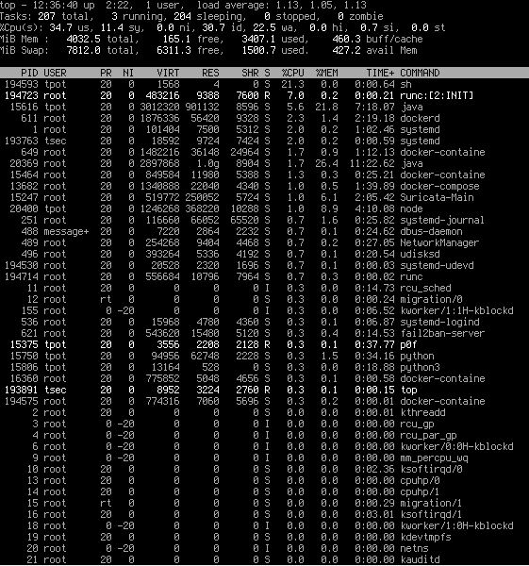

Figure A resource snapshot taken from the T-Pot virtual machine at idle.

Figure 21 above, shows a snapshot of the T-Pot platform virtual machine deployment at idle. The CPU utilization sits at 35% although this does tend to fluctuation. The machine is using 3.4GB of its 4GB of allotted RAM. The machine has also forced the system to rely of heavy swap file usage increasing the hard drive usage by almost 8GB. Swap files are only used when the system is really struggling for physical ram. Despite all this loading of resources, the average load maxed out at 1.13%. So, these spikes that result in high CPU usage would, when combined with sensor logging and digesting, as well visualization through the Kibana app, result in sluggish if not unusable performance. To be clear, this does not indicate that the T-pot platform is a ‘bad’ platform. Rather, it indicates that platform is very resource dependent and low resources create a huge bottleneck.

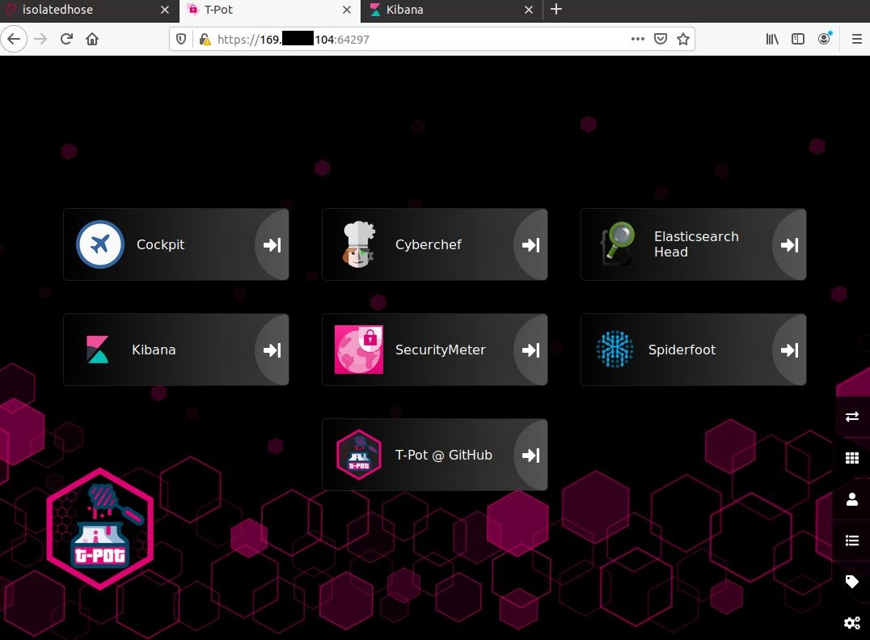

Figure The t-pot platform administrator web platform.

Upon launching the platform, the user is greeted by a very nice home page displaying the list of tools available. These tools include:

* Cockpit: this serves as a web UI interface for the Docker container platform.
* CyberChef: this is a fantastic utility used for cryptographic encryption and decryption, cracking and various other hex and cryptographic functions. While this is a free open source tool that can be downloaded by the user, the fact that is small and light weight and incorporated into the platform reducing external tool sprawl is a very nice quality of life feature.
* ElasticSearch Head: This gives direct access to the Elasticsearch stack search cluster.
* Kibana: the ELK stack virtualization app.
* SecurityMeter: This provides access to an external online threat map with details all attacks against the T-Pot global honey net community (Users most opt in and share data).
* Spiderfoot: This is a web GU based open source intelligence (OSINT) gathering tool. This is relatively like the program this researcher intends to develop as part of this project and retrieves data relating to IPs, Domains, Hashes etc. This tool goes further adding in SHODAN compatibility, geolocation data, Dark Net Queries and more.
* T-Pot @ GitHub: a direct portal to the T-Pot GitHub repository and documentation.

The user may also access menus on the lower right of the home screen that allow for the addition of new dashboards, users, applications, tags and the editing of system info. A review of the analytical side of the platform was undertaken separately in direct comparison against MHN’s analytical capabilities.

In summary, this researcher feels that while the functionality and potential of the T-pot platform, combined with its advanced sensor capabilities make for a truly superb Honeypot platform, it is also felt that it is perhaps too advanced for a novice user. If this researcher attempted to write a guide for this platform that guide would surely be massive in scope and such a guide, let alone the platform itself might be daunting or even intimidating for a novice cyber security enthusiast, analyst or researcher. And lastly, the lack of the ability to rapidly expand this size and scale of the platform onto further services to transform the Honeypot ( meaning sensors on one device) into a honeyweb ( meaning a network of sensor server traversing vast distances and geolocations) is a noteworthy option that is lacking. While it is possible within the T-Pot platform, it is not a simple process to add remote sensors. Or to connect one Installation up to another.

But does the MHN platform offer a suite that is relevant while producing quality viable threat intelligence, while also offering a platform that is simple yet functional while allowing a user to focus on the process of analyzing data without a steep learning curve being required to master the platform prior to analyzing data?

The installation of the MHN platform is based on the container method implemented in Python. The installation is fast, relatively low maintenance and considerably easier than the installation for T-pot which required a full Linux install. The fact that it is not restricted a specific Debian Linux distribution adds some flexibility to that platform’s deployment options. In this case, as the MHN platform has been deployed to a cloud-based server with the CPU and RAM resources allocated compared to those allocated to the T-pot installation, no fair comparison is possible. Naturally, if the T-pot platform had similar resources it would be expected to perform much better than it previously did in testing. However, some things do stand out here. For reasons that will be covered later, this MHN deployment machine has had a Desktop environment installed. Furthermore, during installation the decision was made to not integrate any data analytic platform and instead install the Splunk Enterprise platform separately. AS before, data analytics will be covered later, and it is strictly the sensor deployment and data gathering Honeypot platform we are interested in at this point. The system requirements for the MHN platform are significantly lower than those of the T-Pot platform and are as follows:

MHN Management Server:

* 4GB RAM
* Dual Core CPU minimum
* 40GB drive.

Sensor Server:

* 512MB-1GB RAM
* Dual Core CPU minimum
* 20GB drive.

This deployment has been up and running for over 1 week, and alongside the Desktop environment, 1 sensor has been deployed for testing purposes for that week period. Having been up and running for this time period with no maintenance the Dionaea.log file relating to the sensor is vast (over 124GB in size). So, with a desktop running, and with a huge log file being continuously ingested, the system remains snappy and responsive. Web pages do offer some latency. The system resource use is moderate but shows similar CPU spikes to that of the T-Pot honey pot deployment, but the system is stable, reliable and highly useable.

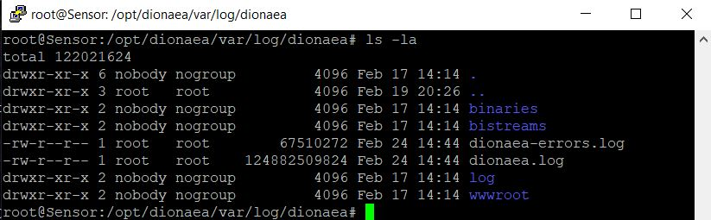

Figure The log file for the Dionaea sensor (dionaea.log) deployed remotely, sitting at over 124GB in size at the time of taking this snapshot.

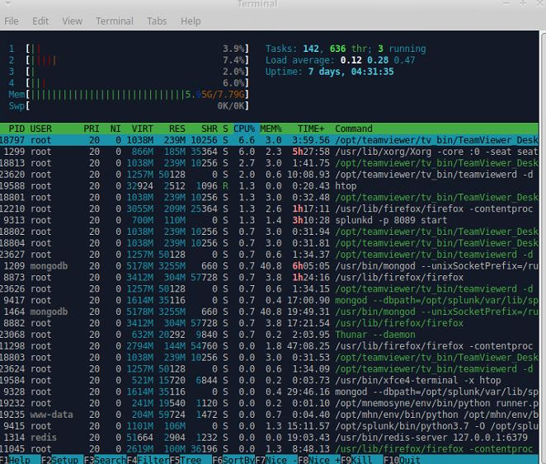

Figure A resource snapshot taken from the MHN cloud machine at idle.

As seen above in figure 24, CPU usage is light, which is to be expected with 4 cores, however periodical high spikes do occur similarly to the T-Pot Platform. In terms of raw performance, it is felt that the MHN Platform does edge out the T-Pot platform because it is currently running a desktop environment and an independent data analytical application (Splunk Enterprise) while also ingesting a log of significant size. This is impressive performance for a platform that has been left unmonitored (for diagnostic purposes via logs) and management for a week.

In terms of the skill requirement to manage the MHN platform, it is relatively low. The interface is web-based and almost strictly visual and requires very little configuration.

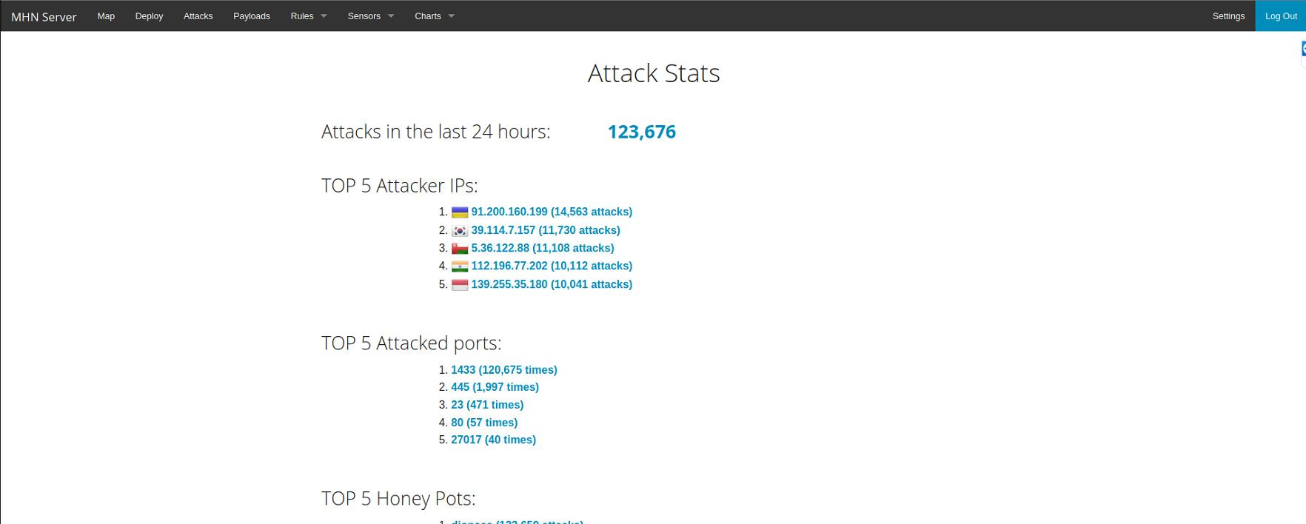

Figure The MHN web portal home page.

Figure 25 displays the MHN web portal home page which highlight some of the most pertinent data such as the top attackers, top attacked ports top sensors and so on. The platform itself is continuously ingesting logs even if it passes logs over to a third party for deeper analysis. This further increases the impressiveness of the performance.

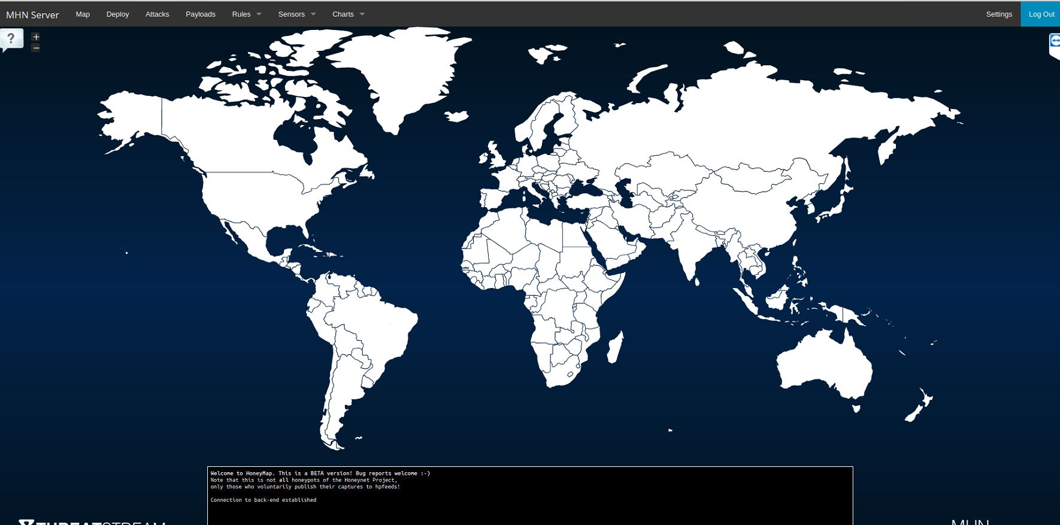

Figure The MHN threatmap

The next tab seen in figure 26, offers the MHN threat map which unlike the T-Pot threat map is an internal map. Much like the inclusion of the CyberChef and SpiderFoot tools incorporated into the T-Pot platform, helps to reduce eternal tool sprawl here (User must opt in to share their data into the threat map).

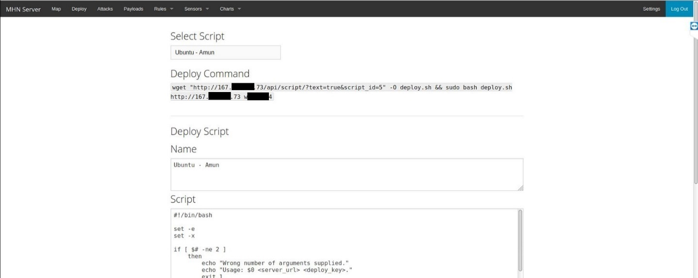

Figure The MHN sensor deploy menu.

Figure 27 displays the sensor deployment menu in the MHN platform. Deployment of sensors is as simple as selecting the sensor and typing out the script displayed into the CLI of the machine onto which you wish to deploy the given sensor. This makes the deployment simply and extremely scalable. Sensors of considerable size can be deployed in minutes with ease and the entire platform can be scaled up to a honeynet of massive scale in a very short period. This makes the scale of Threat intelligence that can be gather extensive and impressive. This is useful from a learning perspective, production environment perspective and a corporate perspective providing flexibility and safety for deployments of almost any size.

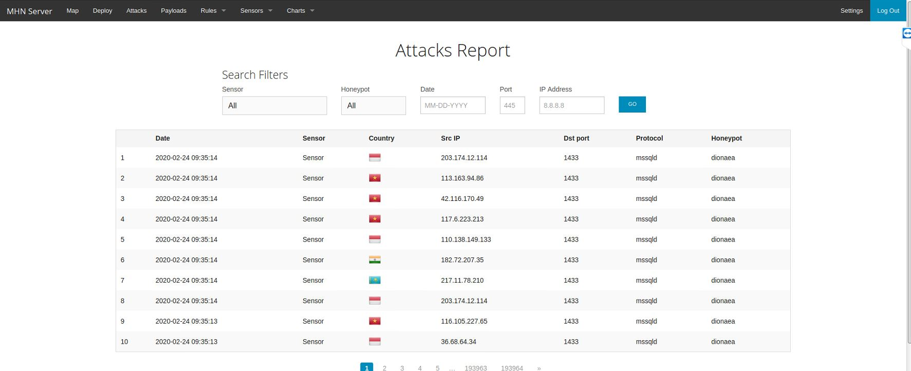

Figure The MHN attack reports page.

The platform offers attack related information direct from its own interface. Although analysis should be left to SIEM tools. This is still a useful quick access overview of the most recent attacks.

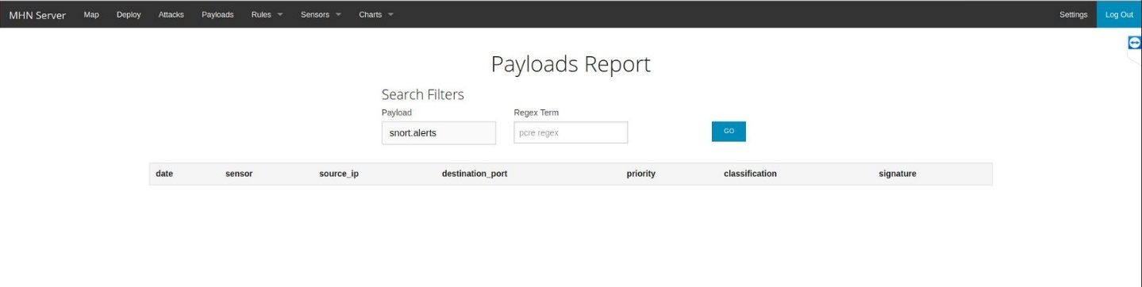

Figure The MHN payload rules screen.

The payload rules tab, seen above in figure 29, offers a view into the reports generated by the rules being managed by IDS or IPS sensors such as Snort or Suricata. Neither of these sensors are yet deployed so no data is available.

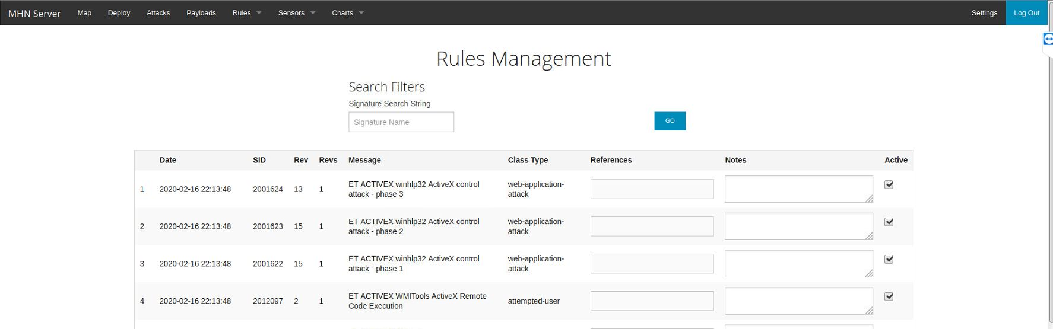

Figure The MHN rule management interface.

The rules can easily be managed with the ability to add notes and references. As users wish to adjust which threats might be able to further penetrate their machine this will become a valuable management interface.

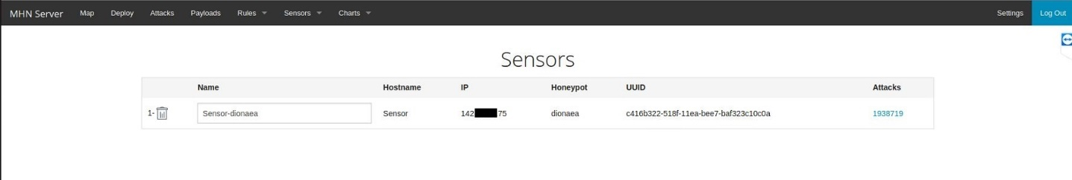

Figure The MHN sensor viewing window.

The user may view the individual sensor information such as IP, Honeypot type, ID and number of attacks. This is useful for highlight geographical hotspots of activity.

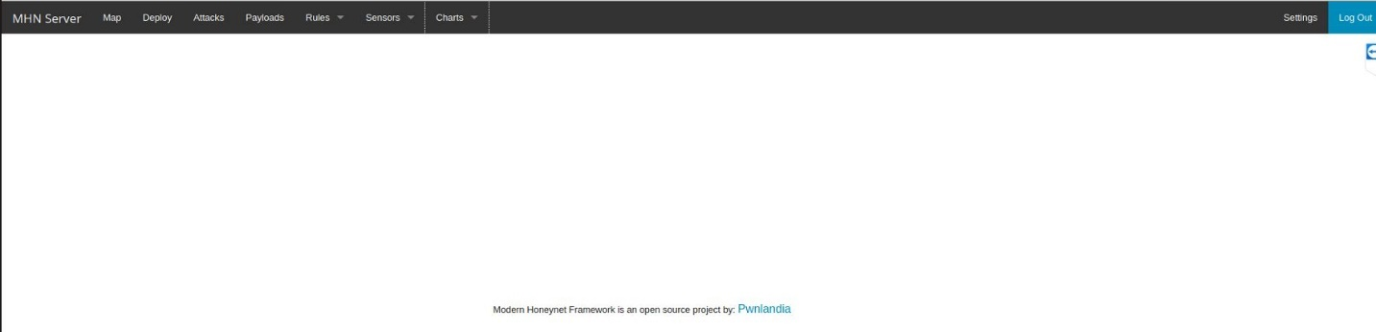

Figure The MHN chart viewing tab.

The chart view allows user to access charts such as top password used, top attackers and so on. This information will be available and visualized to a much deeper degree later.

So, having finished an overview analysis of the MHN platform, the simplicity of the platform stands out. While the installation cannot be considered easy in terms of a novice user with little to no Linux experience, this researcher feels that an installation guide can be written such that even a user with no experience could rapidly deploy the MHN platform. This is also True of the T-Pot platform, so in this regard the Platforms are evenly matched.

The ease at which sensors can be deployed and the vast scalability potential are obviously a huge selling point for the platform. Sensor deployment is handled fantastically, and installation is completely automated once the deployment command is entered and configuration and communication with the management server is also fully automated. The developers deserve to be commended for how smoothly this is handled. This is one of the main reasons the platform might suit being used as a teaching platform.

Users might initially feel that the lack of configuration options are a negative point, however, while the T-Pot platform obviously has more tools, more up to date sensors and advanced configurations options, the lack of obvious configuration options in the MHN platform is a deceptive first impression only, as the configuration options are to be found in configuration files within the platform and sensor binary folders. The platform does in fact have a lot of configuration options available, however, rather than overwhelm the user, they are subtly hidden away. So, a novice user is not likely to be intimidated by the MHN platform. The platform offers the possibility of simply diving in and beginning to gather and analyze data with ease. And while the platform is welcoming of new users, more intermediate users will welcome the configuration options which allow experience users to create new dashboards and attempt to integrate new sensors.

The decision to focus on one platform over the other now comes down to one final consideration.

Can a new user, with little to no experience, dive into the T-Pot platform and have a relatively comfortable experience, to the extent that the can simply focus the process of teaching themselves how to analyze data and generate viable useful threat intelligence? This researcher does not believe so. The potential for problems and rabbit holes or issues that might require study or research is just too big. Although it must be said once more, that the T-Pot platform offers much to the intermediate and advance honeypot user. And ultimately this researcher feels that the MHN platform would help to get the user to the point where they are skilled and comfortable enough to use such an advanced platform. The potential for the T-Pot platform to enter the riskier aspect of Honeypot research is immense, but first, a novice must gain the skills to conduct such research.

The same question must be asked of the MHN platform? Can a new user, with little to no experience, dive into the MHN platform and have a relatively comfortable experience, to the extent that the can simply focus the process of teaching themselves how to analyze data and generate viable useful threat intelligence? This researcher strongly believes that with the help of some guides, yes, this is achievable.

While the potential for problems and rabbit holes or issues that might require study or research still exists, with significantly less containers and repositories required to downloaded and install, the lower complexity of the installation process makes it less likely to occur, or to be an insurmountable obstacle for the user.

Although it must be said once more, that the T-Pot platform offers much to the intermediate and advanced Honeypot user. And ultimately this researcher feels that the MHN platform would help to get the user to the point where they are skilled and comfortable enough to use such an advanced platform. The potential for the T-Pot platform to enter the riskier aspect of Honeypot research field is immense, but first, a novice must gain the skills to conduct such research.

But before a conclusion can be reached, there is one last area to explore. Data analysis and visualization. In order to fully consider all aspects of data analysis it must be approached from two perspectives. Firstly, we must consider the abilities of the tools which are afford by the platforms themselves and what, if any options exist. And secondly, we must examine the outputs of these tools and options for difficulty in terms of understand what we are seeing.

Beginning again with the T-Pot platform, does the platform offer options regarding data analysis? Well, in short, no. The platform comes with an integrated implementation of the Elk stack data analysis platform. This is a very good implementation, and the developers gave over much time to the visualizations and outputs of the data analysis results.

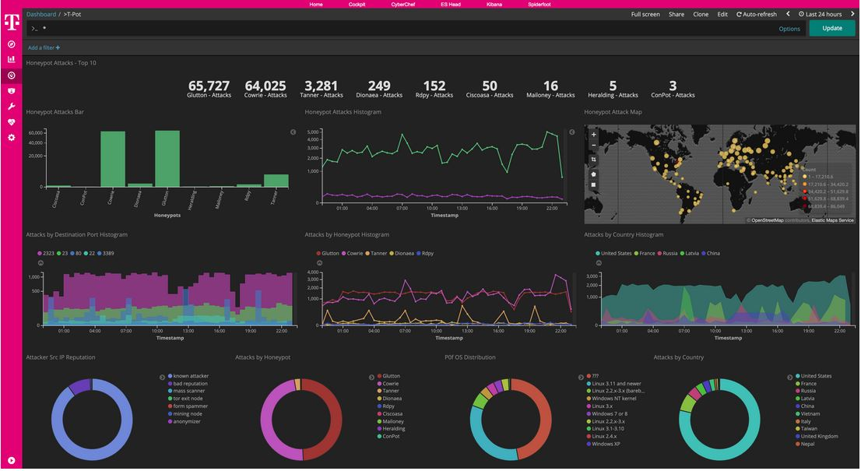

Figure Snapshot of the main overview dashboard of the T-Pot platform.

As seen above in figure 33, the general view of the analytical results is excellently put together. The graphs are easily understood with the most pertinent statistic displayed prominently at the top of the page. It is difficult to find fault in this implementation. Some users may wish to see different data displayed, and of course experienced users can alter the dashboard configuration. But in terms of the visual effect, and ease of ability to understand the data being output, the design is very good. However, T-pot goes even deeper and it is here that perhaps users will begin to get overwhelmed without experience working with the Elk stack.

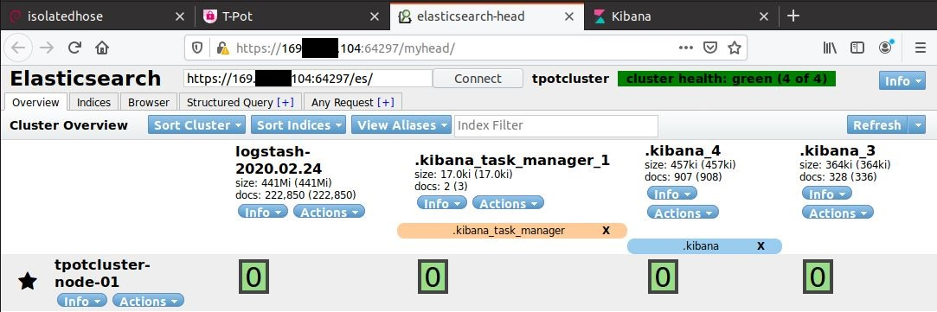

Figure Users can elect to inspect the Elk stack directly.

The platform offers the ability to enter the Elk search stack directly. As can be seen above, this is not a simple interface. While the Elasticsearch stack is immensely powerful, with file indices, a file browser, query creator and a request feature, a novice user could potentially very quickly get overwhelmed here.

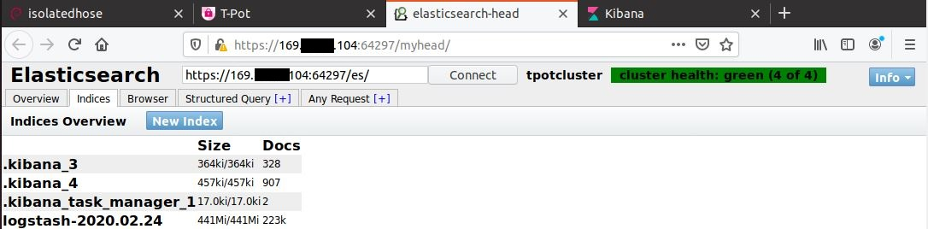

Figure Elasticsearch indexed files

In the indices tab, users can add new files to be indexed. This is relatively simple.

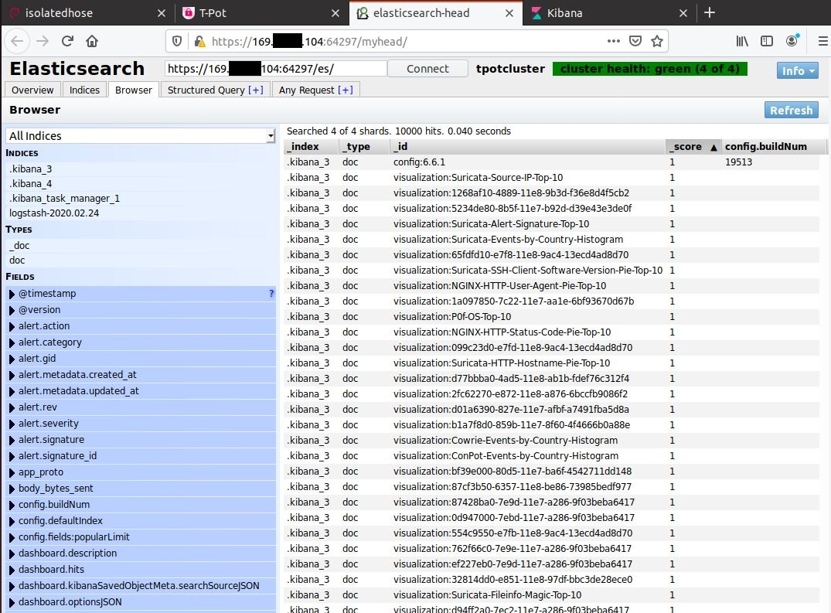

Figure The ELK stack file browser.

The browser tab allows the user to search the indexed files, file types and to search individual elements with all files by element ID. This is a powerful feature, and could be difficult to understand, however, as the goal is to learn how to analyze data and produce viable threat intelligence, this cannot be considered ‘too difficult’, rather. It is hard, but necessary to gain an understand of how-to data mine your files.

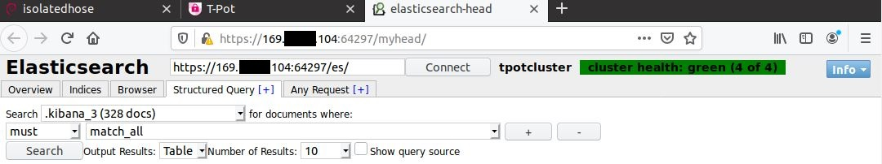

Figure The Structured query tab allows for search queries to be created and stored.

The structured query tab allows for the creation and storing of search queries that can later be converted to visualizations.

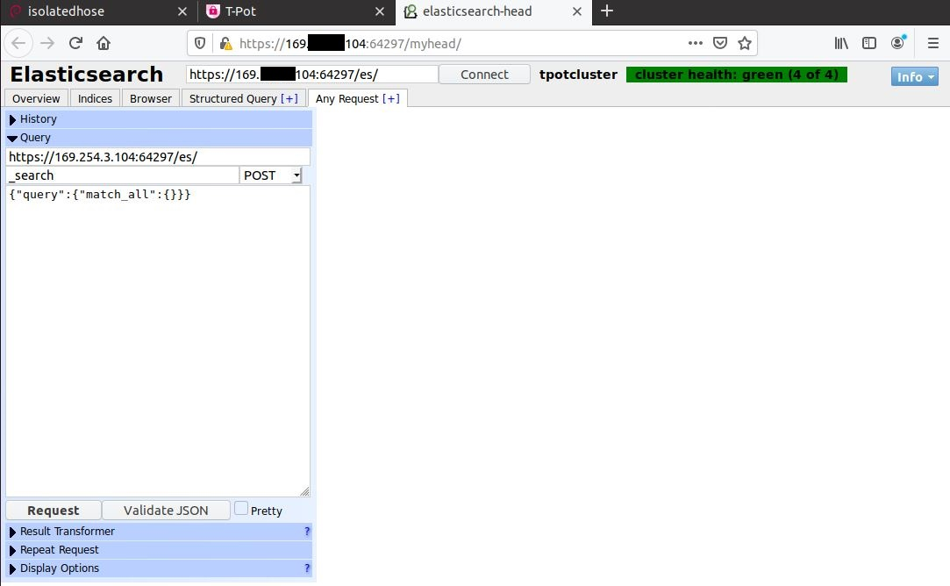

Figure The any request tab for testing queries.

The any request tab allows a user to test a query before adding it to a dashboard and converting the output to a visualization. This is a useful development feature.

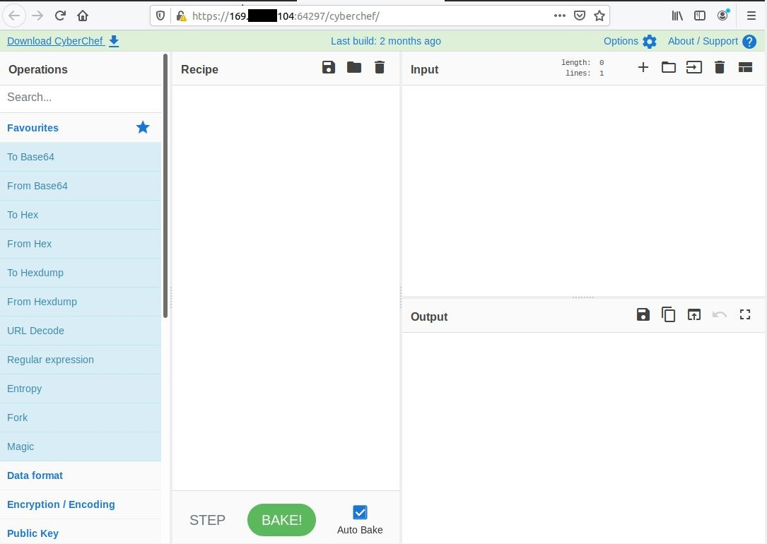

Figure The CyberChef GUI.

The CyberChef GUI cryptographic tool is a fantastic addition. Particularly for advanced users, who may be performing static or dynamic malware analysis against malware that has been uploaded, deployed, or scraped by the sensors. However, this researcher feels that this is an advanced technique and a novice should focus on sensor data collection and analysis rather than binary file analysis or bitstream deconstructions.

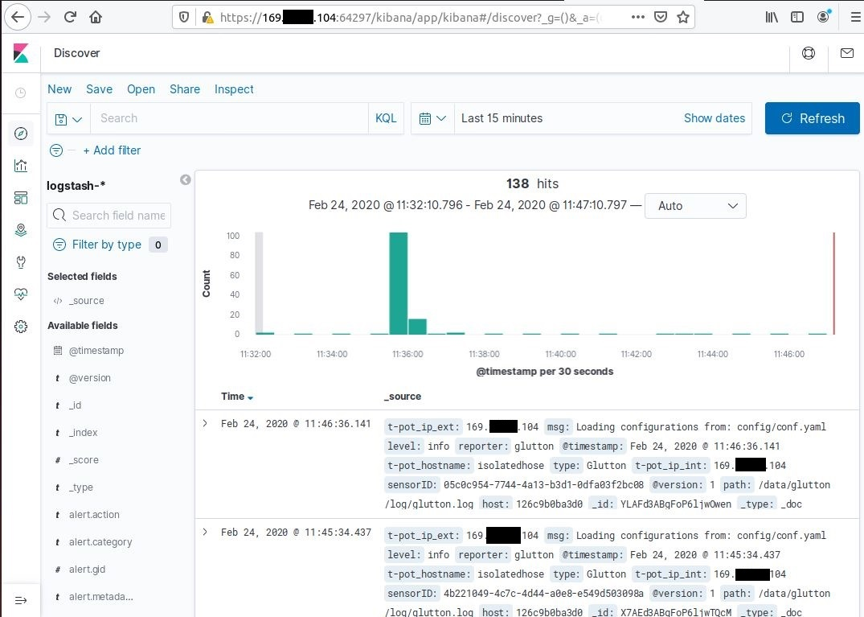

Figure Logstash event data can also be viewed directly.

The Logstash log event data can be viewed in raw format. While this is excellent data, it is best viewed post data mining. However, for an advanced user, who might wish to create new queries, this is an excellent feature. Novice user will not get much use out of this feature but to have it available for later when they gain more skill in data analysis is very useful.

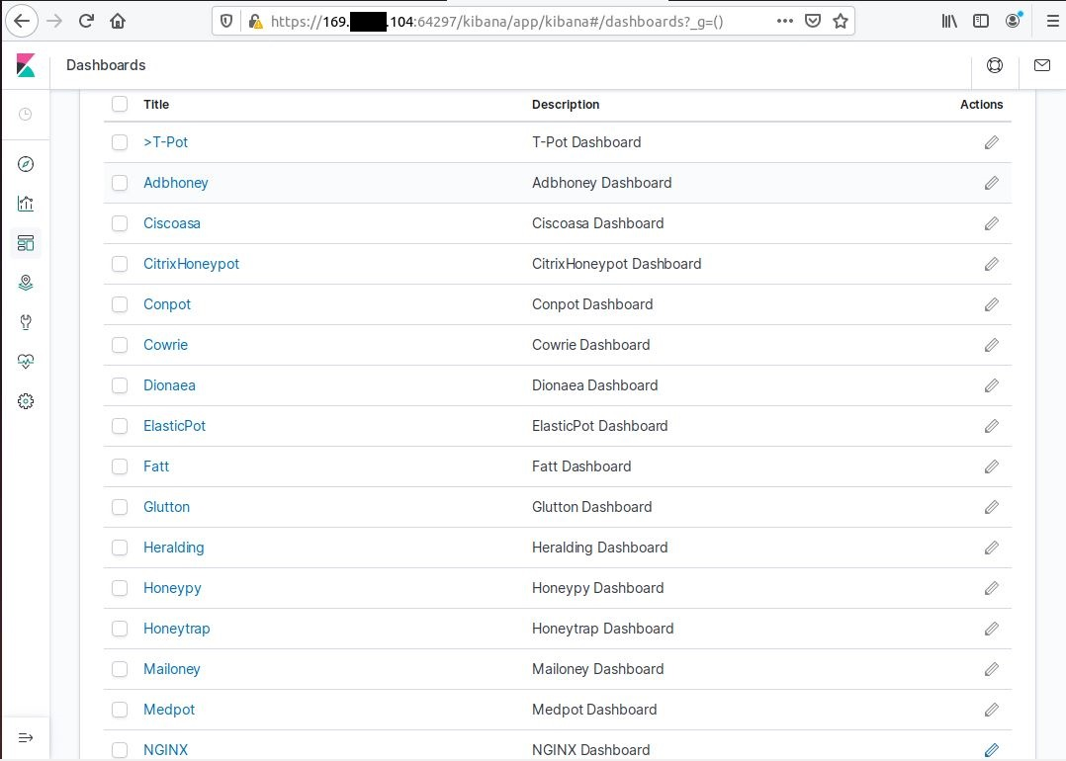

Figure The dashboard modification screen.

The T-Pot dashboard configuration screen allows users to add, delete, and modify dashboards. This feature is more of a tool building and modification development tool and as such has little effect on data analysis, except where users might create new dashboards to output data in a manner specific to their requirements. An intermediate to advanced user feature.

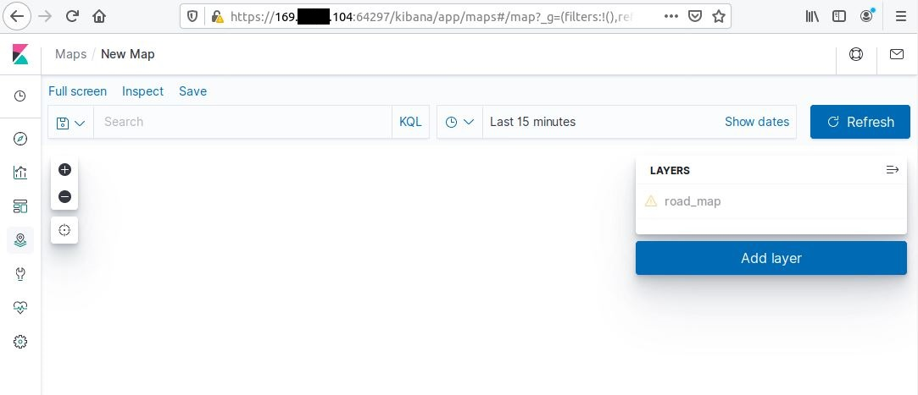

Figure The T-Pot map creation tab.

Figure 42 displays the map creation feature. This allows users to creation new maps from geo location data. This is interesting as most maps are usually just visualizations of geo location data. Without access to raw data feedback on this feature cannot be given except to say that the ability to create interchangeable maps that can integration into any dashboard instead of specific dashboards is a useful feature.

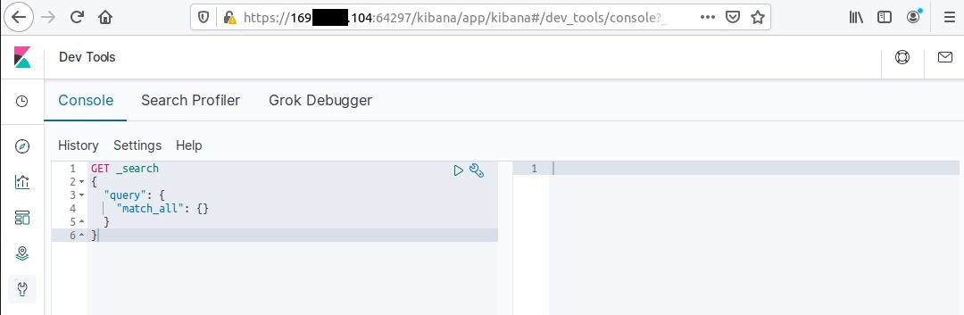

Figure The T-Pot development console.

The T-Pot platform offers a development console for testing functions such as API calls, search queries, dashboard functions and much more. This is not something a novice user needs and could result in damage rather than enhanced performance or data analysis. Only experienced developers should access to development consoles.

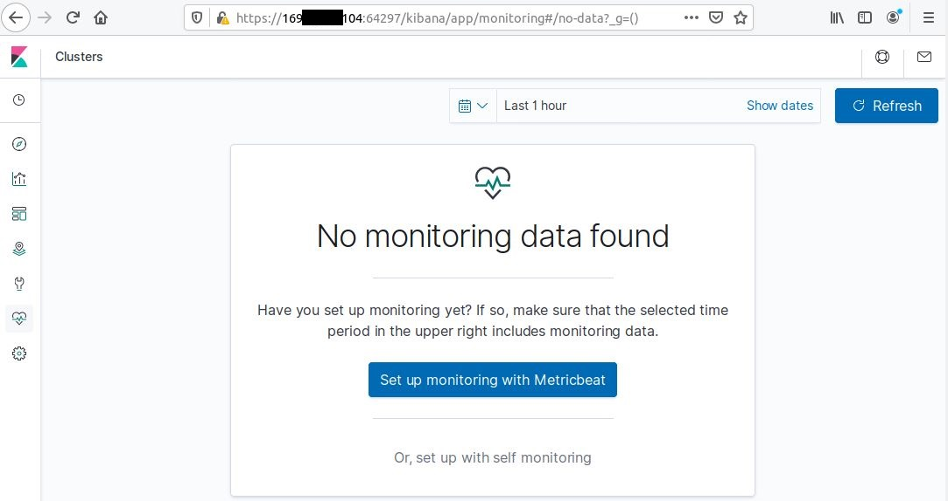

Figure The T-Pot cluster health monitoring feature.

The health monitoring tab allows user to monitor the health of Honeypot clusters. This is a very useful feature allowing users to detect and analyze cluster which may be infected or hijacked remotely. This serves as potential remote monitoring and safety feature.

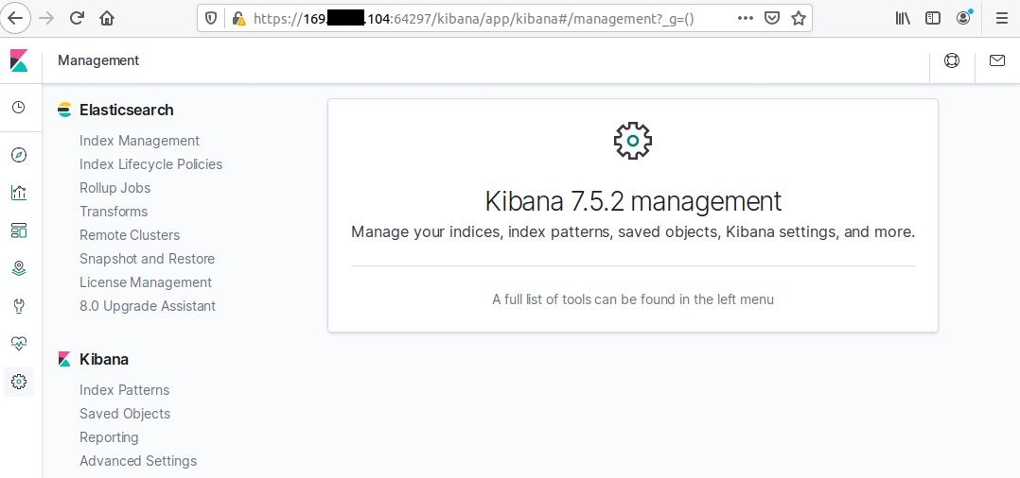

Figure The ELK stack integration management interface.

T-pot allows customization of the Elk Stack integration management options. Of interest here is the snapshot and restore feature, this could be useful in preserving the data base prior to a research cluster deployment. Not a novice feature yet very useful to advanced users.

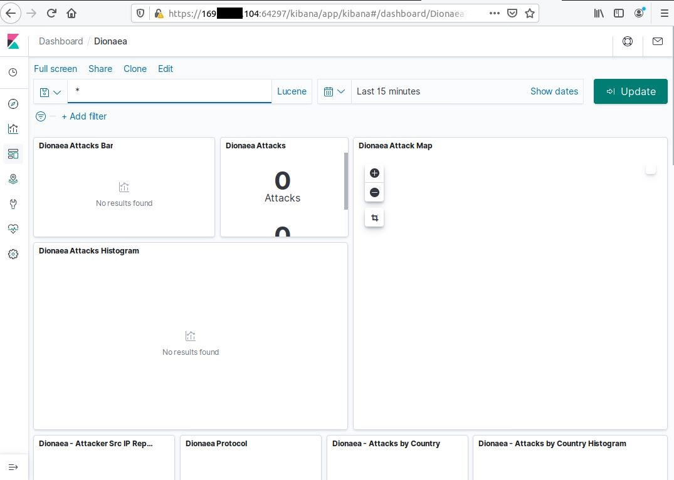

Figure A T-Pot dashboard visualization tab pre data entry.

Figure 46 is an interesting view of a pre data general dashboard, in this case, relating to the Dionaea sensor. This is a good choice since this sensor is deployed on the MHN network for diagnostic purposes. As can be seen above, the dashboard is laid out in a tiled grid style layout making the separation of data easy on the eye. These tiles can be dragged and dropped to adjust the layout should the user file a different layout more optimal. This is a very efficient use of space with data displayed in an appropriately sized font for ease of digestion by the user. In the area of visualization through the Kibana visualization application, the T-pot platforms developers have done an excellent job.

With all aspects of the T-pot data analysis capabilities inspected, this researcher finds that it is a tool rich in features, capabilities and advanced in term of the nature of its sensors. While it has a high skill requirement it is, perhaps the best intermediate to advanced user open source honeypot platform available today. It is however, in this researchers’ considered option, too advanced for a novice user, and in certain areas, perhaps even too much for an intermediate user, particularly if the platform where to deployed on localized physical hardware and configured into a research detection and analysis mode. It is the perfect platform for high end production environments too. However, it is far too advanced to act as a novice teaching tool, therefore, while the threat intelligence that could be gathered would be of great interest, it would also be limited in terms of the number of deployments possible for security novices and enthusiasts.

But how does MHN compare in its data analysis and visualization capabilities? Does it offer better, equal or less capabilities? Does it often greater data analysis options?

In terms of the options offered, MHN does offer some fantastic options. During installation the user is prompted to decide if they would like to integrate the Elk stack, the Splunk Enterprise data analytical platforms. This is not an either/or decision. The user may elect to have both if they wish, though this of course will necessitate more resources being needed to be allocated to the machine f the machine is perform well. This diversity of options opens the platform up to a wider audience in the intermediate skill area of users. Users might have a preference towards one of the other, and both should feel at home once their tool of choice is integrated. Furthermore, since both can be integrated, the teaching aspect is enhanced as users can be taught to analyze data in both common formats and platforms.

However, while these integration options are great, there is no customization involved. No pre-configured dashboards or searches would be included with these default integrations. This again adds options regarding allow users to test their beginner dashboard creation talents, without the worry of destroyer the countless hours of work that a develop has put into creating a beautiful tool such as the T-Pot platforms Elk integration suite.

In the area of SIEM solutions, Splunk is a recognized industry leader in the field of data analysis and extraction. While ELK is often overlooked by novices and simply not evaluated due it being open source, in direct comparison to market leader as, which is closed source. This makes direct market comparisons rather difficult. Therefore, a comparison will be carried out from two perspectives. Firstly, there will be a feature comparison comparative analysis, and secondly the researcher will apply experience using both tools with a viewpoint to determining which is likely to better for a novice and which is likely to be better for an advanced user. Rapid 7, themselves a strong market competitor in the SIEM market rate Spunk as A stand out market leader, as seen below in figure.

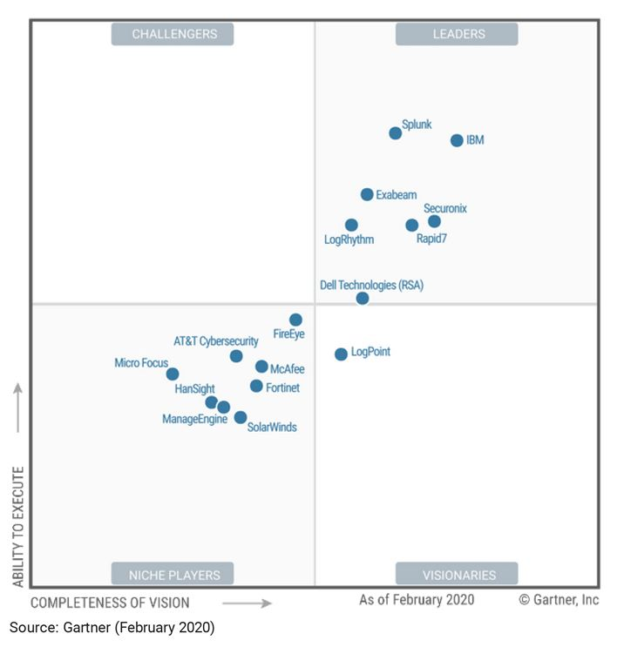[3]

Figure Rapid 7's recognition of Splunk as the dominant market leader in the SIEM arena [49].

It is noticeable that ELK is left out of this comparison chart and this is likely due to its open source nature.

In terms of the learning curve required for both platforms, the Splunk platform has a moderate learning curve initially as the user’s requirements and data analysis expectations grow. At the novice level, the skill requirements are quite low, however as the users moves from analyzing small data sets into the realms of cloud computing and big data, the skill requirement takes on a slow steadily increasing arch. While this arch remains constant it is certainly true to say that as the data complexity increases, the skill required to mine data with Splunk’s more advanced plugins will increase also. ELK, however, has a flat learning curve. While it is a difficult platform to master as a novice, this is because the user is present with almost the full unlimited functionality with no filter from the get-go. What this means is that the user will generally experience a difficult entry level novice experience, but once this period has passed, the learning curve remains relatively flat and it is third party modifications and plugins that the user tends to require experience and skill in beyond this point. So, regarding the learning curve of both platforms, one of the core areas of concern to this project, it seems Splunk is a better novice choice with ELK being better for advanced Honeypot Users.

Popularity will play a factor in how viable the skills that a novice could learn will be if applied to a professional role later. And here I feel that Splunk edges out the ELK platform by a narrow margin. There is however only 1 reason for this. Certifications. While the Elasticsearch organization does offer training and certification, and the ELK platform is certainly a recognized industry standard, the certifications offered by Splunk are a universally recognized standard. Splunk has over 12,000 commercial clients with over 8- of the leading fortune 100 companies being clients. These companies include Coca-Cola, Tesco and Adobe as leading examples. However, The Elasticsearch corporation has almost as many clients and can count E-Bay, Netflix, Verizon and even Cisco among its clientele. It is also impossible to determine how many enthusiasts and researchers use the ELK platform outside the corporate space, however, Splunk also offer a free enterprise edition. This edition does come with a 500MB data limit per day, but it remains a popular edition. So, in terms of popularity and real-world practicality, both platforms are recognized, with Splunk’s certificate recognition perhaps tipping the scales in its favor.

API’s plays a big part in application integration and development. While development is not a factor in novice honeypot use or data analysis, it might be of interest to an intermediate level user, and this is an area where Elk is a clear leader. Splunk offers fantastic API compatibility, integration and development tools, however, only at the corporate level. The standard corporate Splunk enterprise account will allow some API use, but full use and integration development is only available at the Splunk Enterprise Security account level and above. Elk, being an open source platform does not apply such restrictions, while there will of course be some proprietary addons and plugins which are restricted by their respective developers, general access to API functionality, integration and development is not restricted. This opens a world of potential development options and tools up at the expert user level. In this area, ELK is the superior platform. However, there is one not inconsiderable caveat that makes this a moot point. In this specific use case, there is an application (MHN-Splunk) that is compatible with the free Enterprise Splunk version, indeed, it is in fact developed by the MHN platforms development team and is specifically aimed at supporting the log files generated by the MHN Honeypot platform. Integration is simple and the data visualization rivals that of the Kibana visualization dashboards. For this reason, Splunk again comes out on top.

In terms of support, the ELK platform has access to a global community of open source developers and experts and enthusiasts, not to mention the Elasticsearch development team. This researcher has not had any personal experience using the support forums or services, however the UpGuard cyber security corporation rates the support at 5/5. Meanwhile the Splunk platform has access to both public forums and dedicated corporate forums, The public forums is smaller than an open source community, however, this researcher has found then quite useful in the past, Despite this, UpGuard rates the Splunk support network at only 4/5 and thus ELK comes out on top in terms of support.

In terms of ease of use which has briefly been touched on previously, while both Platforms are relatively easy to install (assuming no errors occur) once the procedure is understood, it is this researchers considered opinion, which the UpGuard corporation supports, that Splunk’s easy to use dashboards offer more accessibility, particularly to novice users. The platform is more intuitive to novice users. The management interface for Splunk is slightly easier understand too. However, as previously stated this does tend to balance out as user skill with ELK increases and at the upper levels of advanced implementation tends to swing back to favoring ELK. However, for this project’s requirements, novice and intermediate use take precedence so again, Splunk wins this in this area.

Finally, we have platform capabilities, which are surprisingly equal. Both platforms offer excellent customization, and fully fleshed out feature sets. Splunk’s corporate nature means that for corporate or industrial use, it might be argued that their platform offers better features for the corporate client, with the ELK feature set tending to be wildly diverse since a lot of developers will develop for highly specialized non corporate environments. So, which is better? Neither, as this is not an either/or situation that can be considered in those terms, rather, it is more a case that the world is made better by having access to both. Both platforms, regardless of the data they are ingesting and analyzing, offer advanced reporting, highly reliable and robust search engines, alerting and notification functionality, data visualization, report creation, data exporting and many more incredible options. This consideration does not come out in either platforms favor.

So, with both platforms compared, we can see that in almost all areas, for this projects requirements of being accessible and intuitive system who’s integration will result in the novice user being able to swiftly come to terms with the dashboard implementations and begin ingesting logs and analyzing outputs through both visualizations and data exportation for the purposes of generation viable useful threat intelligence; Splunk comes out on top.

Can a honeypot serve a vehicle for concise skills driven practical training and education in the field of cyber security? To coin a phrase, this research has benefited from being ‘dropped in at the deep end’ in this regard. At first, as complete novice, the experience was quite daunting and intimidating. From installation, to configuration, the process of simply getting the honeypots installed and configured was an arduous journey into the unknown. While guides did exist to help ease the student or enthusiast in, as with many things in the world of open source Linux software implementation, there was a heavily implied level of skill requirement and expectation without it ever being explicitly stated. Help and trouble shooting was scattered around the internet, from GitHub repositories, to forums posts, and questions answered on technical blogs.

While practical skills trouble shooting in Linux were undoubtedly gained, the trouble shooting experience did detract from the user’s ability to focus on developing data analysis skills and gaining experience in this area. More concise and thorough guides are needed to aid in the installation and configuration process to allow users to focus in areas which would serve to provide more threat intelligence and aid in any skill gap that exists in the cybersecurity industry.

There is the issue of physical versus virtual servers to be considered. In educational institutions, the concerns surrounding hacks, ransomware attacks for example; are very real and ever present. It is for this reason that a hard and fast block all and permit as needed blacklisting rule is often adapted by colleges and universities. This is not generally conducive to a very free and open learning environment. In the field of cyber security however, such as practical penetration testing, network security or malware analysis these risks are not just present, they and actively being explored. Therefore, sandboxed environments such as virtual machines are crucial. Devastation would likely ensue if students were allowed to install malware samples, examine and tweak firewalls, or install honeypots/webs on college hardware, or even their own hardware within the college network. Virtual machines and cloud servers on sandboxed environments allow for this kind of testing. This allows users to experiment in these fields of study without risk of harm to data, and damage to hardware. This is also true for enthusiasts and researchers in their own homes and in relation to their own hardware. The secondary advantage of the virtual or cloud-based environment is that it allows students or researchers to establish small medium or large networks at very cost-effective prices. This is recognized by Neil Eliot, of the Dept. of Computing and Information Sciences, North Umbria Newcastle Upon Tyne, in the paper ‘A Flexible Laboratory Environment Supporting Honeypot Deployment for teaching Real-World Cybersecurity skills” [50].

This paper goes on to highlight that honeypot sensors have served as practical real-world teaching tools in many institutions for many years now. Student feedback in the year 1017/18 via a five-point Likert-type survey reported that student found that 86.6% of those surveyed (29 out of 48 surveyed) found the usefulness of the assignment very good or excellent. 96% of students reported that it was not difficult to install or configure the honeypot sensors. This is reflected in the ease of use of the deployment of sensors in the MHN platform. However, it is the platform itself that is likely to provide installation and/or configuration issues in our case study. When asked how many had previously used honeypots and how many felt they would go on to continue to use and learn from them the results were overwhelmingly favorable with 93% revealing they had no previous experience of using honeypots, and 97% reporting they would continue to use and learn from honeypots.

A paper produced by Shiva Azadegan (e al) of the Towson University Maryland further supports this research stating that the University has used honeypots and honeynets as teaching tools in the undergraduate course sine the 2002 in all course available to computer science major. These courses include the follow areas:

* Computer ethics
* Introduction to information security
* Cryptography
* Network Security
* Application Software Security
* Operation system Security
* Computer science Case study

This is a very expansive set field of cyber security subcategories. The objective of these courses is built upon core courses in the computer science program and to provide students with security tools commonly used in the cyber security field. The paper goes on to conclude by stating that this use of honeypots and honey webs is set to expand with purpose-built implementations being planned and course will no longer simply make use of this technology, but instead the technology will become centric to the course [51].

In comparing a physical machine that would serve as a real-world target, against a virtual machine honeypot/net a study undertaken by Aaron Lanoy (et al) on behalf of the Institute of Electrical and Electronics Engineers (IEEE) concluded that I the 4 categories chosen for comparison, two categories had little to no difference. The first category, installation and configuration were expected to be easier on virtual systems but was found to be more difficult due to networking issues. The MHN platform addresses this by automating the setup and configuration of networking communications between he MHN management server and the MHN sensor servers. Data collection was found to be identical on both physical and virtual implementations of the honeypot/web deployments. The report further concludes that if the goal is simply to teach student show to set up a honeypot/web with no research element, that honeypot/web serve as a valuable teaching tool. With guides or help from student or professionals of some experience, students should be able to learn all aspects of basic honeypot/net use from installation, to configuration, maintenance and data analysis [52].

With an overview of the sheer scale and scope of the digital space our networks and the internet they make up, and the massive almost inconceivable amount of data our digital world has generated, and the potential threats faced by this digital world now brought into some focus, and the usefulness of honeypot platforms analyzed, we can begin to see just how valuable these tools are in the continued health and safety of the digital space we rely upon. We can see that a honeypot deployment is useful both in the production and corporate sectors, not to mention at the novice or enthusiast level and that as training tools honeypot have been established as invaluable teaching aids.

# 4.0 System Analysis, Requirements and Design

In making a decision as to which of the two well-known honeypot platforms (MHN & Splunk / T-Pot & ELK) to focus on for this project, for ease of deployment, configuration, coupled with scalability and the given feature set with a view to educating novice and intermediate users, the MHN platform has established itself as the clear choice. In terms of data analysis, the Splunk platform won out as the clear choice for serving as fantastic novice level data analytics tool. This once more validates the selection choice of the Modern Honey Network platform combined with the Splunk Data analytics platform, and confirms the project is viable, feasible, in demand and worthwhile.

To validate these choices, I reached out to 20 professionals within the fields of cybersecurity and secure networking to gather feedback and get their opinions of the project concept. The question and responses

were as follows:

* Participants were asked to state if they had experience of using the Combination of MHN and Splunk MHN only, or with Splunk / another SIEM. All 20 Participants responded. 80% of respondents (16 responses) stated they had experience with the combination of MHN and Splunk, 5% of respondents (1 Response) stated he/she had experience with only MHN and 15% of respondents (3 responses) stated that they had experience with Splunk / another SIEM.

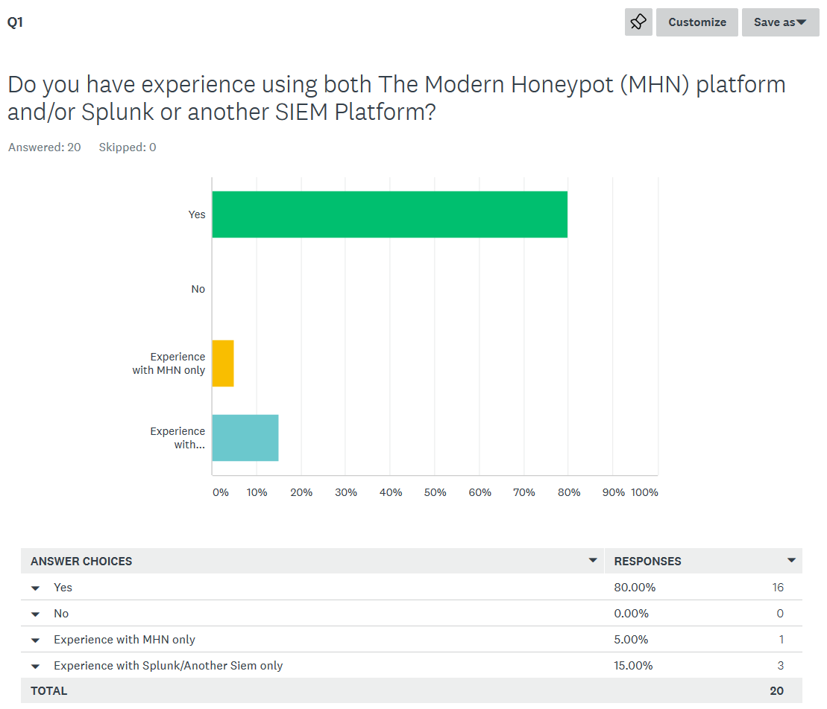

Figure Question 1 of Honeypots, Threat Intel & Teaching survey.

## 4.1 Overview Dashboard

The first dashboard to be examined was the Overview dashboard which acts as the main page for the MHN-Splunk app. This page contains the most relevant data all sensors currently running such as the top MD5’s, URL’s, Top Signatures, Geo location data, And top attackers by country and city. The naming convention used in this and many other sensors is a misnomer. The terms ‘Attack’ and ‘Attackers’ suggest it is a forgone conclusion that the event detected is an attack. However, this is not the case. It is entirely possible for a connection attempt to be made that is innocuous. For this reason, the naming convention will be altered so that the terms ‘Attack’, ‘ Attacks’ and ‘Attackers’ will be replaced with ‘Event’, ‘Events’ and ‘Event Sources’ to more accurately reflect the fact that events should be investigated to confirm they are in fact attacks before presuming they are attacks.

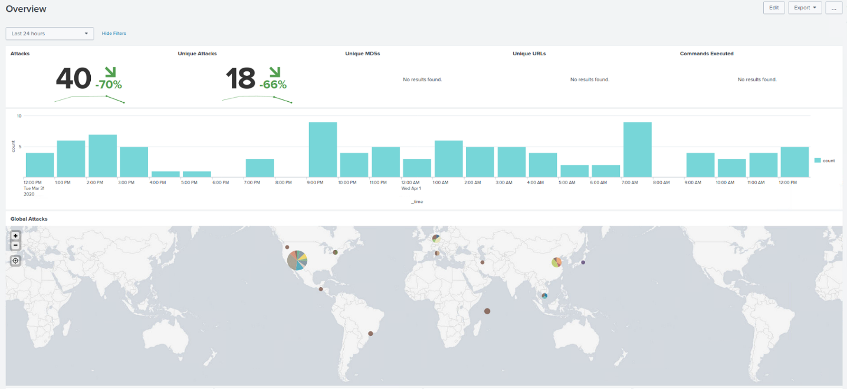The upper third section of the Overview dashboard encompasses the ‘Attacks’, ‘Unique Attacks’, ‘Unique MD5’s’, ‘Unique URLs’, ‘Commands Executed’, ‘Events per Hour’ and ‘Global Attacks’ panels. As we can see the naming convention of many of these panels will need to be updated.

Figure The upper third of the Overview dashboard which acts as the main page of the MHN-Splunk app.

There is a further issue with this dashboard. The ‘Commands Executed’ search is an invalid search. If we enter the edit mode of the dashboard and view this search, we can see that it is currently search for event data related to the Kippo app which has been succeeded by the Cowrie app. This search will be fixed so that it searches for Cowrie events.

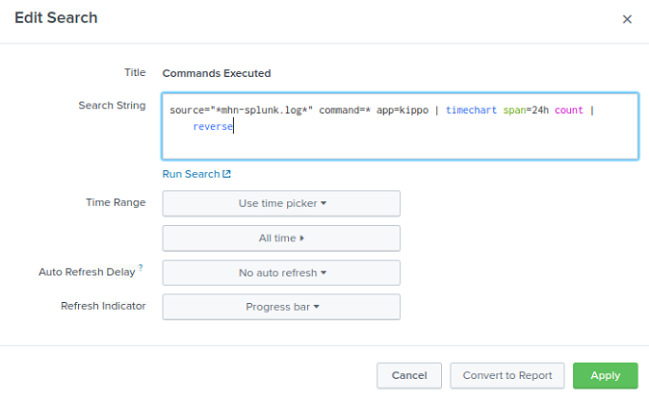

Figure The invalid search relating to the 'Commands Executed' panel within the Overview dashboards upper third section.

The middle third of the Overview dashboard contains the ‘Top Attacker countries’, Top Attacker Cities’, ‘Top Honeypots by Type’ and ‘Top Ports’ Panels. Again, some panels will need their naming convention updated here.

Figure The middle third of the Overview dashboard which makes up the home page of the MHN-Splunk app.

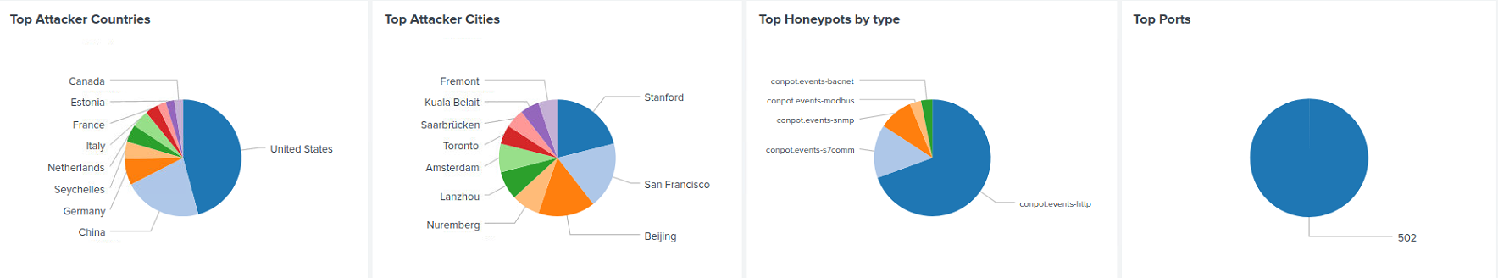

The Lower third of the Overview dashboard encompasses the ‘Top Attackers’, ‘Top Attacker OSes’, ‘Top Usernames’, ‘Top Passwords’, ‘Top Sensors’, ‘Top MD5s’, ‘Top URLs’, and ‘Top Signatures’ panels.

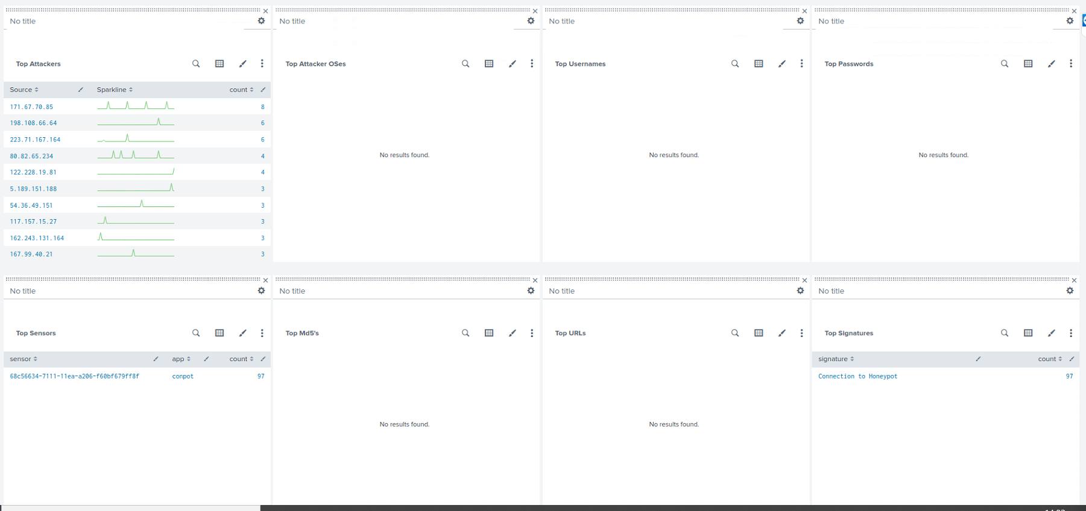

Figure The lower third of the Overview dashboard which makes up the main page of the MHN-Splunk app.

There are two further panels here which contain invalid searches are search for data from the Kippo App.

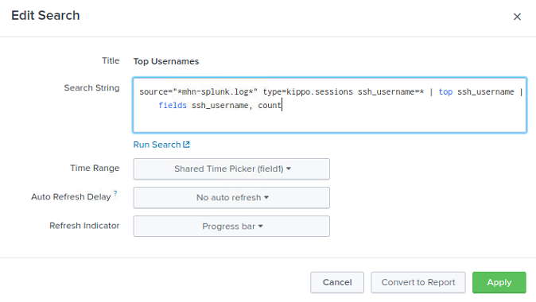

Figure The 'Top Username panels invalid search.

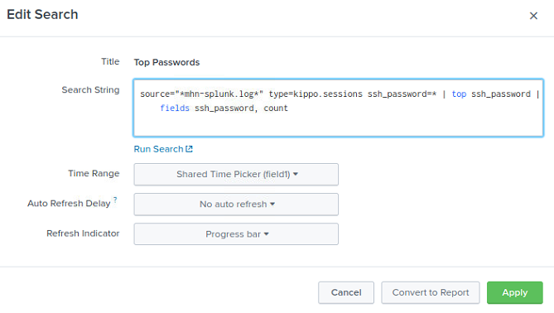

Figure The 'Top Passwords' panels invalid search.

Both searches will be updated to correctly search for data from the Cowrie app.

With the Overview Dashboard analyzed the following changes will be made:

* The naming convention will be updated
* The invalid searches will be fixed to search for the correct data

Indicators Dashboard:

The indicators dashboard contains the ‘Top MD5’s Captured’, ‘Top URLs Captured’ and ‘Top Attackers’ panels. This information is information which can be view on the overview page. As such this dashboard is largely irrelevant and serves no purpose.

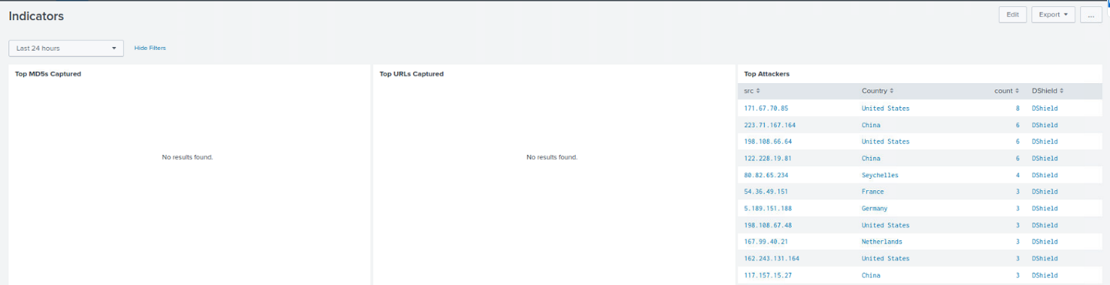

Figure The indicators dashboard.

With the Indicators dashboard analyzed, the following changes will be made:

* The Indicators dashboard will be removed

## 4.2 Sensor ID 1 - Shockpot Sinkhole

The Shockpot sensor is designed to capture activity related to a series of common vulnerability exploits (CVE) attacks known as the Shellshock family of CVE’s. These are also known as ‘Bashdoor’ exploits. The first of these exploits was documented on 12 Sept 2014 (CVE-2014-6271), which at the time of preparing this report, was five years ago [53]. These vulnerabilities have since been patched. This means that computers which have up to date patches are highly unlikely to be vulnerable to the Shellshock family of CVE’s. Therefore, should your system be running up to data patches it is unlikely to see any activity on this sensor as scanning software will alert any intruders to the fact that the system is not vulnerable therefore, in an effort to reduce noise, most bots will not deploy these vulnerabilities unless it is suspected that he system is not vulnerable.

A sink hole server is a server which detects traffic and, having captured the data, forwards this data onto another server for further analysis. This is not particularly relevant for novice students and security researchers. However, there could still be some value in installing a system that would be vulnerable to detect how active the Shellshock family still is for research purposes. Therefore, the currently existing dashboard will not be removed.

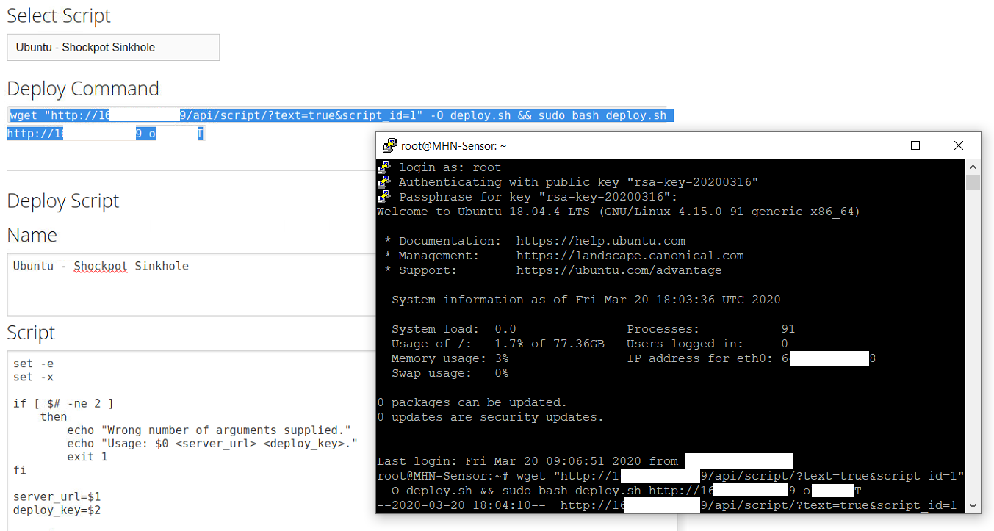

Figure Here we see the Shockpot Sinkhole sensor has been deployed.

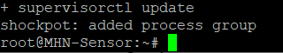

Figure The process is added to the running processes.

Having deployed the Shockpot sinkhole honeypot sensor for several hours we can begin to analyze the sensor. Beginning with the log and configuration files.

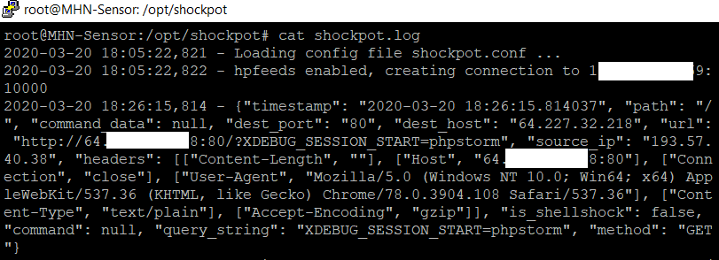

Figure A sample of the Shockpot.log file from the Shockpot sinkhole sensor.

As seen above in figure 58, The Shockpot.log file is not formatted in the proprietary search processing language (SPL) pioneered by the Splunk corporation which begins with a date time and ID number, followed by a simplified json format consisting of keys and values. Instead it employs the Lucene Query Syntax commonly used by systems that work largely on the Linux/Unix platforms. The SPL format is required for the Splunk SIEM platform.

We can see that the log confirms that that the hpfeeds-logger is connected to the management server and indeed we have an logged event. Of note in the log file is the key & value “is_shellshock”: false. What this means is that an event has been detected, screened and is not in fact a shellshock attack. This is the basis of analytics. This is what student will need to learn. Next, the configuration file needs to be examined. However, there is a problem here as seen below in figure 59, in that this value is ignored and not reported by the HPfeeds logger conversion and is not displayed in the MHN-Splunk.log file on the MHN-management server, and therefore, all events recorded are considered attempts to exploit the system. Figure 58 shows an event record at 18:26 on the 20th of the 3rd 2020. This event is logged on the sensor side as not being a true Shockpot attack. However, in figure 65, this same event is logged as a legitimate attempt to exploit the system with Shockpot. This is a false positive caused by the HPfeeds conversion process not being set up to screen out false positives.

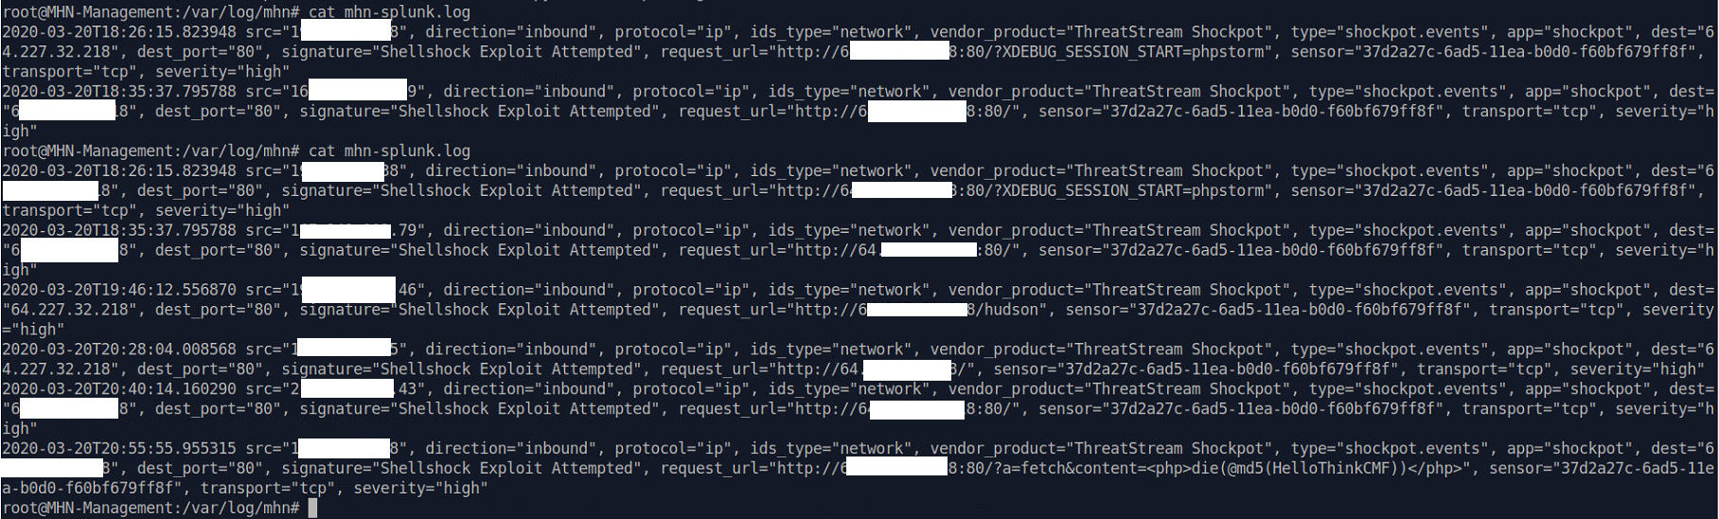

Figure The mhn-splunk.log file displaying false positive results for the Shockpot sensor.

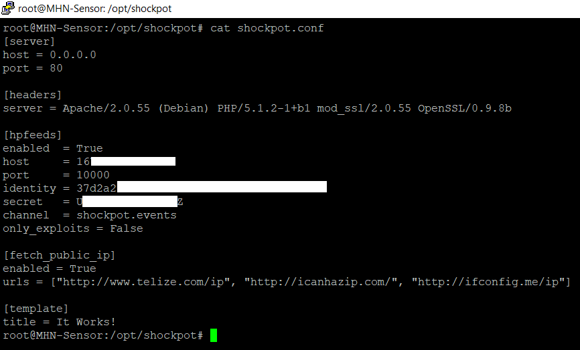

Figure Shockpot sinkhole configuration file

Seen above in figure 60, is the Shockpot sinkhole sensor configuration file with default values. The server host by default is set to 0.0.0.0 with the port set to 80. This is the sinkhole server to which data will be forwarded. The ability to alter the server host details means the data can be forwarded without conflicting with other services. There is also the ability to set “Only Exploits” to true. This means only verified Shockpot exploits will be logged. Moving over to the Shockpot Splunk-MHN dashboard, in figure 61.

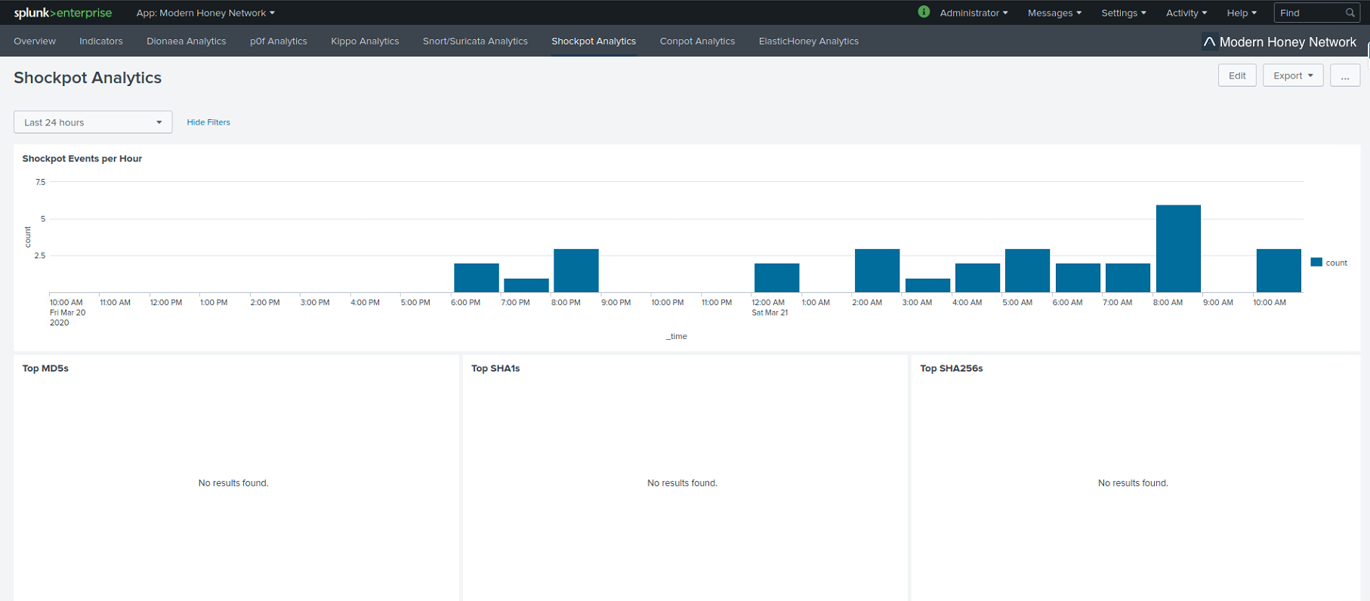

Figure The first 5 panels of the Shockpot dashboard displaying the Events per hour, MD5, SHA1 and SHA256 data.

What is interesting here, as seen above in figure 61, is that from an analytical standpoint is that users do not need to see the MD5, SHA1 and SHA256. Any one of these three, via a virus total lookup will reveal the others. This does not mean the data is not useful however, it simply means that it reduces the dashboard efficiency to display all three at once. The events per hour visualization is very useful and relevant.

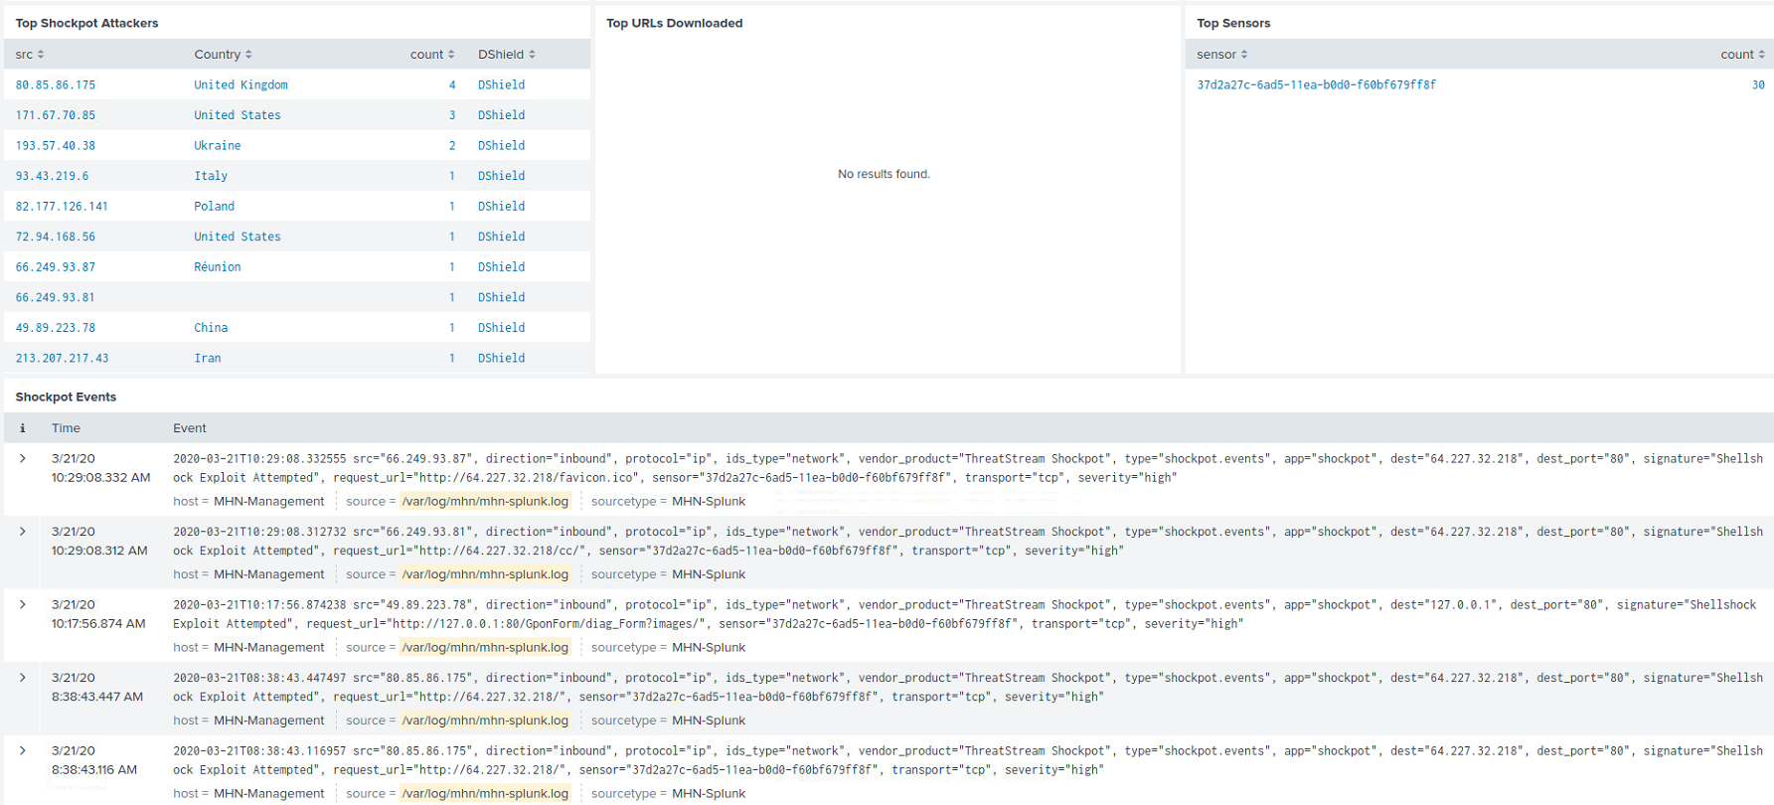

Figure The lower 4 panels displaying the top attackers, top URL's downloaded, top sensors, and Shockpot events.

The panel displaying ‘Top Shockpot’ attackers is deceptive, as seen below in figure 63 (SSH console overlaid over MHN-Splunk app); while the original log indicates the event is not a legitimate shellshock attack (blue arrow), the MHN-Splunk log (red arrow) states a shellshock attack has been attempted.

Each of these events would need to be analyzed based on the data being sent to determine f it really is an attack or simply a detected false positive as the data pertains to the Shellshock family of CVE’s or even indeed, if the data is an attack but not a Shellshock attack.

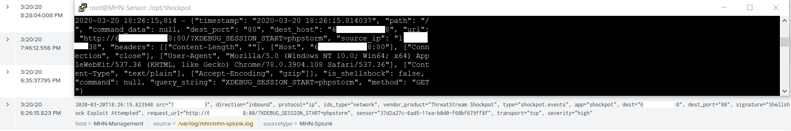

Figure The Shockpot log displayed via SSH overlaid over the MHN-Splunk app highlighting the first Shockpot event logged in both.

While Analyzing why this is occurring is beyond the scope of this report, as it would require analyzing the MHN platforms log conversion process, this is an interesting development from the perspective of teaching students about data analysis.

This brings us the naming convention of the panels used in the dashboard. While most of the dashboard uses good naming convention, the ‘Top Shockpot Attackers’ panel is in this researcher’s opinion badly named and suggests that it is confirmed that the detected event is an attack, rather than an event that must be investigated. This should be renamed to ‘Top Shockpot events’, which would suggest that the events displayed therein are the most relevant events that should be investigated first.

This concludes the analysis of the Shockpot sensor and dashboard with the following changes being needed to improve efficiency, relevance and learning experience:

* A Sensor guide with a configuration walkthrough will be written to explain the configuration file options
* An explanation of the possibility of false positives and how to analyze and identify them will be added to the sensor guide
* The Shockpot Dashboard will be removed from the MHN-Splunk app due to the age of the exploits, the fact that a user would have to use an out of date vulnerable operating system to detect true Shockpot activity and the fact that the dashboard is displaying false positives.

## 4.3 Sensor ID 2 - Dionaea

The Dionaea sensor is a low interaction malware emulation honeypot designed to emulate vulnerabilities which threat actors and botnets will find upon scanning the system. The sensor will then log any connection attempts, attempts to upload files, scrape binary files and collect all relevant data. This is very popular sensor and collects very relevant data pertaining to some of the most common and newly emerging CVE’s and 0day attacks.

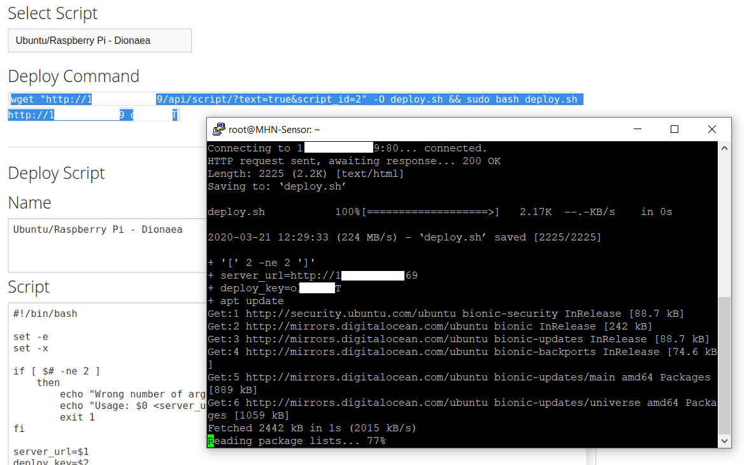

Figure The Dionaea sensor is deployed for analysis.

With the sensor deployed and running for several hours I began to examine the logs and configuration files. For this sensor the configuration file was examined first, as it is important to understand what is being logged by Dionaea.

Seen below in figure 65, in the ‘Dionaea’ section, the configuration file allows the user to alter the storage location for binary files which can be collected. This could be useful if the server being used has access to external drives for remote storage, which would essentially allow Dionaea to be converted into a localized sinkhole server. This could be very useful in a production environment. These binaries and bitstreams can be quite large and over time the folders can grow to be quite a large size taking up a large volume of storage space on the user’s server. This can be managed several ways depending on the user’s preference. The files can be transferred of they can simply be deleted if the user is not going to perform a malware analysis on the files. These options will be explored and explained in the sensor guide for this sensor.

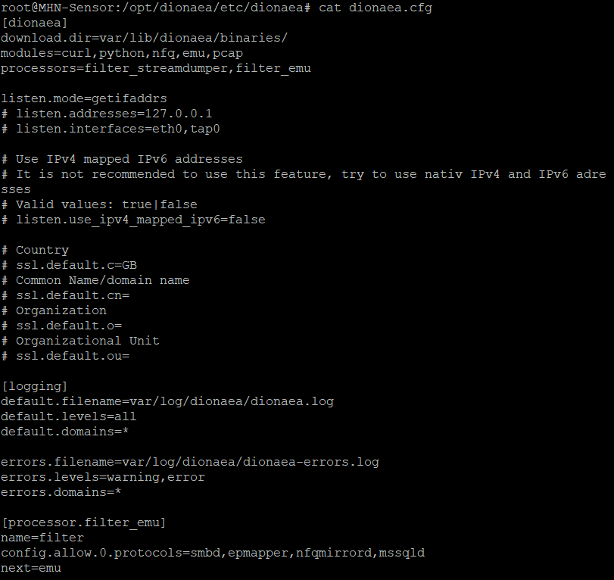

Figure The upper half of the dionaea.conf configuration file.

The ‘logging’ section allows the user to alter the type data being logged. There are 6 levels of logging available for Dionaea which are as follows [54]:

* Debug
* Info
* Warning
* Error
* Critical
* All = Special log level to include all log levels

In in its default mode Dionaea is to ‘default.levels=all’. This file can grow to be huge file. As this researcher has prior experience using the Dionaea sensor, Dionaea was deployed independently on a separate server to demonstrate how extensive this log file can grow to be.

The server on which the separate Dionaea test deployment took place had a 160GB hard drive which is double the storage the current server solution has. Once deployed with the default logging levels set, the server was left to run without interference except regular checks to monitor the deployment. After approximately one week of operation of a single sensors, the ionaea.log file grew to be 125GBs in size. Coupled with the Binaries folder, the files consumed all available space and the sensor crashed. Logging to the management server ceased.

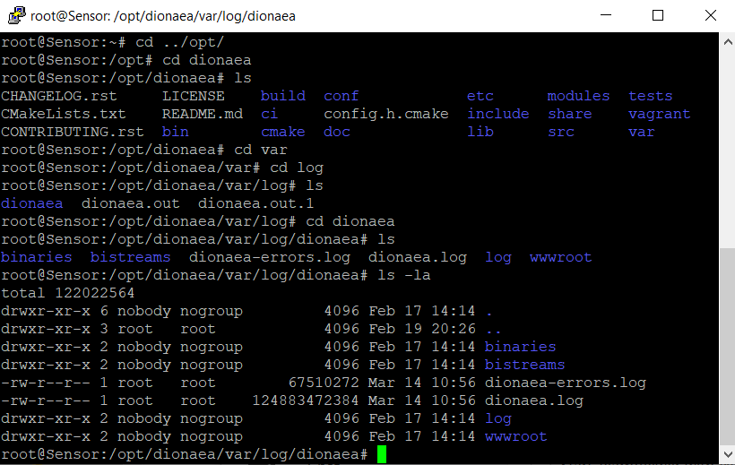

Figure The Dionaea.log in our prior test deployment showing 125GB in size.

This highlights that without alteration, the Dionaea sensor will consume all storage space in under a week on our current deployment. Again, there are several solutions. Firstly. A guide will have to be created to explain the logging settings to novice users so that they can make an informed decision as to the right level of logging to meet their needs. A script can be written to simply overwrite the log file every 24 hours.

Or a script can be written to rotate the logs daily as follows:

cd /etc/logrotate.d/

cat > Dionaea << EOF

* /opt/Dionaea/var/log/Dionaea*.log {
  + notifempty
  + missingok
  + rotate 28
  + daily
  + delaycompress
  + compress
  + create 660 root root
  + postrotate
    - kill -HUP ‘cat /opt/dionaea/var/run/Dionaea.pid’
  + endscript
* }
* EOF

Once the service is restarted the log file will be rotated and reset daily and the Dionaea server will no longer consume all the storage space on the server. A script will be created to deploy this on any server and included in the sensor configuration guide.

One other interesting option novice user may be interested in is the PCAP capturing facility.

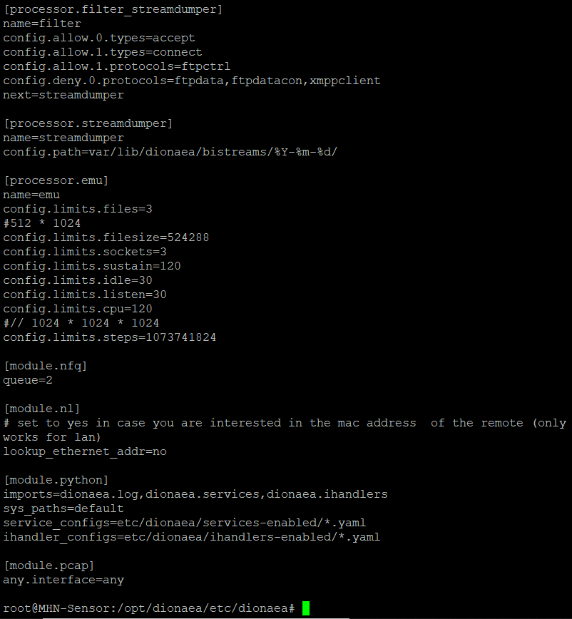

Figure The second half of the dionaea.conf configuration file.

As seen above in figure 67, the PCAP capturing facility can be applied to all interfaces or restricted to individual interfaces should the user desire. This could be useful if the user wished to add a second interface to allow a safe isolated connection.

One thing that stands out as lacking in the configuration options is the ability to alter the IP address, and ports used. However, a function is included to allow interfaces to be assigned.

So, for Dionaea to be used in conjunction with a similar sensor, such the Amun sensor which is also a malleable low interaction malware honeypot (this will be covered later), a second interface with a separate IP address would need to be added.

The dionaea.log file is complex and as the number of events increases the log can be very difficult to read and filter through. However, it is still in basic SPL format as seen below, consisting of a data and time followed by a key and a value, which makes creating Splunk searches quite easy.

Figure A sample of the dionaea.log file.

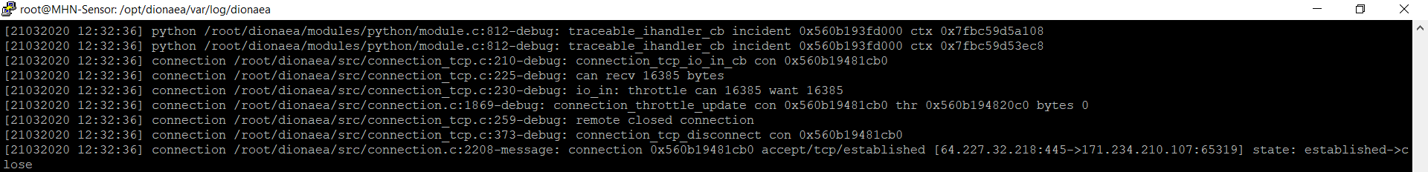

A dashboard already exists for the Dionaea sensor. In examining the Dionaea dashboard, we see a much more efficient dashboard without much unnecessary data being displayed.

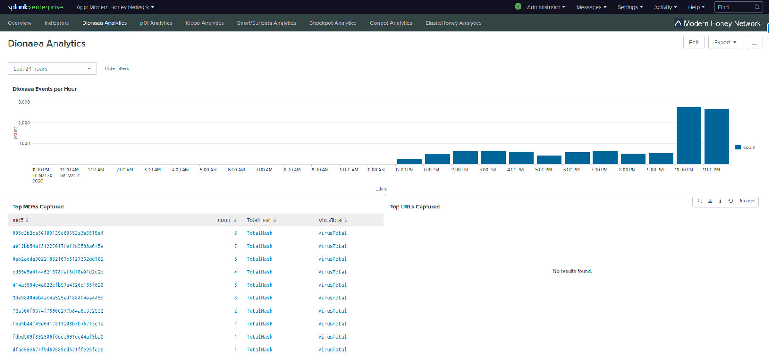

Figure The first 3 panels of the Dionaea dashboard, displaying events per hour, top MD5's and top captured URL's.

This is all highly pertinent information that allows a researcher to immediately determine patterns and collected MD5’s or URL’s for screening against Virus Totals databases.

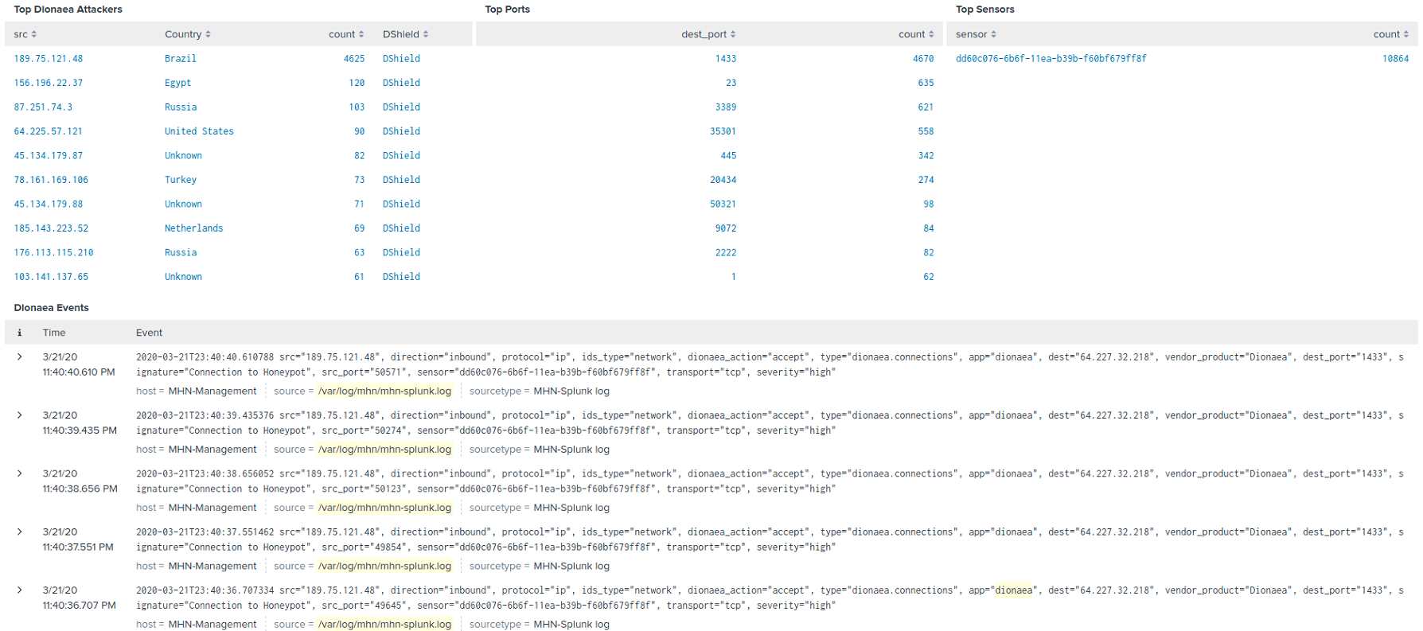

Figure The next 4 panels of the Dionaea dashboard, displaying Top Dionaea attackers, top ports, top sensors and events.

Above in figure 70, we seem that the ‘Top attackers’ and ‘Top Ports’ panels also provide highly pertinent information. However, the events panel reduces the efficiency of the dashboard as it creates recursive lookups over the same index files. Furthermore, this is information That should be moved to a new panel. This increases the efficiency of the primary panel which allows users to focus in on events, and gather further data relating to the event from the event dashboard should it be needed. The naming convention should also be addressed with the term attackers being replaced with events.

With the Dionaea sensor and dashboard analyzed the following changes will be made:

* Create a sensor guide
* Include an explanation of the configuration options with recommended settings based on whether the user will or will not be performing malware analysis of binary files.
* Create a script to automatically add a file to rotate the dionaea.log file to prevent the sensor from consuming all storage space.
* Move the ‘Dionaea Events’ and ‘Top Sensors’ panels to a new dashboard to improvement efficiency.
* Address the naming convention of the ‘Top Attackers Panel’.

## 4.4 Sensor ID 3 - Cowrie

The Cowrie sensor is a medium to high interaction SSH emulation honeypot. It is the successor to the Kippo SSH honeypot. The sensor has two modes. Medium interaction mode is the default mode and in this mode the sensor takes over the standard 22 port used by SHH and redirects all genuine SSH traffic to the 2222 port. All traffic connecting to 2222 is considered valid and not logged however authentication is still required so there is no reduction in security. The second mode, high interaction, allows the sensor to act as a proxy intrusion detection sensor. In this mode the system monitors a remote system for attempted SSH connections. This could be very effective in a production environment. SSH data is highly relevant in security terms as it helps to build rainbow tables and wordlists and lookup tables relating to usernames and passwords. Cowrie will also capture attempts to upload shells, URL’s and files.

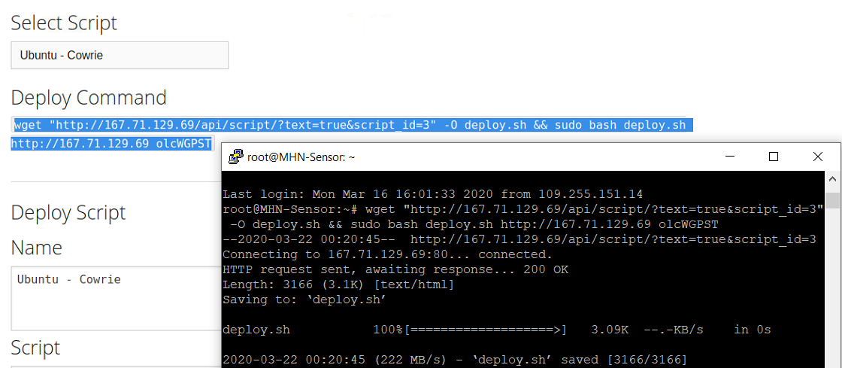

Figure Cowrie is deployed on the sensor server.

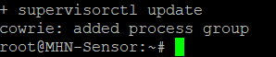

Figure The Cowrie process is added to the running processes.

The cowrie log, seen below, follows the SPL log format with a date, time and then a key and a value. This means SPL Splunk log conversion is simple as would be the creation of a dashboard.

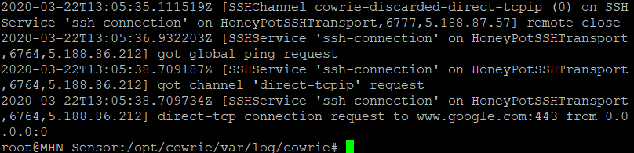

Figure A sample of the cowrie.log file.

The cowrie.cfg configuration file is too large to document and contains some features a novice user may use as well as some powerful threat intelligence generation options. Instead of documenting the entire log, only the settings applicable to a novice or intermediate user will be covered.

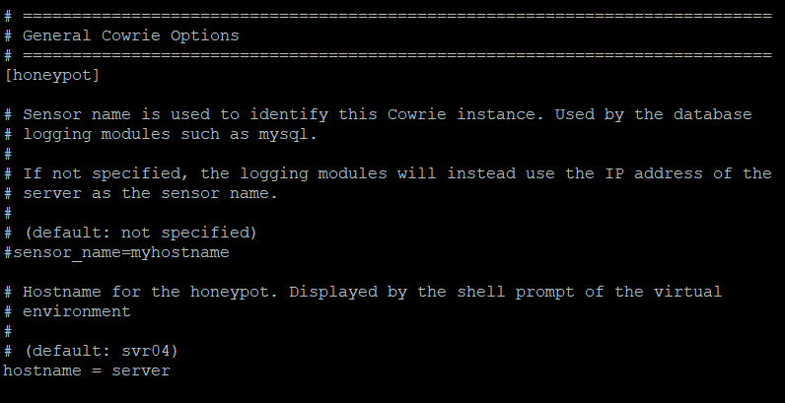

Figure The server identification options in the cowrie.cfg configuration file.

The configuration settings allow the user to change how the server is identified from the default server IP address to a specific user chosen naming convention.

The following settings can also be changed relating to directory locations and file sizes and general settings:

* Log file location
* Downloaded artifact location
* Static data file location
* Variable state file location
* Config file location
* Virtual file contents location
* Simple text commands files location
* Maximum file size for files stored in download paths
* TTY logging enabled/disabled
* TTY log location
* Timeout settings
* Authentication timeout
* Proxy/shell settings
* Cowrie log time-zone settings
* Network specific settings including outgoing connections bind IP address for curl and wget, fake Ip address displayed as the address of the incoming IP address. Internet facing IP address and logging of public IP address.
* The port used by cowrie as the port to listen on which will be logged (22 by default)
* Proxy Options
* Forwarding/tunneling options (to forward data to a proxy server, this essentially turns cowrie into a sinkhole server)
* HPfeeds settings (this is the IP address and port of the MHN management server along with the secret key and debug option)
* There are options to forward data to the following services which feeds threat intelligence directly to these services: Virus Total, Splunk, AWS, Influx, Shodan.
* User may also configure a reverse DNS lookup.

All these settings will need to be explained and detailed in a sensor and configuration guide.

The Cowrie sensor does not have a provided dashboard in the MHN-Splunk app. However, as previously mentioned, the Cowrie sensor is the successor to the Kippo SSH sensor and the MHN-Splunk app does provide a Kippo dashboard. This dashboard will be converted into a Cowrie dashboard.

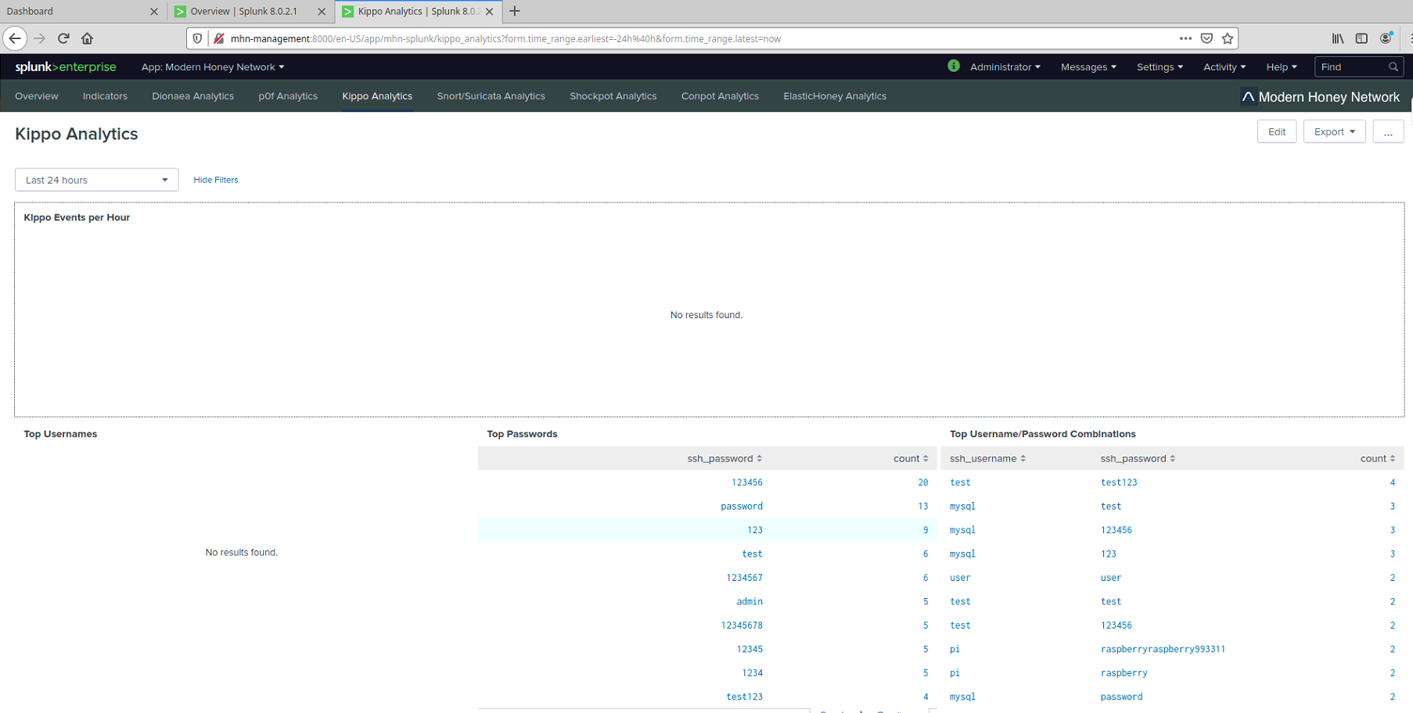

Figure The top 4 panels of the Kippo dashboard that will be converted into a cowrie dashboard.

As seen above in figure 74, the Kippo Dashboard is not producing much data as it is not yet scanning for Cowrie data. However, all the fields are very relevant to the creation of rainbow tables and password lists. A security researcher will get value from this data. No panels need be removed.



Figure The lower 4 panels of the Kippo dashboard which will be converted into a Cowrie dashboard.

Seen above in figure 76, the dashboard displays the ‘Top Kippo Attackers’. This naming convention will need to be changed. As well as the ‘Top SSH versions’, ‘Top Sensors’ and ‘Kippo Events’. The ‘Top sensors’ and ‘Kippo Events’ panels will be moved to a new panel to improve efficiency on thin clients.

With the Cowrie sensor and the Kippo dashboard analyzed the following changed will be made:

* A sensor guide will be made
* A configuration guide will be included in the sensor guide
* The Kippo Dashboard will be converted into a Cowrie dashboard
* The naming convention will be updated where needed
* The ‘Top Sensors’ and ‘Kippo Events’ panels will be moved to a new dashboard to improve efficiency.

## 4.5 Sensor ID 4 - Snort

The Snort sensor is an intrusion detection sensor (IDS) / intrusion prevention sensor (IPS). While technically it is, or can be used as a honeypot sensor, it is more commonly run purely as a network detection and prevention sensor. The sensor works based off rules which are downloaded during install and can be updated at the user’s request. However, it is worth noting that as Snort will listen on all commonly used ports and this may interfere with other sensors.

On the other hand, the sensor may screen out known bad IP’s or attack vectors that present known risks. This could help with filtering out well known malicious vectors when it comes to threat intelligence generation. This will need to be explained in a sensor guide so that users can make an informed decision as to whether to use this sensor.

The Snort alert.log seen below in figure 77, does not follow the standard Splunk SPL log format. Instead it adopts the Lucene Query parsing syntax used by convention in Linux based systems commonly. This researcher does not have a lot of experience working with this syntax, but thankfully a dashboard already exists therefore the log is being converted with the HPfeeds-logger function in the MHN platform.

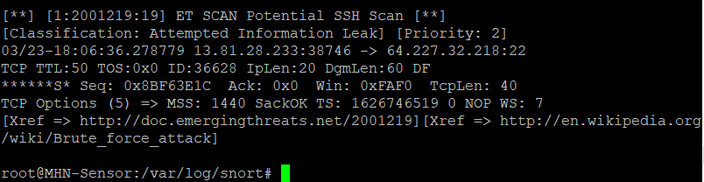

Figure A sample of the Snort alert.log file

While it is not recommended that user adjust the configuration of the Snort sensor, assuming the user has decided to deploy the sensor, there are some settings the user may wish to adjust which include:

* Network variables: IP address to be protected, external, external IP address, DNS servers on the network, SMTP servers on the network, webservers on the network, SQL servers on the network, telnet servers on the network, SSH servers on the network
* List of ports you run web servers on: This can be edited to prohibit Snort from monitoring a given port. Alternatively, a webservice can be set to a specific port and this port can be added to the list for monitoring.
* Customize your rule set: While by default all rules are implemented, the user has the ability to manually add or remove rules. By uncommenting a single rule, the rules enter manual mode and only those rules uncomment

A sensor guide will need to be designed with each of the rules that a novice user may wish to adjust explained.

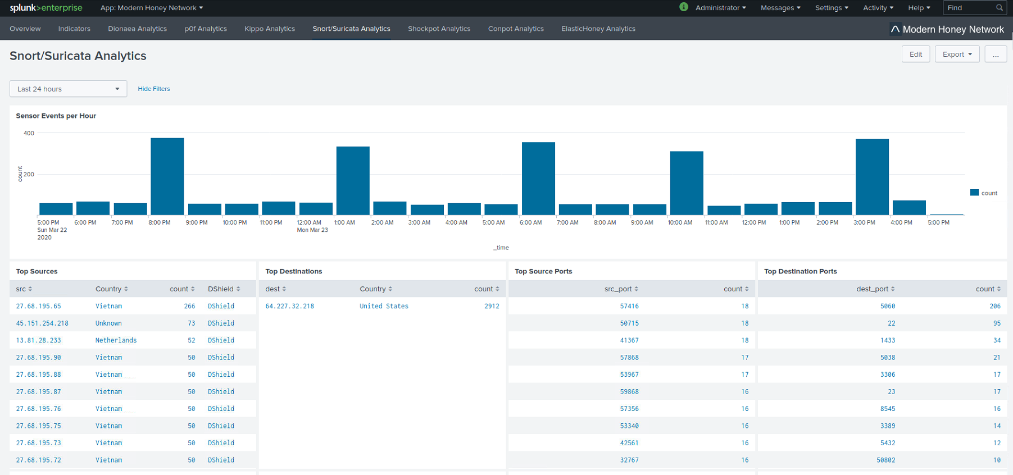The dashboard provided is shared with the Suricata intrusion detection sensor (IDS). I see a negative effect in this sharing of dashboards. A researcher, upon investigating a breach in the network, will immediately want to rule out all alerts that relate to a connection that was blocked. If the Snort sensor is separated, this allows for detections resulting in Snort blocking the connection to be filtered out. For this reason, I will separate these sensors into individual dashboards.

Figure The top 5 panels of the Suricata/Snort dashboard, displaying ‘Events per Hour’, ‘Top Sensors’, Top Destinations’, ‘Top Source Ports’

and ‘Top destination ports.

As an IDS/IPS sensor, the information detected can be vital. It can help to identify patterns of behavior that will help isolate a type of attach which could help isolate a 0day attack which has not been seen before. This is where deterministic rules and logic come into play. These are some of the skills a security researcher will seek to develop. As such all the panels in the upper half of the dashboard display relevant information such a source IP’s, ports, destination addresses, destination ports and number of events per hour to indicate patterns. For example, we can see a pattern emerging in the screenshot that should be investigated.

Figure The lower 5 panels of the Suricata/Snort dashboard.

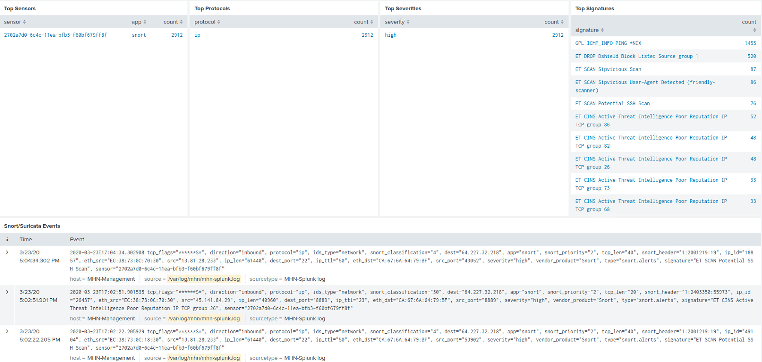Once again, in the lower half of the Suricata/Snort dashboard we see all the panels are relevant. Beginning with the Top Sensors which will help isolating attacking when multiple servers are involved, ‘Top protocols’ which helps in isolating the type of traffic and/or attack, “Top severity’ which will help filter out non-essential events, ‘Top Signatures’ which helps identify the type of event’ followed by the full list of events.

While achieving the most efficient dashboards is a primary goal of the project, this must be balanced against the effective use of the dashboard. As rapid identification of events and being able to drill down into the events for extra data rapidly is key when using an IDS/IPS sensor, the events and ‘Top sensors’ panels will not be moved to another panel in this case.

With the logs, configuration files and dashboard for Snort analyzed the following changes will be made:

* A sensor guide and configuration guide will be designed
* The naming convention will be updated where necessary
* The Suricata and Snort Dashboards will be separated into individual Dashboard.

## 4.6 Sensor ID 5 - Amun

Amun is a low interaction malleable malware honeypot. Much like Dionaea, it seeks to emulate behaviors that will suggest to port-scanners that the system is vulnerable. This will increase the chances of attacks being deployed against the server. No dashboard currently exists in the MHN-Splunk app so an attempt will be made to implement one with a good naming convention.

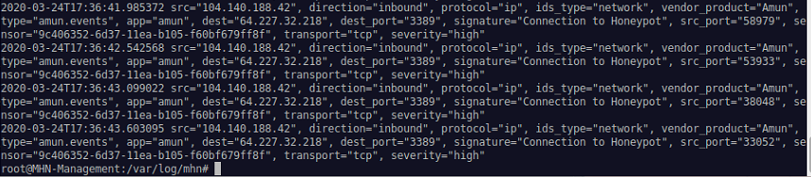

Figure the MHN-Splunk output logged for the Amun sensor via the HPfeeds logger.

As seen above in figure 80, the HPfeeds-logger does a great job of filtering the Lucene Query syntax into the Splunk SPL proprietary format. This makes the job of creating a new dashboard for the Amun sensor feasible.

The Amun sensor has a secondary functionality that allows the sensor to be run in a single file scan mode as seen below in figures 81 & 82. This will need to be added to the sensor guide.

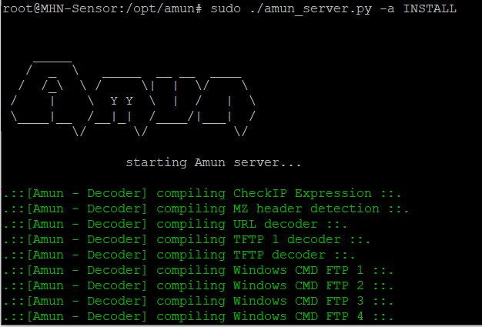

Figure The Amun sensor being run in single file scanning mode.

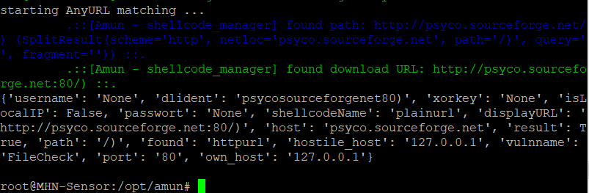

Figure The scan completes with 0 matches.

The Amun sensor, being a low interaction sensor, does not offer a lot of settings that a novice or even intermediate user can, or perhaps should alter. But there are some basic settings that will need to be covered in a sensor guide. Beginning with the IP, IP range and adapter IP settings as seen in figure 83.

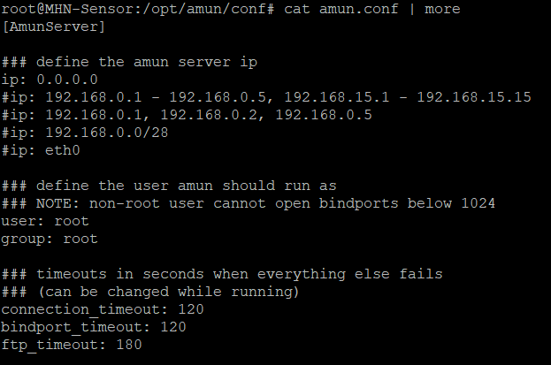

Figure Altering the server IP, IP range, and adapter setting sin the amun.conf file.

Next, the user can alter the block rules relating to IP address, that are refused, time or successfully access and/or exploit the system. It is best for IP’s addresses that successfully access and/or exploit the system to be blocked so an explanation of this will be added to the sensor guide.

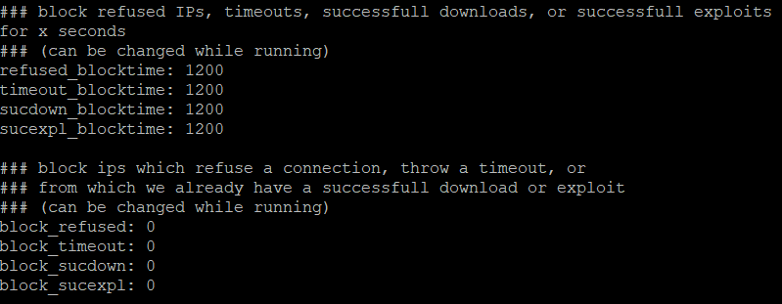

Figure Editing the IP block rules in the amun.conf file.

User can also view the vulnerability modules that will be deployed via the Amun server, filter out modules they wish not to use (not recommended) and view and modify the ports used by these vulnerabilities (not recommended). An explanation of these functions will be added to the sensor guide.

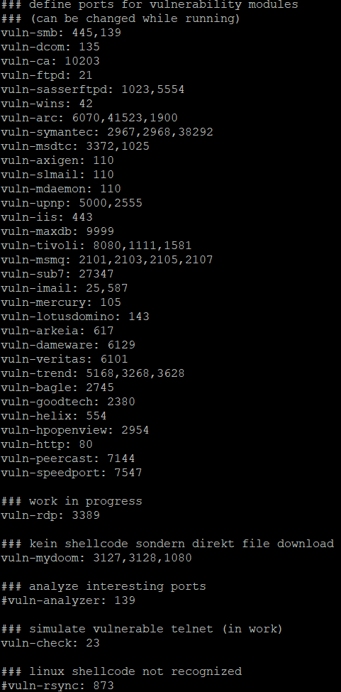

Figure View the vulnerability module ports in the amun.conf file.

Lastly, the log file location can, but must not be changed in the configuration file of the Amun sensor will immediately stop logging to the MHN-Management server. A warning of this will be added to the sensor guide.

## 4.7 Sensor ID 6 - Elastichoney

Elastichoney is a simple honeypot designed to log attempts to exploit the Elasticsearch analytical search engine. While this is best used in an environment where the ELK SIEM has been deployed, it can turn up some interesting results even when deployed on a server where the ELK SIEM has not been deployed. A dashboard already exists for this sensor.

The configuration file for the Elastichoney sensor is very basic but does provide some useful settings as seen below in figure 86.

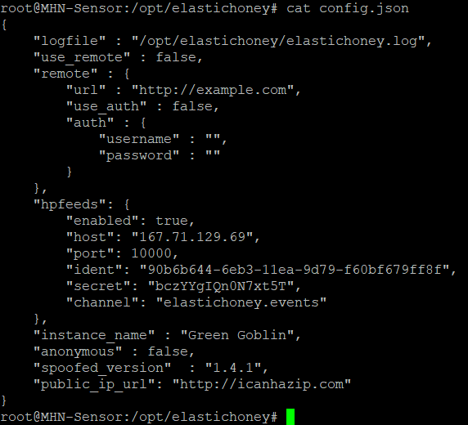

Figure The Elastichoney config.json configuration file.

The config file is a json file. The first key value ‘logfile’ allows the user to alter the sensors log location. This should not be altered, or the sensor will stop logging to the MHN sensor. The second key value ‘use_remote’ allows the user to set the sensor up as a proxy IDS sensor. The remote key contains sub the sub keys ‘url’, ‘use_auth’, and ‘auth’ which allows the user to set the IP of a remote server, to declare that server should use authentication and to declare the username and password to be used for authentication.

The HPfeeds key and sub key should not eb altered or the sensor will stop logging to the MHN management server.

Lastly, the user can rename the instance of the Elastichoney sensor and set it as anonymous if the user desires. A fake public IP is retrieved for the emulated server from the ‘ICANHAZIP’ service. The user may enter another service if they prefer. All these details will be added to a sensor guide.

The Elastic search dashboard is efficient since on systems were the ELK SIEM is not deployed, the user is not likely to see many events. However, if the user were to deploy the ELK SIEM events would be likely to increase. Therefore, the update for this dashboard will designed to cater for possibility of the ELK SIEM being deployed and activity increasing.

Figure The upper half of the current Elastichoney dashboard with encompasses the ‘Events per Hour’ and ‘Global Attacks’ panels.

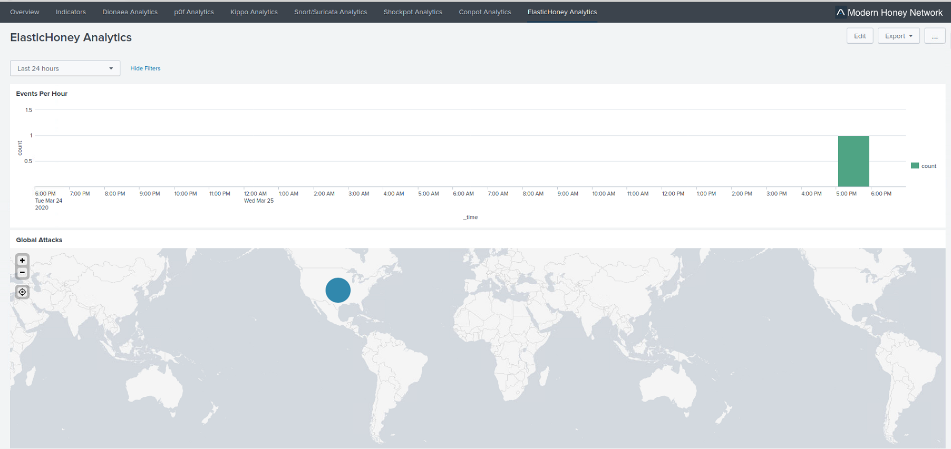

While the dashboard is efficient, like all preexisting dashboard, it suffers from the same inappropriate naming convention where all events are considered attacks. This will need to be addressed in the dashboard update. The upper half of the current dashboard contains the ‘Events Per hour’ and Global Attack’ panels.

The Lower half of the current Elastichoney dashboard contains the ‘Top Attacker Countries’, ‘Top Signatures’, and ‘Top Attacker Cities, ‘Top Attackers’, ‘Top Attack Payloads’ and ‘Top Sensors’ panels. Of note is the lack of a ‘Top Severity’ or ‘Events’ panel which, in cases were the ELK SIEM has been deployed and events were more numerous would seem appropriate. These two panels will be added int the update.

Figure The lower half of the current Elasticsearch Dashboard.

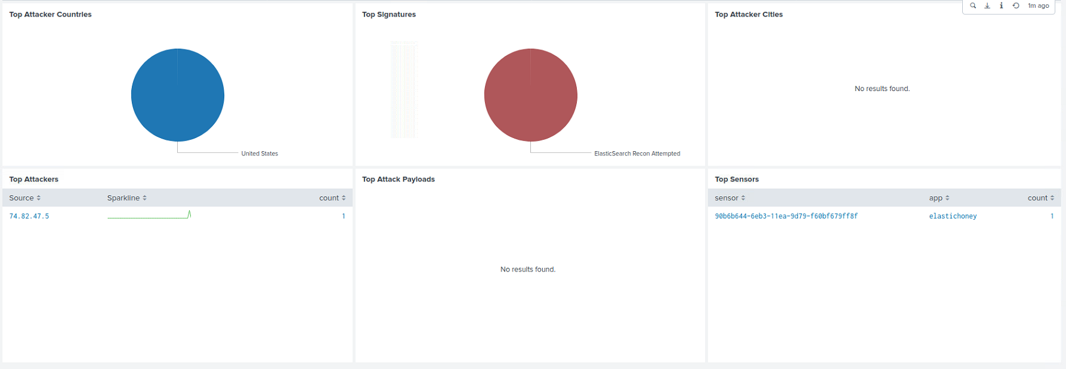

With the sensor, config files and current dashboard analyzed, the following changes shall be made:

* A sensor guide and configuration guide will be designed.
* The dashboard updated with an improved naming convention
* A ‘Top Severities’ panel will be added.
* A second dashboard containing a ‘Elastichoney Events’ panel will be added.

## 4.8 Sensor ID 7 - Glastopf

Glastopf is a medium to high interaction web application honeypot which simulates web server activity over port 80 and port 443. This server is still used but is depreciated. It now has a successor in the SNARE/TANNER sensor [55]. More importantly, the sensor runs into an issue if the user is attempting to install the sensor as the root user. This successor has not been added to the MHN platform.

Upon attempting to install the glastopf sensor for diagnostics, the program runs into an error and cannot deploy. It is unclear why the error occurs however; it is suspected that error occurs because the glastopf sensor require php7.0 to be installed as a normal user. As a dependency the glastopf install package attempts to install php7.0 as a user, however, we have no user and are running as root, therefore php7.0 cannot continue its installation. When glastopf attempts to complete installation and looks for the php.ini file that should be in the /etc/usr/php7.0 directory, the file does not exist, and installation terminates with an error as seen below in figure 89.

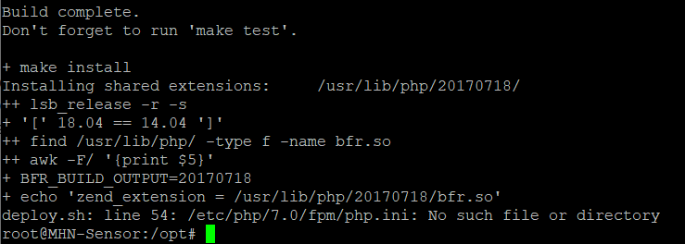

Figure Attempting to install glastopf as root results in a installation error.

No issues exist on the sensors GitHub page and no results were returned upon searching for reasons why this issue occurred. For test purposes a ‘test’ user account was added with sudo permissions and installation was attempted on this account. The same error occurred, and it is unclear if the previous attempt to install as root is causing this issue, or if it is a separate dependency that is causing the problem.

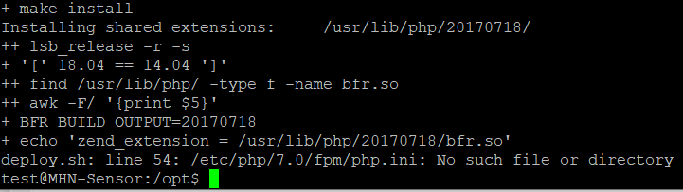

Figure The error is repeated on a test user account with sudo permissions.

The issue first occurred on the 19th of February 2020, and as of writing this section of the document it continues through 23rd March 2020.

## 4.9 Sensor ID 8 - Suricata

The Suricata sensor is commonly used as an intrusion detection system (IDS), intrusion prevention system (IPS) and a network security monitoring sensor (NSM). It is a powerful sensor and it is recommended to be included in any researcher’s sensor deployment plan. However, there are some issues with its integration into the MHN Platform. Upon deployment, the sensor appeared to work perfectly on the sensor server. The sensor was also logging to The MHN management interface. However, the sensor was not logging to the mhn-splunk.log file. After some investigation it was discovered that there were some coding errors in the HPfeeds-logger-splunk.py file which parses the original Suricata data. While altering the code of the MHN platform is beyond the scope of this project generally. In this case an exception was made due to the valuable nature of the potential data and threat intelligence the Suricata sensor can gather. The fix for the issue requires the user to first, stop the hpfeeds-logger-splunk service on the MHN management server with the command:

* Sudo supervisorctl stop hpfeeds-logger-splunk

Next, the user navigates to the ‘opt/hpfeeds-logger/lib/python2.7/site-packages/hpfeedslogger’ directory. There, a file called ‘processors.py’ must be opened with the NANO text editing program. The user the scrolls down to the where the function ‘suricata_events(identifier, payload):’ is defined and finds the line

* kwargs['suricata_{}'.format(field)] = dec.get(field)

This is then changed to:

* kwargs['suricata_{}'.format(field)] = dec[field]

The user can then restart the hpfeeds-logger-splunk service with the command:

* sudo supervisorctl start hpfeeds-logger-splunk

Moving over to the sensor server the Suricata sensor should be restarted to reinitialize its connection to the hpfeeds-logger-splunk service with the command:

* sudo supervisorctl restart Suricata

The mhn-splunk.log file should now be logging Suricata data as seen below in figure 91. A sensor guide will be designed that will include this error and fix.

Figure The Suricata data is now being logged to the mhn-ssplunk.log file with our fix having been applied.

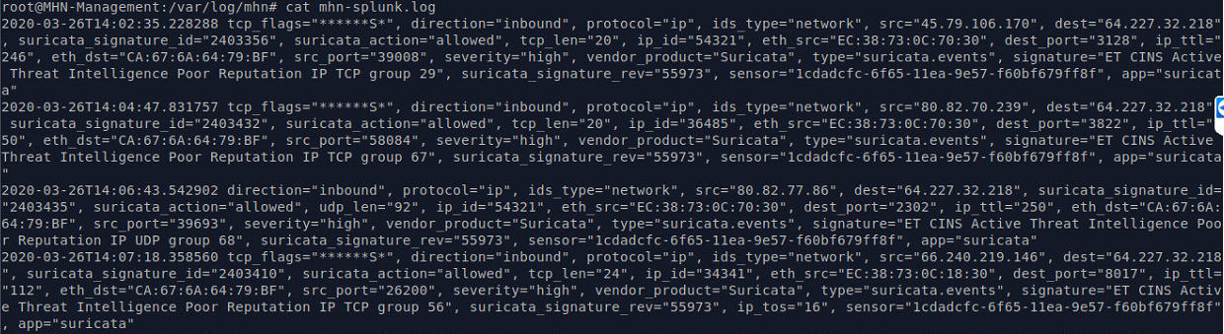

While the Snort/Suricata dashboard has been covered while covering the Splunk sensor, the search functions had to be examined individually as with any sensor and it was discovered that the searches that apply to the Suricata sensor did not work at all in the current Snort/Suricata Analytics dashboard. As the blue arrow indicates in the above sensor log in figure 91, the value within the ‘type’ key in the Suricata log data is ‘suricata.events’.

However, as can be seen below in figure 92, the searches in the Snort/Suricata logs are searching for the type ‘suricata.alerts’ which does not exist. This will be fixed in the soon to be created new Suricata dashboards along with a updated panel naming convention.

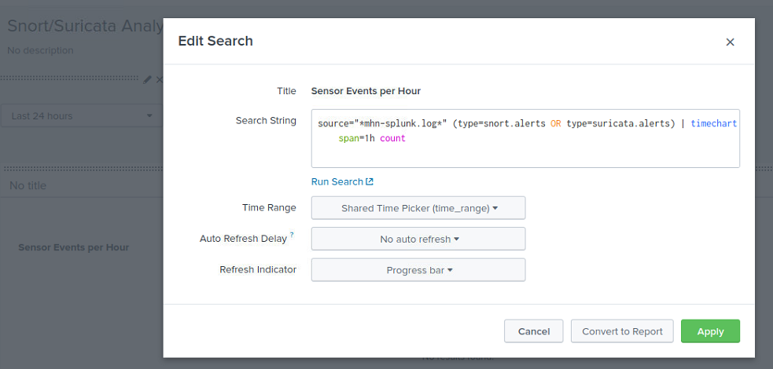

Figure The current Snort/Suricata dashboard consisting of invalid Suricata searches, as the ‘suricata.alerts’ fields does not exist in the log.

As previously discussed, when analyzing the Snort sensor and dashboard, the data retrieved by an IDS/IPS or NMS can be crucial and time sensitive. For this reason, no panels will be removed and the ‘Suricata events’ panel will not be moved to a separate dashboard to allow for expediency of analyzing data. However, some efficiency is gained in separating the Snort and Suricata sensors.

The Suricata configuration file is extensive and any alterations could have drastic effects on the data and the functionality of a sensor server. Therefore, only sections pertinent to a novice user will be covered in the analysis and guide.

Firstly, the user can change the user and group the service will be run by, create a process id file (this could be useful for rotating logs), the working directory, and the log directory locations. The directory location must not be changed, or the sensor will stop logging to the MHN management server.

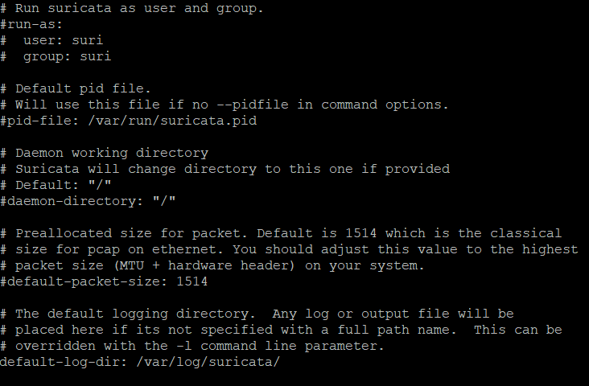

Figure The user, group, PID, and log location settings in the suricata.yaml configuration file.

The user may also enable logging of both TLS and DNS data as seen below in figure 94.

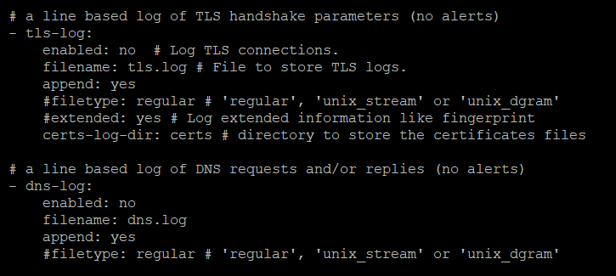

Figure Enabling logging of TLS and DNS data in Suricata.

PCAP logging can be enabled, but PCAP settings may need to be adjusted in another section of the configuration file first.

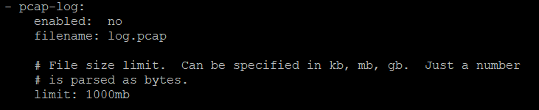

Figure Enabling logging of PCAP information in Suricata.

A debug log can be enabled; however, this is likely to lead to the logging being extensively large. This will be explained to users in the sensor configuration guide.

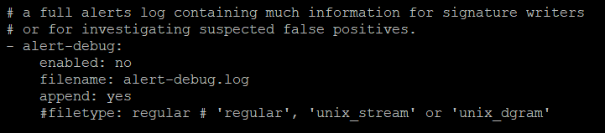

Figure Enabling Debug logging the Suricata.

A syslog and connection drop log can be enabled. Syslog logging is also likely to generate a log of data. Users will be warned of this.

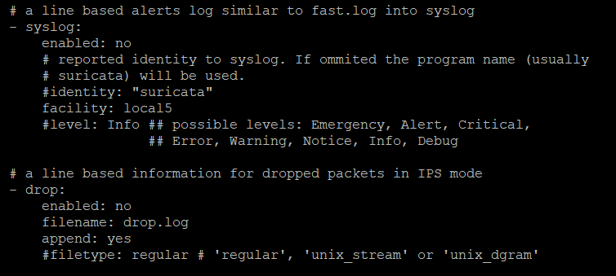

Figure Enabling syslog and dropped connection logging in Suricata.

TCP, HTTP body data (contents of webpages) and LUA (error) data can be enabled but is likely to result in large file size. Users will be warned of this likelihood.

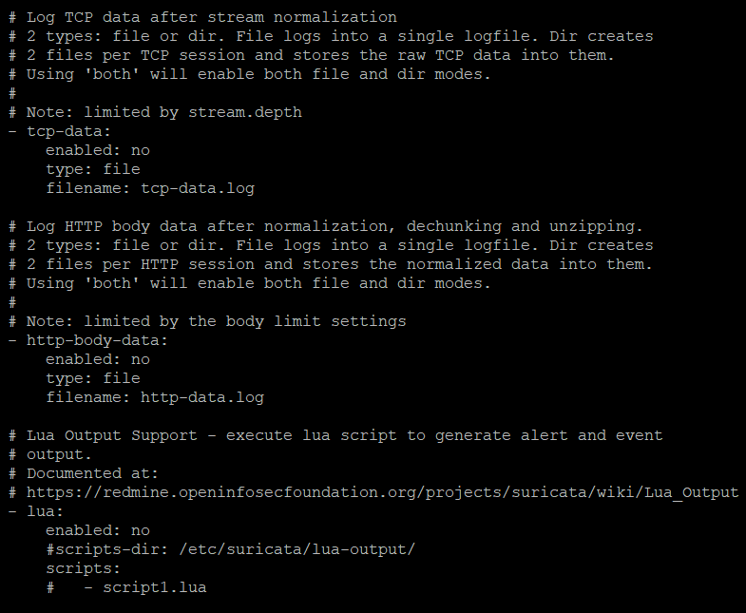

Figure Enabling TCP, HTML body, and LUA (error) logging in Suricata.

Suricata logging can be disabled. This should not be confused with the logging of data to the logs. This is the intrusion detection activation (or deactivation) section of the configuration file. If the enabled carriable is set to ‘no’, the sensor will no longer function as an intrusion detection sensor. This will also shut down any intrusion prevention rules as if the sensor is not sniffing the data on the port, it cannot block connections or reject IP’s.

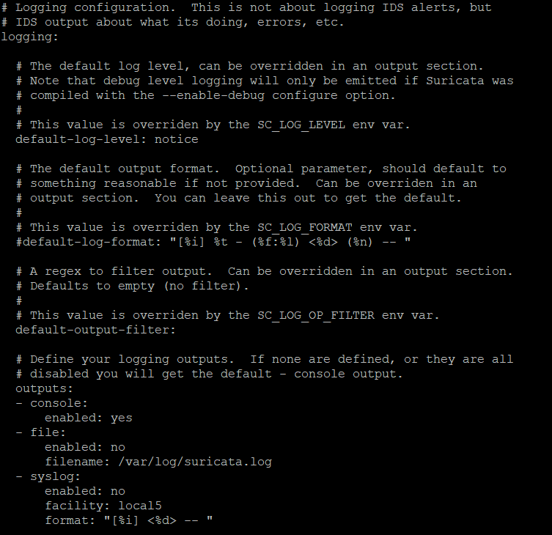

Figure Managing the intrusion detection settings in Suricata.

PCAP settings can be adjusted, which allows settings such as the buffer size and checksum validation settings to be adjusted, however the most important setting is the interface setting. This allows the user to sniff data on ‘any’ interface or specific interfaces. This is an important setting as this setting is the one which allows users to separate inline IPS sensors such as snort and offline IDS sensors such as a Suricata and have both running on the same sensor with minimal effect and without conflicting with each other.

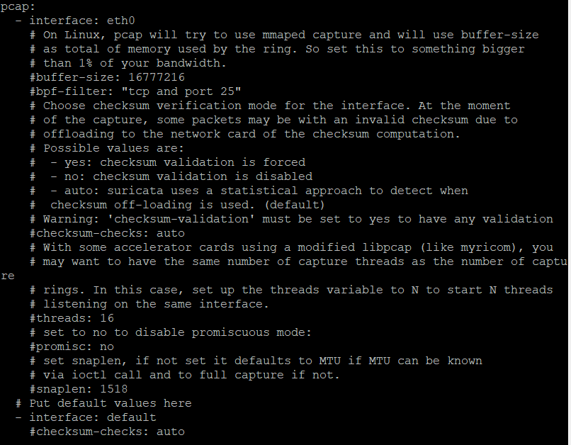

Figure Adjusting the PCAP settings in Suricata.

Lastly, to manage the intrusion prevention aspect of the Suricata sensor, the user can navigate the rules folder. This can be found in the directory ‘opt/Suricata/etc/Suricata/rules/drop.rules’. The user may add, using a very specific format they will have to learn, any rules for IP address or networks they wish to block as seen below in figure 101. A guide on rule creation is available and will be provided in the sensor guide [56].

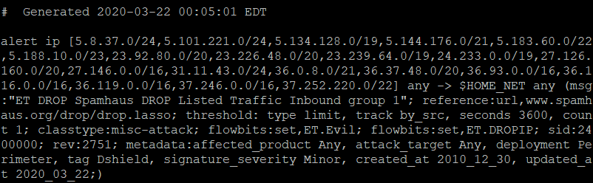

Figure A sample drop rule from the drop.rules file which manages the IPS blocking function of the Suricata sensor.

With the Suricata sensor and dashboard analyzed the following changed will be made:

* A sensor guide will be designed which will include the fix to get the Suricata sensor logging
* A configuration guide will be included in the sensor guide
* A new dashboard will be created with an updated naming convention

## 4.10 Senor ID 9 - p0f

P0f is passive traffic fingerprinting sensor which identifies the sources of any incidental TCP/IP communications without interfering. The senor is scalable and capable of fast identification of source operating systems, applications being deployed against the port being screened, particularly where Nmap scans are blocked, slow, unreliable or too noisy.

The sensor can also measure the uptime of source machines, and network hookup details, distance and the topology of the network, address translation and/or packet filtering. The detections are automatic and include load balancing and application-level proxying setups. Detection of false servers/clients that forge declarative statements such as false User-Agent declarations is possible. The sensor can be run inline or as a service with real-time API implementation of third-party components, although this is beyond the scope of novice researchers use of the sensor. A dashboard is provided for the p0f sensor and will be updated as needed. The configuration file contains no settings that a novice user might need to alter. This is a purely plug and play sensor.

The dashboard for the p0f sensor contains no panels that display irrelevant data. This is to be suspect as all data that can be scraped from a fingerprint sensor would be expected to be useful and highly relevant from a detection and identification, and indeed a potential mitigation standpoint.

Figure The upper half of the current p0f dashboard.

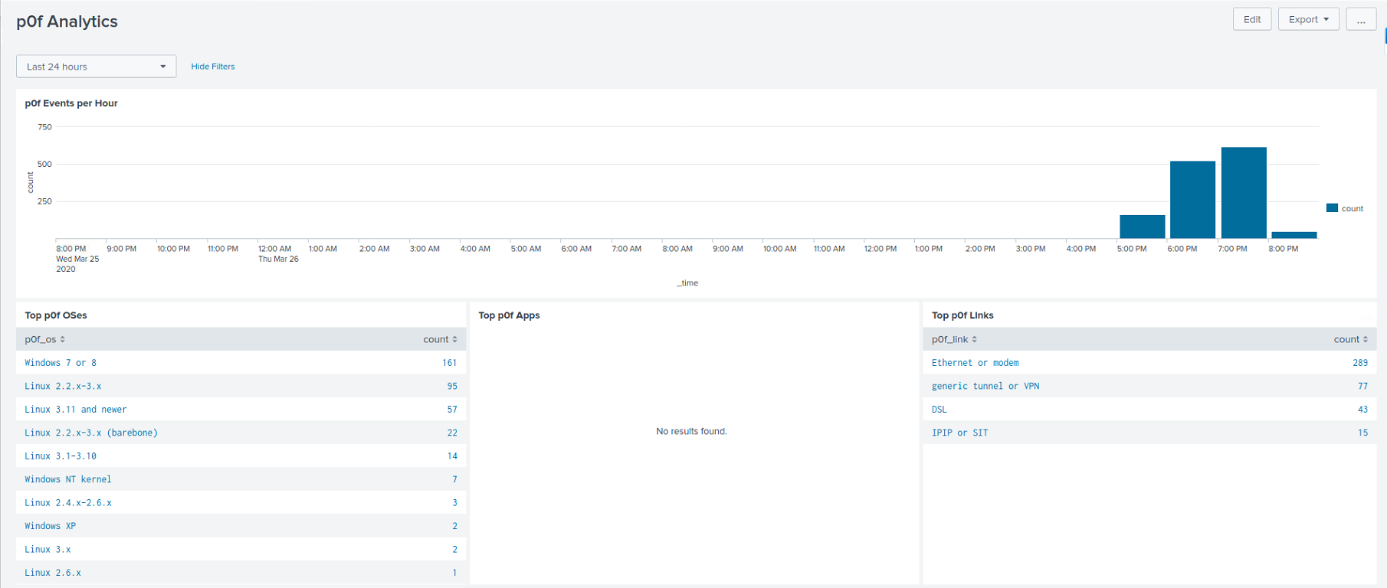

The upper half of the current p0f dashboard encompasses the ‘p0f Events per Hour’, ‘Top p0f OSes’, ‘Top p0f Apps’, and ‘Top p0f Links’ panels. Except for the ‘Top OSes’ panel which will have its naming convention altered, no changes will be made here.

Figure The lower half of the current p0f sensor.

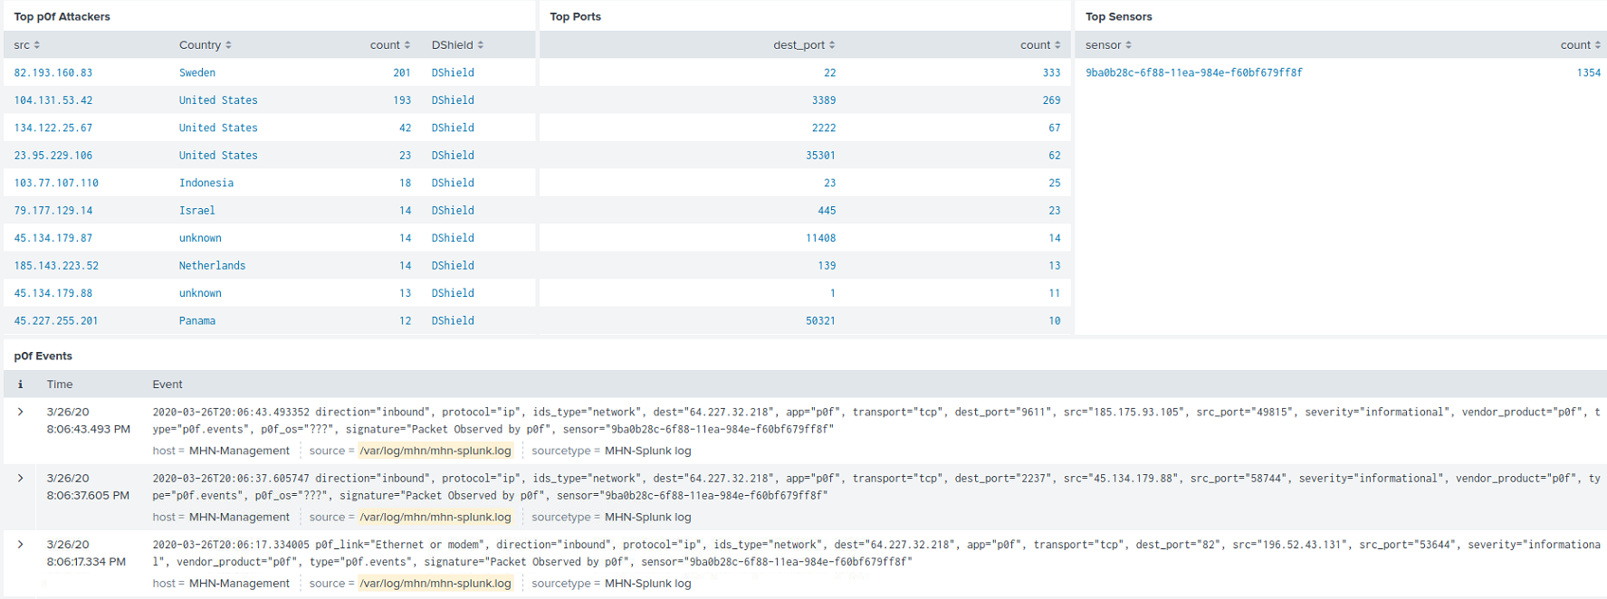

The lower half of the p0f sensors dashboard encompasses the ‘Top P0f Attackers’, ‘Top p0f Ports’, ‘Top p0F sensors’ and ‘p0f Events panels. The ‘Top attackers’ panel will have its naming convention altered to better reflect that not all connections are attacks and each connection should be investigated to confirm they are or are not attacks.

With the sensor, configuration file and dashboard analyze the following changes will be made:

* A sensor guide and configuration guide will be designed although it shall simply state the sensor is plug and play and the configuration file should not be altered by novice users.
* The Dashboard will have the naming convention updated
* A new dashboard will be created to house the ‘p0f Events’ panel

## 4.11 Sensor 10 - Shockpot

The Shockpot sensor is a copy of the previously documented Shockpot Sinkhole sensor. However, there is one significant difference beyond the naming convention of the sensor. This version of the Shockpot sensor comes preconfigured to only log verified Shellshock detections as seen below. The removes the problem of false positives being relayed via the Shockpot Sinkhole version of the sensor.

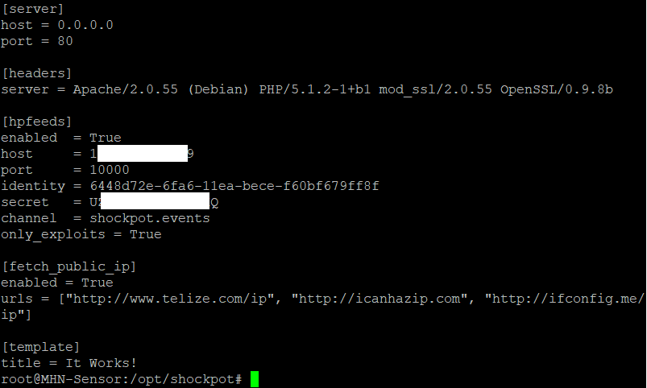

Figure The second Shockpot sensor (non-sinkhole version) with the 'only_exploits' attribute pre-configured to 'True'.

While the Shockpot Sensor is an old sensor which documents old CVE’s, as they can still appear in the wild. The dashboard will be re-added so that should researchers wish to attempt to document Shockpot attempts against a susceptible old un-patched operating system to highlight why regular patch maintenance is important, they will have the facility to do so.

With the Shockpot sensor and configuration file having been analyzed, and the dashboard having been previously analyzed, the following changes will be made:

* A sensor guide and configuration guide will be designed
* The Shockpot dashboard will be re-added to the app with an updated naming convention.

## 4.12 Sensor 11 - Wordpot

The Wordpot sensor is a low interaction WordPress honey pot which is designed to detect attempt to can WordPress plugins, themes, timthumb (an imaging resizing PHP-based script which has in the past been known to be vulnerable) and other assorted files used to attempt to fingerprint a WordPress installation. It is important to clarify that Wordpot does not screen typical port scans but instead search for specific WordPress related scans. For this reason, Users will not be likely to see much activity unless a word press website with common plugins or scripts such as timthumb have been deployed. A dashboard for this sensor does not exist.

The Wordpot configuration file allows for some basic configuration. Users can adjust the host server address, port, theme and server type/version.

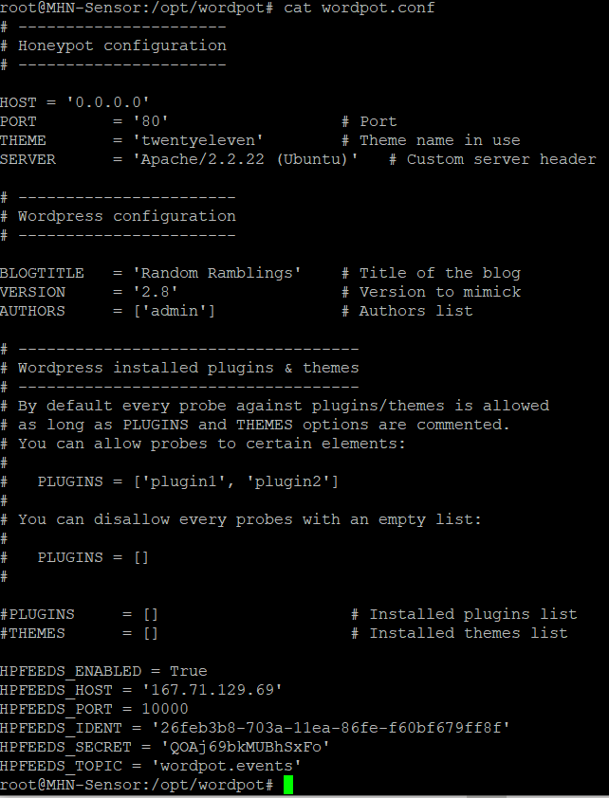

Figure Adjusting the Wordpot server details via the Wordpot.conf configuration file.

The name of the blog displayed, the emulated version to mimick and the author details can also be altered.



Figure altering the blog title, version and author WordPress details via the wordpot.conf configuration file.

And lastly, the plugins and themes can be added or removed. This is done but uncommenting the theme or plugin array parameters and entering plug or theme names into the arrays. For example:

* PLUGINS = [‘plugin1’,plugin2’]
* THEMES = [‘theme1’,theme2’]



Figure Adding plugins and theme in the Wordpot.conf file.

With the sensor, and configuration file analyzed the following changes will be made:

* A sensor guide and configuration guide will be designed
* A dashboard will be created

## 4.13 Sensor 12 - Magenpot

The Magenpot sensor (Short for Magneto Honeypot) is an anti-spam bot sensor. The sensors purpose is to deploy a website which detect bots and scripts attempt to autofill form entries on the website, such as username and password fields on webforms and prevent brute force attempts to gain access. The Magenpot sensor is a derivate of the Drupal honeypot sensor originally designed by Geff Geerling [57].

The Magenpot configuration file is basic and allows only minimal customization. Firstly, the user can manage the port on which the Magenpot webserver will be deployed. Along with the name of the website to be deployed.

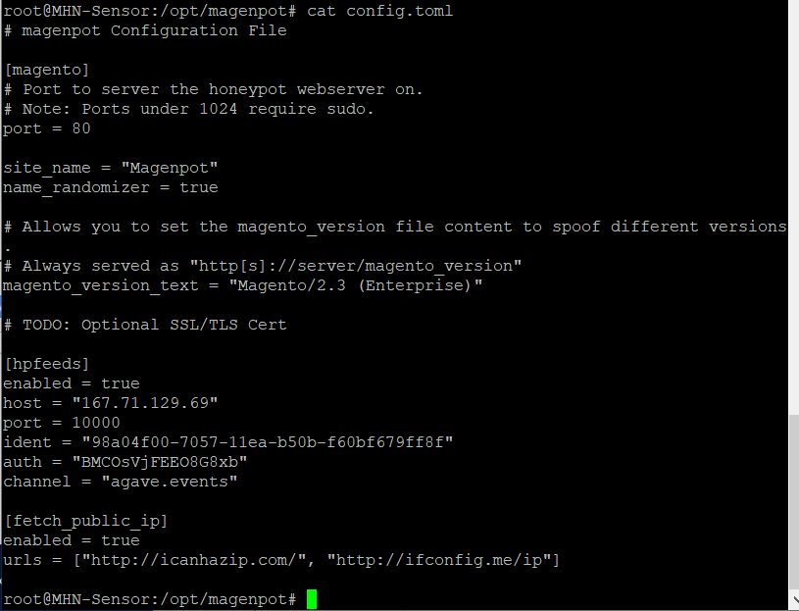

Figure Editing the Magenpot webserver deployment port and name of the website to be deployed.

Next, the user can edit the version of Magento Honeypot which is declared to be running. This could be used to fool sniffers, for example, if a sensor was searching for Magenpot version 1.0 to deploy known attacks, but the Magneto version is declared as version 2.3, attacks may possibly be negated.



Figure Adjust the version information that will be declared when running the Magenpot sensor.

Lastly, the hpFeeds information and public IP fetching URL details can be altered. The HPFeeds data should not be changed. Of note is ident number ‘98a0f00-7057-11ea-b50b-f60bf67679ff8f, and the channel name which is declared as ‘agave.events’ seen in below figure 110.

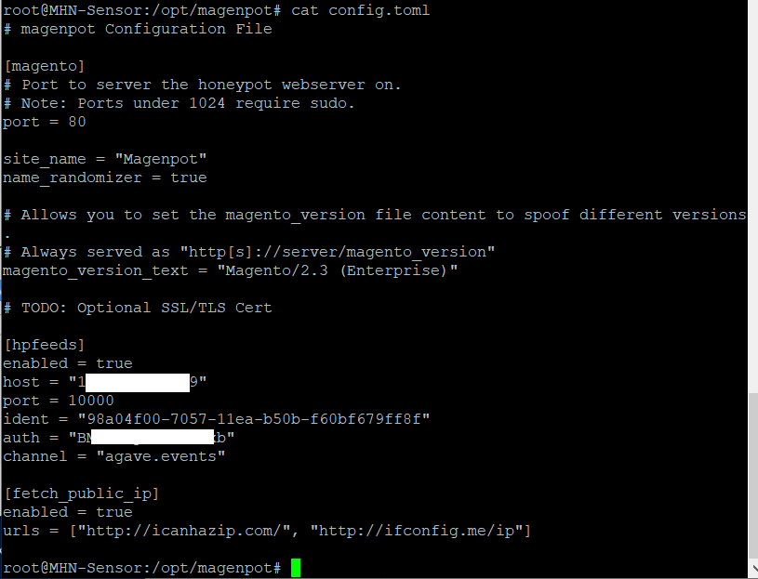

Figure HPFeeds and public IP configuration options for the Magenpot sensor

However, there is a strange problem with the Magenpot logging setup. If we move over to the MHN sensor and examine the sensor which matches the above ident number, we can see that the sensor is logging events against the server as seen below in figure 111.

Figure events being logged against our deployed Magenpot sever.

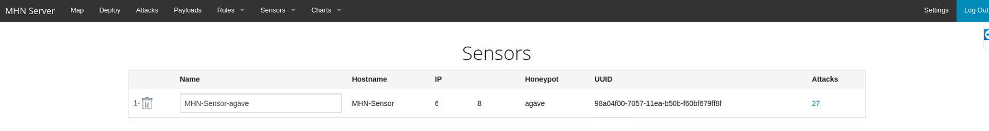

But if we attempt to view these events directly no events are found.

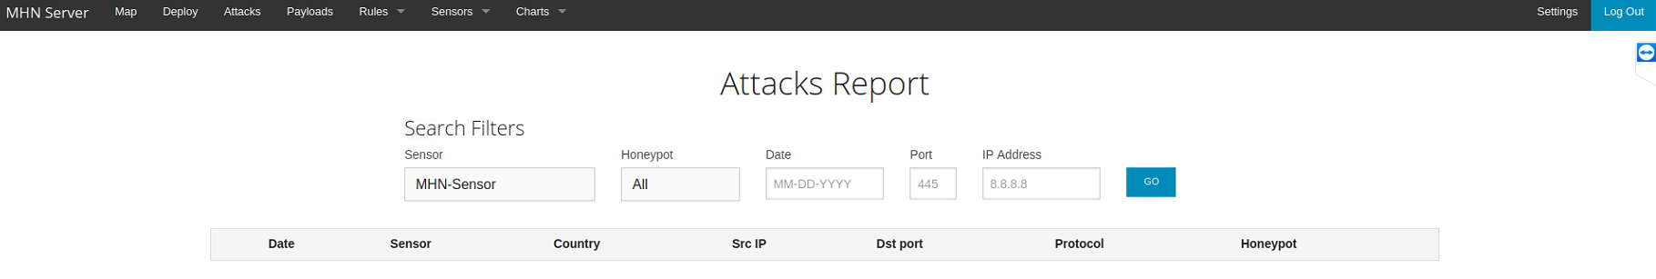

Figure No individual events returned from the agave (Magenpot) sensor.

The homepage of the MHN platform also displays no events.

Figure No events at all showing on the MHN webservers main page.

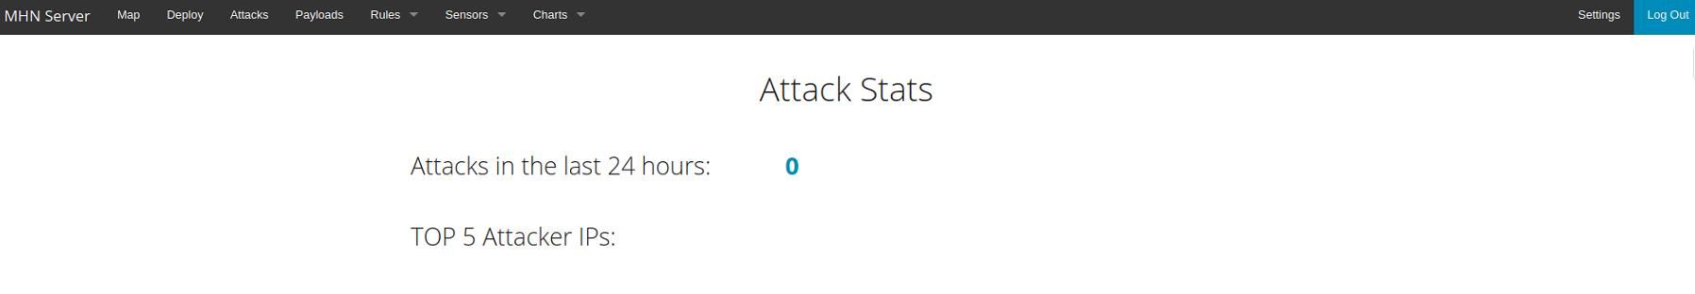

Yet curiously, a processing function does exist within the MHN platforms HPfeeds-logger file as seen below, however, there appears to be some issues with it as we can see that the prepared error handling statement states that the sensor is the Dionaea sensor.

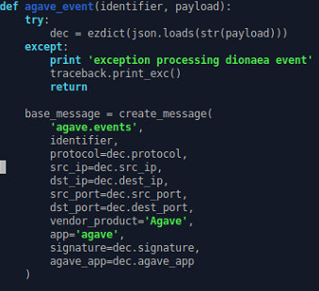

Figure The MHN platforms HPfeeds-Logger file which the preprocessing function for agave.event (Magenpot) sensor with the highlighted error.

The mhn-splung.log file contains no agave.events log data and therefore a search return nothing.

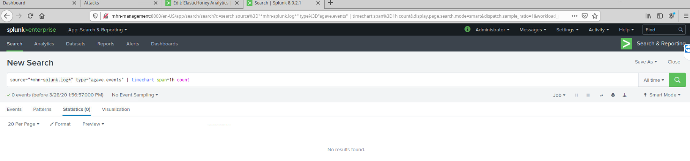

Figure 0 Events retuned when searching for agave.events log data in the mhn-plunk.log index..

In searching for the Magenpot log file, no file can be found. Therefore, what appears to be happening is that events are being logged directly to the MHN platform on an individual basis with no log being stored, therefore, no dashboard can be created for this sensor.

With the sensor and configuration file analyzed the following changes will be made:

* A sensor guide will be designed for the sensor
* A configuration guide will be included in the sensor guide
* No dashboard will be created due to no logs being created.

## 4.14 Sensor 13 - Drupot

The Drupot sensor is another Drupal derivative like Magenpot. In fact, it is almost an exact copy of Magenpot. The configuration file is identical as can be seen blow in figure 122.

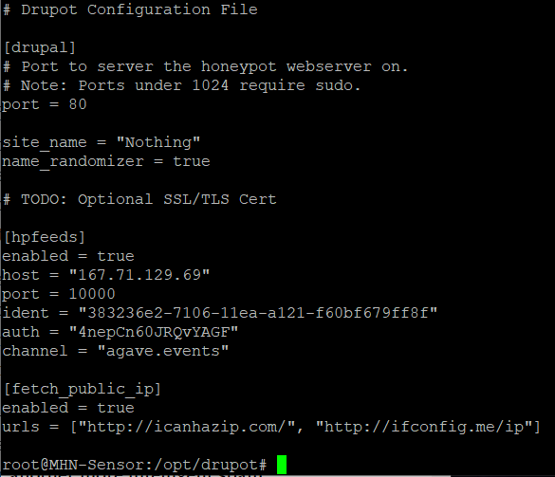

Figure The drupal config.toml file which mirrors the Magenpot config.toml file.

Like Magenpot, the purpose of the sensor is to deploy a website and detect attempts to auto fill form input fields by bots and scripts.

Similarly, the same issue with logging exist, whereby the sensor only logs individual events but does not create a log file. Therefore, log no dashboard can be created.

With the Sensor and configuration file analyzed, the following changes will be made:

* A sensor guide will be designed
* A configuration guide will be added to the guide.
* No dashboard will be created.

## 4.15 Sensor 13 - Conpot

The Conpot sensor is a low interaction control industrial system emulator designed to simulate services and activity that suggests to a potential attacker that they have found an industrial server that might be worth investigation. It is important to note that Conpots job is to attract activity, but that the activity may not necessarily be over the default port upon which Conpot is listening (502). Therefore, while Conpot will document events coming into its listening port, it should be paired without another sensor that will detect events coming in over other ports including common ports. This will need to be documented in a sensor guide. A dashboard is provided for the Conpot Sensor.

The configuration file for the Conpot sensor is basic but does afford some configuration options. Users can alter the ID of the Sensor, change the timeout duration, change the user and group settings, set the log in json format and change the location of the log file (This should not be altered) as seen below in figure 117.

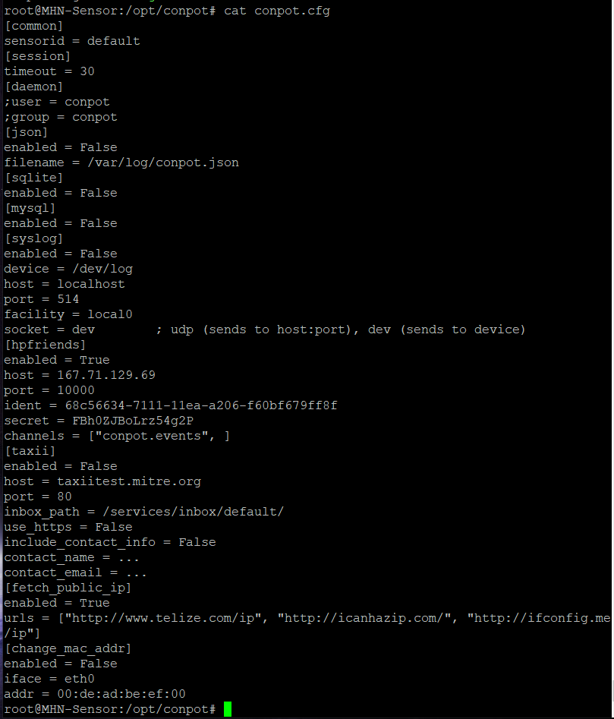

Figure Channing the sensor ID, timeout duration, user/group settings and log file location in the Conpot config.cfg file.

The user has the ability to run on simulated modules for SQLite, MYSQL, syslog (as well as setting the location for the syslog log file), the servers running port as well as the facility and socket (port) settings. The running port could be changed as needed to simulate a running servic for a specfic type of industrial server.



Figure Activating the SQLite, MYSQL, and Syslog setting, as well adjusting the host, facility and socket (port) settings.

User may also alter the HPfeeds details, although this should not be alterd or the sensor will stop logging to the MHN management server.

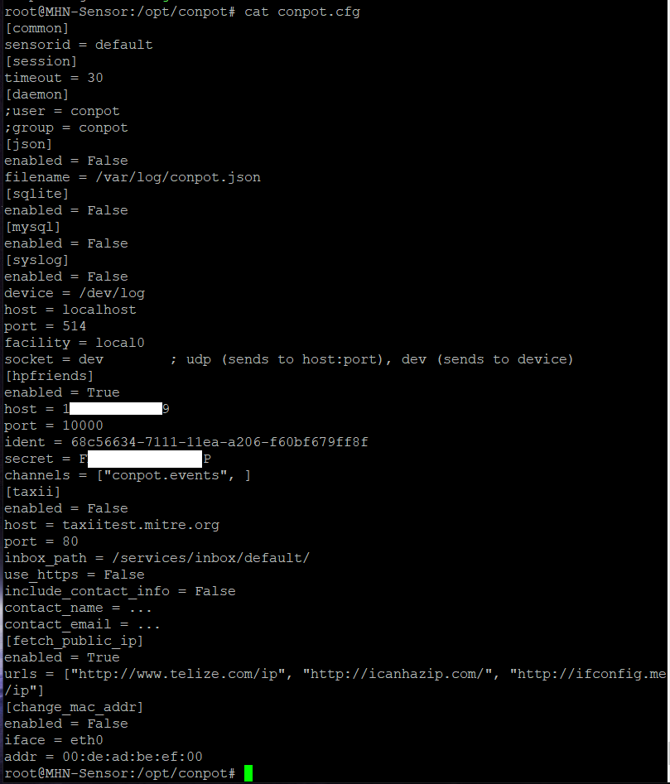

Figure Altering the HPfeeds details (this will result in the sensor no longer logging to the MHN management server).

User have access to the TAXII RESTful API through the adjustment of TAXII settings within the Conpot config.cfg file. TAXII, or Trusted Automated Exchange of Intelligence Information, is an API that facilitates the exchange of cyber threat intelligence (CTI) through the MITRE foundation [58].

Lastly, the user can alter the service from which the servers public IP address will be obtained as well as setting the Interface and mac address upon which the server will be deployed. This could be useful in instances where the physical server has multiple interface installed.

**

Figure altering the public IP service from which a public IP will be obtained as well as the interface and mac address settings.

The Conpot Dashboard is minimal containing only 6 panels. However, it does suffer from the same naming convention misnomer which suggests all connections are attacks instead of events that should be investigated. This will be rectified in the dashboard update.

The first half half of the Conpot Dashboard encompasses the ‘Conpot Events per Hour’, ‘Top Types’, ‘Top Attacker Countries’, ‘Top Conpot Attackers’ and ‘Top Conpot Sensors’ panels. The naming convention of all panels containing the word Attacker will be updated.

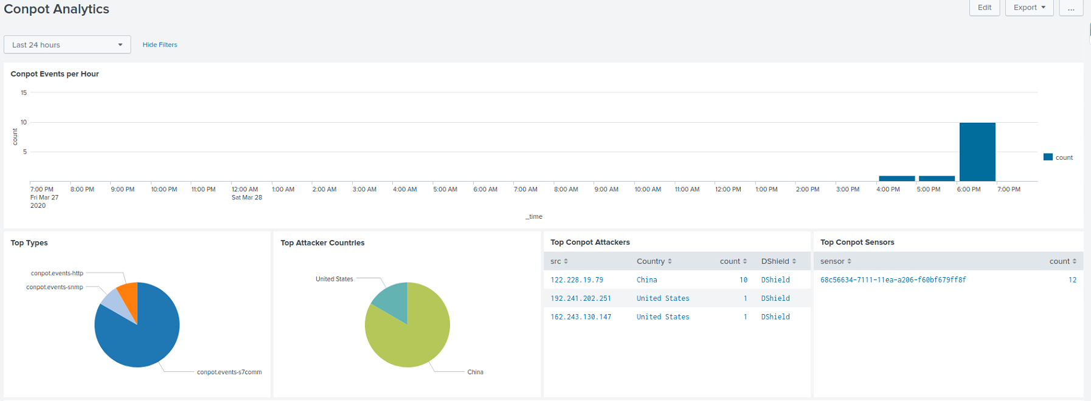

Figure The upper half of the current Conpot Dashboard.

The lower half of the current Conpot dashboard contains only the ‘Conpot Events’ panel. This panel will be moved to a new dashboard to increase efficiency by reducing recursive algorithms during searches.

Figure The lower half of the current Conpot dashboard.

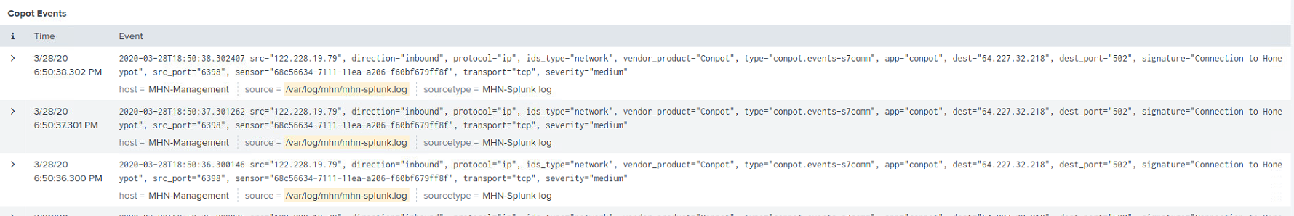

With the sensor, configuration file and dashboard analyzed the following changes will be made:

* A sensor guide will be designed
* A configuration guide will be included in the sensor guide
* The dashboard will be updated with the Conpot Events panel being moved to a new dashboard.

## 4.16 Vimal Python based Virus total Parser

Once the user has Installed and configured the MHN platform and deployed sensors to their liking, data will be generated. This data, depending on the types of sensors deployed will consist of Hashes, IP addresses, Domains, URL’s and potentially scraped files. However, only a minimal amount of data is immediately available upon viewing this information. For example, if a hash is determined to be a known variant of WannaCry ransomware this is very useful information, but this does not reveal any information about the source of this ransomware. IS the IP address or Domain related to a known BotNet, or are either on known bad reputation or block lists? This is crucial information. Either they are on such lists and the IP{ address will have to added to the local internal blocklist across any and all networks, of the threat intelligence gained is new information and should be added to uploaded to database to update data sets at sites like Virus Total before adding the suspect IPs URLs or Domains to local bad reputation or block lists.

In order to gather this information, 3rd party sources and/or tools must be used. In this case, the MHN platform uses the Virus Total API functionality to retrieve basic information and determine if something is suspect or not. This information retrieved however is basic and much more information is available via the Virus Total platform. To access this information the API contains very specific lookups requests for various types of lookups including Hashes, IPs Domains and Files.

I will develop a python-based parser which will be capable of using this extended API functionality to retrieve specific data related to the types of data mined by the MHN-Splunk apps sensors.

This app will have the following requirements:

* The app will be open source and nonprofit
* The app will have a GUI
* The GUI must be simple to navigate
* A windows version will be created
* A Linux Version will be Created
* For windows a closed source precompiled version will be supplied as an optional extra for users who only wish to use and never adapt or improve the opensource version
* The App will contain a Main Menu with A Banner Image and basic navigation links as well as an exit button
* The App will contain individual frames to house the individual Lookup frames
* The App will contain frames to house the following functions:
  + A Hash Lookup page:
    - The ability to request a Hash report
    - The ability to request and mine only statistical data from a Hash report
    - The ability to display data in a text field in a formatted easily readable format
    - The ability to create text file from this data for use later in reports
    - And exit program button
  + A Scan ID Lookup page:
    - The ability to request a Scan ID report
    - The ability to request and mine only statistical data from a Scan ID report
    - The ability to display data in a text field in a formatted easily readable format
    - The ability to create text file from this data for use later in reports
    - And exit program button
  + A File Lookup page:
    - The ability to request a File report having selected a local file from the local machine for scanning
    - The ability to display data in a text field in a formatted easily readable format
    - The ability to create text file from this data for use later in reports
    - And exit program button
  + A URL Lookup page:
    - The ability to request a URL report
    - The ability to request a new URL scan and report
    - The ability to request and mine only statistical data from a URL report
    - The ability to display data in a text field in a formatted easily readable format
    - The ability to create text file from this data for use later in reports
    - And exit program button
  + An IP Lookup page:
    - The ability to request a IP report
    - The ability to request and mine only statistical data from a IP report
    - The ability to display data in a text field in a formatted easily readable format
    - The ability to create text file from this data for use later in reports
    - And exit program button
  + A Domain Lookup page:
    - The ability to request a Domain report
    - The ability to request and mine only statistical data from a Hash report
    - The ability to display data in a text field in a formatted easily readable format
    - The ability to create text file from this data for use later in reports
    - And exit program button

The program will be subject to white box testing and limited external black box testing with feedback and suggestions from testers and will be subject to update and change based on this feedback.

Having elected to design a stand-alone Virus Total Parser as part of my project in order to reduce the time taken to expand on the data retrieved from the MHN platform, we must examine the Virus Total platform which, upon receiving a request outputs a report which is then broken up into 4 tabs as seen below in figure 7 to 11.

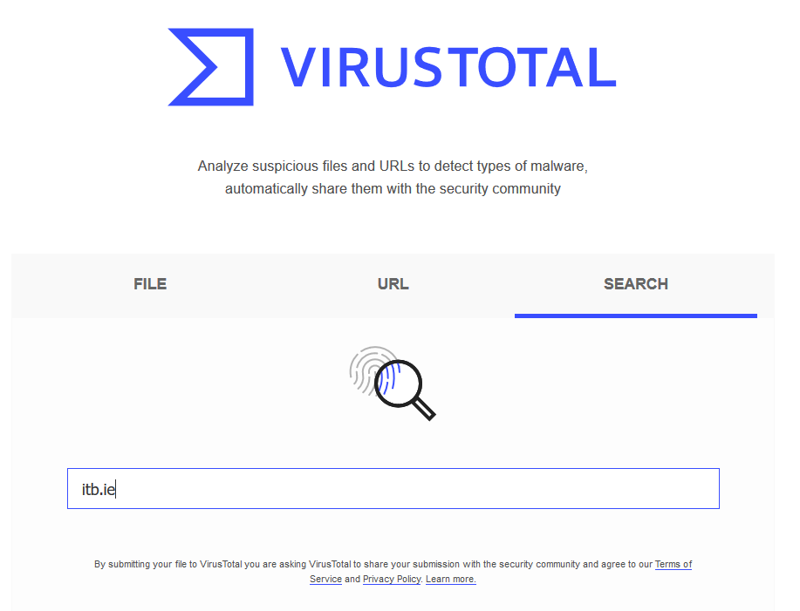

Figure A sample search of the itb.ie domain on the Virus Total website [12].

Above you can see a sample search was conducted against the itb.ie domain for illustration purposes.

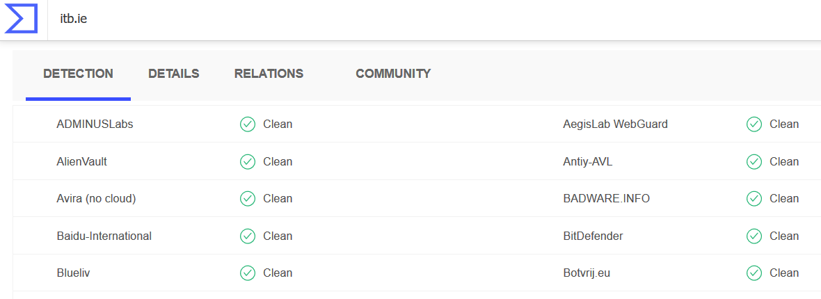

Figure Here we see a sample of the detection results, or lack thereof, as the case may be [12].

Here we see a sample of the detection results. With over 60 detection engines, you can see how this could quite a lot of data to document for a report if the scan resulted in a lot of detections. You can also see how the scan returned four separate tabs of information ranging from detection to community.

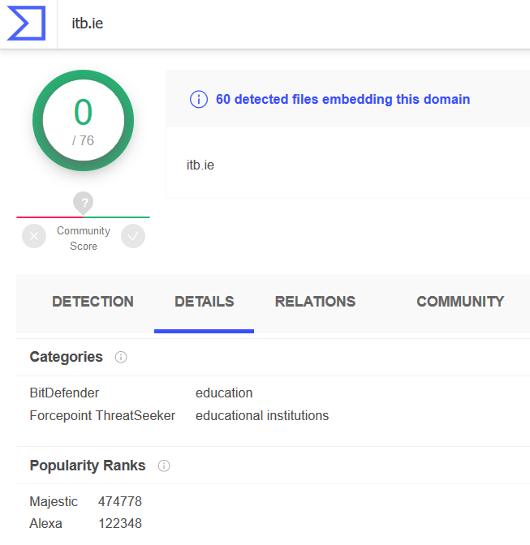

Figure Here we see the verbose output from the details tab [12].

In the details tab above generic information such as WHOIS results, SSL certificate information, DNS records, google results and popularity ranks amongst other results are displayed. This again, can result in a lot of information which could result in a time-consuming documentation process.

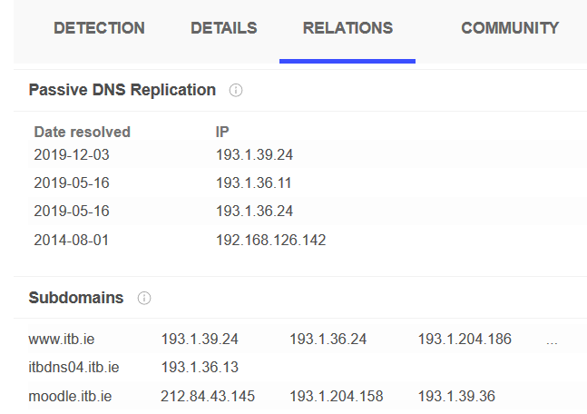

Figure Data from the relations tab [12].

Next up we have the relations tab. This displays URL and subdomain data, as well as historical certificate, DNS, subdomain, referenced files and WHOIS lookup data.

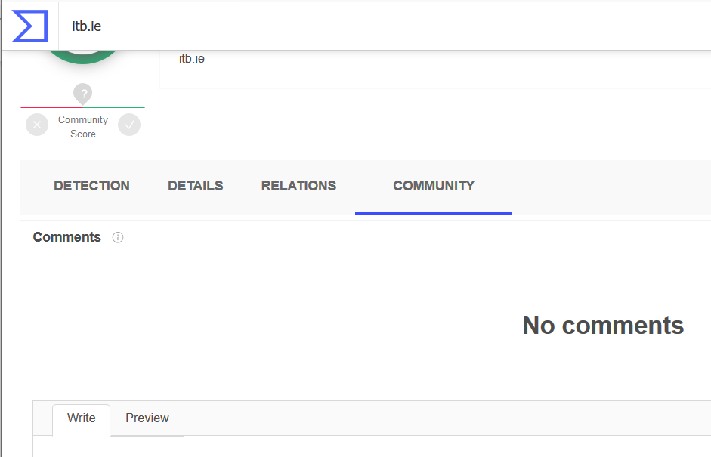

Figure The community tab containing community comments, if any [12].

The final tab is the community tab which contains comments on the subject matter related to the scan, if any comments exist. This section could provide contextual data, but mining of this section is not containing within the API functionality of the Virus Total platform.

As we see above, there is potentially a lot of information to be mined and filtered and then documented by the researcher. While the U.I. of Virus Total is very user friendly and the output is highly readable, switching between tabs to copy and paste data or even read data and see how it all fits together can be quite time consuming. Furthermore, having extra tabs open in a browser consumes more power and for researchers working on the go in a mobile situation, for example, on a thin laptop client; preserving battery power may be important. My parsing App aims to remove these problems by using the generously provided Virus Total API to provide the ability to mine all data in one output and transfer all the data into a readable file at the touch of a button.

The requirements of my parsing App will be as follows:

* To facilitate the dependencies that will need to be imported, the ‘Pillow-Pil’, easygui and ‘requests’ libraries must be imported to the Python project environment. To Make this easier I will use the PyCharm community edition IDE [59].
* The App will be GUI-Based and will use a card style layout combined with the pack method to contain the widgets within the GUI. The GUI will be managed by the ‘tkinter’ library.
* The API calls will be handled using the ‘requests’ library.
* Json files will be mined using the json library.
* Alerts will be handled using the ‘messagebox’ and easy gui library.
* Images will be handled by the ‘ImageTK’ function from the PIL ‘library’.
* Local file selection will be handled using the ‘askopenfilename’ function from the ‘tkinter.filedialog’ library.
* Error handling will be handled with try/except functions
* Pyinstaller will be used to create a standalone windows executable for demonstration purposes [60].
* The App must have the ability to request a report of previously scanned hash.
* The App must have the ability to request a report by its scan ID.
* The App must have the ability to request a scan of a locally stored file on the user’s computer.
* The App must have the ability to request a report of previously scanned URL.
* The App must have the ability to request a scan of new URL.
* The App must have the ability to request a report of previously scanned IP address.
* The App must have the ability to request a report of previously scanned domain.
* The App must have the ability to filter any report down to just its statistical data.
* The App must have the ability to transfer any data in the output fields to readable text file at the touch of a button.
* The App must have the ability to dump text data to files at the request of the user.
* The App must have the ability to track the numerical create of files to allow users to track files via naming convention that they have created.

The entire code of the program shall not be documented here in the main body of work but shall be provided both on disc and in the appendix of the document. Here the focus will be on how each of the requirements of as set out above have been met.

A set of activity diagrams drawn up using the Umlet UML design software began the process of laying out how the program was to be designed and how it would function. These activity diagrams were broken up into individual functions extending from the main menu. This was followed up by a use case diagram.

The legends for both diagrams follow.

# 5.0 System Implementation

## 5.1 Modern Honey Network Management/Sensor Server & Analytics SIEM Installation Guide

MY MHN installation guide covered all aspects of the setup of a small home Honeypot centric security operations center, including the main MHN platform setup with secure SSH access. The Splunk SIEM; both on the server and the local machine. The MHN-Splunk app was then incorporated. The TeamViewer VNC client was added for users who wish to have a visual access to the server. This is purely an optional extra for users who might be learning how to use the platform and the Linux environment, and who benefit from a visual learning environment.

The guide can be found and downloaded via the public GitHub repository: <https://github.com/JamesFinglas/4th-year-Thesis-project-Files>.

## 5.2 MHN Management & Sensor Server Scripts

I create several scripts to help user with the management of the MHN platform and the Dionaea sensor as this sensor tends to consume server storage capacity at an alarmingly fast rate if unmanaged.

The first script establishes an auto rotate function which rotates the dionaea.log file regularly to conserve disk space. This script is accompanied by a README.txt file which explains how to use the script.

The second script sets up a Cronjob which will compress the Dionaea Bitstreams folder every hour and delete it every 6 hours. This again conserves diskspace while providing a 5nhours window for files to be retrieved in case the user wishes to perform a manual digital forensic investigation of the files. This File is also accompanied by a README.txt file explained how to deploy the script and activate the Cronjob.

The third script established a Cronjob on the MHN management server which controls an hourly restart of the MHN platform related services and verifies that the required log files retain the correct file permissions and group access. Again, this file is accompanied by a README.txt file explaining how to deploy the script and activate the Cronjob.

The fourth script established a rolling restart of any sensors that may be deployed on the MHN sensor servers. Every hour this rolling restart begins with A sensor being shut down and restarted every 2 mins until all possible deployed services have been restarted. As with all other scripts, the script is accompanied by a README.txt file explaining how to deploy the script and activate the Cronjob.

The scripts are also available at the following link: <https://github.com/JamesFinglas/4th-year-Thesis-project-Files>.

## 5.3 Updating the MHN-Slunk App

The process of adding a dashboard to the MHN-plunk app is relatively straight forward involving a two-step process. Firstly, a webpage, called a ‘view’ in the Splunk app must be created.

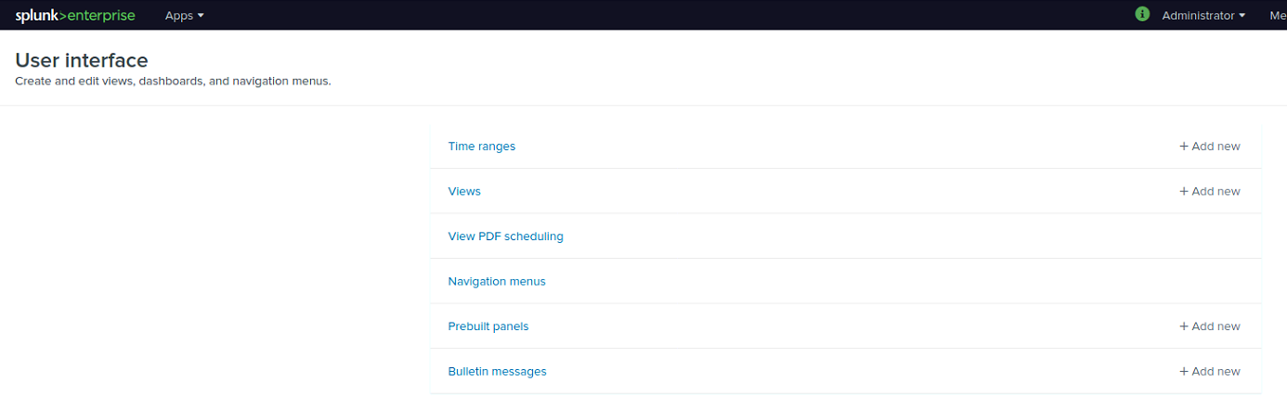

Figure Entering the view section of the Splunk platform to add a view.

Views are added, and then compiled into an XML format. We must assign a view to an app with an appropriate name (this is the name that must be used in our navigation links), as seen below. Once created we simply adjust the permissions on the page so that the only the MHN-Splunk app may access the dashboard.

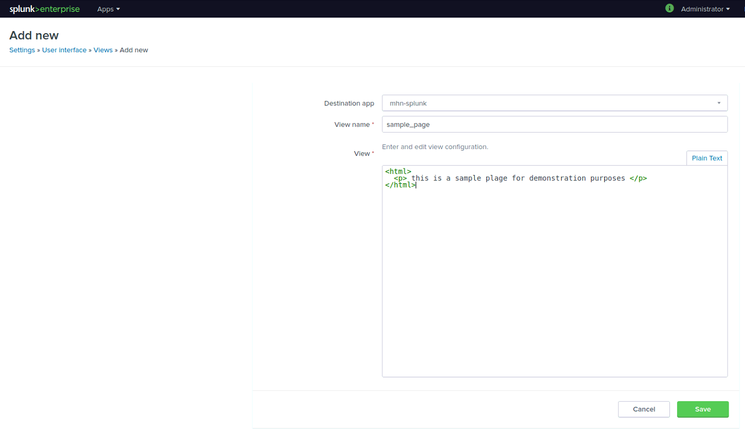

Figure Assigning the identification features to a view.



Figure Entering view permission settings.

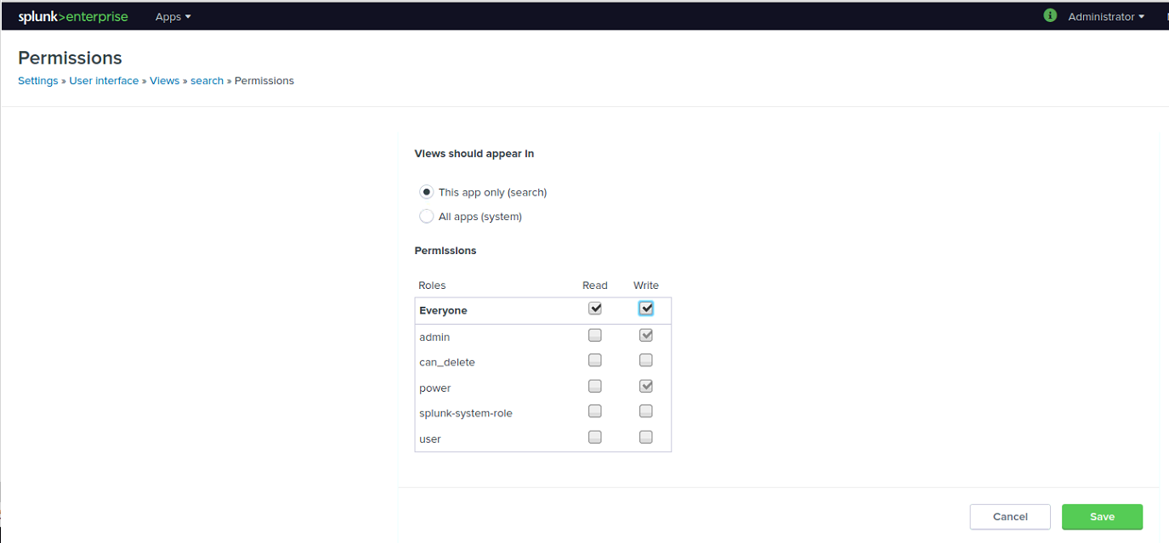

Figure Adjusting permissions settings so that only pour current app can access the new view.

A sample of a custom-made view is provided below in figure 132. All views will follow this template altered to suit the specific needs of each sensor.

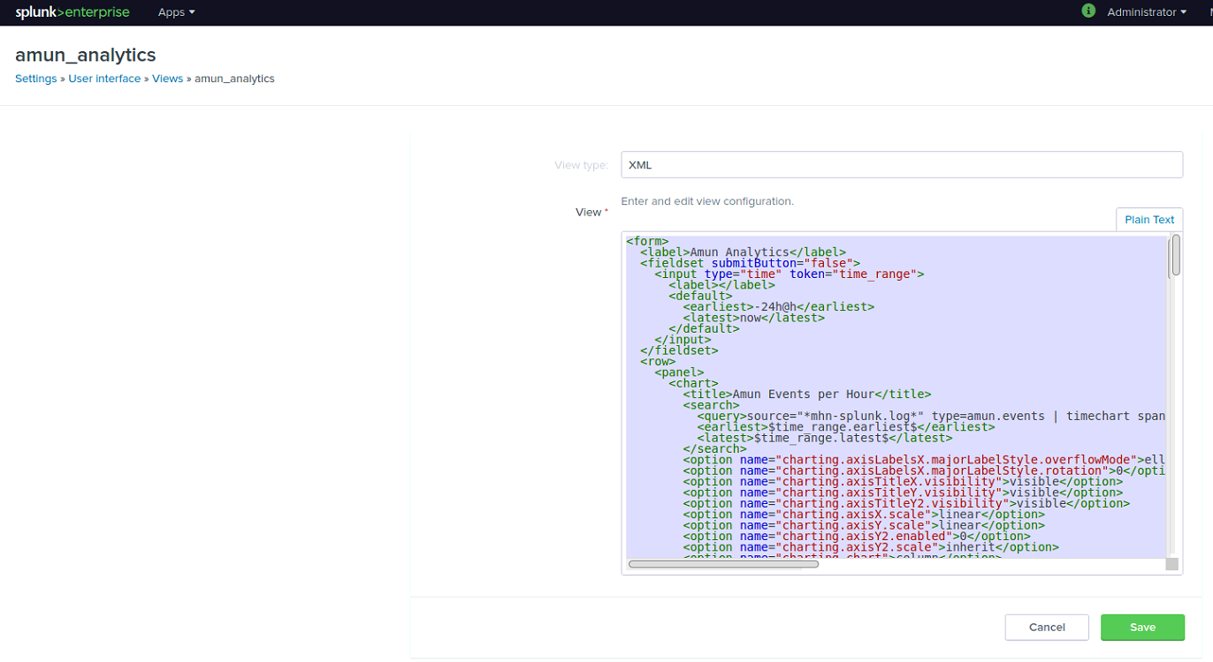

Figure Designing the webpage, or view, for the first of two Amun based dashboards.

Once the webpage or view has been completed and compiled, we must create a navigation link that will appear on the navigation bar of our MHN-Splunk app. This is done by entering the navigation menus link, and altering our navigation bar code which is created in simple html before being compiled into XML format as seen blow in figures 133 & 134.



Figure Entering the navigation menu to add a navigation link.

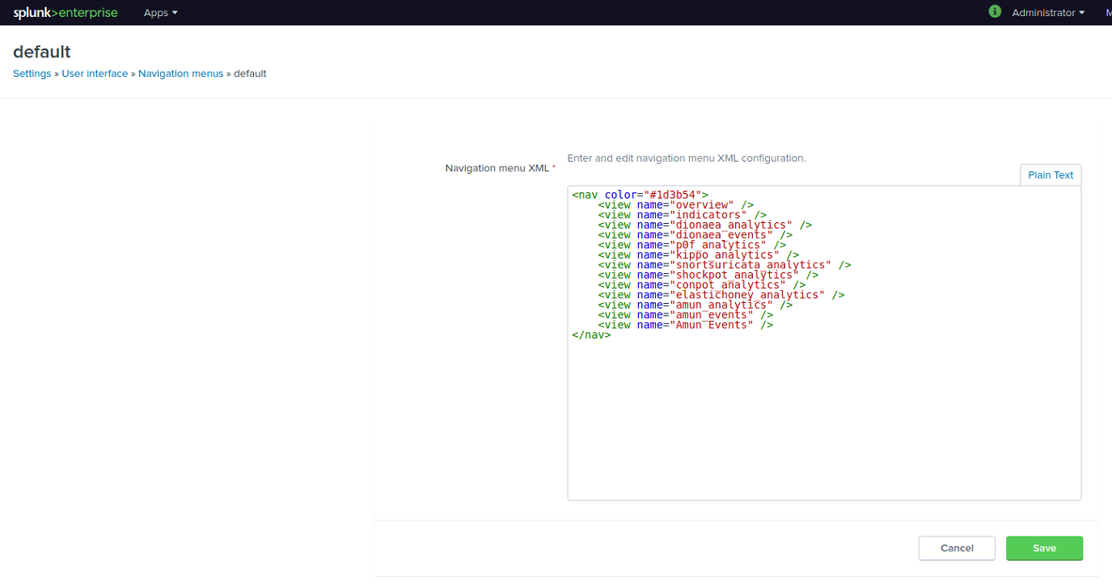

Figure Adding the navigation links for our two new Amun dashboard views.

With our new nav links added we will now see our new dashboard links appearing on the dashboard navigation bar in our MHN-Splunk app as seen below in figure 135.



Figure The new Amun dashboards are ready to be formatted.

### 5.3.1 Overview Dashboard Update

The naming convention of the Overview dashboard was updated where needed to better reflect that all events should be investigated and confirmed as attacks, before assuming they are attacks. The invalid searches were also updated to search for data from the Cowrie app instead of the Kippo App. The upper third of the updated Overview dashboard now encompasses the ‘Events’, “Unique Events’, ‘Unique MD5s’, Unique URLs’, ‘Commands Executed’ and ‘Total Events per Hour’ panels.

Figure The upper third of the updated Overview dashboard.

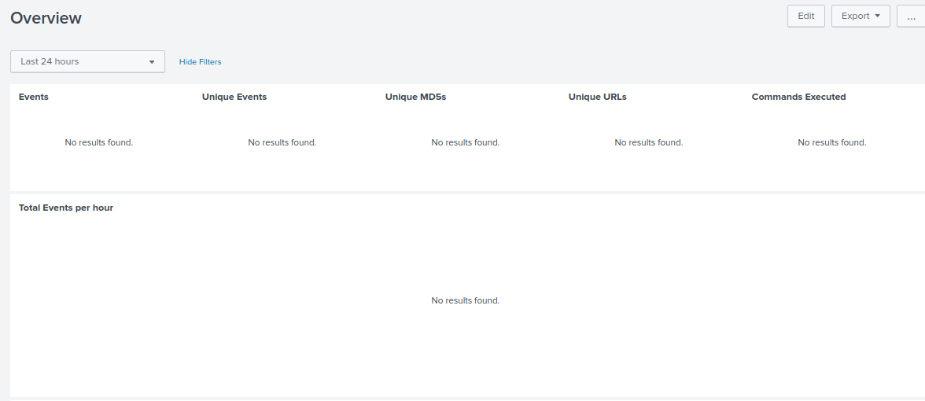

The ‘Commands executed’ panel has had its search parameters update to correctly search for Cowrie data instead of Kippo data.

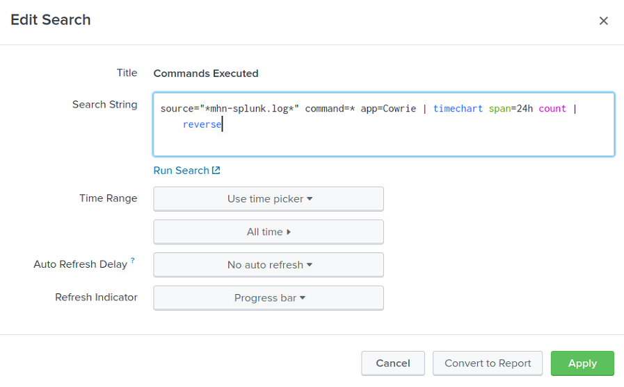

Figure The updated 'Commands executed' search field which is now correctly searching for Cowrie data.

The middle third of the updated Overview dashboard now encompasses the ‘Global Events Panel’, ‘Top Event Source Countries’, ‘Top Event Source Cities’, Top Honeypots by Type’ and ‘Top Ports’ panels.

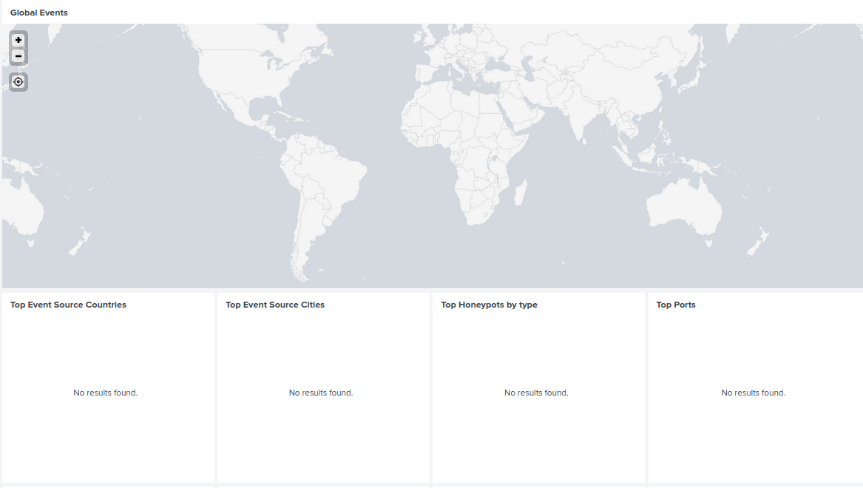

Figure The middle third of the newly updated Overview dashboard.

The lower third of the newly updated Overview dashboard now encompasses the ‘Top Events’, ‘Top Event Source OS’s’, ‘Top Usernames’, ‘Top Passwords’, ‘Top Sensors’, ‘Top MD5’s’, ‘Top URL’s’, and ‘Top Signatures’ panels.



Figure The lower third of the newly updated Overview dashboard.

The ‘Top Usernames’ and ‘Top Passwords’ panels have had their search parameters updated and are now correctly searching for Cowrie data instead of Kippo Data as seen below in figures 140 and 141.

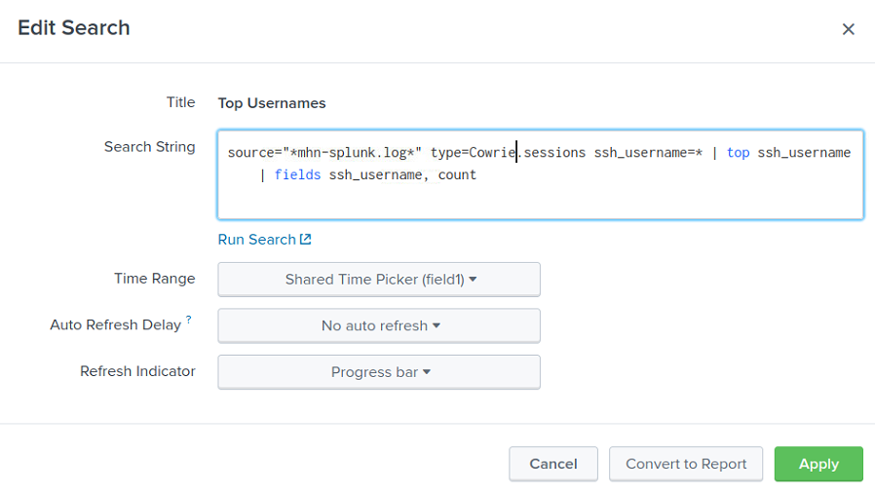

Figure The 'Top Usernames' panel with its updated search parameters, now correctly searching for Cowrie data.

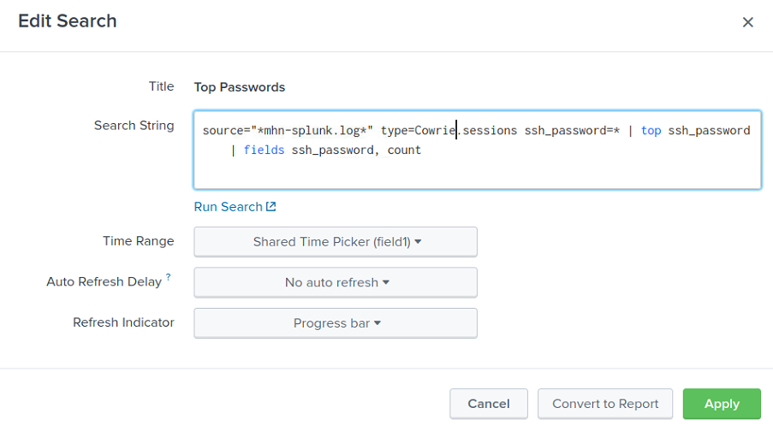

Figure The 'Top Passwords' panel with its updated search parameters, now correctly searching for Cowrie data.

### 5.3.2 Indicator Dashboard Removal

The Indicator dashboard was removed due to containing repetitive data. The 'Top Usernames' panel with its updated search parameters, now correctly searching for Cowrie data.

### 5.3.3 Shockpot Sinkhole Sensor Dashboard Removal

The Shockpot Sinkhole server was removed from the MHN-Splunk App due to false positives being issued by the MHN-Splunk log.

### 5.3.4 Dionaea Dashboard Update

The Dionaea dashboard had its naming convention updated due to the old dashboard suggesting all events were attacks, rather than events. This is misleading as many events, may simply be false positives or innocuous connection attempts rather than attacks.

The dashboard was then split in two dashboards to improve efficiency by reducing recursive searches. The first is called ‘Dionaea Analytics’ and the second is called ‘Dionaea Events’. This resulted in snappy responsive dashboards.

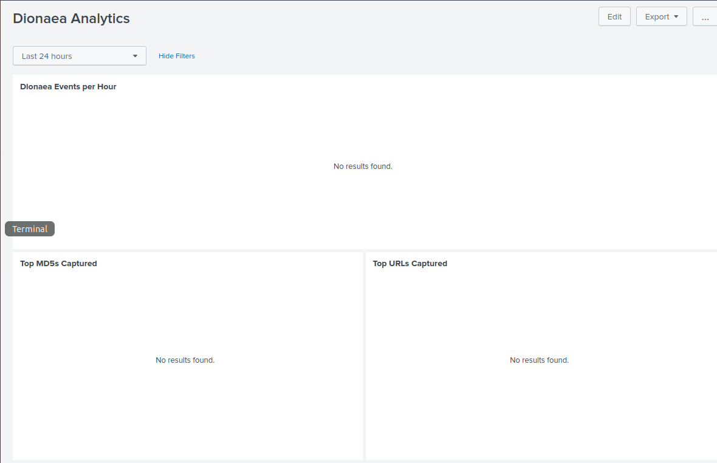

Figure The top 3 panels of the new updated Dionaea dashboard.

The upper half of the Dionaea Analytics dashboard displays ‘Top Events per Hour’, ‘Top MD5’s Captured’, and ‘Top URL’s Captured’.



Figure The lower half of the Dionaea Analytics dashboard.

The lower half of the new Dionaea Analytics dashboard contains the ‘Top Event Sources’ (formerly attacks), ‘Top Ports’ and ‘Top Sensors’ panels.

The second new panel, ‘Dionaea Events’, contains only the ‘Dionaea Events’ panel. This panel now loads very fast which should improve its performance on thin clients.

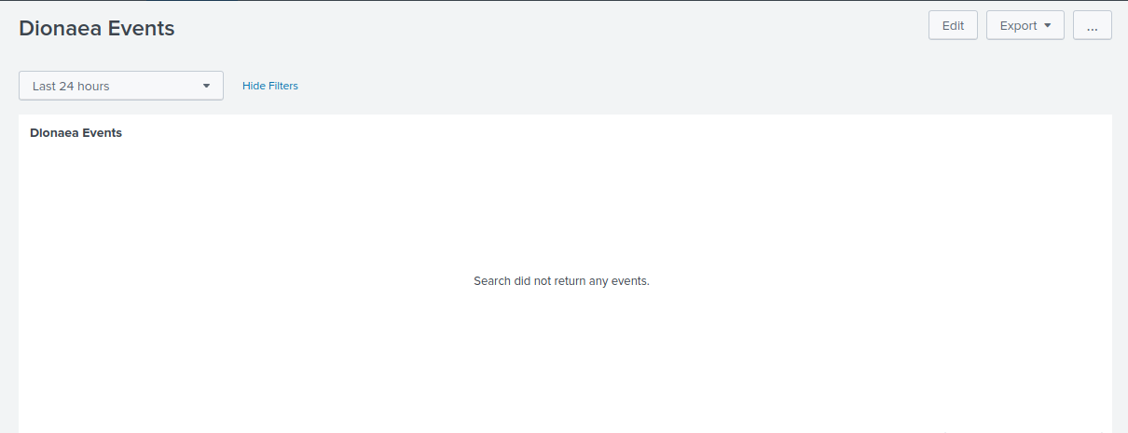

Figure The second new Dionaea dashboard, 'Dionaea Events'.

### 5.3.5 Cowrie (Formerly Kippo) Dashboard Update

The Kippo dashboard was deleted and 2 new dashboards were created for the Cowrie sensor, which is the successor to the Kippo sensor. The first dashboard was named ‘Cowrie Analytics’ and the upper half of the dashboard encompassed the ‘Cowrie Events per Hour’, ‘Top usernames’, ‘Top Passwords’, ‘Top Username/Password Combinations’ panels. The lower half of the dashboard encompasses the ‘Top URL’s Downloaded’, “Top Commands Executed’, ‘Top Cowrie Event Sources’, ‘Top SSH

Versions’, And ‘Top Sensors’ panels.

The separation of the Analytics and Events serves to reduce recursive searches and increases efficiency. The naming convention of the dashboards was changed due to the term attacks suggesting all events are attacks, when in fact each event needs to be investigated to be confirmed as an attack

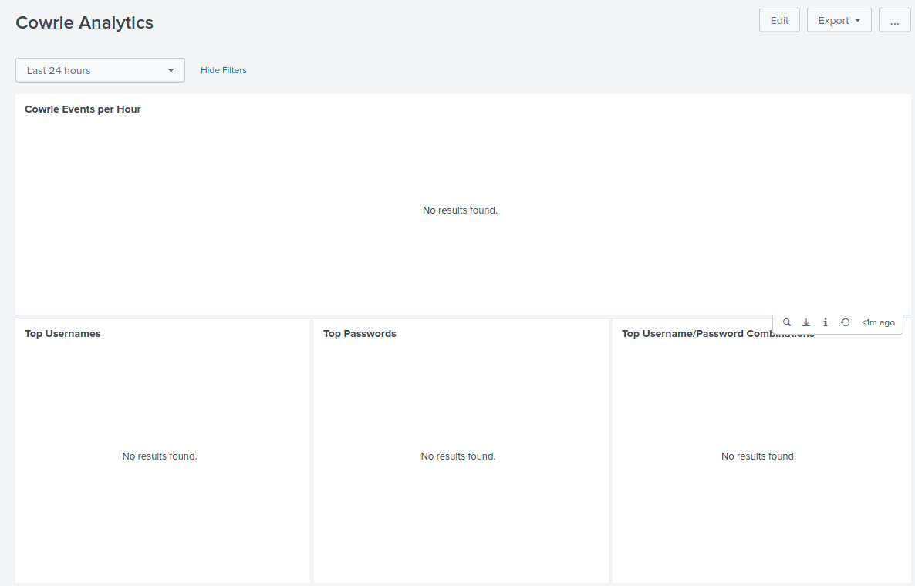

Figure The top 4 panels of the newly created Cowrie Analytics Dashboard designed to replace the Kippo Dashboard.



Figure The lower 5 panels of the newly created Cowrie Dashboard designed to replace the Kippo dashboard.

.

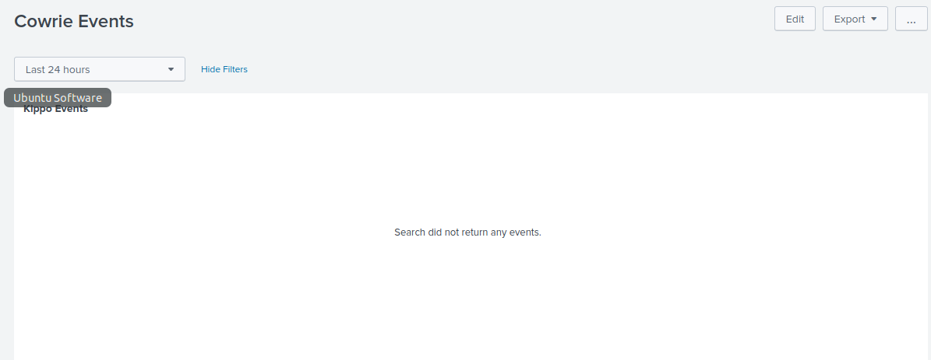

Figure The Newly created Cowrie Events dashboard designed to increase the efficeny of the Cowrie Analytics dashboard by reducing recurrsive searches.

### 5.3.6 Snort Dashboard Update

The Snort/Suricata joint dashboard was deleted to make way for a new pair of individual dashboards for both Snort and Suricata. This was done to improve efficiency. However, unlike as was done with previous dashboards, the ‘Snort Events’ panel was not moved to a separate panel. The decision to leave the ‘Snort Events’ panel within the analytics panel was done for expediency as when a researcher is viewing IDS/IPS alerts, these are usually triggered by potentially dangerous events and as such the research will, for the sake of expediency want fast access to all data. As such, in this case of these IDS and IPS sensors, extra panels only serve to create tool sprawl and slow the analytics process down. Therefore, some allowable inefficiency in the form of extra recursive searches is afforded to these sensors. However, since the Suricata and Snort sensors have been separated, in cases were both sensors are deployed (which is common in cases where a detection sensor is needed to cover specific interface, while an IPS is needed to cover the main inbound interface) some efficiency is gained.

The naming convention of the new snort dashboard was updated to reflect the fact that an event is just that, and event, and it is up to the researcher to determine if it is an actual attack. The upper half of the new Snort dashboard encompasses the ‘Snort Events per Hour’, ‘Top Sources’, ‘Top Source ports’, ‘Top Destinations’, and ‘Top Destination Ports’.

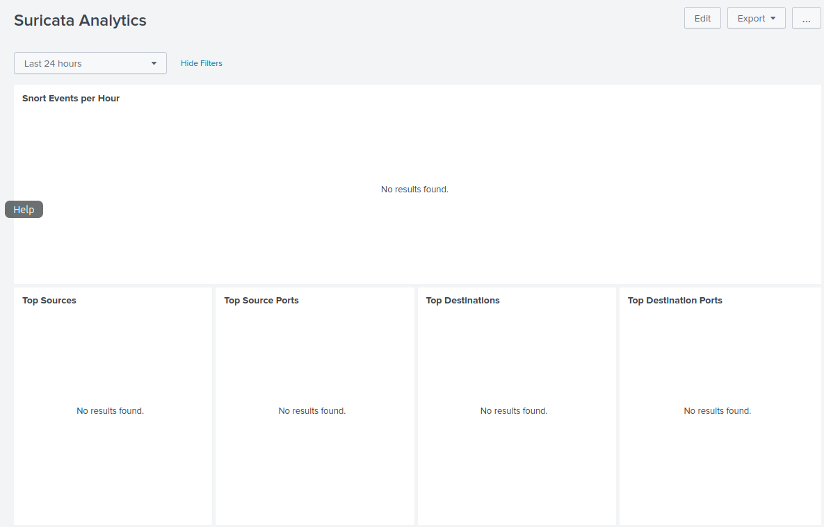

Figure The upper of the new Snort Dashboard.

The lower half of the new Snort Dashboard encompasses the ‘Top Sensors’, “Top Protocols’, ‘Top Severities’, ‘Top Signatures’ and ‘Suricata Events’ panels.



Figure The lower half of the newly created Snort Dashboard.

### 5.3.7 Amun Dashboard Creation

The Amun dashboard was successfully added with up to date naming convention which does not suggest that an event is an attack. It is up to the user to investigate each event and determine if it is an attack, or a false positive, just as they would if they worked in a real-world security operations center.

The first Dashboard was named ‘Amun Analytics’ and is aimed at being a snapshot overview of the activity being recorded on the Amun sensor. This dashboard includes panels for the following areas:

* Amun Events per Hour
* Top Event Sources
* Top Source Ports
* Top Destination Ports
* Top Sensors
* Top Protocols
* Top Event Severity
* Top Signatures

The second Dashboard was called ‘Amun Events’ and consists of only the Amun sensor events. This means we are not performing less recursive searches. The dashboards appear snappy and responsive as well as being visually easy to navigate data is easily identifiable.

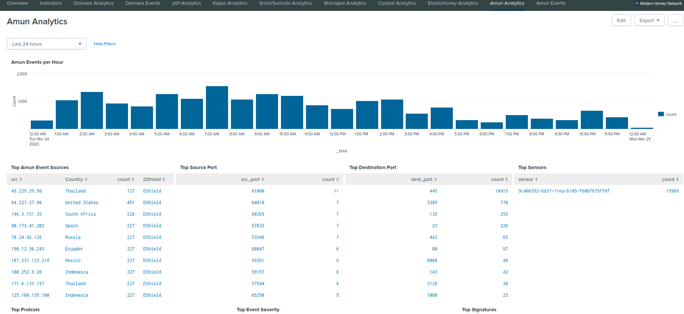

Figure The lower three panels of the newly created Amun Analytics dashboard.

Figure The first 5 panels of the newly created Amun analytics dashboard.

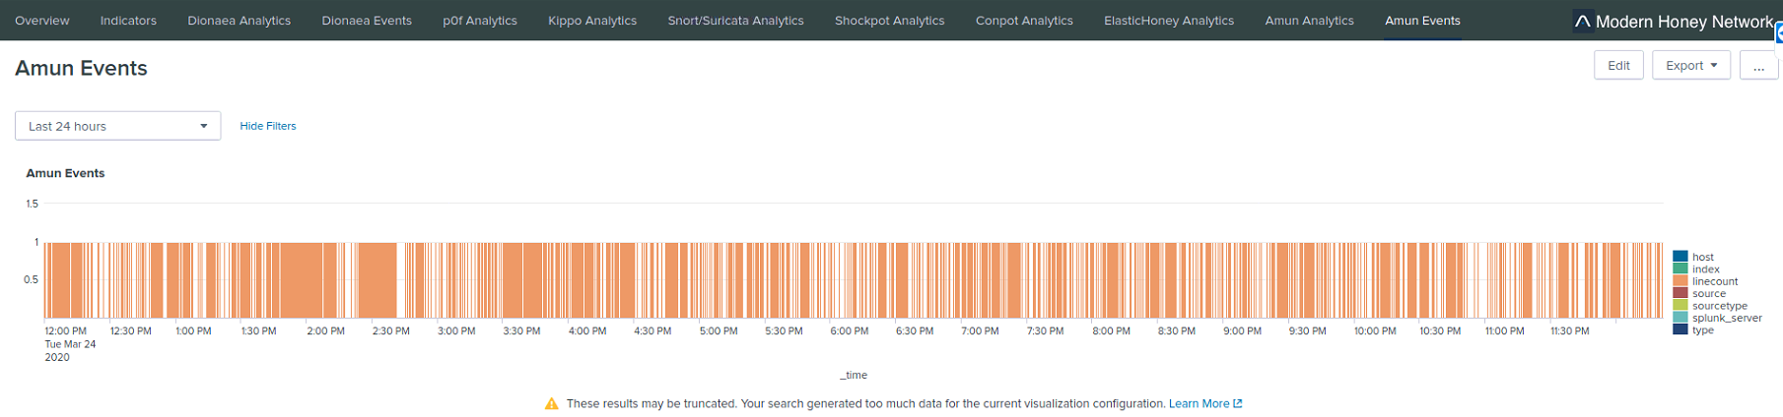

Figure The Newly created Amun Events dashboard containing the Amun events panel.

### 5.3.8 Elastichoney Dashboard Update

The Elastichoney dashboard update was designed to facilitate the possibility of the user having the ELK SIEM deployed. While this could potentially have a negative effect on the efficiency of Splunk users’ if they find themselves getting a lot of event detections, this is unlikely. However, it will allow for the platform to be multi platform in terms of its ability to work with multiple SIEMS.

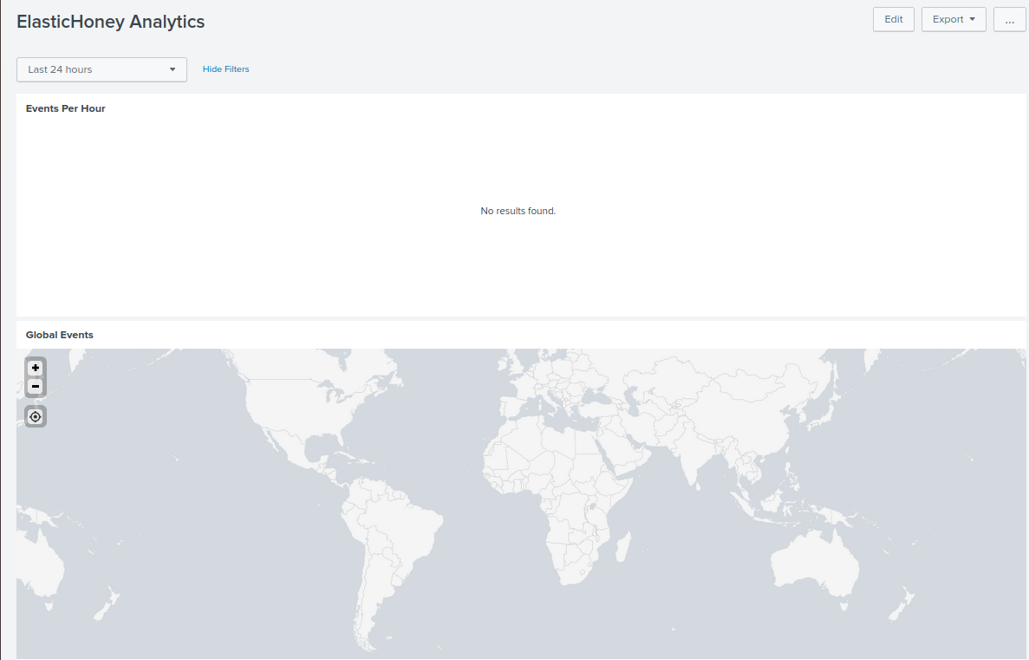

Figure The updated Elastichoney Analytics dashboard containing the 'Events per Hour' and 'Global Events' panels.

The upper half of the Elastichoney Analytics dashboard encompasses the ‘Events Per Hour’ and ‘Global Events’ panels.



Figure The lower half of the updated Elastichoney Analytics dashboard.

The lower half of the updated Elastichoney Analytics dashboard now encompasses the ‘Top Event Source Countries’, ‘Top Signatures’, ‘Top Severity’, ‘Top Event Source Cities’, ‘Top Events’, ‘Top Event Payloads’ and ‘Top Sensors’ panels. The ‘Top Severity is a new addition which adds useful relevant data.

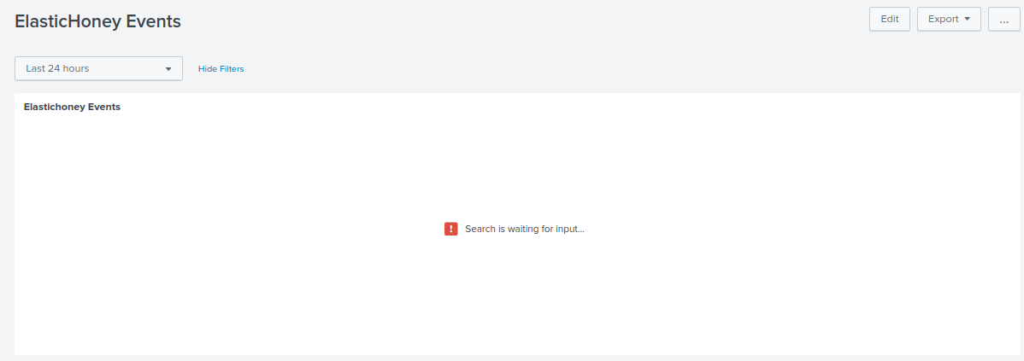

Figure The newly added Elastichoney Events dashboard.

The newly created Elastichoney Events dashboard contains only the ‘Elastichoney Events panel’ for efficiency if the app is being used on a system where the ELK platform has been deployed and a lot of events are recorded.

### 5.3.9 Glastopf Dashboard Creation

Glastopf is a medium to high interaction web application honeypot which simulates web server activity over port 8o and port 443. This server is still used but is depreciated.

### 5.3.10 Suricata Dashboard Creation

With the Snort/Suricata dashboard being deleted a new sensor was created for the Suricata Dashboard. The naming convention was updated and the search parameters where fixed so that the correct data was being mined. The resulting dashboard provides useful data relevant to event alerts and some efficiency has been gained by separating the snort searches out into a dashboard of their own.

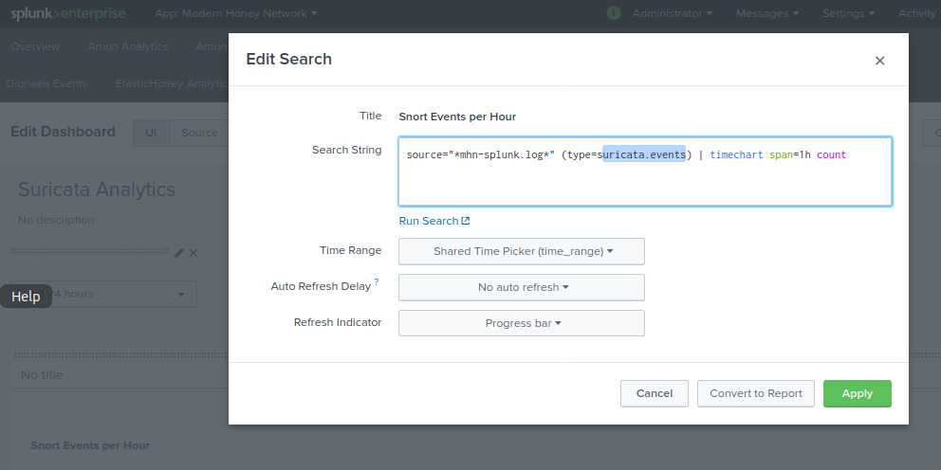

Figure The search parameters of the new dashboard are updated to search for the correct field 'suricata.events., instead of 'suricata.alerts'.

The upper half of the new Suricata dashboard encompasses the ‘Suricata Events per Hour’, ‘Top Sources’. ‘Top Source Ports’, ‘Top Destinations’ and ‘Top Destinations panels.

The lower half of the new Suricata panel encompasses the ‘Top Sensors’, ‘Top Protocols’, ‘Top Severities’, ‘Top Signatures (a new addition) and ‘Suricata Events’ panels.

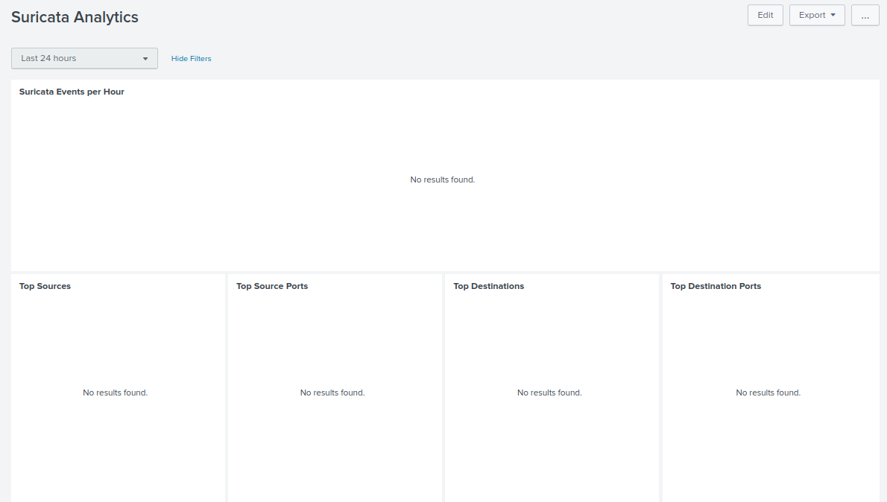

Figure The upper half of the newly created Suricata Dashboard.

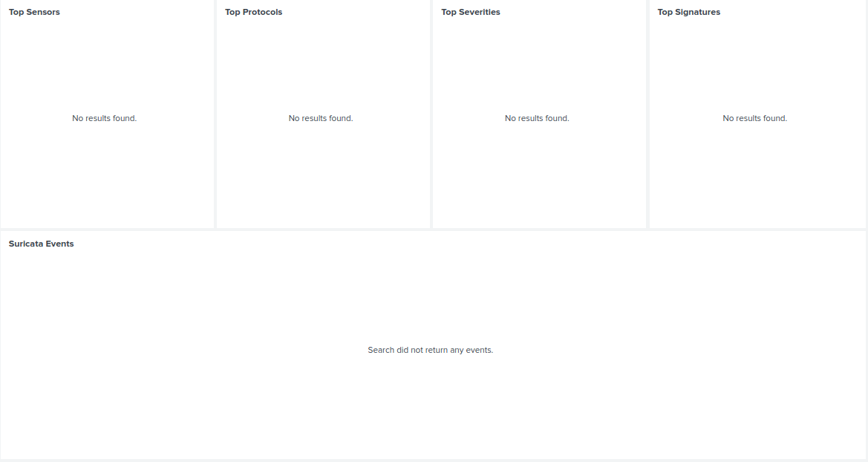

Figure The lower half of the newly created Suricata dashboard.

### 5.3.11 p0f Dashboard Update

The p0f Analytics dashboard was updated to improve the naming convention to remove the word attackers. This better reflects the fact that researchers should always investigation events to confirm they are attacks before assuming they are attacks, even if an app tells them they are attacks. Failure to investigate is a failure to investigate possible false positives.

The upper half of the updated p0f dashboard includes one change with the naming convention of the ‘Top

OSes’ panel being changed to ‘Top Os’s’. This panel now encompasses the ‘p0f Events per Hour’, ‘Top p0f OS’s’, ‘Top p0f Apps’ and ‘Top p0f Links’ Panels’.

Figure The upper half of the updated p0f panel.

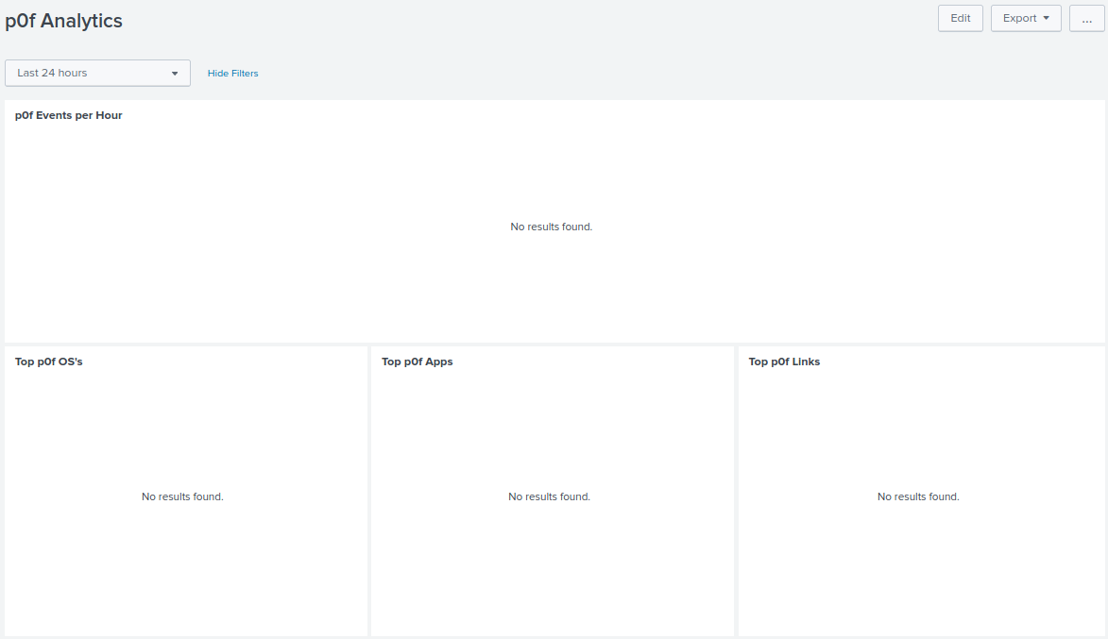

The lower half of the updated p0f panel includes an update to the naming convention for the former ‘Top p0f Attackers’ panel which is now the ‘Top p0f Event Sources’ panel. The lower half of the panel now encompasses the ‘Top p0f Event Sources’, ‘Top Ports’ and ‘Top sensors’ panels.

A new panel was created for the ‘p0f Events’ panel which was called the ‘p0f Events’ dashboard. This was done to increase efficiency by reducing recursive searches in the main dashboard.

Figure The lower half of the updated p0f dashboard.

Figure The new p0f Events dashboard which contains only the p0f Events panel.

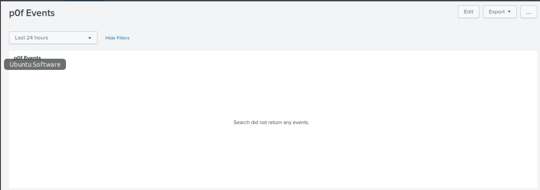

### 5.3.12 Shockpot Dashboard Update

The Shockpot dashboard, having been removed when the Shockpot Sinkhole server was Discovered to be reported false positives, was reinstated once it was discovered the non-sinkhole Shockpot sensor only reports verified Shellshock attacks. The Dashboard was separated into two dashboards to improve efficiency.

The upper half of the newly reinstated Shockpot Analytics dashboard encompasses the ‘Shockpot Events per Hour’, ‘Top MD5s’, ‘Top SHA1s’, and ‘Top SHA256’s’ panels.

Figure The upper half of the Shockpot Analytics Dashboard.

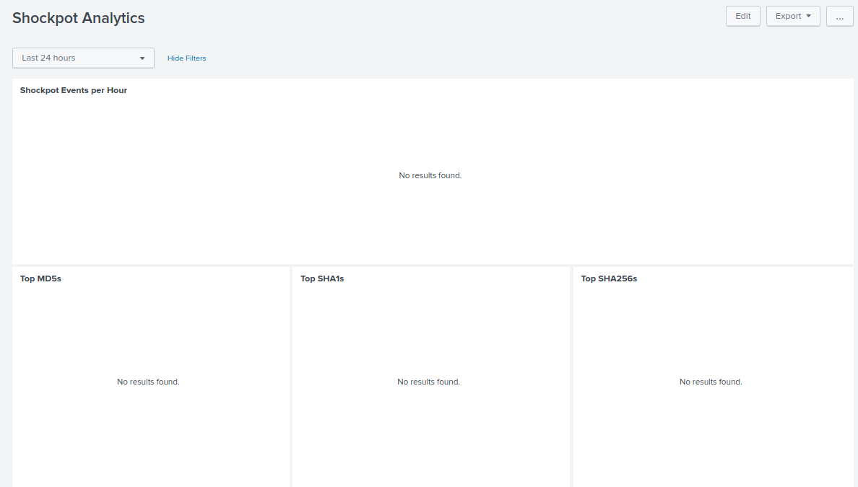

The lower half of the Shockpot Analytics sensor encompasses the ‘Top Shockpot Event Sources’, Top URLs Downloaded’ and ‘Top Sensors’ panels.

The newly created ‘Shockpot Events’ dashboard contains the ‘Shockpot Events’ panel which was moved to increase efficiency by reducing recursive algorithms.

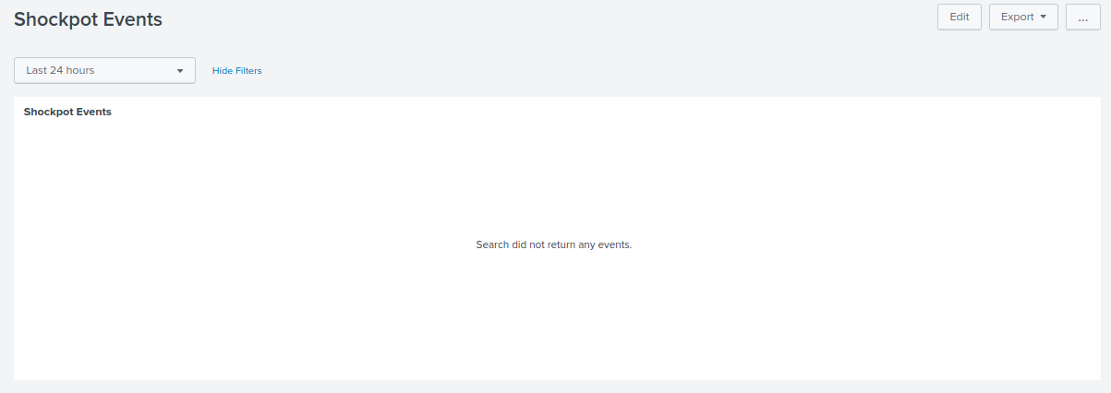

Figure The newly created Shockpot Events dashboard.

### 5.3.13 Wordpot Dashboard Creation

A dashboard for the Wordpot sensor does not exist. The lack of activity due to not having any WordPress themes or plugins installed also fails to produce any logs. However, working with the HPfeeds-logger file on the MHN management server the fields available can be viewed. Working from other dashboards, we can generate searches and confirm they work, before substituting the ‘type’ field for the ‘wordpot.events’ attribute that would, if data was available mine the Wordpot data from the mhn-splunk.log file and say with reasonable certainty that the dashboard will work.

While this researcher has never seen any activity on this sensor, it is possible that intermediate or perhaps even novice users may wish to deploy a WordPress blog and some themes and/or plugins for research purposes. For this reason, while the creation and deployment of a WordPress Blog is out of scope for this project, a dashboard was designed to facilitate this possibility. A second dashboard as created to house the ‘Wordpot Events’ panel to increase efficacy by reducing recursive searches.

The upper half of the new Wordpot Analytics Dashboard encompassed the ‘Wordpot Events per Hour’, ‘Top Wordpot Event Sources’, and ‘Top Source Ports’ panels.

Figure The upper half of the newly created Wordpot dashboard.

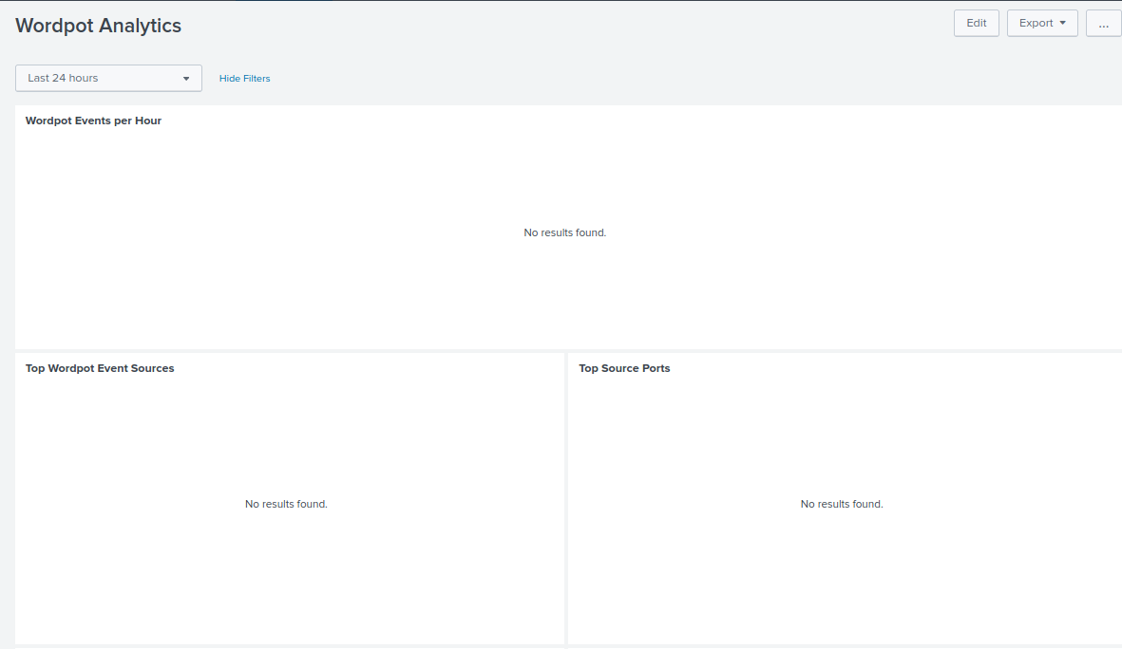

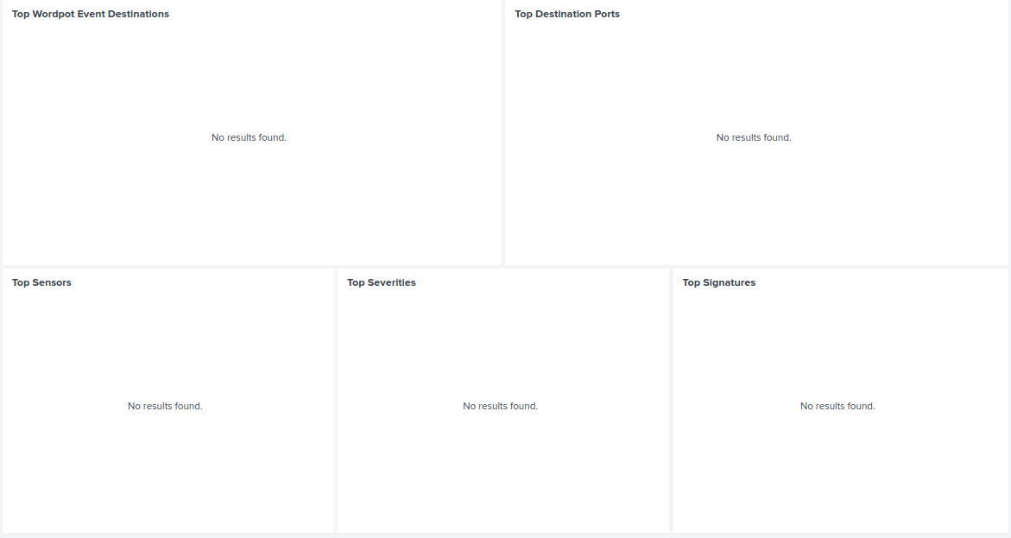The lower half of the Wordpot dashboard encompasses the ‘Top Wordpot Event Destinations’, ‘Top Destination Ports’, ‘Top Sensors’, ‘Top Severities’ and ‘Top Signatures’ panels.

Figure The lower half of the newly created Wordpot dashboard.

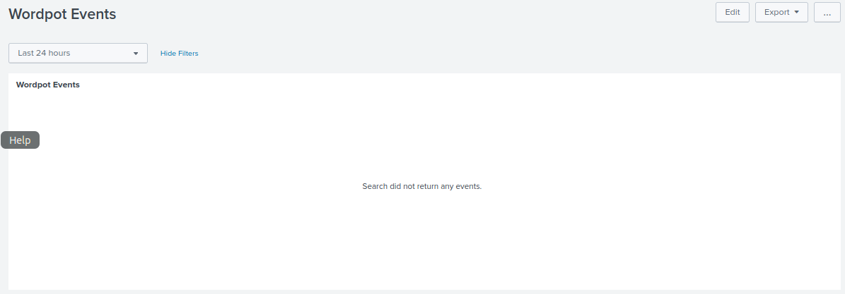

Figure The newly created second dashboard 'Wordpot Events' created to house the 'Wordpot Events' panel.

### 5.3.14 Magenpot Dashboard Creation

No dashboard can be implemented for the Magenpot sensor as no logs are produced that the HPfeeds-logger function can translate into the mhn-splunk.log file.

### 5.3.15 Drupot Dashboard Creation

No dashboard can be implemented for the Drupot sensor as no logs are produced that the HPfeeds-logger function can translate into the mhn-splunk.log file.

### 5.3.16 Conpot Dashboard Update

The Conpot Analytics dashboard was upgraded to improve the naming convention. The new Analytics dashboard now encompasses the ‘Conpot Events per Hour’, ‘Top Types’, “Top Event Source Countries’, ‘Top Conpot Event Sources’ and ‘Top Conpot Sensors’ panels.

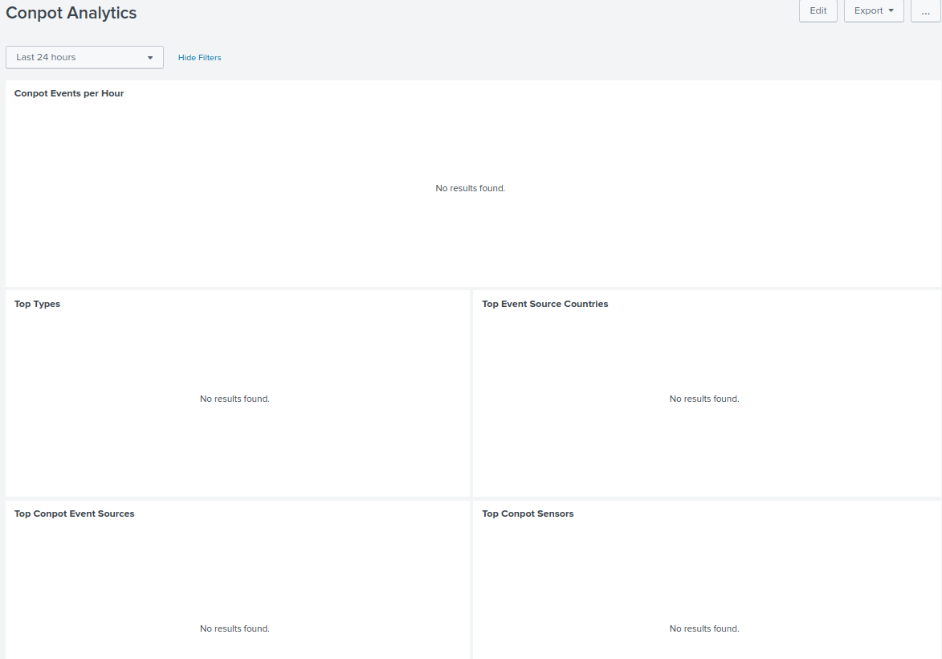

Figure The newly updated Conpot analytics sensor.

The newly created Conpot Events dashboard contains only the ‘Conpot Events’ Panel. By moving this panel into a new dashboard, we increase efficiency in both dashboard by reducing recursive searches.

Figure The newly created Conpot Events dashboard containing the Conpot events Panel.

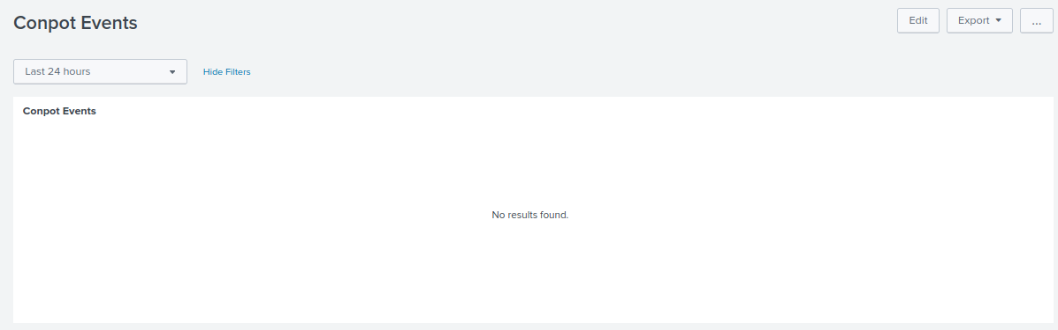

## 5.4 ViMal-Total: A Python-Based VirusTotal Parser

**Activity diagram Legend:**

 = Program initial state.

 = Program end state.

= Action/control flow directional indicator.



 =Action or activity state.

 = Decision node with branching.

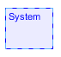 = System boundary.

**Use case diagram Legend:**

 = Actor.

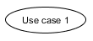 = Use case.

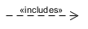 = includes branch leading to extended functionality.

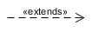 = Extends branch which extends from a function activated (example: Error) by a previous function.

 = Divider added to separate functions visually.

 = System boundary.

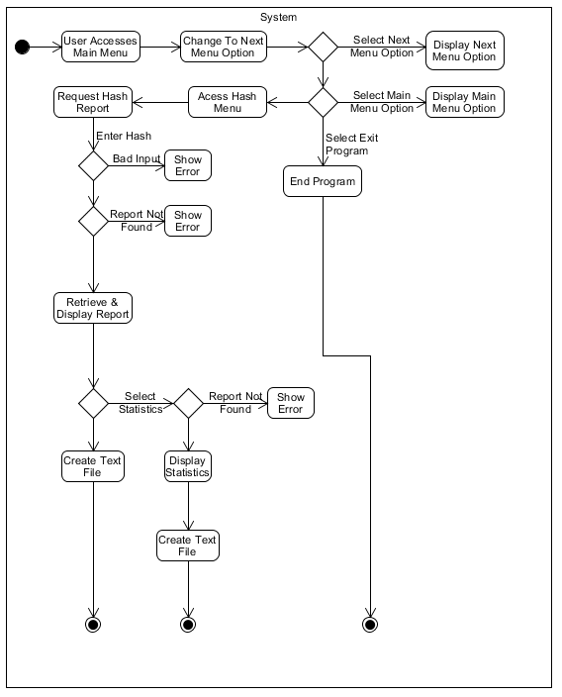

Figure Activity diagram laying out the functionality of the first sub menu option, the HASH options.

Here in figure 169, we see the first sub menu option activity diagram, the HASH options menu. This diagram lays out the programs initial state, activity flows, decisions trees with branches activity and action states finishing each branch with the program ending state.

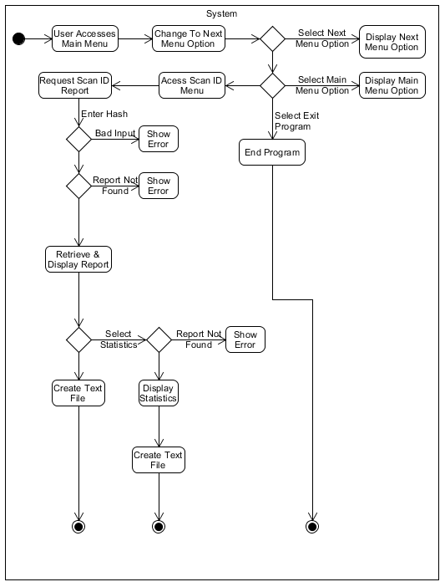

Figure Activity diagram laying out the functionality of the second sub menu option, the Scan ID options.

Above in figure 170, we see the second sub menu option activity diagram, the Scan ID options menu.

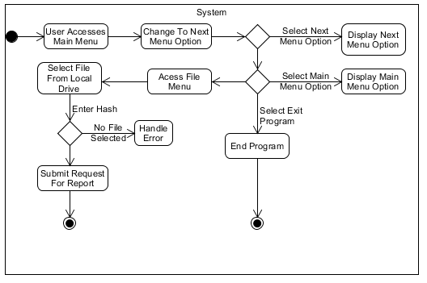

Figure Activity diagram laying out the functionality of the third sub menu option, the File options.

Above, in figure 171, we see the third sub menu option activity diagram, the File options menu.

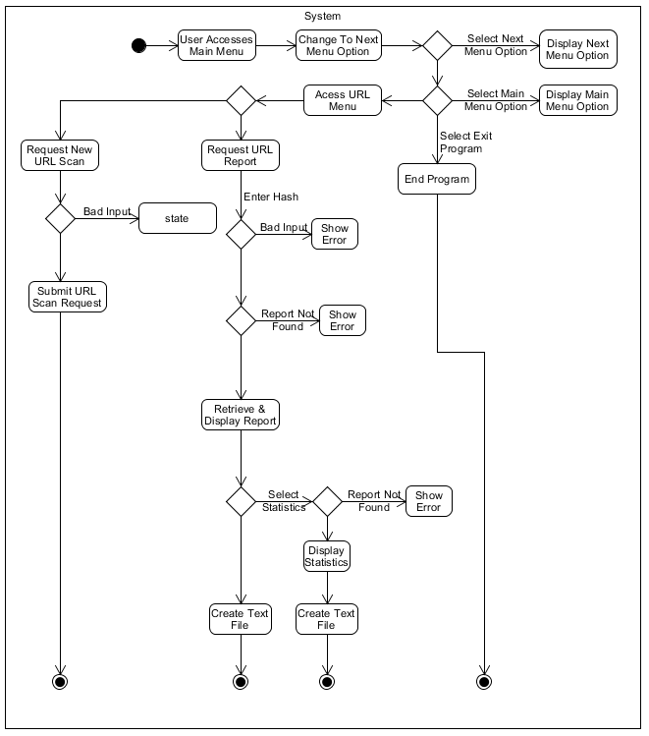

Figure Activity diagram laying out the functionality of the fourth sub menu option, the URL options.

Next, in figure 172, we see the fourth sub menu option activity diagram, the URL options menu.

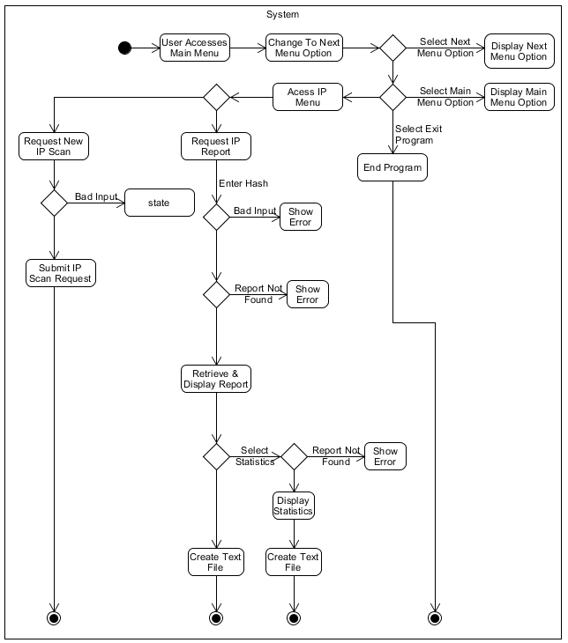

Figure Activity diagram laying out the functionality of the fifth sub menu option, the IP options.

In figure 173, we see the fifth sub menu option activity diagram, the IP options menu.

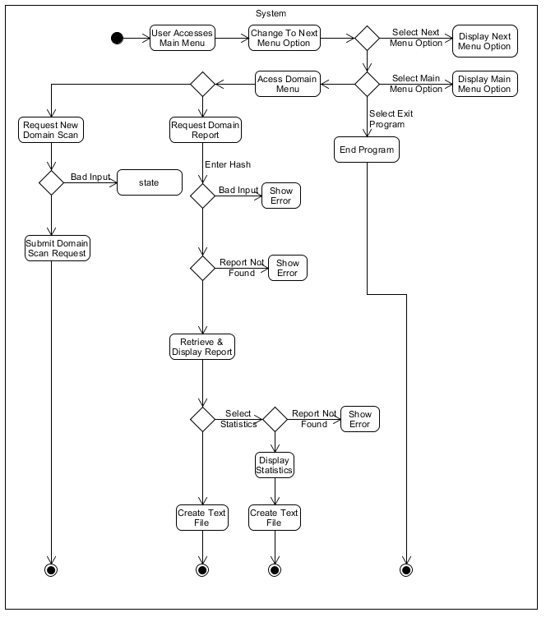

Figure Activity diagram laying out the functionality of the sixth and final sub menu option, the Domain options.

And lastly regarding activity diagrams, figure 18 shows the sixth and final sub menu option activity diagram, the IP options menu.

Next, a consolidated use case diagram was designed. This allowed for further examination of the functionality of the entire program to determine if any changes were needed and if any functionality had been overlooked in the activity design phase.

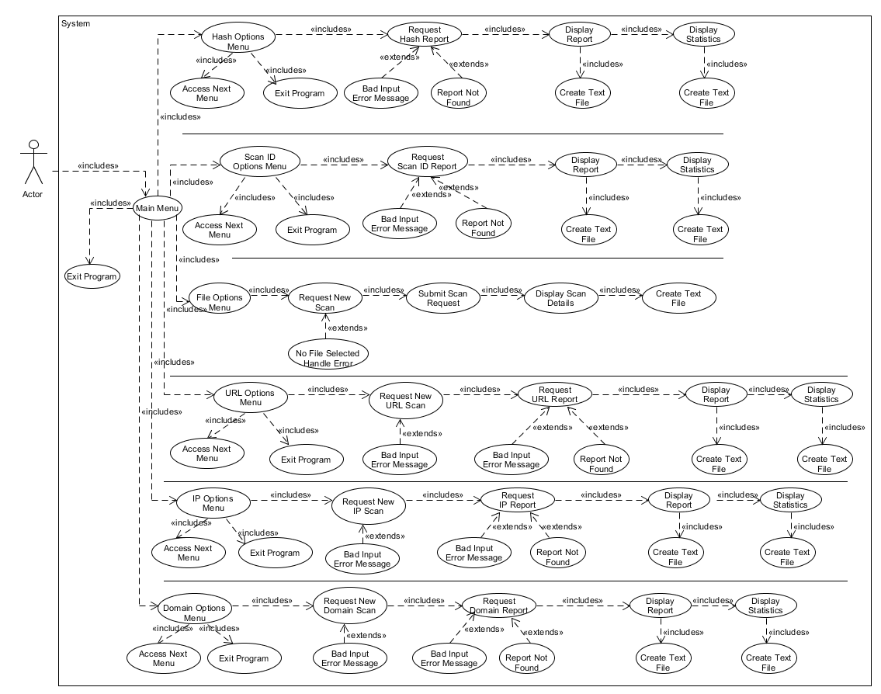

Figure Consolidated use case Diagram displaying all functions.

Here we can see the consolidated use case diagram incorporating all potential errors which will have to addressed.

**Implementation Phase:**

The breakdown of the implementation of the applications code was handled in snippets. Since the full code will be available for examination from a git hub repository listed in the Appendix of this document.

The focus will be on small snippets displaying the core functions. Basic code, such as minor functions such as ‘message alert’ functions, and ‘print’ functions are not documented.

While approaching the implementation of the code, efficiency was the key driving factor. The program had to be simple. So simple that anybody with the most basic understanding of Python could alter, adapt or improve upon its functionality. For example, as a future project I am considering adding in some Shodan API functions that would for the addition of Shodan functionality which would allow access to information pertaining to Internet of Things (IoT) device data to also be collected and displayed as it is quite possible that an attack agent might pivot through an IoT device to launch an attack against a system. Any user who can implement basic API calls using the request function similarly to how it has been used in the program, should be able to understand the programs code and add this functionality in reasonably quickly.

For this reason, after some consideration, object orientated code was ruled out in favor on one classless file. After consultation with my project advisor, code modularization was adopted to reduce code repetition.

**Core Functions**

I began the documentation process with the declaration of the global API key and global functions, and the root frame creation and the layout of what will essentially be a card style layout of the frames upon which the widgets will be placed.

# This is the global API key variable, users must enter their own API key here if this field is set as a blank string  
# this is an academic key which allows for 20,000 API calls per day.  
apikey = '****************************************************************'  
  
  
# define function to raise a card to the front of the deck  
def raise_frame(frame):  
 frame.tkraise()  
  
  
# define function to quit program  
def QuitProgram():  
 exit(0)

Here we see the global API key declaration (the key has been redacted for security purposes), followed by a function to raise frames when called. While on startup, all frames are created and held in memory, this function will raise a frame to the foreground and send all other frames to the background. One interesting bonus from this simple implementation is that when a frame is pushed to the background by the raising of another frame, the contents of the frame remain in memory. So, until the program is shutdown, or a new search conducted within the backgrounded frame, the last search is retained in the frames output text field for display or text file creation purposes. Lastly in this code snippet we see a general function to handle exiting the program with the ‘exit(0)’ function.

Next up, as seen below, I created the root frame with the ‘root =TK()’ command which calls the creation of a root frame from the tkinter library. A title was amended to this frame using the ‘root.title(‘’)’ function.

A static size was set using the ‘root.geometry(‘’)’ function and the ability to resize the frame was disabled with the ‘root.resizeable(False,False)’ function. This is followed by the declaration of the constituent frames upon which all the desired widgets will be placed on frame creation as and when called. Each frame is created using the template ‘<FRAME NAME> = Frame(root, bg =’Navy Blue’)’ (where FRAME NAME is a place holder for the actual frame name). The addition of root attribute attaches the constituent frames to the root frame and the addition of the ‘bg’ attribute sets a background color of Navy Blue to each of the constitute frames.

Lastly, a for loop was declared which places the frames into an array which is organized based on a grid layout. This allows for frames to be called very easily with a smooth transition and the alignment of widgets on each frame. It was important to decide carefully here which layout to use for the frames, as the grid layout and pack layout styles cannot be used on the same frames. A pack layout would have resulted in much smaller frames and a grid layout for widgets would have resulted in larger buttons, labels and other widgets. This would have resulted in a rather disproportionate looking GUI. Therefore, the decision to go with a grid frame layout was felt to be the correct route to go. Once grid was used at this stage, it restricted the widget layout on widget container frames to the .pack().

# declare root frame  
root = Tk()  
root.title('ViMal - Total : A VirusTotal Parser by James Finglas')  
root.geometry('556x730')  
root.resizable(False, False)  
  
# Declare frames for card layout  
MainMenu = Frame(root, bg='Navy Blue')  
Hash = Frame(root, bg='Navy Blue')  
ScanID = Frame(root, bg='Navy Blue')  
File = Frame(root, bg='Navy Blue')  
URL = Frame(root, bg='Navy Blue')  
IP = Frame(root, bg='Navy Blue')  
Domain = Frame(root, bg='Navy Blue')  
  
# For loop to to select a frame from a list  
for frame in(MainMenu, Hash, ScanID, File, URL, IP, Domain):  
 frame.grid(row=1, column=0, sticky='news')

"""########################################## MAIN MENU OPTIONS #####################################################"""  
  
img = ImageTk.PhotoImage(PilImage.open('D:\\USB Backup\\Year 4\\Applicaton Security\\CA3\\ViMal\\vimal logo.png'))  
Label(MainMenu, image=img).pack()  
Label(MainMenu, width=60, text='Version 2.0 - Developed With VirusTotal API and Python 3.7', bg='gray').pack()  
MainMenuLAbelFrame = LabelFrame(MainMenu, width=60, text='Welcome to the Main Menu', bg='gray')  
MainMenuLAbelFrame.pack(expand=1)  
Label(MainMenuLAbelFrame, width=60, text='Main Menu', bg='gray').pack()  
Label(MainMenu, width=60, text='Please Select from the following options:', bg='gray').pack()  
Button(MainMenu, width=60, text='Go to Hash Lookup Page', command=lambda: raise_frame(Hash)).pack()  
Button(MainMenu, width=60, text='Go to Scan ID Lookup Page', command=lambda: raise_frame(ScanID)).pack()  
Button(MainMenu, width=60, text='Go to File Lookup Page', command=lambda: raise_frame(File)).pack()  
Button(MainMenu, width=60, text='Go to URL Lookup Page', command=lambda: raise_frame(URL)).pack()  
Button(MainMenu, width=60, text='Go to IP Lookup Page', command=lambda: raise_frame(IP)).pack()  
Button(MainMenu, width=60, text='Go to Domain Lookup Page', command=lambda: raise_frame(Domain)).pack()  
Button(MainMenu, width=60, text='Exit Program', command=lambda: QuitProgram()).pack()  
Label(MainMenu, width=60, text='With thanks to Virus-Total For their free use of their amazing API!', bg='gray').pack()  
  
"""##################################################################################################################"""

For the Main Menu frame I created a banner that includes an image , I began the process of adding widgets an image using the ‘img = imageTk.PhotoImage(pilImage.open(‘<IMAGE LOCAL LOCATION>’)’ function (Where IMAGE LOCAL LOCATION is a place holder for the images storage location on the local disk. This makes use of the Pillow and Pillow-PIL libraries to declare the creation of an image object. This was then attached to the main menu via a label with the ‘Label(MainMenu, Image=img).pack()’ function. The MainMenu attribute attaches the label to the MainMenu frame, and the Image=img attribute attaches the previously created image to the label. The pack function shrinks the space used by the object to only the absolute space needed to fit the object. This img object became the main menu banner image.

In relation to the general GUI widget component declaration and initialization process, while they shall not all be documented, two types of button creation were documented. First, an anonymous button was covered.

Button(MainMenu, width=60, text='Go to Hash Lookup Page', command=lambda: raise_frame(Hash)).pack()

Here we can see that the button has no name and is referenced anonymously at the time of user interaction.

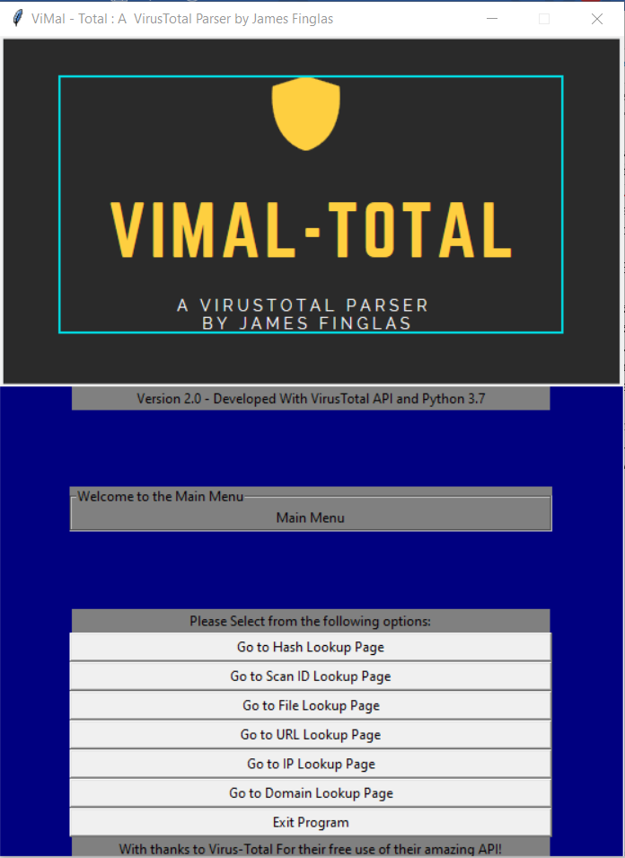

Figure Here we see the MainMenu frame displayed.

**Hash lookup Page**

Moving onto the first frame to contain a VirusTotal API request, we can see below that the function declares a URL which is the URL variable that will be sent in the request call to the API. This is the web address from which the specific type of data response we wish to get will be returned. In this case, we are specifically request a ‘File report’ response. This API function allows for request of a report via the hash or Scan ID.

Next, the input that will make up the Hash or Scan ID that we wish to request is declared and initialized from user input, retrieved from the input field ‘HashIdTextBox’ in this case with the .get() function and assigned to the variable ‘hashuserinput’.

The parameters for the request which will be sent from this function are then set by declaring the global API key declared as the API key to be used in the request and the ‘resource’ (or item we wish to request a response for) to be sent in the request set as the user input variable ‘Hashuserinput’ just declared previously.

Finally, the request is sent, and the response is received, declared and initialized all in one function. This is handled by the requests package via the ‘requests.get()’ function, with the url added, the params set and the response set to be returned as a JSON file with the code: ‘response = requests.get(url, params=params).json()’.

# function to request a file or hash report  
def hashfunction(event):  
 url = 'https://www.virustotal.com/vtapi/v2/file/report'  
  
 hashuserinput = HashIdTextBox.get()  
  
 params = {'apikey': apikey,  
 'resource': hashuserinput}  
 response = requests.get(url, params=params).json()

Once the response has been received, the .delete() function is used to ensure that the text field is empty as the functions to insert text, insert text from the current last character position as can be seen below. This function deletes all text from the first character position to the last. What this means is that if any text exists, whatever text the program is attempting to write to the text field, will be appended to the end of the file. Therefore, the text field must be empty when new data is being output from a new response.

# ensure text field is empty  
Hashreportoutput.delete(1.0, END)

The next function creates a file to track the creation of new Hash reports if they are requested by the user.

# Function to maintain count and id of file/hash files  
def makehashfile(event):  
 newcounter = 0  
 if os.path.isfile('hash_counterFile.json'):  
 with open('hash_counterFile.json') as data_file:  
 data = json.load(data_file)  
 newcounter = data["counter"] + 1  
 data_file.close()  
  
 with open('hash_counterFile.json', 'w') as fp:  
 fp.write("{\"counter\": " + str(newcounter) + "}")  
 fp.close()  
 else:  
 with open('hash_counterFile.json', 'w') as fp:  
 fp.write("{\"counter\": 0}")  
 # create file which will be used for file number iteration and maintain file/hash data record  
 with open('Hash report ' + str(newcounter), 'w') as fp:  
 fp.write(Hashreportoutput.get(1.0, END))  
 hashthank2()

Above, the second method of button creation declares a specific name and the button then has a function event bound to it. These methods of anonymous and non-anonymous widget creation processes were used through the program. The advantage of an anonymous widget is that several functions can be attacked to one widget if the programmer wished.

The next function, the ‘makehashfile()’ function, creates a text file from the text data contained within the frames report text field output. In order to track the numerical creation of these files a method must be designed to track the count of the files that have previously been created. This is handled by the reaction of json file the contains a {‘key’:‘value’} combination which holds the value of a counter variable. A ‘newcounter’ variable is declared and initialized at 0. To determine if a ‘counterfile’ related to this frames file creation process exists, the ‘os.path.isfile()’ function is used to check if there is a file called ‘hash_counterFile.json’ in the programs directory.

If the file exists, the ‘open()’ function is used to create while opening the file as a data object called ‘data_file’. The text is then and extracted from the JSON file converted to a data object called Data. The ‘newcounter’ variable is then reinitialized to increase by. The data file object is then closed. The result is that the very first file will always by file 0, the second will be file 1 and so on with each file incrementing my 1. The deletion of the ‘hash_counterfile’ (or similarly named file pertaining to any of the other frames) will reset this count with the counterFile being recreated on the next call. If the file does not exist the open() function is used to create while opening the file ‘hash_counterFile.json’. The file then has the {‘key’ : ‘value’} data written to the file which sets the key value to the default value of the ‘newcounter’, which is 0 as declared initially. With the method to track the text file creation now setup, the open() function is not used to create while opening a file called “Hash Report <Number of file> with <Number of file> being place hold for the value contained in the ‘hash_counterFile’ JSON file. The data contained in the Targeted text field within the Hash Lookup Page frame is written to the file in the program’s directory.

The final function, the ‘displayhashstatsonly()’ function replicates the functionality of the first function ‘hashfunction()’, however, rather than mining all data returned within the json file, this function focuses on mining only data that pertains to the details of the resource that was searched and the statistical data that is returned such as the total number of engines the resource was scanned by, and the results of the scans.

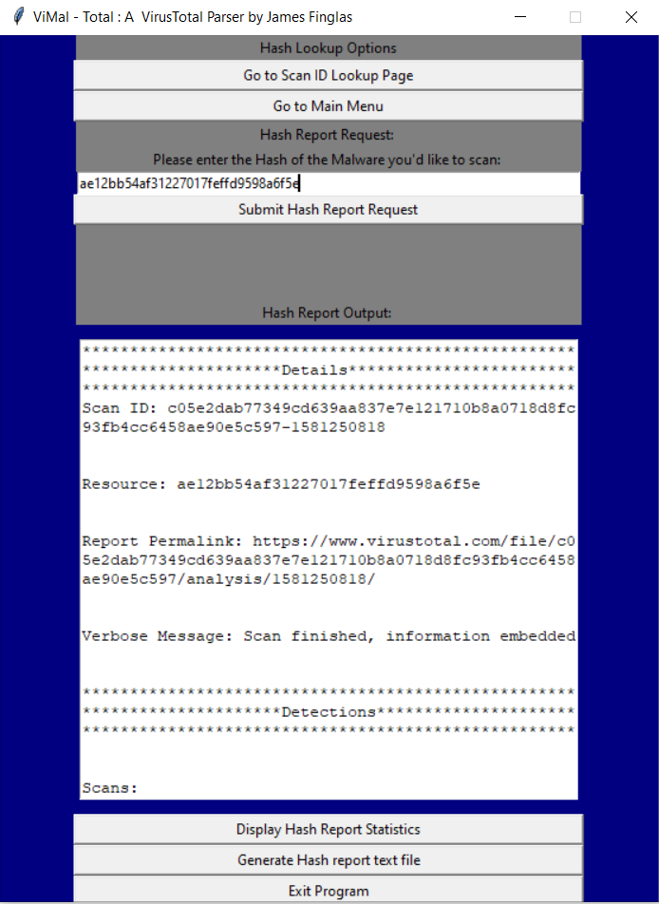

Figure Here we see a sample Hash report mined from a json and output to the Hashreportoutput text field.

Above in figure 177, the user has requested a Hash report and the response has been received, mined and output to the ‘Hashreportoutput’ text field.

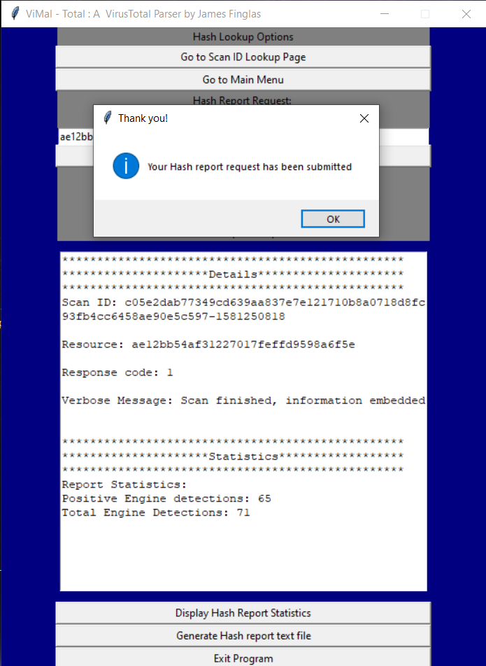

Figure Here we see a sample of statistical data mined from a json and output to the Hashreportoutput text field (With confirmation alert message).

Here in figure 178, the user has requested the same report but only the statistical related data and identifying details.

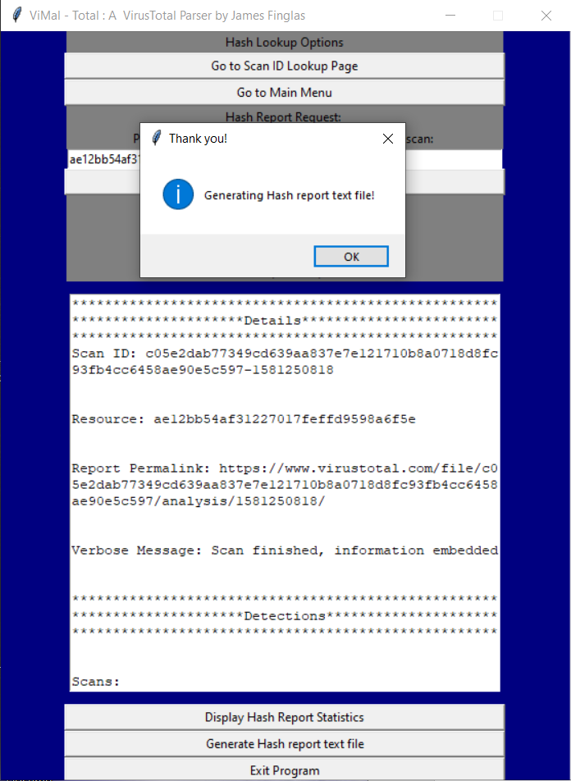

Figure here we see that the user has requested a text file be generated from the data contained within the Hashreportoutput text field.

Above in figure 179, the user has requested that a text file be generated with from the data contained within the text field.

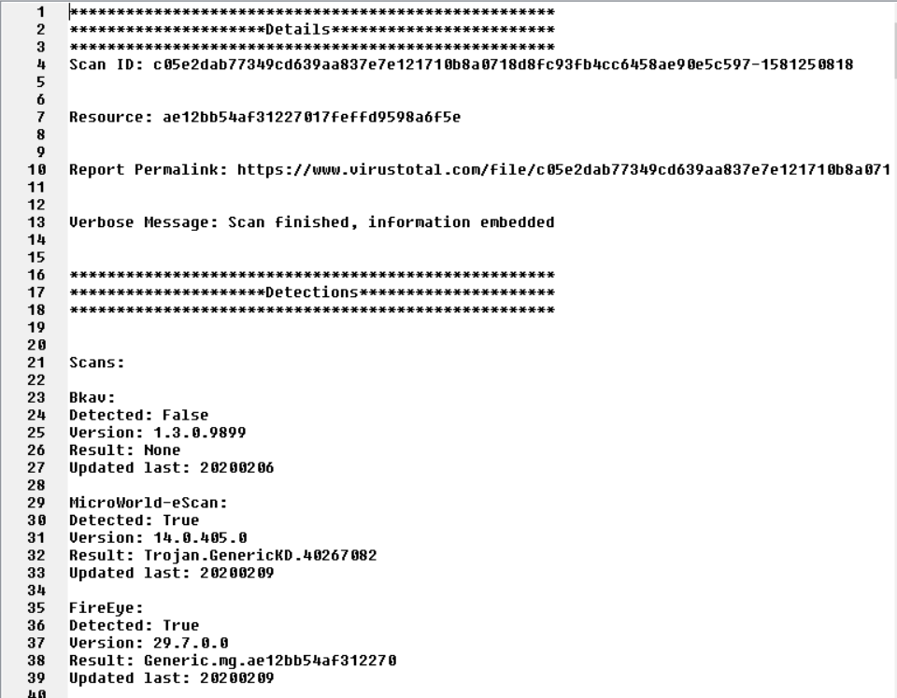

Figure Here we see a sample of the text file generated by the users request to create a text file.

Here we see a sample of a text report generated at the users request from the data contained within the ‘Hashreportoutput’ text field.

**Scan ID Lookup Page**

The functionality of the Scan ID Lookup Page replicates the functionality of the Hash Lookup page. As previously documented, VirusTotal the file/report API URL allows for looking up any hash or scan ID. However, upon some consideration it was decided to separate the searching of hashes and Scan IDs into two separate functions. This was done to increase usability as some users new to the field of cyber security may be confused by this dual functionality. More importantly, by separating the two search options possible via this URL, it allows for saving a hash scan and a Scan ID scan as a either a Hash text file or a Scan ID file making it easier to file specific files by type.

# function to request a file or hash report  
def ScanIdFunction(event):  
 url = 'https://www.virustotal.com/vtapi/v2/file/report'  
  
 scanuserinput = ScanIdTextBox.get()  
  
 params = {'apikey': apikey,  
 'resource': scanuserinput}  
 response = requests.get(url, params=params).json()  
  
 # ensure text field is empty  
 ScanIdReportOutput.delete(1.0, END)

Following the same format as the Hash Lookup Page frame, The Scan ID Lookup Page began with some API request functions. As seen above, some variable names change to variables specific to this frame, but the overall structure remains the same. Before attempting to write data from the response JSON function again ensures the text field is empty. The JSON data is then mined for existing JSON keys and values and the data is output to the text field.

# Function to maintain count and id of ScabID files  
def MakeScanIdFile(event):  
 newcounter = 0  
 if os.path.isfile('ScanId_counterFile.json'):  
 with open('ScanId_counterFile.json') as data_file:  
 data = json.load(data_file)  
 newcounter = data["counter"] + 1  
 data_file.close()  
  
 with open('ScanId_counterFile.json', 'w') as fp:  
 fp.write("{\"counter\": " + str(newcounter) + "}")  
 fp.close()  
 else:  
 with open('ScanId_counterFile.json', 'w') as fp:  
 fp.write("{\"counter\": 0}")  
 # create file which will be used for file number iteration and maintain file/hash data record  
 with open('Scan ID report ' + str(newcounter), 'w') as fp:  
 fp.write(ScanIdReportOutput.get(1.0, END))  
 scanidthank2()

As before, the same method used in the Hash Lookup Page frame is used to create a file creation number tracking process, before a text file is created from the data is created from the text contained in the Scan ID’s Lookup Page frames text field.

Finally, the first function of the Scan ID Lookup Page is replicated, and similarly to the final function for the Hash Lookup page, this time the response is mined only for data relating the details and statistics pertaining the item for which a report was requested.

The outputs are the same as the previous frame with the only differences being the names of variables and potentially the specific keys which might contain data.

There are 6 frames of Lookup Page menus contained in the program which:

* Hash Lookup Page
* Scan ID Lookup Page
* File Scan Request Page
* URL Lookup Page
* IP Lookup Page (New and previously existing)
* Domain Lookup Page (New and previously existing)

It is important to note that should the user Elect to a File from the local drive, make a URL report request, or make an IP or a domain request; any one of these search types will result in both a hash and a Scan ID. This allows for report pertaining to these searches to be retrieved via either the Hash Lookup Page or The Scan ID Lookup page.

**File Lookup page**

The File Lookup Page frame is the first frame to make use of another API URL request address and request type. This first function seen below, ‘fileoutput()’, accesses the file/scan API URL address to request a scan of a new file located on the users local disk, be it a hard drive, phone, flash device etc. This has an interesting additional bonus of allowing a user to scan a suspicious file, any file, even those not generated or mined by the MHN platform, not just by their own localized antivirus but by all of the virus engines incorporated into the VirusTotal API web framework. This helps to rule our false positives such as user created programs, JAR files, or modified files such customized Driver Files that may be highlighted as suspicious.

This function also varies in how it declares and initializes the resource that the user wished to scan. While the resource is still set via user input, this time the ‘askopenfilename()’ function is used to select the file directly from a file navigation and selection browser window. Once the file has been selected it is converted into a file data object with the ‘file:(<NAME OF FILE VARIABLE>, open(Fileselection, ‘rb’))’ method. This selects the file, opens the file and assigns to the newly initialized ‘files’ variable. The params, files and URL variables are then fed into the request as previous functions have done.

# Function to select file you wish to be scanned and request the scan  
def fileoutput():  
 url = 'https://www.virustotal.com/vtapi/v2/file/scan'  
  
 FileSelection = askopenfilename()  
  
 params = {'apikey': apikey}  
 files = {'file': (FileSelection, open(FileSelection, 'rb'))}  
 response = requests.post(url, files=files, params=params).json()  
  
 # ensure text area is empty  
 FileIdReportOutput.delete(1.0, END)

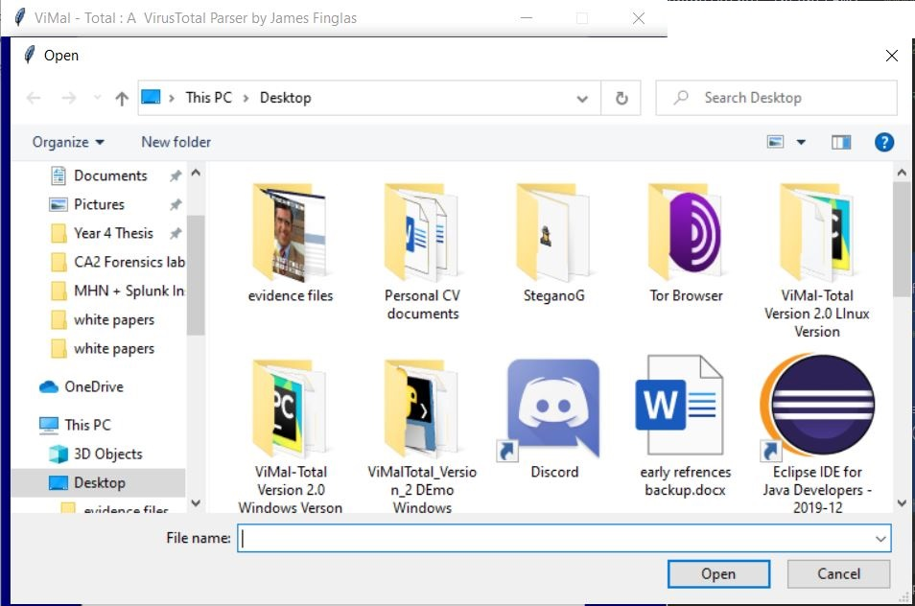

Figure The file browser window opened by the askopenfilename() function.

Unlike before, while the user can still elect to create a text file from the date contained with the frames text field, a record is also automatically created. This file is called the ‘File Scan Id File”. This file records the basic details of the item searched, such as Scan ID, Hash, permalink URL and name of item searched. This information is mined from the JSON request and written to the file as it is being output to the text field.

The difference between this file and the other user create text files is that this file does not create a new file with each file scan requested. Instead, a new record is added the the ‘FileScan ID File’ which is added by the use of the ‘a’ attribute in the ‘with open(File Scan ID File’, ‘a’) as fp’ object, which creates or opens the file as an ‘fp’ object and appends the data to the file. Finally a text alert message function, ‘filescanthank()’, is called to generate a confirmation that the request has been submitted.

# create record file of scan data  
with open('File Scan ID File', 'a') as fp:  
 # define function to write a divider  
 fp.write("**************************New Record******************************")  
 fp.write("" + "\n")  
 fp.write("The File Scanned was: " + str(response["resource"]) + "\n")  
 fp.write("The scan Id is: " + str(response["scan_id"]) + "\n")  
 fp.write("The permalink is: " + str(response["permalink"]) + "\n")  
 fp.write("The result of the request was: " + str(response["verbose_msg"]) + "\n")  
 fp.write("" + "\n")  
 fp.write("******************************************************************")  
 fp.write("" + "\n")  
filescanthank()

Next the process of creating a file creation number tracking system as before we created to track the creating of user request text files from the data contained in the frames test field.

This option is added as a usability and quality of life option. It allows a user to create an individual record rather that a record contain in a list. As Honeypot generated by the sensors contained in the MHN platform for example, can be quite extensive results in thousands of binary scraped files, as specific files are identified as being of key interest to the researcher he or she, may wish to generate an individual record relating to that data for swift recovery of the associated report.

The final function handles the same method used in the Hash Lookup Page frame and Scan ID Lookup frame, which was used to create a file creation number tracking process, before a text file is created from the data is created from the text contained in the Scan ID’s Lookup Page frames text field. Only the file name varies from previous uses of the function.

# Function to maintain count and id of FileScanID files  
def makefileidfile():  
 newcounter = 0  
 if os.path.isfile('FileScanId_counterFile.json'):  
 with open('FileScanId_counterFile.json') as data_file:  
 data = json.load(data_file)  
 newcounter = data["counter"] + 1  
 data_file.close()  
  
 with open('FileScanId_counterFile.json', 'w') as fp:  
 fp.write("{\"counter\": " + str(newcounter) + "}")  
 fp.close()  
 else:  
 with open('FileScanId_counterFile.json', 'w') as fp:  
 fp.write("{\"counter\": 0}")  
 # create file which will be used for file number iteration and maintain file/hash data record  
 with open('File Scan ID report ' + str(newcounter), 'w') as fp:  
 fp.write(FileIdReportOutput.get(1.0, END))

**URL Lookup Page**

The format for the URL Lookup Page frame changes once again. This time we have the option to create a new URL report request or request a previously existing URL report. The first function handles the request to scan a new URL by accessing the URL/scan API URL address.

# Function to outputreport to URL text field  
def newurlscanrequest():  
 url = 'https://www.virustotal.com/vtapi/v2/url/scan'  
  
 MyURl = NewUrlScan.get()  
  
 params = {'apikey': apikey, 'url': MyURl}  
 response = requests.post(url, data=params).json()  
  
 # ensure text field is empty  
 UrlReportOutput.delete(1.0, END)

The second function on the URL Lookup Page accesses the URL report request API URL url/report, to request previously existed reports. This function follows the same format as similar previously documented functions as can be seen below.

# Function to output report to URL text field  
def urlreportrequest():  
 url = 'https://www.virustotal.com/vtapi/v2/url/report'  
  
 MyURl2 = UrlReportID.get()  
  
 params = {'apikey': apikey,  
 'resource': MyURl2}  
 response = requests.get(url, params=params).json()  
  
 # ensure text field is empty  
 UrlReportOutput.delete(1.0, END)

The third function within the URL is the function that handles the creation of a method to track the creation of URL request related text files from the text contained within the URL Lookup Page text field which can be seen below. The function is carried out just as documented previously with only the file names altered.

# Function to maintain count and id of URL files  
def makeurlfile():  
 newcounter = 0  
 if os.path.isfile('urlcounterFile.json'):  
 with open('urlcounterFile.json') as data_file:  
 data = json.load(data_file)  
 newcounter = data["counter"] + 1  
 data_file.close()  
  
 with open('urlcounterFile.json', 'w') as fp:  
 fp.write("{\"counter\": " + str(newcounter) + "}")  
 fp.close()  
  
 else:  
 with open('urlcounterFile.json', 'w') as fp:  
 fp.write("{\"counter\": 0}")  
  
 # write file that will be used to iterate and maintain record of URL data  
 with open('URL report ' + str(newcounter), 'w') as fp:  
 fp.write(UrlReportOutput.get(1.0, END))  
 urlthank2()

The final function handles the requesting of a previously existing report, however only the details and statistics related to the resource for which a scan was request are mined.

# function to retrieve stats from desired url report  
def displayurlstatsonly():  
 url = 'https://www.virustotal.com/vtapi/v2/url/report'  
  
 MyURl3 = UrlReportID.get()  
  
 params = {'apikey': apikey,  
 'resource': MyURl3}  
 response = requests.get(url, params=params).json()  
  
 # ensure text field is empty  
 UrlReportOutput.delete(1.0, END)

**IP Lookup Page**

The first function relating the IP Lookup Page frame is the function to request a previously existing new IP report. Unlike with the URL Lookup Page frame, there is no ability within the IP and Domain API requests to request new scans. The reason for this is because the VirusTotal web framework is not directly generating this data. Instead, the data relating to IP addresses and domains is sourced eternally from partners who provide data such as WHOIS data, DNS data, sub domain data, and much more.

The IP-address/report API URL address is used to access report requests pertaining to IP addresses. The rest of the function, as seen below, follows the method documented in the Hash and SCAN ID Lookup Page frames with only carriable names changing.

# Function to outputreport to URL text field  
def ipreportrequest():  
 url = 'https://www.virustotal.com/vtapi/v2/ip-address/report'  
  
 NewIp = NewIPScan.get()  
  
 params = {'apikey': apikey,  
 'ip': NewIp}  
 response = requests.get(url, params=params).json()  
  
 # ensure text field is empty  
 IPReportOutput.delete(1.0, END)

The second function contained within the section for the IP Lookup Page is the function to track the numerical creation of text files created from the text within the IP Lookup Page and the creation of the text file which can be seen blow.

# Function to maintain count and id of URL files  
def makedomainfile():  
 newcounter = 0  
 if os.path.isfile('domaincounterFile.json'):  
 with open('domaincounterFile.json') as data_file:  
 data = json.load(data_file)  
 newcounter = data["counter"] + 1  
 data_file.close()  
  
 with open('domaincounterFile.json', 'w') as fp:  
 fp.write("{\"counter\": " + str(newcounter) + "}")  
 fp.close()  
 else:  
 with open('domaincounterFile.json', 'w') as fp:  
 fp.write("{\"counter\": 0}")  
  
 # write file that will be used to iterate and maintain record of URL data  
 with open('Domain report ' + str(newcounter), 'w') as fp:  
 fp.write(DomainReportOutput.get(1.0, END))  
 domainthank2()

Finally, for this was the creation of the function to request the report for a previously existing report and mine the details and statistical data only pertaining to the required request.

# function to retrieve stats from desired url report  
def displayurlstatsonly():  
 url = 'https://www.virustotal.com/vtapi/v2/url/report'  
  
 MyURl3 = UrlReportID.get()  
  
 params = {'apikey': apikey,  
 'resource': MyURl3}  
 response = requests.get(url, params=params).json()  
  
 # ensure text field is empty  
 UrlReportOutput.delete(1.0, END)

**Domain Lookup Page**

The final frame, the Domain Lookup Page frame begins with the function to request a domain request with is requested from the domain/report URL API address. There are no new changes to this function and the only changes in relation to previous similar functions are the variable names, which can be seen below.

# Function to outputreport to URL text field  
def domainreportrequest():  
 url = 'https://www.virustotal.com/vtapi/v2/domain/report'  
  
 NewDomain = NewDomainScan.get()  
  
 params = {'apikey': apikey,  
 'domain': NewDomain}  
 response = requests.get(url, params=params).json()  
   
 # ensure text field is empty  
 DomainReportOutput.delete(1.0, END)

The second function for this frame handles the creation of the method to track the numerical creation of the text files from the text contained in the frames text field.

# Function to maintain count and id of URL files  
def makedomainfile():  
 newcounter = 0  
 if os.path.isfile('domaincounterFile.json'):  
 with open('domaincounterFile.json') as data_file:  
 data = json.load(data_file)  
 newcounter = data["counter"] + 1  
 data_file.close()  
  
 with open('domaincounterFile.json', 'w') as fp:  
 fp.write("{\"counter\": " + str(newcounter) + "}")  
 fp.close()  
 else:  
 with open('domaincounterFile.json', 'w') as fp:  
 fp.write("{\"counter\": 0}")  
  
 # write file that will be used to iterate and maintain record of URL data  
 with open('Domain report ' + str(newcounter), 'w') as fp:  
 fp.write(DomainReportOutput.get(1.0, END))  
 domainthank2()

The third and last function for this frame was the function to display the details and statistical only related data pertaining to the resource for which a report has been requested.

# function to retrieve stats from desired url report  
def displaydomainstatsonly():  
 url = 'https://www.virustotal.com/vtapi/v2/domain/report'  
  
 NewDomain2 = NewDomainScan.get()  
  
 params = {'apikey': apikey,  
 'domain': NewDomain2}  
 response = requests.get(url, params=params).json()  
  
 # ensure text field is empty  
 DomainReportOutput.delete(1.0, END)

**Final Global Method Calls**

The program closes out with the method call to the ‘raise_frame()’ method which raises the MainMenu frame as the opening frame.

# call the method to generate the main menu frame on intial loop through program  
raise_frame(MainMenu)

This is followed by the ‘root.Mainloop()’ function call, which, as th name suggests creates a functional infinite loop which loops the program and sets the program into a wait mode as it waits for a function or method call.

# execute main program loop  
root.mainloop()

Finally, an exit function is called with the exit code. This immediately exits the program should it ever reach the point of execution of this code, which it should not while the main loop function is functioning correctly. Essentially, this ‘exit(0)’ function servers as an emergency break function.

# if no functions are called, exit program (sthis should never execute if all is working as intended)  
exit(0)

**Evaluation of the requirements to determine if all requirements have been met**

* The App must have the ability to request a report of previously scanned hash.

This requirement has been met within the Hash Lookup Page.

* The App must have the ability to request a report by its scan ID.

This requirement has been met within the Scan ID Lookup Page.

* The App must have the ability to request a scan of a locally stored file on the user’s computer.

This requirement has been met within the File Lookup Page.

* The App must have the ability to request a report of previously scanned URL.

This requirement has been met within the URL Lookup Page.

* The App must have the ability to request a scan of new URL.

This requirement has been met within the URL Lookup Page.

* The App must have the ability to request a report of previously scanned IP address.

This requirement has been met within the IP Lookup Page.

* The App must have the ability to request a report of previously scanned domain.

This requirement has been met within the Domain Lookup Page.

* The App must have the ability to filter any report down to just its statistical data.

This requirement has been met within each Lookup Page.

* The App must have the ability to transfer any data in the output fields to readable text file at the touch of a button.

This requirement has been met within each Lookup Page.

With all requirements fulfilled, and the program entered a testing phase. The first phase testing phase consisted of a relatively small series of the white box testing conducted by this researcher. The length of the process was determined by the relatively basic nature of the functionality of the program.

The second phase of testing consisted of a series of blind black box testing carried by random test users of the program via LinkedIn and other online mediums due to the restricting nature of the Covid-19 pandemic prohibiting any live physical testing. The results of the testing will determine if the programs software design life cycle is complete, and the program was ready for use or if revisions to the software are required. If so, these shall be documented in a further section.

# 6.0 System Testing

## 6.1 ViMal-Total Python Based VirusTotal Parser Testing

General white box testing of the parsing app was conducted on a frame by frame basis. Frames that produced no errors or unexpected behavior where no documented except to state that no issues were detected.

## 6.1.1 Uncompiled Window/Linux Version Testing White Box Testing

**Main Menu Frame:**

No issues Detected.

**Hash Lookup Frame:**

Attempting to create a text file when no text is present allows the creation of a file containing no text. While this is not an error, it is behavior that perhaps should be handled and prevented.

This issue persists through all subsequent frames.

Attempting to submit a Hash Report request, or Display statistic from a report results in no activity. Perhaps some display message should be created to inform the user that a request cannot be performed without some form of data entry. This produces a TypeError error (TypeError: list indices must be integers or slices, not str). This is because the function is attempting to mine the json keys and values of the response when no response exists.

Figure The TypeError error that is produced if the user attempt to perform a search with no data present in the search field.

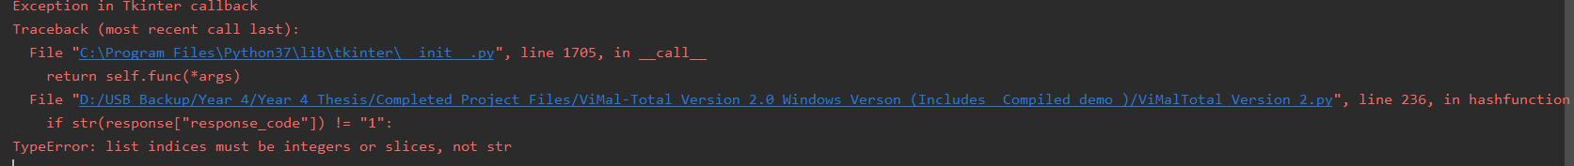

This issue persists through all subsequent frames with the exception of the File Lookup Frame.

**Scan ID Lookup Frame:**

No New Issues Detected.

**File Lookup Page:**

If the user begins the process of attempting to request a new File scan, and then selects the cancel button, the function to request a new file scan attempts to proceed with the request. This returns a file not found error (FileNotFoundError: [Errno 2] No such file or directory:) as seen below in figure 181.

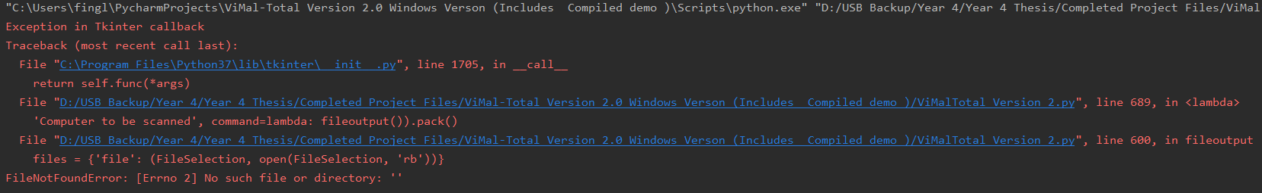

Figure The error created when the user attempts to select a file to be scanned then cancels the file selection process.

**URL Lookup Page:**

No New Issues Detected.

**IP Lookup Page:**

No New Issues Detected.

**Domain Lookup Page:**

No New Issues Detected.

## 6.1.2 Compiled Window/Linux Version Testing White Box Testing

While all the issues from the uncompiled version of the program previously documented remain consistent through the compiled windows executable version of the program, one further bug was discovered.

When the program is executed it immediately crashed back to the desktop with no error code displayed. Upon investigation it was discovered that once compiled, the Banner logo image is no longer in the same folder as the file executed to run the program, so, when the program searches the main project folder and does not find this image, the program crashes. As the program is now being operated outside of both an IDE and a CLI/Terminal environment, there is no appropriate area to display a related error message.

This fix for this issue is simple, once the program has been compiled using the PyInstaller 3rd party package, the banner image ‘vimal logo.png’ is simply compiled and pasted into the project folder where the new windows executable is housed. This allows the program to function once more.

## 6.1.2 Window/Linux Version Testing Black Box Testing

Black box testing for the Uncompiled and Compiled apps was conducted by providing the project files alongside a document describing the project environment creation/setup steps via a GitHub link and requesting feedback via a survey monkey survey. The links where shared via Discord amongst my fellow cyber security students, LinkedIn and A Facebook groups consisting of Cyber Security Professionals. I also contacted several industry contacts directly to enlist their participation in the black testing phase of the project. All feedback was anonymous. No suggestions where provided for testing other than to test and attempt to break any aspect of the program the testers felt like exploring. I did not want to guide the testers to any area or place limitations on their attempt to discover bugs. The first 9 questions where specifically focused on testers feedback in relation to the useful ness of the frames and features of the app, with the final question provided a feedback area to detail any bugs, feedback or suggestions the tester has discovered or wished to provide. 38 respondents participated in the survey.

## 6.1.2.1 Window/Linux Version Testing Black Box Testing Survey Question 1

The first question related to user feedback regarding the usefulness of the Hash Lookup and Scan ID Lookup Page frames.

Did you find the Hash lookup / Scan ID Lookup functions useful for private or professional research?

The response to this first question was favorable with 38 responses and 0 participants skipping this question. 97.37% of respondents stated they found the frames useful with 2.63% stating they did not.

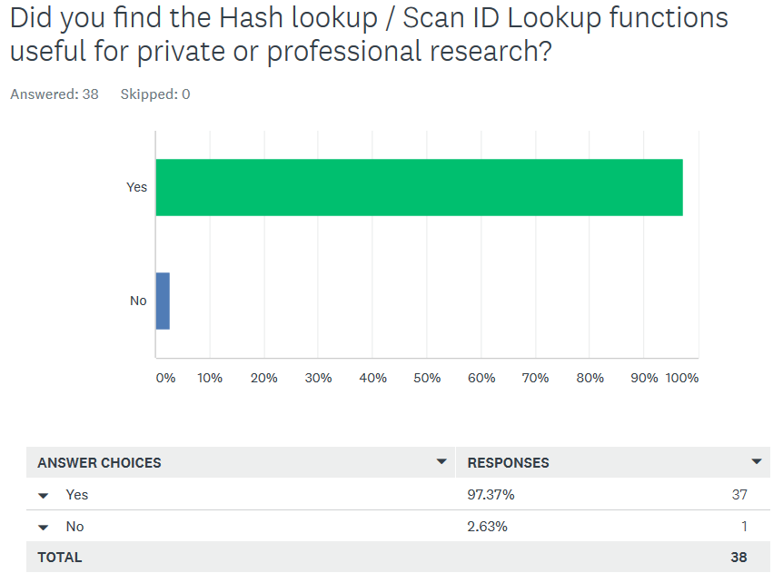

Figure The responses to the black box testing survey question 1.

## 6.1.2.2 Window/Linux Version Testing Black Box Testing Survey Question 2

The second question related to user feedback regarding the usefulness of the File Lookup Page frame.

Did you find the File Scan option useful for private or professional research?

The results for this question matched those of the previous question with 97.37% of respondents stated they found the frames useful with 2.63% stating they did not.

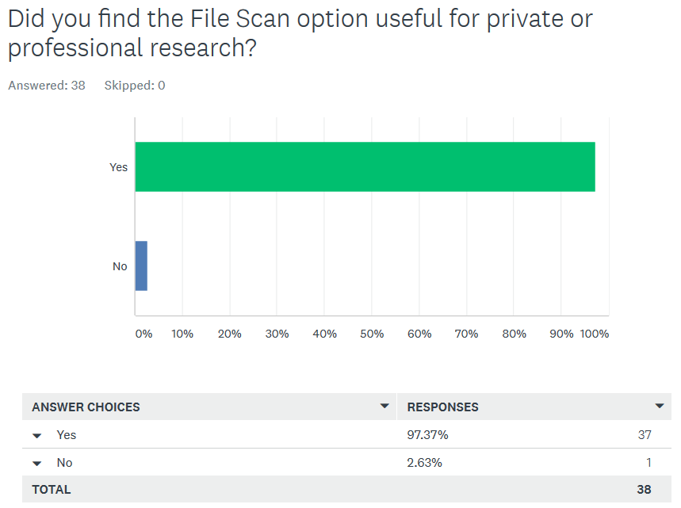

Figure The responses to the black box testing survey question 2.

## 6.1.2.3 Window/Linux Version Testing Black Box Testing Survey Question 3

The third question related to user feedback regarding the usefulness of the URL Lookup Page frame (Pre-existing URL Report Request Function).

Did you find the URL Report Request option useful for private or professional research?

The results for this question matched those of the both previous questions with 97.37% of respondents stated they found the frames useful with 2.63% stating they did not.

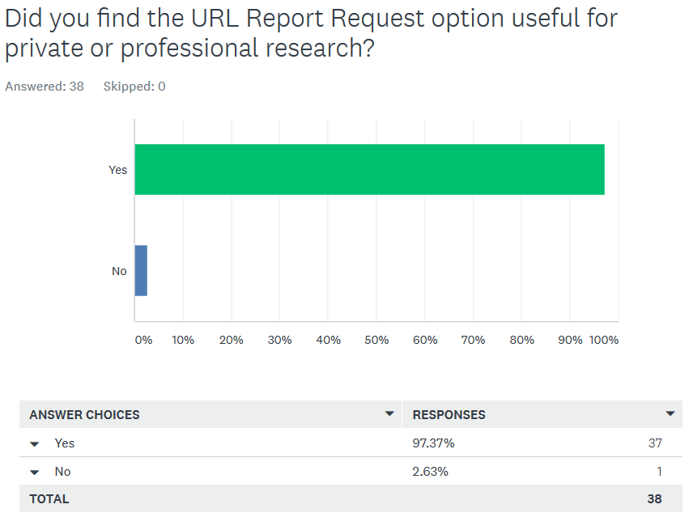

Figure The responses to the black box testing survey question 3.

## 6.1.2.4 Window/Linux Version Testing Black Box Testing Survey Question 4

The fourth question related to user feedback regarding the usefulness of the URL Lookup Page frame once again (New URL Scan Function).

Did you find the New URL Scan option useful for private or professional research?

The results for this question matched those of the all of the previous questions with 97.37% of respondents stated they found the frames useful with 2.63% stating they did not.

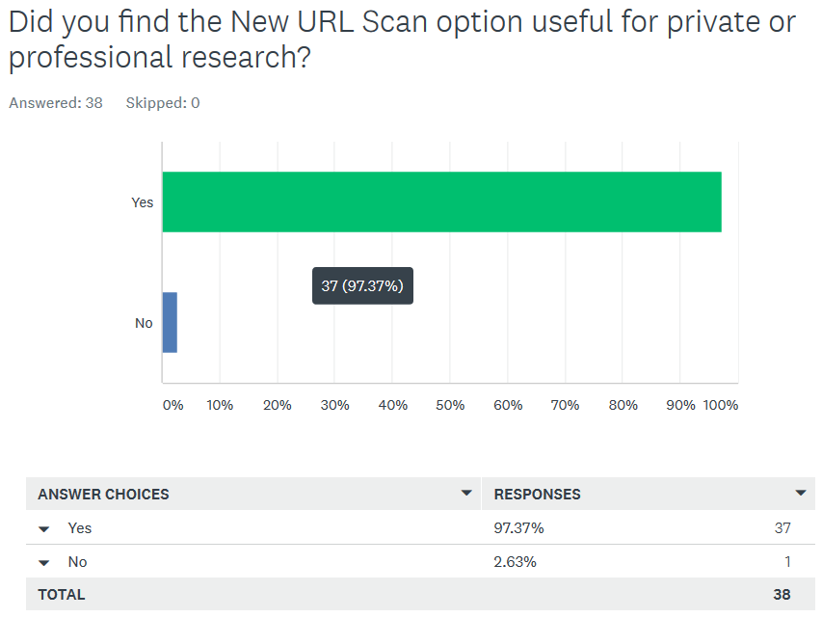

Figure The responses to the black box testing survey question 4.

## 6.1.2.5 Window/Linux Version Testing Black Box Testing Survey Question 5

The fifth question related to user feedback regarding the usefulness of the IP Lookup Page frame.

Did you find the IP Lookup option useful for private or professional research?

The results for this question matched those of the all the previous questions with 97.37% of respondents stated they found the frames useful with 2.63% stating they did not.

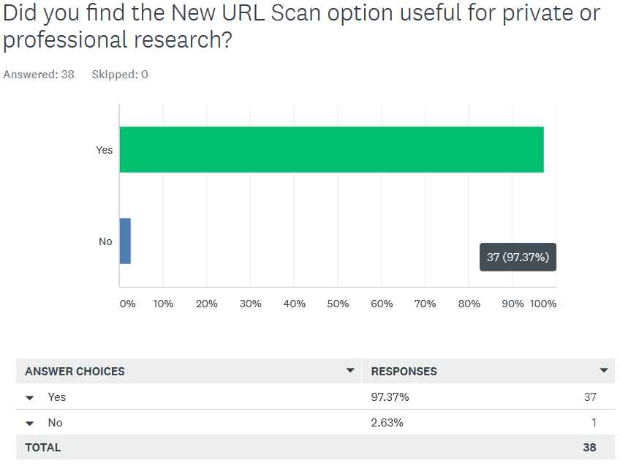

Figure The responses to the black box testing survey question 5.

## 6.1.2.6 Window/Linux Version Testing Black Box Testing Survey Question 6

The sixth question related to user feedback regarding the usefulness of the Domain Lookup Page frame.

Did you find the Domain Lookup option useful for private or professional research?

The results for this question matched deviated slightly from previous responses with 92.11% of respondents stated they found the frames useful with 7.89% stating they did not.

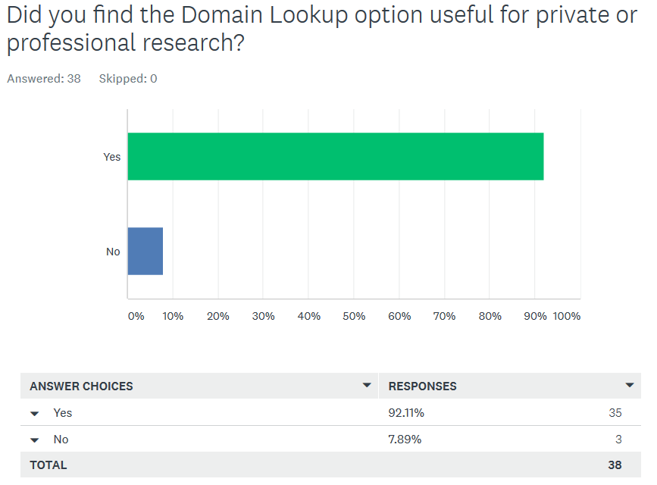

Figure The responses to the black box testing survey question 6.

## 6.1.2.7 Window/Linux Version Testing Black Box Testing Survey Question 7

The seventh question related to user feedback regarding the overall program usability.

Overall how would you rate the programs usability? Please rate from 1 to 5 stars?

The results for this question are as follows:

* Total Responses: 38
* Weighted average: 3.5 / 5 stars
* 1-star rating: 2.63%
* 2-star rating: 13.16%
* 3-star rating: 28.95%
* 4-star rating: 39.47%
* 5-star rating: 15.79%

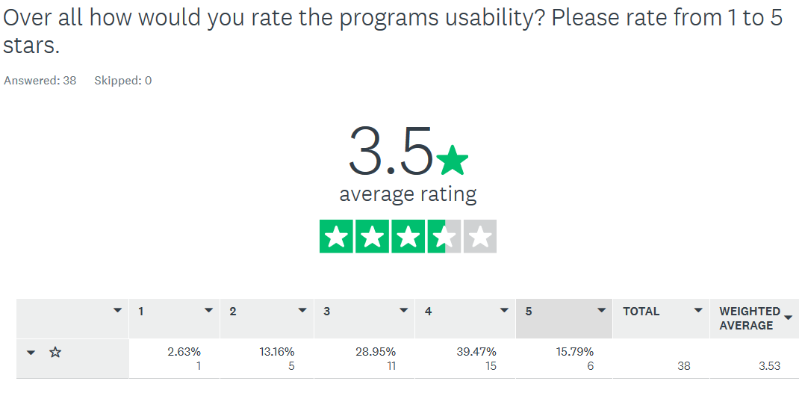

Figure The responses to the black box testing survey question 7.

## 6.1.2.8 Window/Linux Version Testing Black Box Testing Survey Question 8

The eight-question related to user feedback regarding the program’s GUI Implementation.

Please rate the programs GUI from 1 to 5 stars.

The results for this question are as follows:

* Total Responses: 37
* Total Respondents Skipped: 1
* Weighted average: 4.14 / 5 stars
* 1-star rating: 2.70%
* 2-star rating: 0%
* 3-star rating: 10.81%
* 4-star rating: 54.05%
* 5-star rating: 32.43%

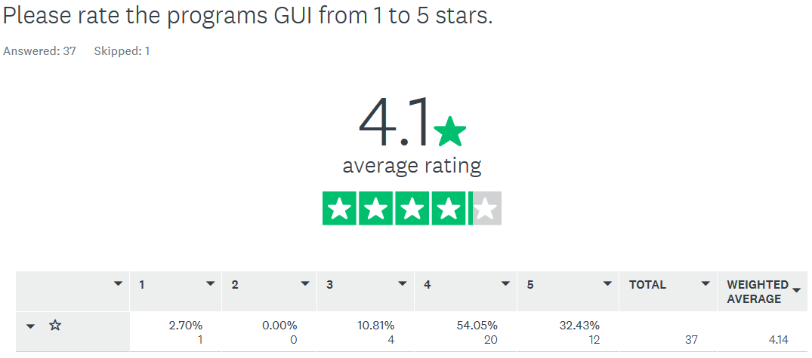

Figure The responses to the black box testing survey question 8.

## 6.1.2.9 Window/Linux Version Testing Black Box Testing Survey Question 9

The ninth question related to user feedback regarding the program’s ability to convert any text in a frames’ given text area to a file which can then be persistently stored for later use in reports. This question also allowed for user feedback regarding this function.

Did you find the automatically generated text files documenting search/report details, as well as the ability to manually create text files from any given text field useful for later consumption or for compiling future reports? Please feel free to add your feelings as to how much this might ease the workload of security researchers in compiling reports relating to new research or potential security incident reports?

The results for this question are as follows:

* Total Respondents: 38
* Total Positive responses: 37
* Total Negative responses: 1 (This appears to be due to user’s inability to get the program running. The user stated he/she was using a MAC and no testing development was undertaken for that platform nor was any testing performed foe that platform).
* User Feedback was largely positive with some interesting suggestions regarding how the text may be better formatted before being output. I will give examples of user feedback below.



Figure A sample of user feedback to question 9.

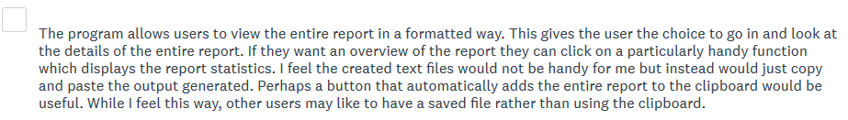

Figure Another sample of user feedback to question 9.



Figure Another sample of user feedback to question 9.



Figure Another sample of user feedback to question 9.



Figure Another sample of user feedback to question 9.

## 6.1.2.10 Window/Linux Version Testing Black Box Testing Survey Question 10

The tenth question related to general user feedback regarding any bugs discovered or specific feedback and suggestions users wished to provide.

Users were informed of a bug relating to the cancelation of file selection on the File Lookup Page frame. This was the only documented bug prior to user testing commencing.

Please provide any additional feedback you feel is appropriate, including bug reports, potential security issues, suggestions for changes, or any feature that might be added further down the road that you feel would enhance the threat intelligence collection properties of the program.

There were 19 user response in this section. They are as follows:

* There’s an undocumented issue when executing functions with a blank string as a variable. The API should be stored persistently. Would like to see scrollbars added for text areas.

While this issue was known, it was only discovered just after the black box testing phase was discovered.

* The API key is not persistently stored. this seems like a flaw to me. Also, there should be a way to enter it directly in the program. There an error related to executing functions with blank strings.

This was known and was not considered a bug. But it was recognized as a potential usability concern.

* A basic error related to searching for functions with blank strings. Could you make it easier to add and store the API key? Really didn’t like having to re add it every time i ran it. Otherwise, excellent little program. Good work.
* You should really handle that documented error. There is also a basic error related to attempting to search for reports with blank strings.

This response relates to the documented known error discussed above. I took this fair criticism on board.

* Ran some basic SQLI tests and whatnot. couldn’t find anything of any major concern due to the back-end error handling by the Virus Total API. I have some experience working with it so I expected it to be ok. Would like to see persistent storage of the API key and a better way to enter it. Also, there’s an undocumented issue with perform in API calls with blank strings that should be handle with a try catch. Your implementation is quite nice in concept. GUI could be tidier. All in all, a very solid effort and a nice little program in function even if the code is a bit sloppy.
* The program creates an error if the user attempts to search for a anything without entering anything in the text fields. this is persistent across all frames, I think.
* I'd like the option to enter my API key at the program initialization stage. Not sure why this option was left out.
* Only error I found is when I search for a report with a blank string. And the pre documented error related to files.
* An error is created when I try to search for a report with no text entered. This is not declared in the test documentation.
* I felt the ability to create text files from the text returned in the text fields was fantastic. Also, the ability to have files scanned directly from the local machine was quite nice too. This extends the antivirus screen well beyond what ever local of agentless screening rules exist on the local machine.
* No major bugs found.
* No major issues found. Great Work.
* I'd like to see some further lookup options such as Shodan lookups.

This is something I am considering for a future revision for the project but is, for now, beyond the scope fo this project.

* No Bugs found. Some areas I see room for improvement.
* Not sure about having a hard-coded API key. Also, I know you were aware of the bug related to the file selection being left blank, but this should really be handled. Otherwise, solid little program. Have been using it in work and like it a lot. Have even shared it with a few of my colleagues who I believe are going to contribute with your survey. best of luck!
* My only real complaint is that the program required me to create an environment on my Linux Machine to run it. For most inexperienced users this may be difficult. The pre-compiled windows version makes up for this. But the Linux environment rebuilding issue is a real buzzkill. otherwise, nice app. great first effort at developing a new tool. Good Job man.

This is an unavoidable issue. It is simply the nature of this type of program requiring multiple dependencies and 3rd party packages to be installed. However, it is only required once on each machine. The Windows precompiled version which is included does not require this setup process and is ready to function immediately with no setup.

* Reading over the documentation. It looks like a cool application. However, if I can't run it. I can’t test it.
* 1. Exit Program button does not work. 2. A scrollbar for the text output fields would be good. 3. Maybe a better way to display the information would be for a structured table instead of just a text box/file (makes it easier to read and get the main points across) 4. View domain report statistics and view IP lookup report statistics are confusing with the amount of "positive detections" being printed out. 5. report files that are generated are hard to find because they are not in a folder on their own (hash reports could be in a hash report folder etc.) 6. Perhaps add in a copy to clipboard button on reports? 7. The text is a tiny bit too small. I was wearing my glasses and found it difficult to read especially with the black on grey text surrounded by dark blue. (Example is the "Welcome to the main Menu" label) 8. A console appears in the background displaying information of errors. This is useful for debugging but should be removed for a full release.

Regarding the scrollbar consideration this user raises. It was my original intention to include scrollbars, however this created a serious error with the program in the very early stages of development. I was never able to adequately pin down the cause of this problem. I therefore elected to move on and come back to this issue later. However, having run out time, this must be addressed in future work. I will however revise the program to inform users on the available controls to navigate within text areas.

The user also points out that reports can be difficult to locate because all they are not stored in separate folders. This is a fair criticism, and this will be addressed in future work with each file that can be created having its own sub folder storage location in a future revision.

I will also aim to address the text size, and background console points in a future revision.

The Exit button issue will be investigated.

## 6.1.2.11 ViMal-Total Python base VirusTotal Parser System Revisions

Based on user feedback the following revisions will be adopted:

* Implement the ability to enter the API key at the program initialization stage and have the key be stored persistently
* Investigate the program exit function not working and fix this issue.
* Ensure that users cannot initiate a search with a blank string

To facilitate the ability to enter the user’s API key at initialization coupled with persistent storage of the API key several steps were required. Firstly, A function was created a new local Json file to store the API key in the Json format as seen below in figure 196. This function used the ‘open()’ function o open the file as an ‘fp’ object and the ‘fp.write()’ function to write to the file.

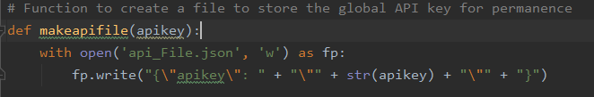

Figure The function to create the API key storage Json file 'api_File.json'.

Next, the logic to manage the API entry prompt message box prompt was created. While initially the message box was deployed in a very simple format with no validation logic this created an issue which allowed the user to simply cancel the message box which created further errors if any attempt was made to perform an API call. as the call would be performed with an empty string as the API key. The VirusTotal API is supposed to return a response code 403 error in this scenario, however this was not being returned and it is unknown why this as response was not being received. Therefore, logic was required to ensure the user both was aware that the API key should not be left blank, and that the API key needed to be validated prior to executing each API function call. After some trial an error this was accomplished in a multistep process.

First, during the program initialization the user is prompted to enter an API key. Just in case it is not yet available, and the user would still like to view the programs options, the logic allows for the cancelling the API key entry, yet the file is still created with a blank string. Naturally if any attempt is made to perform an API call this will result in an error, therefore more logic will be employed later at each API function call to handle this potential problem.

The logic consists of the API key variable being pre-defined as a blank string. A Boolean variable ‘swtchmode’ is declared and initialized to true. If the API is entered the ‘switchmode’ variable is set to false and the program continues its initialization.

The program then enters a while loop, while the Boolean remains true. Next the program detects if the API key is a blank string. If this check returns true or the key is null, the program enters a try which prompts the easygui package to display an entry box. The user either enters their API or they do not. If they chose to enter their API key now, the ‘makeapifile(apikey)’ function is called with th new apikey variable fed into it, which creates the API key file. If the user elects to cancel the prompt the apikey is defaulted to a null value. Should this occur a break statement is used to exit the function, the apikey is then set as a null (‘None’ in Python) value. If the key is set the switchmode Boolean is reset to false which breaks the while loop. The second half of the logic will be completed at the API function calls.

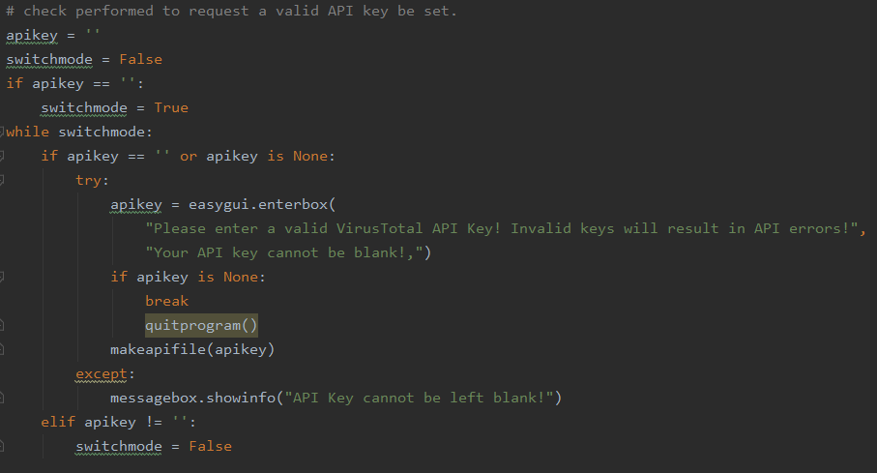

Figure The API entry logic with messagebox prompt handled by easygui.

Next we move to the function calls which have been verified to contain the two errors documented in the testing phase:

1. If a blank string is entered in any API function call resource entry area, this will create an error
2. If the user selects cancel when selecting cancel at the file selection point on the File Lookup Page frame

These will need to address while completing the API key logic.

Each API call requires that the global API variable be fed into the function call. Our logic above allows for two possibilities that will return errors.

1. The API key will return a blank string
2. The API key will be null

Logic must be created to handle these potential errors. Each function must also now retrieve the API key which is now stored in the ‘api_File.json’ file. To achieve this a ‘get()’ function called ‘getapikey()’ was created to retrieve the ‘apikey’ variable from the file. This is a simple function which uses the ‘os.pathisfile()’ function to detect if the ‘api_File.json’ file exists. If so the ‘open()’ function is used to open the file as a ‘data_file’ object. The data contained in the Json file is then initialized as a data object. The ‘apikey’ variable is then initialized as the key value at the Json key “apikey” within this data object. The ‘apikey’ variable is then returned and fed into whatever API function is calling it.

This ‘getapikey()’ function is now called when an API function button is pressed and immediately fed into the function call.

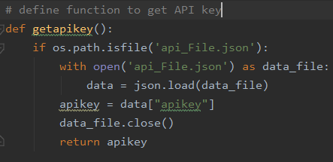

Figure The new getapikey() get function to retrieve the apikey from the api_File.json file.



Figure Here we can see an example of the getapikey() function being called when the Hashfunction button is pressed.

Once this check is complete, we will still retain the previous error where the user can potentially enter a blank string into the API function calls resource entry area.

This is handled as follows. In each function which contains an API, the params variable is set which contains the ‘apikey’ variable and the resource variable. If either of these variables is invalid it will create an error. Therefore, a Try is inserted at the next line where the response variable is declared which is dependent on the ‘apikey’ and resource variables being correct. If these variables are correct, no error is returned and the function proceeds as normal. If an error is detected, the program jumps to that functions exception clause which begins at the point where the function would normally end. An example of the Try’s implementation can be seen below with a snip of the Hash report request function.

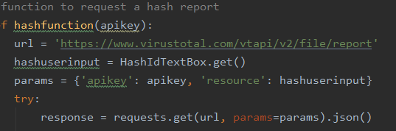

Figure Here we see the try being inserted just below the declaration of the apikey and resource variables, and just above the response variable declaration to catch errors related to invalid apikey or resource errors.

Next we jump down past the function to the exception or ‘except’ clause as it is called in Python. Here, we have a simple if/else combination logic to handle the two possible errors which may be detected at this point. First a ‘isempty’ Boolean is declared and initialized to true.

The if statement detects if the resource for the function is set to a blank string. In this case the resource variable is the ‘hashuserinput’ variable, but this will be different for each function naturally. If this resource variable is a blank string, this prompt’s a while loop which continues while the ‘isempty’ Boolean remains true. Next, a prompt is displayed warning the user that a search cannot be performed with on a blank string. And an error message is output to the frames text area. The Boolean ‘isempty’ is then se to false and the while loop breaks.

If the program detects that the resource variable is not a blank string, it proceeds to the else statement. This mean that the error is related to an invalid key or no key being entered during the program initialization phase. The logic of the API key entry prompt is repeated at this point to prompt the user to enter their API key. This prompt will repeat at each attempt to conduct an API function call until a valid key is entered.  
  
So coming into this revision of the software there were 5 goals we aimed to achieve:

* Retest the programs exit button to attempt to recreate the error declared during the testing phase

This error could not be repeated and in further testing no issues with this function where detected.

* Address the issue of cancelling the file selection process ion the File Lookup Page frame.

This has been addressed with our new try catch logic which detects if this variable has been left blank and enters the exception clause of the function.

* Address the issue of API functions calls with blank strings returning errors.

This has been addressed by the IF statement in the new try/except logic with has been added to each API function call.

* The API should be persistently stored.

This has been address in the new ‘makeapifile()’ function which stored the ‘apikey’ variable in a Json file.

* The program should allow the user to enter the API key at the program initialization and a validity check should be performed at each API call

This is now handled by the logic which prompts the ‘easygui’ entry box prompt during the program initialization phase, and the else section of the except clause in each API function call which validates that a correct entry key has been entered and prompts the user to enter a valid API key if one is not detected.

## 6.1.3 Re-developed MHN-Splunk App Comparative Testing

In redeveloping the MHN Splunk application I have created disparity between the original version and the revised version. This makes a straightforward series of comparative testing that would result in an overall 1:1 comparative test, impossible. This disparity arises from the fact that where the original MHN-Splunk app does not have certain dashboards related to certain sensors, such as Amun and Wordpot, no comparison can take place. However, obviously, this does not preclude the ability to conduct comparative testing where a dashboards existence over both versions remains consistent. This is where the comparative testing was focused.

The testing methodology shall be simple. Testing will be conducted on my local machine. This machine has the following specifications:

* CPU: Processor AMD Ryzen 9 3900X 12-Core (24 thread) Processor, 3793 Mhz, 12 Core(s), 24 Logical Processor(s)
* Ram:
  1. Installed: 31.9GB running at 3200mhz
  2. Page File Size: 21.2GB
  3. Virtual memory: 52.9GB
* GPU: Nvidia GeForce RTX 2600 Super OC 8GB DDR5 VRAM

While this revised app is aimed at being capable of run on thin clients with limited resources, in the region of 8GB’s of ram with a basic quad core modern processor with perhaps 6-8 logical cores, testing is being performed on a high end machine to remove all potential hardware bottlenecks and allow both versions of the app to run to their max potential.

Naturally, it would not be valid to simply test the app on a powerful local machine with a small amount of data, and while the app is not primarily aimed at performing analytics on big data clusters, to make the test strenuous and show the app is being pushed relatively hard compared to expected normal use, a sample of MHN-Splunk logs has been compiled which have been collected over a period of almost 8 months. This sample set of logs is 4.25GB is size placing it in the realm of big data, and far beyond the scope of what could be considered normal expected use for the MHN-Splunk app. This means the test will be strenuous and conclusive in testing performance, functionality and consistency.

Within the folder are MHN-Splunk logs relating to the following sensors:

* Amun
* Dionaea
* Conpot
* Cowrie
* Elastichoney
* P0f
* Snort
* Suricata
* WordPot
* Shockpot

Regarding the Overview dashboard in the original MHN-Splunk app versus the Overview Dashboard in the revised MHN-Splunk app, it must be noted that fixes to the revised version mean this dashboard is now also accessing Cowrie and Amun sensor data. This means that should the time be the same for these sensors it shall not be a true reflection of any increased efficiency since this is not a true apples to apples comparison. We must also consider the fix we applied during the installation phase of the MHN platform which allowed the Suricata sensor to generate data where it had previously not generated data. This brings the total of extra sensors including the data mining of the revised MHN-Splunk app up to three extra sensors. Our test logs include some data for each of these extra sensors.

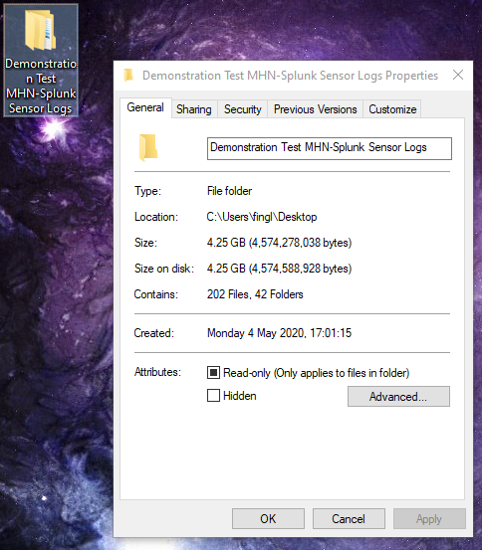

Figure The test log folder to be used in the MHN-Splunk app comparative testing.

Each Dashboard shall be refreshed, and a simple timer will be used to time the process of mining all indexed logs contained within the test log folder. Each test will be performed ten times with the time for each test being recorded. The difference will then be calculated. The average percentage of overall difference between the dashboard shall be considering the percentage of efficiency gained or lost in the app’s redevelopment.

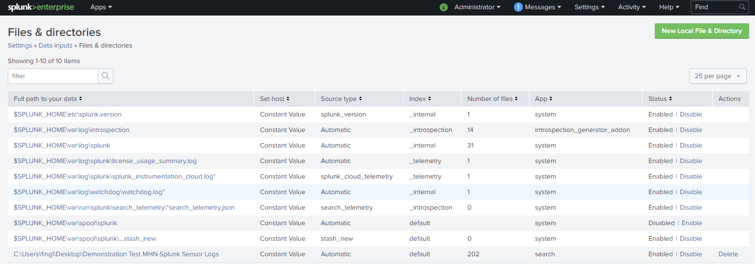  
Testing will be performed first on the original MHN-Splunk App, with the demonstration log files pre-indexed to ensure all the local machines available resources are focused on mining the indexed files.

Figure Here we see the demonstration logs have been added as an index.

As seen below in figure 203, this gives us a total of 18,221,600 pre-indexed events to mine.

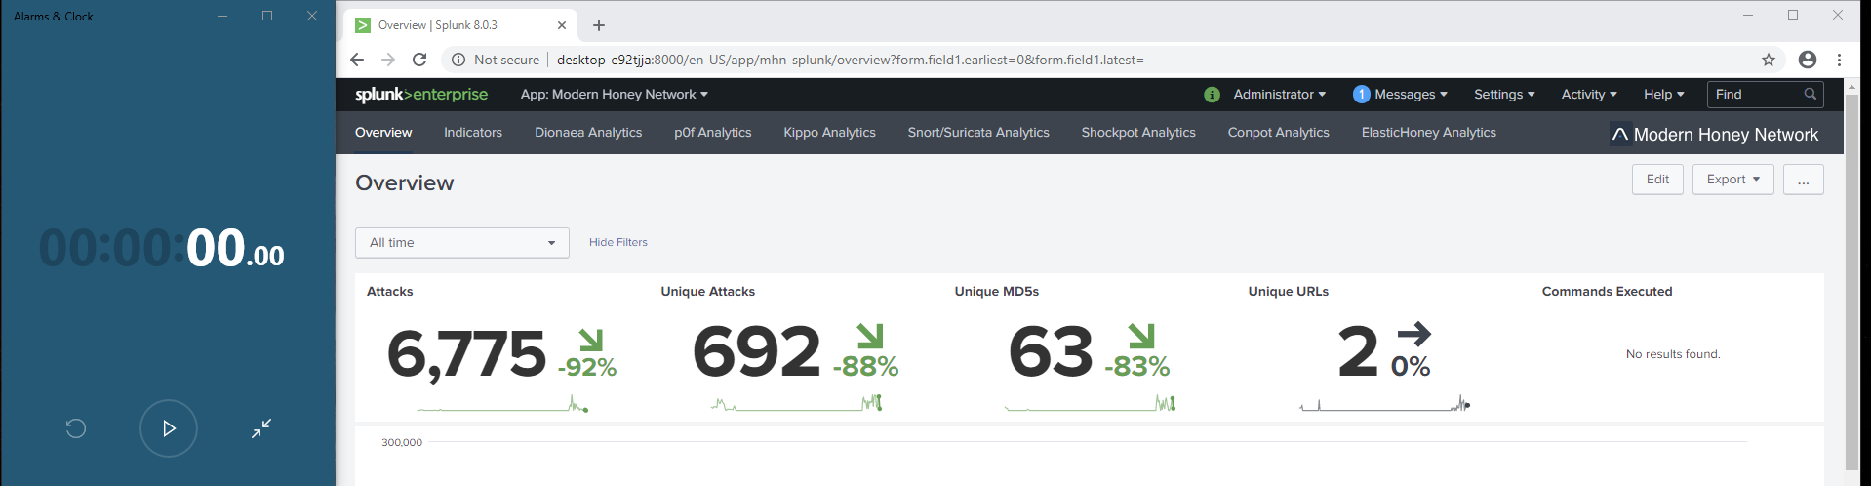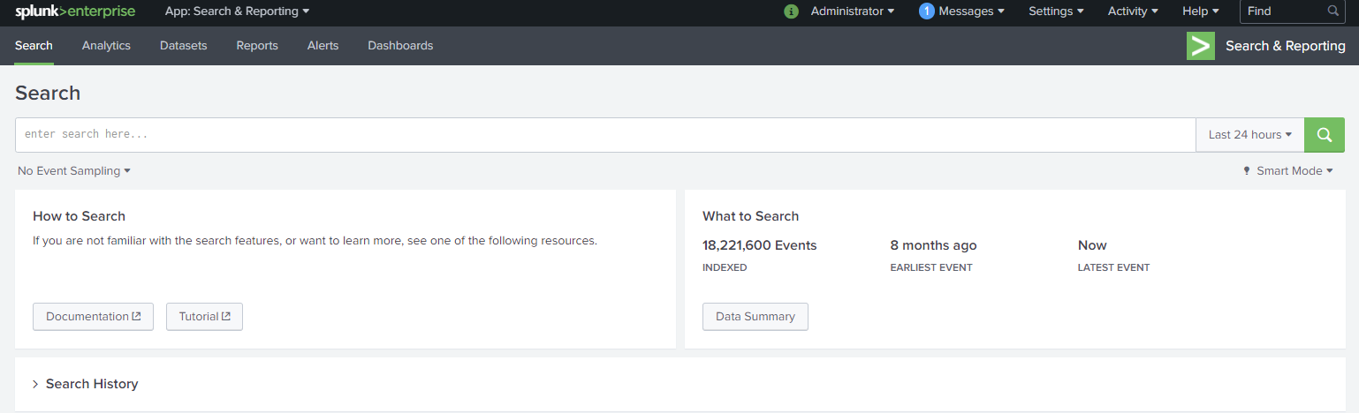

Figure The index has been created and pre-indexing has completed giving us 18,221,600 events to conducting our testing with.

Figure Here we can see that the original MHN-Splunk has been imported into the Splunk platform and we are ready to begin the first round of testing.

|  |  |  |  |  |  |
| --- | --- | --- | --- | --- | --- |
| **App** | **Dashboard** | **Number of Test** | **Time Taken** | **Time Difference** | **Efficiency Gained in % (+) / Lost (-)** |
| Original MHN-Splunk App | Overview | 1 | 3:37 | N/A | N/A |
| Original MHN-Splunk App | Overview | 2 | 3:34 | N/A | N/A |
| Original MHN-Splunk App | Overview | 3 | 3:26 | N/A | N/A |
| Original MHN-Splunk App | Overview | 4 | 3:25 | N/A | N/A |
| Original MHN-Splunk App | Overview | 5 | 3:26 | N/A | N/A |
| Original MHN-Splunk App | Overview | 6 | 3:28 | N/A | N/A |
| Original MHN-Splunk App | Overview | 7 | 3:51 | N/A | N/A |
| Original MHN-Splunk App | Overview | 8 | 3:34 | N/A | N/A |
| Original MHN-Splunk App | Overview | 9 | 4:05 | N/A | N/A |
| Original MHN-Splunk App | Overview | 10 | 4:05 | N/A | N/A |
| Revised MHN-Splunk App | Overview | 1 | 3:30 | - 7 secs | + 3 % |
| Revised MHN-Splunk App | Overview | 2 | 3:31 | - 3 secs | + 1 % |
| Revised MHN-Splunk App | Overview | 3 | 3:51 | + 15 secs | - 7 % |
| Revised MHN-Splunk App | Overview | 4 | 3:31 | + 6 secs | - 3 % |
| Revised MHN-Splunk App | Overview | 5 | 3:30 | + 4 secs | - 2 % |
| Revised MHN-Splunk App | Overview | 6 | 3:28 | + 0 secs | +/- 0 % |
| Revised MHN-Splunk App | Overview | 7 | 3:34 | - 17 secs | + 8 % |
| Revised MHN-Splunk App | Overview | 8 | 3:29 | - 5 secs | + 2 % |
| Revised MHN-Splunk App | Overview | 9 | 3:31 | - 34 secs | + 14 % |
| Revised MHN-Splunk App | Overview | 10 | 3:24 | - 41 secs | + 17 % |

Table Overview dashboard comparison table [4].

If we take add the total of the % gained/lost in efficiency and average it by the number of tests completed, we get a calculation of:

* 3 + 1 + (- 7) + (- 3) + (- 2) + 0 + 8 + 2 + 14 + 17 / 10 = 3%

This gives the Overview dashboard an increased average efficiency per refresh of 3% rounded to the nearest decimal place. Considering we have increased the number of Dashboards and therefore the number of sensors and logs being mined, I feel this is a successful increase in efficiency. As previously stated, this is not a perfect comparative analysis given that revised Overview dashboard is forced to crunch more data than the original dashboard but that this came out positively in favor of the revised dashboard, I feel is a very positive result for the project.

|  |  |  |  |  |  |
| --- | --- | --- | --- | --- | --- |
| **App** | **Dashboard** | **Number of Test** | **Time Taken** | **Time Difference** | **Efficiency Gained in % (+) / Lost (-)** |
| Original MHN-Splunk App | Dionaea | 1 | 32 | N/A | N/A |
| Original MHN-Splunk App | Dionaea | 2 | 32 | N/A | N/A |
| Original MHN-Splunk App | Dionaea | 3 | 32 | N/A | N/A |
| Original MHN-Splunk App | Dionaea | 4 | 31 | N/A | N/A |
| Original MHN-Splunk App | Dionaea | 5 | 33 | N/A | N/A |
| Original MHN-Splunk App | Dionaea | 6 | 32 | N/A | N/A |
| Original MHN-Splunk App | Dionaea | 7 | 32 | N/A | N/A |
| Original MHN-Splunk App | Dionaea | 8 | 33 | N/A | N/A |
| Original MHN-Splunk App | Dionaea | 9 | 39 | N/A | N/A |
| Original MHN-Splunk App | Dionaea | 10 | 32 | N/A | N/A |
| Revised MHN-Splunk App | Dionaea | 1 | 27 | - 5 secs | + 16 % |
| Revised MHN-Splunk App | Dionaea | 2 | 28 | - 4 secs | + 13 % |
| Revised MHN-Splunk App | Dionaea | 3 | 26 | - 6 secs | + 19 % |
| Revised MHN-Splunk App | Dionaea | 4 | 28 | - 3 secs | + 10 % |
| Revised MHN-Splunk App | Dionaea | 5 | 28 | - 5 secs | + 15 % |
| Revised MHN-Splunk App | Dionaea | 6 | 27 | - 5 secs | + 16 % |
| Revised MHN-Splunk App | Dionaea | 7 | 27 | - 5 secs | + 16 % |
| Revised MHN-Splunk App | Dionaea | 8 | 26 | - 7 secs | + 21 % |
| Revised MHN-Splunk App | Dionaea | 9 | 27 | - 12 secs | + 31 % |
| Revised MHN-Splunk App | Dionaea | 10 | 26 | - 6 secs | + 19 % |

Table Overview dashboard comparison table.

If we take add the total of the % gained/lost in efficiency and average it by the number of tests completed, we get a calculation of:

16 + 13 + 19 + 10 + 15 + 16 + 16 + 21 + 31 + 19 / 10 = 18%

This gives the Dionaea dashboard an increased average efficiency per refresh of 18% rounded to the nearest decimal place. Dionaea is one of the most active and telling dashboards within the MHN platform and this being a direct comparison, the reduction of recursive searches has resulted in marked improvement in efficiency. This is a very positive result in favor of the project.

|  |  |  |  |  |  |
| --- | --- | --- | --- | --- | --- |
| **App** | **Dashboard** | **Number of Test** | **Time Taken** | **Time Difference** | **Efficiency Gained in % (+) / Lost (-)** |
| Original MHN-Splunk App | p0f | 1 | 29 | N/A | N/A |
| Original MHN-Splunk App | p0f | 2 | 24 | N/A | N/A |
| Original MHN-Splunk App | p0f | 3 | 25 | N/A | N/A |
| Original MHN-Splunk App | p0f | 4 | 29 | N/A | N/A |
| Original MHN-Splunk App | p0f | 5 | 29 | N/A | N/A |
| Original MHN-Splunk App | p0f | 6 | 29 | N/A | N/A |
| Original MHN-Splunk App | p0f | 7 | 1:12 | N/A | N/A |
| Original MHN-Splunk App | p0f | 8 | 26 | N/A | N/A |
| Original MHN-Splunk App | p0f | 9 | 32 | N/A | N/A |
| Original MHN-Splunk App | p0f | 10 | 29 | N/A | N/A |
| Revised MHN-Splunk App | p0f | 1 | 31 | + 2 secs | - 7 % |
| Revised MHN-Splunk App | p0f | 2 | 31 | + 7 secs | - 29 % |
| Revised MHN-Splunk App | p0f | 3 | 30 | + 5 secs | - 20 % |
| Revised MHN-Splunk App | p0f | 4 | 31 | + 2 secs | - 6 % |
| Revised MHN-Splunk App | p0f | 5 | 31 | + 2 secs | - 7 % |
| Revised MHN-Splunk App | p0f | 6 | 31 | + 2 secs | - 7 % |
| Revised MHN-Splunk App | p0f | 7 | 30 | - 42 secs | + 58 % |
| Revised MHN-Splunk App | p0f | 8 | 33 | + 6 secs | - 23 % |
| Revised MHN-Splunk App | p0f | 9 | 27 | - 5 secs | + 19 % |
| Revised MHN-Splunk App | p0f | 10 | 30 | + 1 secs | - 3 % |

Table p0f dashboard comparison table.

If we take add the total of the % gained/lost in efficiency and average it by the number of tests completed, we get a calculation of:

(- 7) + (- 29) + (- 20) + (- 6) + (-7) + (- 7) + 58 + (- 23) + 19 + (- 3) / 10 = - 2%

This gives the p0f dashboard a decreased in average efficiency per refresh of - 2% rounded to the nearest decimal place. This is a surprising and unexpected negative result. I must also acknowledge that the results would have come out worse had the original p0f dashboard not suffered a resource starvation related use spike on one of its refreshes. This was likely caused by some of the system resource being taken up by a background process, although more extensive testing would be required to test this.

While the results here are slightly negative, I consider a loss of - 2% efficiency to be within margins of error.

|  |  |  |  |  |  |
| --- | --- | --- | --- | --- | --- |
| **App** | **Dashboard** | **Number of Test** | **Time Taken** | **Time Difference** | **Efficiency Gained in % (+) / Lost (-)** |
| Original MHN-Splunk App | Conpot | 1 | 2 | N/A | N/A |
| Original MHN-Splunk App | Conpot | 2 | 3 | N/A | N/A |
| Original MHN-Splunk App | Conpot | 3 | 2 | N/A | N/A |
| Original MHN-Splunk App | Conpot | 4 | 2 | N/A | N/A |
| Original MHN-Splunk App | Conpot | 5 | 2 | N/A | N/A |
| Original MHN-Splunk App | Conpot | 6 | 2 | N/A | N/A |
| Original MHN-Splunk App | Conpot | 7 | 2 | N/A | N/A |
| Original MHN-Splunk App | Conpot | 8 | 2 | N/A | N/A |
| Original MHN-Splunk App | Conpot | 9 | 2 | N/A | N/A |
| Original MHN-Splunk App | Conpot | 10 | 2 | N/A | N/A |
| Revised MHN-Splunk App | Conpot | 1 | 1 | - 1 sec | + 50 % |
| Revised MHN-Splunk App | Conpot | 2 | 1 | - 2 sec | + 33 % |
| Revised MHN-Splunk App | Conpot | 3 | 1 | - 1 sec | + 50 % |
| Revised MHN-Splunk App | Conpot | 4 | 1 | - 1 sec | + 50 % |
| Revised MHN-Splunk App | Conpot | 5 | 2 | + 0 sec | +/- 0 % |
| Revised MHN-Splunk App | Conpot | 6 | 1 | - 1 sec | + 50 % |
| Revised MHN-Splunk App | Conpot | 7 | 2 | + 0 sec | +/- 0 % |
| Revised MHN-Splunk App | Conpot | 8 | 1 | - 1 sec | + 50 % |
| Revised MHN-Splunk App | Conpot | 9 | 1 | - 1 sec | + 50 % |
| Revised MHN-Splunk App | Conpot | 10 | 1 | - 1 sec | + 50 % |

Table Conpot dashboard comparison table.

If we take add the total of the % gained/lost in efficiency and average it by the number of tests completed, we get a calculation of:

50 + 33 + 50 + 50 + 0 + 50 + 0 + 50 + 50 + 50 / 10 = 38%

This gives the Conpot dashboard an increased average efficiency per refresh of 38% rounded to the nearest decimal place. This is a very positive result, although the numbers are quite small. Such fast iterations over logs also lower the chances of resource starvation issues due to background processes interfering with the availability of CPU cores or memory addressing. This could be indicative of increased efficiency gains with smaller log files, but further in-depth testing would be required to confirm this before I would feel comfortable presenting this hypothesis.

|  |  |  |  |  |  |
| --- | --- | --- | --- | --- | --- |
| **App** | **Dashboard** | **Number of Test** | **Time Taken** | **Time Difference** | **Efficiency Gained in % (+) / Lost (-)** |
| Original MHN-Splunk App | Elastichoney | 1 | 3 | N/A | N/A |
| Original MHN-Splunk App | Elastichoney | 2 | 2 | N/A | N/A |
| Original MHN-Splunk App | Elastichoney | 3 | 2 | N/A | N/A |
| Original MHN-Splunk App | Elastichoney | 4 | 2 | N/A | N/A |
| Original MHN-Splunk App | Elastichoney | 5 | 2 | N/A | N/A |
| Original MHN-Splunk App | Elastichoney | 6 | 3 | N/A | N/A |
| Original MHN-Splunk App | Elastichoney | 7 | 3 | N/A | N/A |
| Original MHN-Splunk App | Elastichoney | 8 | 3 | N/A | N/A |
| Original MHN-Splunk App | Elastichoney | 9 | 2 | N/A | N/A |
| Original MHN-Splunk App | Elastichoney | 10 | 3 | N/A | N/A |
| Revised MHN-Splunk App | Elastichoney | 1 | 2 | - 1 sec | + 50 % |
| Revised MHN-Splunk App | Elastichoney | 2 | 3 | + 1 sec | - 33 % |
| Revised MHN-Splunk App | Elastichoney | 3 | 1 | - 1 sec | + 50 % |
| Revised MHN-Splunk App | Elastichoney | 4 | 1 | - 1 sec | + 50 % |
| Revised MHN-Splunk App | Elastichoney | 5 | 1 | - 1 sec | + 50 % |
| Revised MHN-Splunk App | Elastichoney | 6 | 2 | + 0 sec | +/- 0 % |
| Revised MHN-Splunk App | Elastichoney | 7 | 1 | - 2 sec | + 100 % |
| Revised MHN-Splunk App | Elastichoney | 8 | 3 | + 0 sec | +/- 0 % |
| Revised MHN-Splunk App | Elastichoney | 9 | 1 | - 1 sec | + 50 % |
| Revised MHN-Splunk App | Elastichoney | 10 | 2 | - 1 sec | + 50 % |

Table Elastichoney dashboard comparison table.

If we take add the total of the % gained/lost in efficiency and average it by the number of tests completed, we get a calculation of:

50 + (- 33) + 50 + 50 + 50 + 0 + 100 + 0 + 50 + 50 / 10 = 38%

This gives the Elastichoney dashboard an increased average efficiency per refresh of 38% rounded to the nearest decimal place. This is not only a very positive result but averages out at the same increase in efficiency as the Conpot dashboard. While this is not enough data to prove that increased efficiency is gained over smaller workloads, it is certainly highly indicative at this point.

With 3 out of 4 of my comparative testing results resulting in what I consider to be strongly positive results, and the fourth test being within a margin of error, alongside the fixing of the Suricata sensor, I am happy to consider my attempts to add more dashboards, while also increasing efficiency in previously existing dashboards a success.

Time constraints prevented me from completing the optional requirement of adding the Python based Virus Total API parsing functionality of my ViMal-Total program into my dashboards, but this will be completed beyond the scope of the project’s timeframe.

# 7.0 Future Work

In terms of additional functionality, I would like to investigate the possibility of adding in API calls from Shodan, Maltego and TheHarvester. This would extent the data collection functionality into the IoT and Social media digital realms of Osint.

I would also like to investigate the functionality of MHN sensors which allow for direct uploading of threat intelligence to databases such as Virus Total and add this into the MHN sensor/ sensor configuration guide.

As far as further fixes go, I would like to remove the ability for the user to create a text area from a blank text field. This is not an error, or even unexpected behavior. However, it is something that simply just shouldn’t happen as it serves no useful purpose. It was my intention to return to this and create some basic logic to prevent this, but time constraints made this impossible.

The main future work will focus around creating a Python endpoint controller for the revised MHN-Splunk app that formed a major part of my project.

The steps to create this end point are as follows:

* Create a custom mount point for the new python end point (my naming convention must avoid collisions with default Splunk endpoints), for example: http://localhost:8000/custom/<AppName>/
* Declare a host controller for the custom endpoint in the web.conf configuration file found here: $SPLUNK_HOME/etc/apps/<APP_NAME>/default/. Add the following lines to the web.conf configuration file:
  1. [endpoint:<unique identifier>]
  2. # no other content required
* Place the python functions to be called in the custom endpoint, in the controller’s directory found here: $SPLUNK_HOME/etc/apps/<APP_NAME>/appserver/controllers/.
* The controller framework will then import my python module and controller class declared in web.conf, however, a full restart will be required. Any changes to the Python code will also require a full restart.

This will then allow me to transplant the functionality of the VIMal-Total Python based Virus Total parser into the MHN-Splunk app dashboards. I am now confident that I can achieve this however lack of time has prohibited me from carrying this step out during the timeframe allotted for the completion of my project.

This step will require me to create a HTML form to be added to each dashboard. The python functions will then be added to a python backend logic controller. The python functions calls will then be made in the webpage with Splunk pointing these function calls to the custom created python back end logic controller.

Lastly, I would like to perform more extensive testing of both major app development projects once the current Covid-19 epidemic has passed. I feel there is much fine tuning and improvements I can make in the GUI of the ViMal-Total Python based Virus Total parser app. I would also like to continue to investigate the possibility of increased efficiency in the revised MHN-Splunk app over small workloads which be a major boon on thin clients with reduced resource availability.

# 8.0 Personal Mission Statement

It is my hope to revitalize a threat intelligence gathering platform, and modernize the provided data mining tools associated with this platform, with a degree of skill level requirement low enough that the average cyber security novice can deploy the platform with a minimum amount of Linux skill; and analyze the data with minimal Linux/Windows skill. Through this project I hope to help stimulate an interest in cybersecurity defense and threat intelligence gathering among young cybersecurity enthusiasts as well as giving back to the cybersecurity industry that is suffering from a talent starvation problem.

# 9.0 Conclusion

In the introduction section of my project I highlighted the recruitment gap within the cyber security sector. It is of course far too soon to attempt to predict the long-term effects of the Covid-19 pandemic on the Irish cyber security economic sector. The journalist Conor Pope, on behalf of The Irish Times, in an recent online article raised awareness of the fact that cyber criminals where already attempting to use the Covid-19 pandemic as a smoke screen to hide online attempts to conduct phishing scams [61]. So, from a domestic point of view, cybercrime continues unabated. It is reasonable to presume that cyber criminals will be continuing to target businesses and as such, demand for digital security will continue. Any slowdown is likely to be tied hand in hand with any economic recovery and it could be reasonably expected that as the economy recovers in coming years, the cyber security job sector growth will return to normal and potentially grow even faster as new business roll out. However, given the huge jump in unemployment and large volumes of businesses that have either hit hard time during the Covid-19 pandemic and collapsed, or those that are unlikely to survive long term, retraining or upskilling within the cyber security job sector is going to become a very enticing option, more so even than it was prior to the outbreak of the pandemic when it was arguably one of the fastest growing job sectors. This puts my project in a new light I feel and adds further justification to its conception.

My literature review identifies the importance of honeypots in relation to the research that is the back bone of protecting the digital space which our world is not so reliant upon, and how they can also be used as teaching tools to increase their effectiveness in this area, by increasing the amount of threat intelligence generated in the home consumer and enthusiast cyber security fields.

The goal of my project was to provide a suite of tools in the form of apps, guides and scripts that would allow a novice or intermediate user of the MHN platform to be able to deploy the MHN platform and sensors, and focus on the job of developing skills with regard to SIEM interaction (via the MHN-Splunk app) and data analytics. This would allow the user to gain real world practical cyber security related skills that could develop interests or hobbies into real world employment opportunities. This could in turn, help to reduce the recruitment gap in the cyber security sector.

It is impossible for me to tell in the short term if the work I have undertaken, and the practical products of my work will result in any effect on the cyber security recruitment gap. This would require in-depth long-term study. But I feel that I have provided the tools necessary to greatly reduce the learning curve required by the MHN platform with regard to installation, sensor combinations and deployment, sensor configuration, platform maintenance and upkeep all of which allows users to focus on the development of cyber security related data analytics.

To achieve this aim I set myself several goals:

1. To develop a comprehensive installation guide for the MHN Platform.
2. To develop am MHN sensor / sensor configuration guide.
3. To develop a set of basic management scripts to help manage the MHN management server and sensor servers and most troublesome sensors, with a view to increasing platform uptime, thus allowing the user to focus on skill acquisition and data analytics.
4. To redesign and redevelop the MHN-Splunk app, adding in more dashboards and attempting to increase the overall efficiency of the app by increasing the efficiency of preexisting and new dashboards.
5. To develop a GUI Python based data parser which makes use of the Virus total API functions to retrieve threat intelligence reports from the Virus total databases.
6. Optional: To import the functionality of the Python based virus Total API parsing program into the dashboards contained with the MHN-Splunk app.

I have achieved each of these goals except for the final optional goal which is not possible due to time constraints. As previously stated, this will be completed as future work beyond the project’s completion date. Indeed, this entire project has become a labor of love and will be continued as a practical project that I hope to develop much further.

The creation of the MHN installation guide allows even the most unskilled Linux user to follow a step by step comprehensive installation process which helps avoid many of the issues that can result in broken platform installations and sensor deployments.

The sensor guide / sensor configuration guide helps users avoid combining incompatible sensors and avoid common issues such as socket locks preventing sensors from accessing required ports resulting in a failure to log sensor data.

The Revised MHN-Splunk app allows the new version of the App to produce more data, via the addition of the new dashboards, while increasing efficiency by reducing recursive searches in preexisting dashboard. This results in better work throughput on thin clients by reducing the thread requirements of each dashboard. The levels of efficiency gained vary of course as each dashboard is different, ranging from -2% efficiency lost to +38% efficiency gained, but overall the result indicate that the revised MHN-Splunk app will perform better on thin clients of machines with limited resources/

My Vimal-Total Python based parsing app is still a work in progress. While I am happy with its current state in regard to it meeting my projects requirements, its functionality and the data is capable of extracting from the Virus Total API, my focus for this project was on implementing the functions from the perspective of achieving a cyber security focused outcome. When viewed from the perspective of a programmer, I see much that can be improved going forward now that the functionality has been achieved.

In order to achieve the desired goals stated in the ‘Future work’ section of this document, I feel that the program will have to be converted in a multiclass and fully object orientated program. This will likely require a new combined SDLC heavily based in the waterfall methodology, with a strong emphasis on Scrum agile implementation.

The Covid-19 pandemic has had a huge impact on each students ability to work on their thesis this year (2020) and I feel I must again extend my thanks to my course tutors, course coordinator, project supervisor and to all the staff both academic and administration based. The impact was felt most strongly in my project in the area of testing. I would have liked much more black-box testing of my Vi-Mal Python based parsing app and I would have also added black box testing to the testing framework of my revised MHN-Splunk app had the situation permitted it. In this area the University simply couldn’t help me much. However, in all other areas the universities extraordinary efforts to facilitate the learning process and ability to continue our studies during this deeply concerning time must be commended. This has been a very difficult time and I thank you all for your incredible efforts to see us through it.

# 10.0 Appendix

All project files including Apps, scripts, and guides including source code and README files can be download from the GitHub repository found here: <https://github.com/JamesFinglas/4th-year-Thesis-project-Files>.

# 11.0 Glossary

MHN: Modern Honey Networks

DNS: Domain Name System

RCE: Remote Code Execution

MITM: Man in the Middle

Honeypot: A digital sensor designed to detect and record or even prevent unauthorized access through a computer network access port.

Honeyweb: A networked deployment of Honeypot sensors deployed across the internet or an intranet

PCAP: Packet Capture (relates to network packets sent over digital medium or WIFI)

UNIX: A family of multitasking and multiuser operating systems originally conceived and designed by Bell labs research center by Ken Thompson & Dennis Richie amongst others.

Perl: A family of two high-level general-purpose programming languages.

Flask: A micro web framework scripting in Python, devoid of an abstraction layer, form validation, and database functionality that provides common functionalities to web-based applications.

CeleryWorker: A service used to manage tasks, task quests, processes and threads.

HPFeeds: A service used to publish and subscribe data sharing models to facilitate the transfer of large volumes of data in real time between different sub sections of honeypot networks.

Cronjob: A scripted file to be executed according to a preset scheduled via the Crontab task management service.

Crontab: a scheduled task management service within the Linux operating system.

XFCE: An acronym for "XForms Common Environment", a desktop interface for the Linux operating system. (No longer uses the Xforms Toolkit).

BGP: Border Gateway Protocol.

0day: A reference used to describe newly emerging threats on the first day they are discovered.

Foothold: the initial access gained into a system by a hacker that leads to further system/network exploitation.

sudo: a commend used in Linux to escalate user privileges and allow kernels access (Super User Do)

BotNet: a collection of networked compromised machines which have been hacked and hijacked for malicious purposes.

VNC: Virtual Network Client, a remote desktop environment virtualization program.

Shodan: A search engine for Internet of things (IoT) based devices.

Maltego: Software platform used for open source intelligence and digital forensics.

TheHarvester: An open source intelligence-based data mining tools.

Osint: An acronym for Open Source Intelligence.

# 12.0 References

|  |  |
| --- | --- |
| [1] | Cisco, "security," 2019. [Online]. Available: https://www.cisco.com/c/dam/en/us/products/collateral/security/2019-threats-of-the-year-cybersecurity-series-dec-2019.pdf. [Accessed 27 January 2019]. |
| [2] | European Commision, "presscorner," 19 September 2017. [Online]. Available: https://ec.europa.eu/commission/presscorner/detail/en/IP_17_3193. [Accessed 9 January 2019]. |
| [3] | ISACA, "cyber," 2019. [Online]. Available: http://m.isaca.org/Knowledge-Center/Research/Documents/cyber/state-of-cybersecurity-2019-part-1_res_eng_0319a.pdf. [Accessed 27 January 2019]. |
| [4] | ISACA, "cyber," 2019. [Online]. Available: http://m.isaca.org/Knowledge-Center/Research/Documents/cyber/state-of-cybersecurity-2019-part-1_res_eng_0319a.pdf. [Accessed 27 January 2019]. |
| [5] | R. Joshi and J. Sardana, "google preview," 02 June 2014. [Online]. Available: scholar.google.com/scholar_url?url=https://content.taylorfrancis.com/books/download%3Fdac%3DC2010-0-49721-9%26isbn%3D9780429061905%26format%3DgooglePreviewPdf&hl=en&sa=X&scisig=AAGBfm0GDndyVqEYWNsh2YsmbV0DtwPTnw&nossl=1&oi=scholarr. [Accessed 27 January 2019]. |
| [6] | F. Cohen, "dtk," [Online]. Available: http://www.all.net/dtk/dtk.html. [Accessed 27 January 2019]. |
| [7] | Pwnlandia, "mhn," 20 December 2013. [Online]. Available: https://github.com/pwnlandia/mhn. [Accessed 29 January 2019]. |
| [8] | T. Yardley, "ICS-Security-Tools," 4 December 2009. [Online]. Available: https://github.com/ITI/ICS-Security-Tools/tree/master/tools/honeypots. [Accessed 29 January 2019]. |
| [9] | B. Koops, "sol3," September 2011. [Online]. Available: https://papers.ssrn.com/sol3/papers.cfm?abstract_id=1738223. [Accessed 29 January 2019]. |
| [10] | C. Marcum and (. a. , "publication," March 2014. [Online]. Available: https://www.researchgate.net/publication/263610666_Hacking_in_High_School_Cybercrime_Perpetration_by_Juveniles. [Accessed 29 January 2019]. |
| [11] | VirusTotal, "home/upload," 2020. [Online]. Available: https://www.virustotal.com/gui/home/upload. [Accessed 30 January 2019]. |
| [12] | VirusTotal, "refrence," 2020. [Online]. Available: https://developers.virustotal.com/reference. [Accessed 30 January 2019]. |
| [13] | XFCE Development Team, "xfce.org," 2020. [Online]. Available: https://www.xfce.org/. [Accessed 18 February 2020]. |
| [14] | TeamViewer, "TeamViewer Homepage," 2020. [Online]. Available: https://www.teamviewer.com/en/. [Accessed 18 February 2020]. |
| [15] | H. Eychenne, "iptables(8) - Linux man page," [Online]. Available: https://linux.die.net/man/8/iptables. [Accessed 18 February 2020]. |
| [16] | J. Strandboge, "ufw.8.html," 2019. [Online]. Available: http://manpages.ubuntu.com/manpages/trusty/man8/ufw.8.html. [Accessed 18 February 2020]. |
| [17] | Suricata, "Suricata Open Source IDS / IPS /NSM engine," 2020. [Online]. Available: https://suricata-ids.org/. [Accessed 18 February 2020]. |
| [18] | Snort (Cisco), "Get Started," 2020. [Online]. Available: https://www.snort.org/. [Accessed 18 February 2020]. |
| [19] | Y. Heling, "ncdu(1) - Linux man page," [Online]. Available: https://linux.die.net/man/1/ncdu. [Accessed 18 Feruary 2020]. |
| [20] | Github, "github.com," 2020. [Online]. Available: https://github.com/. [Accessed 18 February 2020]. |
| [21] | Splunk, "download/splunk-enterprise.html," 2020. [Online]. Available: https://www.splunk.com/en_us/download/splunk-enterprise.html. [Accessed 17 February 2020]. |
| [22] | Pwnlandia, " pwnlandia /," 2020. [Online]. Available: https://github.com/pwnlandia/mhn-splunk. [Accessed 17 February 2020]. |
| [23] | Python, "Python," 2020. [Online]. Available: https://www.python.org/. [Accessed 18 February 2020]. |
| [24] | JetBrains, "pycharm," 20202. [Online]. Available: https://www.jetbrains.com/pycharm/. [Accessed 19 Feruary 2020]. |
| [25] | WinSCP.net, "download.php," 2020. [Online]. Available: https://winscp.net/eng/download.php. [Accessed 19 February 2020]. |
| [26] | SSH Communications Security, Inc., "Putty - Graphical Terminal & SSH Clinet for linux," 2020. [Online]. Available: https://www.ssh.com/ssh/putty/linux. [Accessed 19 February 2020]. |
| [27] | SurveyMonkey®, "SurveyMonkey," 2020. [Online]. Available: https://www.surveymonkey.com/. [Accessed 22 February 2020]. |
| [28] | (. a. Johan Bollen, "Clickstream Data Yields High-Resolution Maps of Sciences," 11 March 2009. [Online]. Available: https://journals.plos.org/plosone/article?id=10.1371/journal.pone.0004803. [Accessed 22 February 2020]. |
| [29] | B. Keim, "Map of Science Looks Like Milky Way," 3 November 2009. [Online]. Available: https://www.wired.com/2009/03/mapofscience/. [Accessed 22 February 2020]. |
| [30] | C. Botnet, "geovideo.gif," 2012. [Online]. Available: http://internetcensus2012.github.io/InternetCensus2012/images/geovideo.gif. [Accessed 22 February 2020]. |
| [31] | A. Guadamuz, "European Court rules on Internet jurisdiction," 26 October 2017. [Online]. Available: https://www.technollama.co.uk/european-court-rules-on-internet-jurisdiction. [Accessed 22 February 2020]. |
| [32] | (. a. P. Mahadevan, "The Internet AS-Level Topology: Three Data Sources and One Definitive Metric," 26 January 2006. [Online]. Available: https://www.caida.org/publications/papers/2006/as_topology/. [Accessed 22 February 2020]. |
| [33] | (. a. Yuliy Baryshnikov, "Asymptotic Traffic Flow in a Hyperbolic Network: Definition and Properties of the Core," October 2010. [Online]. Available: https://www.researchgate.net/publication/47438256_Asymptotic_Traffic_Flow_in_a_Hyperbolic_Network_Definition_andProperties_of_the_Core. [Accessed 22 Feburary 2020]. |
| [34] | (. t. g. Anonymous, "Internet Census 2012," 2012. [Online]. Available: http://internetcensus2012.github.io/InternetCensus2012/paper.html. [Accessed 22 February 2020]. |
| [35] | J. Rone, "338541523_Hacking_and_hacktivism," January 2020. [Online]. Available: https://www.researchgate.net/publication/338541523_Hacking_and_hacktivism. [Accessed 22 February 2020]. |
| [36] | G. Huston, "IPv4/," 23 Feruary 2020. [Online]. Available: https://www.potaroo.net/tools/ipv4/. [Accessed 22 February 2020]. |
| [37] | Cisco, "How Can Service Providers Face IPv4 Address Exhaustion?," 12 June 2012. [Online]. Available: https://www.cisco.com/c/en/us/products/collateral/ios-nx-os-software/enterprise-ipv6-solution/whitepaper_c11-698132.html. [Accessed 22 February 2020]. |
| [38] | Talos, Cisco, "email_rep#global-volume," February 2020. [Online]. Available: https://talosintelligence.com/reputation_center/email_rep#global-volume. [Accessed 23 February 2020]. |
| [39] | 45Drives, "Front Panel for the Storinator Pod - With and without Graphic Design," 20202. [Online]. Available: https://www.45drives.com/products/front-panel.php. [Accessed 23 February 2020]. |
| [40] | 45Drives, "what-is-ceph-why-our-customers-love-it.htm," 2020. [Online]. Available: http://45drives.blogspot.com/2019/01/what-is-ceph-why-our-customers-love-it.html. [Accessed 23 February 2020]. |
| [41] | Linus Tech Tips, (Linus Sabastian), "YouTube - Unboxing 3 PETABYTES of storage!!," 20 February 2020. [Online]. Available: https://www.youtube.com/watch?v=EtZXMj_gUjU. [Accessed 23 February 2020]. |
| [42] | (. a. Huadong Guo, "Scientific big data and Digital Earth," December 2014. [Online]. Available: https://www.researchgate.net/publication/274233315_Scientific_big_data_and_Digital_Earth. [Accessed 23 February 2020]. |
| [43] | P. Mazur, "Honeypot," December 2019. [Online]. Available: https://www.researchgate.net/publication/337868885_Honeypot. [Accessed 23 February 2020]. |
| [44] | A. Verma, "production-honeypots-organizations-view/105831," 23 October 2003. [Online]. Available: https://www.giac.org/paper/gsec/3585/production-honeypots-organizations-view/105831. [Accessed 23 February 2020]. |
| [45] | (. a. Nor Badrul Anuar, "Honeypot through Web (Honeyd@WEB): The Emerging of Security Application Integration," 2003. [Online]. Available: https://www.academia.edu/2612478/Honeypot_through_Web_Honeyd_at_WEB_The_Emerging_of_Security_Application_Integration. [Accessed 24 Feruary 2020]. |
| [46] | dtag-dev-sec, "tpotce," 2020. [Online]. Available: https://github.com/dtag-dev-sec/tpotce. [Accessed 23 February 2020]. |
| [47] | C. Cardoza, "Docker expands Official Repositories with 11 language stacks," 26 September 2014. [Online]. Available: https://sdtimes.com/docker/docker-expands-official-repositories-11-language-stacks/. [Accessed 23 Feruary 2020]. |
| [48] | (. S. D. dtag-dev-sec, "requirements," 2020. [Online]. Available: https://github.com/dtag-dev-sec/tpotce#requirements. [Accessed 23 February 2020]. |
| [49] | (. a. Kelly Kavanagh, "Magic Quadrant for Security Information and Event Management," 18 Feruary 2020. [Online]. Available: https://www.rapid7.com/c/2020-siem-mq/1/. [Accessed 24 February 2020]. |
| [50] | (. a. Neil Eliot, "A Flexible Laboratory Environment Supporting Honeypot Deployment for Teaching Real-World Cybersecurity Skills," 12 July 2018. [Online]. Available: https://ieeexplore.ieee.org/stamp/stamp.jsp?arnumber=8396216. [Accessed 25 February 2020]. |
| [51] | (. a. Shiva Azadegan, "Use of Honeynets in Computer Security Education," [Online]. Available: https://ieeexplore.ieee.org/document/1515422. [Accessed 24 February 2020]. |
| [52] | (. a. Aaron Lanoy, "A Virtual Honey Net as a Teaching Resource," [Online]. Available: https://ieeexplore.ieee.org/document/4141694. [Accessed 25 February 2020]. |
| [53] | CVE, "CVE-2014-6271," The Mitre Corporation, 9 September 2014. [Online]. Available: https://cve.mitre.org/cgi-bin/cvename.cgi?name=CVE-2014-6271. [Accessed 20 March 2020]. |
| [54] | dionaea Revision baf25d6d, "Configuration," 2015. [Online]. Available: https://dionaea.readthedocs.io/en/latest/configuration.html. [Accessed 21 March 2020]. |
| [55] | MushMush Foundation, "MushMush Foundation," [Online]. Available: http://mushmush.org/. [Accessed 25 March 2020]. |
| [56] | OSIF, "intro.html," 2016. [Online]. Available: https://suricata.readthedocs.io/en/suricata-4.1.4/rules/intro.html. [Accessed 26 March 2020]. |
| [57] | J. Geerling, "Introducing the Honeypot form spam protection module for Drupal," 17 August 2011. [Online]. Available: https://www.jeffgeerling.com/blogs/jeff-geerling/introducing-honeypot-form-spam. [Accessed 28 March 2020]. |
| [58] | Cyber Threat Intelligence Technical Committee, "Introduction to TAXII," 25 March 2020. [Online]. Available: https://oasis-open.github.io/cti-documentation/taxii/intro.html. [Accessed 28 March 2020]. |
| [59] | JetBrains, "PyCharm," 2020. [Online]. Available: https://www.jetbrains.com/pycharm/. [Accessed 4 February 2020]. |
| [60] | Pyinstaller Development Team, "pyinstaller.org," 2005-2019. [Online]. Available: https://www.pyinstaller.org/. [Accessed 9 February 2020]. |
| [61] | C. Pope, "Online criminals exploiting Covid-19 crisis, security firm warns," The irish Times, 12 April 2020. [Online]. [Accessed 05 May 2020]. |
| [62] | UpGuard, "splunk-vs-elk," 20 November 2019. [Online]. Available: https://www.upguard.com/articles/splunk-vs-elk. [Accessed 24 February 2020]. |

1. All data taken from the paper ‘State of Cybersecurity 2019’, chapter: ‘Respondent Demographics’, with statistics derived for a survey totaling 1500 cybersecurity professionals surveyed across the US.
2. All information regarding T-Pot’s specifications, compatibility, functionality requirements or component application breakdown, where not directly sourced from testing the platform, has been sourced from the platforms official GitHub development repository page which can be accessed here: <https://github.com/dtag-dev-sec/tpotce> and the platforms GitHub forum which can be accessed here: <https://dtag-dev-sec.github.io/>.
3. While this researchers personal experience of using both platforms plays a part in the comparison between Splunk and ELK, Statistical data and general overviews of both platforms has been sourced from the Cyber Security Corporation UpGuard [62].
4. All dashboard times recorded in minutes/seconds for all tables and rounded to the nearest second for average calculations.